

IEEE Standard for

Local and metropolitan area networks—

Part 15.7: Short-Range

Optical Wireless Communications

IEEE Computer Society

### Sponsored by the

LAN/MAN Standards Committee



IEEE

3 Park Avenue

New York, NY 10016-5997 USA

### IEEE Std 802.15.7™-2018

(Revision of IEEE Std 802.15.7™-2011)

## IEEE Std 802.15.7™-2018

(Revision of IEEE Std 802.15.7-2011)

**IEEE Standard for**

**Local and metropolitan area networks—**

**Part 15.7: Short-Range**

**Optical Wireless Communications**

Sponsor

#### LAN/MAN Standards Committee

of the

#### IEEE Computer Society

Approved 5 December 2018

#### IEEE-SA Standards Board

**Abstract:** A physical layer (PHY) and medium access control (MAC) sublayer for short-range optical wireless communications (OWC) in optically transparent media using light wavelengths from 10 000 nm to 190 nm are defined. The standard is capable of delivering data rates sufficient to support audio and video multimedia services and also considers mobility of the optical link, compatibility with various light infrastructures, impairments due to noise and interference from sources like ambient light, and a MAC sublayer that accommodates the unique needs of visible links as well as the other targeted light wavelengths. It also accommodates optical communications for cameras where transmitting devices incorporate light-emitting sources and receivers are digital cameras with a lens and image sensor. The standard adheres to applicable eye safety regulations.

**Keywords:** IEEE 802.15.7™, laser diode, LD, LED, light-emitting diode, OCC, optical camera communications, OWC, short-range optical wireless communications, visible light, visible-light communication, VLC

The Institute of Electrical and Electronics Engineers, Inc. 3 Park Avenue, New York, NY 10016-5997, USA

Copyright © 2019 by The Institute of Electrical and Electronics Engineers, Inc.

All rights reserved. Published 23 April 2019. Printed in the United States of America.

IEEE and IEEE 802 are registered trademarks in the U.S. Patent & Trademark Office, owned by The Institute of Electrical and Electronics Engineers, Incorporated.

|  |  |  |
| --- | --- | --- |
| PDF: | ISBN 978-1-5044-5431-5 | STD23483 |
| Print: | ISBN 978-1-5044-5432-2 | STDPD23483 |

[*IEEE prohibits discrimination, harassment and bullying.*](https://www.ieee.org/about/corporate/governance/p9-26.html)

[*For more information, visit*](https://www.ieee.org/about/corporate/governance/p9-26.html) [*https://www.ieee.org/about/corporate/gove*](http://www.ieee.org/about/corporate/governance/p9-26.html)*r*[*nance/p9-26.h*](http://www.ieee.org/about/corporate/governance/p9-26.html)*tml.*

*No part of this publication may be reproduced in any form, in an electronic retrieval system or otherwise, without the prior written permission of the publisher.*

# Important Notices and Disclaimers Concerning IEEE Standards Documents

[IEEE documents are made available for use subject to important notices and legal disclaimers. These notices and](https://standards.ieee.org/ipr/disclaimers.html) [disclaimers, or a reference to this page, appear in all standards and may be found under the heading “Important Notices and Disclaimers Concerning IEEE Standards Documents.” They can also be obtained on request from IEEE or viewed at](https://standards.ieee.org/ipr/disclaimers.html) [ht](https://standards.ieee.org/ipr/disclaimers.html)tps://standards.ieee.org/ipr/disclaimers.html.

#### Notice and Disclaimer of Liability Concerning the Use of IEEE Standards Documents

IEEE Standards documents (standards, recommended practices, and guides), both full-use and trial-use, are developed within IEEE Societies and the Standards Coordinating Committees of the IEEE Standards Association (“IEEE-SA”) Standards Board. IEEE (“the Institute”) develops its standards through a consensus development process, approved by the American National Standards Institute (“ANSI”), which brings together volunteers representing varied viewpoints and interests to achieve the final product. IEEE Standards are documents developed through scientific, academic, and industry-based technical working groups. Volunteers in IEEE working groups are not necessarily members of the Institute and participate without compensation from IEEE. While IEEE administers the process and establishes rules to promote fairness in the consensus development process, IEEE does not independently evaluate, test, or verify the accuracy of any of the information or the soundness of any judgments contained in its standards.

IEEE Standards do not guarantee or ensure safety, security, health, or environmental protection, or ensure against interference with or from other devices or networks. Implementers and users of IEEE Standards documents are responsible for determining and complying with all appropriate safety, security, environmental, health, and interference protection practices and all applicable laws and regulations.

IEEE does not warrant or represent the accuracy or content of the material contained in its standards, and expressly disclaims all warranties (express, implied and statutory) not included in this or any other document relating to the standard, including, but not limited to, the warranties of: merchantability; fitness for a particular purpose; non- infringement; and quality, accuracy, effectiveness, currency, or completeness of material. In addition, IEEE disclaims any and all conditions relating to: results; and workmanlike effort. IEEE standards documents are supplied “AS IS” and “WITH ALL FAULTS.”

Use of an IEEE standard is wholly voluntary. The existence of an IEEE standard does not imply that there are no other ways to produce, test, measure, purchase, market, or provide other goods and services related to the scope of the IEEE standard. Furthermore, the viewpoint expressed at the time a standard is approved and issued is subject to change brought about through developments in the state of the art and comments received from users of the standard.

In publishing and making its standards available, IEEE is not suggesting or rendering professional or other services for, or on behalf of, any person or entity nor is IEEE undertaking to perform any duty owed by any other person or entity to another. Any person utilizing any IEEE Standards document, should rely upon his or her own independent judgment in the exercise of reasonable care in any given circumstances or, as appropriate, seek the advice of a competent professional in determining the appropriateness of a given IEEE standard.

IN NO EVENT SHALL IEEE BE LIABLE FOR ANY DIRECT, INDIRECT, INCIDENTAL, SPECIAL, EXEMPLARY, OR CONSEQUENTIAL DAMAGES (INCLUDING, BUT NOT LIMITED TO: PROCUREMENT OF SUBSTITUTE GOODS OR SERVICES; LOSS OF USE, DATA, OR PROFITS; OR BUSINESS INTERRUPTION) HOWEVER CAUSED AND ON ANY THEORY OF LIABILITY, WHETHER IN CONTRACT, STRICT LIABILITY, OR TORT (INCLUDING NEGLIGENCE OR OTHERWISE) ARISING IN ANY WAY OUT OF THE PUBLICATION, USE OF, OR RELIANCE UPON ANY STANDARD, EVEN IF ADVISED OF THE POSSIBILITY OF SUCH DAMAGE AND REGARDLESS OF WHETHER SUCH DAMAGE WAS FORESEEABLE.

#### Translations

The IEEE consensus development process involves the review of documents in English only. In the event that an IEEE standard is translated, only the English version published by IEEE should be considered the approved IEEE standard.

A statement, written or oral, that is not processed in accordance with the IEEE-SA Standards Board Operations Manual shall not be considered or inferred to be the official position of IEEE or any of its committees and shall not be considered to be, or be relied upon as, a formal position of IEEE. At lectures, symposia, seminars, or educational courses, an individual presenting information on IEEE standards shall make it clear that his or her views should be considered the personal views of that individual rather than the formal position of IEEE.

#### Comments on standards

Comments for revision of IEEE Standards documents are welcome from any interested party, regardless of membership affiliation with IEEE. However, IEEE does not provide consulting information or advice pertaining to IEEE Standards documents. Suggestions for changes in documents should be in the form of a proposed change of text, together with appropriate supporting comments. Since IEEE standards represent a consensus of concerned interests, it is important that any responses to comments and questions also receive the concurrence of a balance of interests. For this reason, IEEE and the members of its societies and Standards Coordinating Committees are not able to provide an instant response to comments or questions except in those cases where the matter has previously been addressed. For the same reason, IEEE does not respond to interpretation requests. Any person who would like to participate in revisions to an IEEE standard is welcome to join the relevant IEEE working group.

Comments on standards should be submitted to the following address: Secretary, IEEE-SA Standards Board

445 Hoes Lane

Piscataway, NJ 08854 USA

#### Laws and regulations

Users of IEEE Standards documents should consult all applicable laws and regulations. Compliance with the provisions of any IEEE Standards document does not imply compliance to any applicable regulatory requirements. Implementers of the standard are responsible for observing or referring to the applicable regulatory requirements. IEEE does not, by the publication of its standards, intend to urge action that is not in compliance with applicable laws, and these documents may not be construed as doing so.

#### Copyrights

IEEE draft and approved standards are copyrighted by IEEE under U.S. and international copyright laws. They are made available by IEEE and are adopted for a wide variety of both public and private uses. These include both use, by reference, in laws and regulations, and use in private self-regulation, standardization, and the promotion of engineering practices and methods. By making these documents available for use and adoption by public authorities and private users, IEEE does not waive any rights in copyright to the documents.

#### Photocopies

Subject to payment of the appropriate fee, IEEE will grant users a limited, non-exclusive license to photocopy portions of any individual standard for company or organizational internal use or individual, non-commercial use only. To arrange for payment of licensing fees, please contact Copyright Clearance Center, Customer Service, 222 Rosewood Drive, Danvers, MA 01923 USA; +1 978 750 8400. Permission to photocopy portions of any individual standard for educational classroom use can also be obtained through the Copyright Clearance Center.

Users of IEEE Standards documents should be aware that these documents may be superseded at any time by the issuance of new editions or may be amended from time to time through the issuance of amendments, corrigenda, or errata. A current IEEE document at any point in time consists of the current edition of the document together with any amendments, corrigenda, or errata then in effect.

Every IEEE standard is subjected to review at least every ten years. When a document is more than ten years old and has not undergone a revision process, it is reasonable to conclude that its contents, although still of some value, do not wholly reflect the present state of the art. Users are cautioned to check to determine that they have the latest edition of any IEEE standard.

In order to determine whether a given document is the current edition and whether it has been amended through the issuance of amendments, corrigenda, or errata, visit the IEEE-SA Website at [https://ieeexplore.ieee.org](https://ieeexplore.ieee.org/) or contact IEEE at the address listed previously. For more information about the IEEE SA or IEEE’s standards development process, visit the IEEE-SA Website at [https://standards.ieee.org](https://standards.ieee.org/).

#### Errata

Errata, if any, for all IEEE standards can be accessed on the IEEE-SA Website at the following URL: [https://](https://standards.ieee.org/findstds/errata/index.html) [standards.ieee.org/findstds/errata/index.html](https://standards.ieee.org/findstds/errata/index.html). Users are encouraged to check this URL for errata periodically.

#### Patents

Attention is called to the possibility that implementation of this standard may require use of subject matter covered by patent rights. By publication of this standard, no position is taken by the IEEE with respect to the existence or validity of any patent rights in connection therewith. If a patent holder or patent applicant has filed a statement of assurance via an Accepted Letter of Assurance, then the statement is listed on the IEEE-SA Website at [https://standards.ieee.org/about/](https://standards.ieee.org/about/sasb/patcom/patents.html) [sasb/patcom/patents.html](https://standards.ieee.org/about/sasb/patcom/patents.html). Letters of Assurance may indicate whether the Submitter is willing or unwilling to grant licenses under patent rights without compensation or under reasonable rates, with reasonable terms and conditions that are demonstrably free of any unfair discrimination to applicants desiring to obtain such licenses.

Essential Patent Claims may exist for which a Letter of Assurance has not been received. The IEEE is not responsible for identifying Essential Patent Claims for which a license may be required, for conducting inquiries into the legal validity or scope of Patents Claims, or determining whether any licensing terms or conditions provided in connection with submission of a Letter of Assurance, if any, or in any licensing agreements are reasonable or non-discriminatory. Users of this standard are expressly advised that determination of the validity of any patent rights, and the risk of infringement of such rights, is entirely their own responsibility. Further information may be obtained from the IEEE Standards Association.

# Participants

At the time this standard was submitted to the IEEE-SA Standards Board for approval, the IEEE P802.15.7 Working Group had the following membership:

Hendrik Ahlendorf Koorosh Akhavan Richard Alfvin Bernd Baer

David Barras Tuncer Baykas Philip Beecher Friedbert Berens Monique Brown Chris Calvert

Radhakrishna Canchi Jaesang Cha Matthew Chang

Soo-Young Chang Clint Chaplin Boris Danev

Luc Darmon Hendricus De Ruijter Brandon Dewberry Anthony Fagan James Gilb

Matthew Gillmore Tim Godfrey Jianlin Guo

Joachim Hammerschmidt Chong Han

Shinsuke Hara Hiroshi Harada Timothy Harrington Chris Hartman

**Robert Heile,** *Chair*

**Patrick Kinney,** *Vice-Chair*

Christopher Hett Jay Holcomb Iwao Hosako Brima Ibrahim Tetsushi Ikegami Yeong Min Jang Seongah Jeong Seong-Soon Joo Volker Jungnickel

1. G. Karthik Paul Kettle Shoichi Kitazawa Tero Kivinen Daniel Knobloch Ryuji Kohno Fumihide Kojima Ann Krieger Thomas Kuerner Jack Lee

Frank Leong Huan-Bang Li Qiang Li Zheda Li

Sang-Kyu Lim Thomas Lorbach Masood Maqbool Vinayagam Mariappan Alejandro Marquez Michael McInnis Ayman Naguib

Jaroslaw Niewczas Paul Nikolich Mohammad Noshad Aditya V. Padaki Taejoon Park

Glenn Parsons Charles Perkins Albert Petrick Joe Polland Clinton Powell Demir Rakanovic Ivan Reede

Joerg Robert Richard Roberts Benjamin Rolfe Ren Sakata

Ruben E. Salazar Cardozo Ioannis Sarris

Peter Sauer

Nikola Serafimovski Kunal Shah

Tushar Shah

Stephen Shellhammer Gary Stuebing

Don Sturek Billy Verso Xu Wang

Johannes Wechsler Brian Weis Hidetoshi Yokota

The following members of the individual balloting committee voted on this standard. Balloters may have voted for approval, disapproval, or abstention.

Nobumitsu Amachi Hideki Aoyama Harry Bims

Nancy Bravin Demetrio Bucaneg William Byrd Radhakrishna Canchi Jaesang Cha

Soo-Young Chang Suresh Channarasappa Keith Chow

Steven Crowley Avraham Freedman Yukihiro Fujimoto Randall Groves Michael Gundlach Qiang Guo

Marco Hernandez

Noriyuki Ikeuchi Atsushi Ito

Raj Jain Sangkwon Jeong Ruediger Kays Stuart Kerry Yongbum Kim Shoichi Kitazawa Yasushi Kudoh Thomas Kurihara Hyeong Ho Lee Michael Lynch Elvis Maculuba Nicolai Malykh

Vinayagam Mariappan Stephen McCann Ryan Mennecke

Nick S..A. Nikjoo Bansi Patel

Clinton Powell Venkatesha Prasad

R. K. Rannow Maximilian Riegel Richard Roberts Robert Robinson Benjamin Rolfe Naotaka Sato Nikola Serafimovski Daniel Smith Thomas Starai Walter Struppler Mark Sturza

Mark-Rene Uchida George Vlantis Haifei Wang

Scott Willy Oren Yuen

When the IEEE-SA Standards Board approved this standard on 5 December 2018, it had the following membership:

Ted Burse Guido R. Hiertz Christel Hunter

Joseph L. Koepfinger* Thomas Koshy

Hung Ling Dong Liu

*Member Emeritus

**Jean-Philippe Faure,** *Chair* **Gary Hoffman,** *Vice Chair* **John D. Kulick,** *Past Chair*

**Konstantinos Karachalios,** *Secretary*

Xiaohui Liu Kevin Lu Daleep Mohla Andrew Myles Paul Nikolich

Ronald C. Petersen Annette D. Reilly

Robby Robson Dorothy Stanley Mehmet Ulema Phil Wennblom Philip Winston Howard Wolfman Jingyi Zhou

# Introduction

This introduction is not part of IEEE Std 802.15.7-2018, IEEE Standard for Local and metropolitan area networks—Part 15.7: Short-Range Optical Wireless Communications.

This edition is a revision of IEEE Std 802.15.7-2011 and broadens the standard’s scope to include more optical wireless communications (OWC) technologies. This revision adds new clauses for physical layer (PHY) types IV, V, and VI (see Clause 13, Clause 14, and Clause 15) and several related annexes (see Annex G through Annex N).

In OWC, data is transmitted by intensity modulating optical sources, such as light-emitting diodes (LEDs) and laser diodes (LDs), faster than the persistence of the human eye. OWC merges lighting and data communications in applications such as area lighting, signboards, streetlights, vehicles, traffic signals, status indicators, displays, LED panel, and digital signage. This standard describes the use of OWC for optical wireless personal area networks (OWPANs) and covers topics such as network topologies, addressing, collision avoidance, acknowledgment, performance quality indication, dimming support, visibility support, colored status indication, and color stabilization.

# Contents

* 1. Overview 16
     1. Scope 16
     2. Purpose 16
  2. Normative references 17
  3. Definitions, acronyms, and abbreviations 17
     1. Definitions 17
     2. Acronyms and abbreviations 18
  4. General description 21
     1. Introduction 21
     2. Network topologies 21
        1. Peer-to-peer topology 22
        2. Star topology 22
        3. Broadcast topology 23
     3. Modulation-domain spectrum 23
     4. Architecture 23
        1. PHY types 24
        2. MAC sublayer 26
        3. Dimming and flicker-mitigation support 26
     5. Functional overview 31
        1. Superframe structure 32
        2. Data transfer model 32
        3. Clock-rate selection 34
        4. Frame structure 34
        5. Improving probability of successful delivery 34
     6. Security 35
     7. Concept of primitives 36
     8. Some media access mechanisms by PHY types 37
     9. Decoding 37
  5. MAC protocol specifications 38
     1. MAC functional description 38
        1. Channel access 39
        2. Starting a OWPAN 45
        3. Maintaining OWPANs 51
        4. Association and disassociation 53
        5. Synchronization 55
        6. Transaction handling 57
        7. Transmission, reception, and acknowledgment 58
        8. GTS allocation and management 65
        9. Fast link recovery 70
        10. Multiple channel resource assignment 73
        11. OWC cell design and mobility support 75
        12. Color function support 78
        13. Color stabilization 81
        14. Visibility and dimming support 82
     2. MAC frame formats 87
        1. General MAC frame formats 88
        2. Format of individual frame types 96
     3. MAC command frames 103
        1. Association request command 104
        2. Association response command 105
        3. Disassociation notification command 107
        4. Data request command 108
        5. OWPAN ID conflict notification command 109
        6. Beacon request command 109
        7. Coordinator realignment command 110
        8. GTS request command 111
        9. Blinking notification command 112
        10. Dimming notification command 113
        11. Fast link recovery command 113
        12. Mobility notification command 114
        13. GTS response command 114
        14. Clock rate change notification command 115
        15. Multiple channel assignment command 115
        16. Color stabilization timer notification command 116
        17. Color stabilization information command 116
        18. CVD disable command 116
        19. Information element command 117
  6. MAC sublayer service specification 124
     1. Overview 124
     2. MAC data service 124
        1. MCPS-DATA.request 125
        2. MCPS-DATA.confirm 128
        3. MCPS-DATA.indication 130
        4. MCPS-PURGE.request 132
        5. MCPS-PURGE.confirm 133
        6. Data service message sequence chart 134
     3. MAC management service 134
        1. Association primitives 135
        2. Disassociation primitives 143
        3. Beacon notification primitive 149
        4. Primitives for reading PIB attributes 151
        5. GTS management primitives 153
        6. Primitives for resetting the MAC sublayer 160
        7. Primitives for specifying the receiver enable time 161
        8. Primitives for channel scanning 165
        9. Communication status primitive 168
        10. Primitives for writing PIB attributes 172
        11. Primitives for updating the superframe configuration 174
        12. Primitive for synchronizing with a coordinator 179
        13. Primitive for synchronization loss with a coordinator 180
        14. Primitives for requesting data from a coordinator 183
     4. MAC constants and PIB attributes 186
        1. MAC constants 186
        2. MAC PIB attributes 188
     5. Optical clock-rate selection 199
        1. Optical-clock-rate selection for peer-to-peer topology 199
        2. Optical-clock-rate selection for star topology 202
        3. Clock-rate selection for multicast topology 204
     6. Message sequence charts illustrating MAC-PHY interaction 206
  7. Security suite specifications 214
     1. Overview 214
     2. Functional description 214
        1. Outgoing frame security procedure 214
        2. Outgoing frame key retrieval procedure 215
        3. Incoming frame security procedure 216
        4. Incoming frame security material retrieval procedure 218
        5. Key descriptor lookup procedure 219
        6. Blacklist checking procedure 219
        7. Device descriptor lookup procedure 220
        8. Incoming security level checking procedure 220
        9. Incoming key usage policy checking procedure 220
     3. Security operations 221
        1. Integer and octet representation 221
        2. CCM* nonce 221
        3. CCM* prerequisites 221
        4. CCM* transformation data representation 222
        5. CCM* inverse transformation data representation 223
     4. Auxiliary Security header 224
        1. Integer and octet representation 224
        2. Security Control field 224
        3. Frame Counter field 226
        4. Key Identifier field 226
     5. Security-related MAC PIB attributes 227
        1. PIB security material 227
        2. Key table 230
        3. Device table 231
        4. Minimum security level table 231
        5. Frame counter 231
        6. Automatic request attributes 231
        7. Default key source 231
        8. Coordinator address 231
  8. PHY specification 232
     1. Overview 232
     2. Operating modes 232
     3. General requirements 235
        1. Wavelength band plan 235
        2. Optical mapping 235
        3. Maximum error tolerance for multiple optical sources 236
        4. Minimum LIFS, SIFS, and RIFS periods 237
        5. TX-to-RX turnaround time 237
        6. RX-to-TX turnaround time 237
        7. Transmit data clock frequency tolerance 237
        8. Wavelength quality indicator (WQI) 238
        9. Clear channel assessment (CCA) 238
     4. Data modes 239
     5. Dimming and flicker mitigation 239
        1. Dimming during idle time 240
        2. Dimming during data transmission time 241
        3. Flicker mitigation 245
        4. CSK color stabilization at the transmitter 246
     6. PPDU format 247
        1. Preamble field 247
        2. PHY Header field 252
        3. HCS field 256
        4. Optional fields 256
        5. PSDU field 259
  9. PHY service specifications 265
     1. Overview 265
     2. PHY management service 265
        1. PLME-CCA.request 266
        2. PLME-CCA.confirm 266
        3. PLME-GET.request 267
        4. PLME-GET.confirm 267
        5. PLME-SET.request 268
        6. PLME-SET.confirm 269
        7. PLME-SET-TRX-STATE.request 270
        8. PLME-SET-TRX-STATE.confirm 270
        9. PLME-SWITCH.request 271
        10. PLME-SWITCH.confirm 272
     3. PHY data service 272
        1. PD-DATA.request 273
        2. PD-DATA.confirm 273
        3. PD-DATA.indication 274
     4. PHY enumeration description 275
     5. PHY constants and PIB attributes 275
        1. PHY constants 275
        2. PHY PIB attributes 276
  10. PHY I specifications 290
      1. Reference modulator diagram 290
      2. Outer FEC encoder 290
      3. Interleaving and puncturing block 291
      4. Inner FEC encoder 292
         1. Rate-1/4 code 293
         2. Rate-1/3 code 293
         3. Rate-2/3 code 293
      5. RLL encoder 294
         1. 4B6B encoding for VPPM modes 294
         2. Manchester encoding for OOK mode 295
      6. Data mapping for VPPM 295
  11. PHY II specifications 296
      1. Reference modulator diagram 296
      2. FEC encoder 296
      3. RLL encoder 297
      4. Data mapping for VPPM 297
  12. PHY III specifications 298
      1. Reference modulator diagram 298
      2. Scrambler 298
      3. Channel encoder 299
      4. CSK constellation overview 300
      5. CSK constellation design rules 301
         1. Design rule for 4-CSK 301
         2. Design rule for 8-CSK 301
         3. Design rule for 16-CSK 302
      6. Data mapping for CSK 303
      7. Valid color band combinations 304
      8. CSK color mapping 306
      9. CSK calibration at the receiver 307
  13. PHY IV specifications 309
      1. UFSOOK 309
         1. Reference modulator diagram 309
         2. UFSOOK encoder 309
         3. UFSOOK spatial FEC 309
         4. UFSOOK temporal FEC 310
         5. UFSOOK MIMO protocol 311
      2. Twinkle VPPM 316
         1. Reference modulator diagram 316
         2. VPPM encoder 316
         3. Twinkle generation 317

13.3 S2-PSK 318

* + 1. Reference architecture 318
    2. S2-PSK bit-to-symbol mapping 318
    3. S2-PSK 1/2-rate line coding 319
    4. S2-PSK FEC encoder 319
  1. HS-PSK 319
     1. Reference architecture 319
     2. DS8-PSK modulator 320
     3. HS-PSK encoder 321
     4. HS-PSK FEC encoder 322
  2. Offset-VPWM 322
     1. Reference architecture 322
     2. Offset-VPWM PHY encoder 322
  3. PHY V specifications 325
     1. RS-FSK 325
        1. Transmitted signal frequency 325
        2. Symbol duration 325
     2. CM-FSK modulation 325
        1. Reference architecture 325
        2. Asynchronous bit(s) insertion 325
        3. CM-FSK encoder 326

14.3 C-OOK 328

* + 1. Reference architecture 328
    2. C-OOK encoder 328
    3. Packet structure specification modes 330

14.4 MPM 330

* + 1. Sequence Number subfield 331
    2. Last Sequence Flag subfield 331
    3. PLCP Header/Center/Footer subfields 331
    4. Front Payload subfield and Back Payload subfield 332
    5. MPWM/MPPM waveform 332
  1. PHY VI specifications 334

15.1 A-QL 334

* + 1. Reference architecture 334
    2. Channel encoder 335
    3. Bits-to-intensity mapping 337
    4. Channel estimation and color calibration 337
  1. VTASC specifications 338
     1. VTASC reference architecture 338
     2. Synchronization sequence 339
     3. VTASC code design 340
     4. VTASC encoder 342
     5. Asynchronous communication mode 345
     6. Scalable bitrate controller 346
  2. SS2DC specification 347
     1. SS2DC reference architecture 347
     2. SS2DC code design 347
     3. SS2DC encoder 348
  3. IDE specification 349
     1. IDE reference architecture 349
     2. Synchronization sequence 350
     3. IDE encoder 350
  4. Hidden A-QL (HA-QL) 353
     1. Reference architecture 353
     2. Channel encoder 354
     3. Bits-to-intensity mapping 355

Annex A (informative) Bibliography 356

* 1. General 356
  2. Regulatory documents 357

Annex B (normative) Service-specific convergence sublayer (SSCS) 360

B.1 IEEE 802.2 convergence sublayer 360

Annex C (normative) Cyclic redundancy check (CRC) 364

Annex D (normative) Channel assignment 365

Annex E (informative) Considerations for OWC using LED displays 371

* 1. Introduction—Dynamic displays vs. addressed displays 371
  2. Dynamic displays 371
  3. Addressed displays 375

Annex F (informative) Receiver performance variation on multi-color channels 376

Annex G (informative) RS-FSK tutorial 380

* 1. RS-FSK transmitted waveform 380
  2. Transmitted signal frequency 380
  3. Symbol duration 381
  4. Relation between signal frequency and the observed strip width in the captured image 381
  5. Survey of parameters of commercially available image sensors 382

Annex H (informative) PHY modes TX and RX profile 383

* 1. PHY modes TX profiles 383
  2. PHY modes RX profile 384

Annex I (informative) PHY IV, PHY V, and PHY VI OCC waveforms decoding guide 386

* 1. S2-PSK decoding method 386
  2. DS8-PSK decoding method 386
  3. HS-PSK decoding method 388
  4. C-OOK decoding method 388
  5. A-QL decoding method 392
  6. HA-QL decoding method 393
  7. Offset-VPWM decoding method 394
  8. VTASC decoding method 395
  9. SS2DC decoder 396
  10. IDE decoder 396

Annex J (normative) Hamming code and majority bit voting 398

* 1. Generation of Hamming code 398
  2. Temporal error correction using majority bit voting 400

Annex K (informative) PHY mode-specific characteristics 401

* 1. VTASC 401
  2. SS2DC 401
  3. IDE 401

Annex L (normative) Frequency-based invisible watermarking 402

Annex M (informative) UFSOOK MIMO decoder protocol 403

Annex N (informative) Receiver details on Twinkle VPPM processing 405

**IEEE Standard for**

**Local and metropolitan area networks—**

**Part 15.7: Short-Range**

**Optical Wireless Communications**

## Overview

#### Scope

This standard defines a physical layer (PHY) and medium access control (MAC) sublayer for short-range optical wireless communications (OWC) in optically transparent media using light wavelengths from 10 000 nm to 190 nm. The standard is capable of delivering data rates sufficient to support audio and video multimedia services and also considers mobility of the optical link, compatibility with various light infrastructures, impairments due to noise and interference from sources like ambient light, and a MAC sublayer that accommodates the unique needs of visible links as well as the other targeted light wavelengths. It also accommodates optical communications for cameras where transmitting devices incorporate light- emitting sources and receivers are digital cameras with a lens and image sensor. The standard adheres to applicable eye safety regulations.

#### Purpose

This standard provides a global standard for short-range OWC. The standard provides the following:

* + - Access to several hundred terahertz of unlicensed spectrum.
    - Immunity to electromagnetic interference and noninterference with radio frequency systems.
    - For visible light systems, additional security by allowing the user to see the communication channel.
    - Communication augmenting and complementing existing services (e.g., illumination, display, indication, decoration).

## Normative references

The following referenced documents are indispensable for the application of this document (i.e., they must be understood and used; therefore, each referenced document is cited in text, and its relationship to this document is explained). For dated references, only the edition cited applies. For undated references, the latest edition of the referenced document (including any amendments or corrigenda) applies.

ANSI/INCITS 373: Fiber Channel Framing and Signaling Interface (FC-FS).1

IEEE Std 802.15.4TM-2015, IEEE Standard for Information technology—Telecommunications and information exchange between systems—Local and metropolitan area networks—Specific requirements— Part 15.4: Wireless Medium Access Control (MAC) and Physical Layer (PHY) Specifications for Low-Rate Wireless Personal Area Networks (LR-WPANs).2,3

ITU-T I.432.1, Series I: Integrated Services Digital Network, ISDN user-network interfaces—Layer 1RecommendationsB-ISDN user-network interface—Physical layer specification: General characteristics, <http://www.itu.int/rec/T-REC-I.432.1-199902-I/en.4>

## Definitions, acronyms, and abbreviations

For the purposes of this document, the following terms and definitions apply. The *IEEE Standards Dictionary Online* should be consulted for terms not defined in this clause.5

#### Definitions

**blending:** The disproportional merging of two different images as a single image.

**color function:** A function that provides information, such as device status and channel quality, to the human eye via color.

**color stabilization:** A control loop for the stabilization of the color emitted by color-shift keying (CSK) transmitters.

**color visibility dimming (CVD) frame:** A frame used for color, visibility, and dimming support.

**compensation time:** The idle time inserted in the idle pattern or in the data frame, where the light is turned ON or OFF with the appropriate ratio to meet dimming requirements.

**dimming:** Reducing the radiant power of a transmitting light.

**idle pattern:** A pattern whose duty cycle variation results in a change of brightness for dimming support.

**image sensor:** A sensor that captures an image and translates it into a light-coded output signal.

**macro cell:** An aggregate cell formed using all the cells available at the optical media.

1 ANSI publications are available from the American National Standards Institute (<http://www.ansi.org/>).

2 IEEE publications are available from The Institute of Electrical and Electronics Engineers, Inc. (<http://standards.ieee.org/>).

3 The IEEE standards or products referred to in this clause are trademarks of The Institute of Electrical and Electronics Engineers, Inc.

4 ITU-T publications are available from the International Telecommunications Union (<http://www.itu.int/>).

5 *IEEE Standards Dictionary Online* is available at [http://dictionary.ieee.org](http://dictionary.ieee.org/).

**modulation-domain spectrum:** The spectrum observed at the output of the receiver’s photodetector. **optical clock rate:** The frequency at which the data is clocked out to the optical source. **photodetector:** A device that captures optical power and translates it into an output signal.

**PHY switch:** A switch at the transmission interface between the physical layer (PHY) and the optical service access point (SAP), used to send and receive data to and from a single or multiple optical sources and photodetectors in a selective manner.

**point-and-shoot:** The alignment of devices by the transmission of a color visibility dimming (CVD) frame to illuminate the target receiving device.

**region of interest (ROI):** An interesting subset of an image region.

**switching level:** A distinct amplitude level that defines ON and OFF of the light source for communications. **visibility pattern:** An in-band idle pattern used in the payload of a color visibility dimming (CVD) frame. **watermarking:** The process of hiding digital information in a digital image.

#### Acronyms and abbreviations

2D two-dimensional

2-PSK two-phase shift keying

AB average brightness

ACK acknowledgment

AES advanced encryption standard

AM amplitude modulation

A-QL asynchronous quick link

AR acknowledgment request

B-ACK block acknowledgment

BE backoff exponent

BP beacon period

BSN beacon-sequence number

CAP contention access period

CC convolutional coding

CCA clear channel assessment

CCM* extension of CBC-MAC [i.e., cipher block chaining message authentication code] CFP contention-free period

CIE Commission internationale de l'Eclairage (International Commission on Illumination) CM-FSK camera m-ary frequency-shift keying

C-OOK camera ON-OFF keying

CRC cyclic redundancy check

CS compensation symbols

CSK color-shift keying

CSMA/CA carrier sense multiple access with collision avoidance CVD color visibility dimming

D/A digital-to-analog converter

DC direct current

DCT discrete cosine transform

DME device management entity

DP data packet

DS8-PSK dimmable spatial eight-phase shift keying DSN data-sequence number

ENC encryption mode

FCS frame check sequence

FDM frequency division multiplexing

FEC forward error correction

FER frame-error ratio

FLP fast locking pattern

FP FEC packet or frame pending

FSK frequency shift keying

GF Galois field

GTS guaranteed time slot

HA-QL hidden asynchronous quick link

HCS header check sequence

HP hopping pattern

HS-PSK hybrid spatial phase shift keying

Hybrid-MPFSK hybrid m-ary phase-frequency shift keying ID identifier

IDE invisible data embedding

IE information element

IFS interframe space

LAN local area network

LD laser diode

LED light-emitting diode

LIFS long interframe space

LLC logical link control

LPDU LLC protocol data unit

LSB least significant bit

M-FSK m-ary frequency shift keying

M-PSK m-ary phase shift keying

MAC medium access control

MCPS MAC common-part sublayer

MCS modulation and coding scheme

MFR MAC footer

MFTP maximum flickering-time period

MHR MAC header

MIC message integrity code

MLME MAC (sub)layer management entity MIMO multiple-input, multiple-output

MPM mirror pulse modulation

MPDU MAC protocol data unit

MPPM mirror pulse position modulation

MPWM mirror pulse width modulation

MSDU MAC service data unit

NB number of backoffs

OCC optical camera communications Offset-VPWM offset variable pulse width modulation OOK ON-OFF keying

OWC optical wireless communications OWPAN optical wireless personal area network PAN personal area network

PD PHY data

PHR PHY header

PHY physical layer

PIB PAN information base

PLCP physical layer conversion protocol

PLME physical layer management entity

PPDU physical protocol data unit

PSDU PHY service data unit

PWM pulse width modulation

RGB red, green, blue

RIFS reduced interframe space

RLL run-length limited

ROI region of interest

RS Reed-Solomon

RS-FSK rolling shutter frequency shift keying RX receiver

SAP service access point

S2-PSK spatial two-phase shift keying

SD symbol delimiter

SFD start frame delimiter

SHR synchronization header

SIFS short interframe space

SPDU SSCS protocol data unit

SS2DC sequential scalable two-dimensional color SS spread spectrum

SSCS service-specific convergence sublayer

SSID service set identifier

TDP topology-dependent pattern

TRX transceiver

TX transmitter

UFSOOK undersampled frequency shift ON-OFF keying VPPM variable pulse position modulation

VTASC variable transparent amplitude-shape-color WQI wavelength quality indicator

ZCD zero-correlation duration

## General description

#### Introduction

In optical wireless communications (OWC), data is transmitted by intensity modulating optical sources, such as light-emitting diodes (LEDs) and laser diodes (LDs), faster than the persistence of the human eye. OWC merges lighting and data communications in applications such as area lighting, signboards, streetlights, vehicles, traffic signals, status indicators, displays, LED panel, and digital signage. This standard describes the use of OWC for optical wireless personal area networks (OWPANs) and covers topics such as network topologies, addressing, collision avoidance, acknowledgment, performance quality indication, dimming support, visibility support, colored status indication, and color stabilization.

Some of the characteristics found in this standard are as follows:

1. Star, peer-to-peer, or broadcast operation
2. 16-bit short or 64-bit extended addresses
3. Scheduled or slotted random access with collision avoidance transmission
4. Fully acknowledged protocol for transfer reliability
5. Wavelength quality indication
6. Dimming support
7. Visibility support
8. Color function support
9. Color stabilization support

#### Network topologies

As shown in Table 1, three classes of devices are considered for OWC: infrastructure, mobile, and vehicle.

##### Table 1—Device classification

|  |  |  |  |
| --- | --- | --- | --- |
|  | **Infrastructure** | **Mobile** | **Vehicle** |
| Fixed coordinator | Yes | No | No |
| Power supply | Ample | Limited | Moderate |
| Form factor | Unconstrained | Constrained | Unconstrained |
| Light source | Intense | Weak | Intense |
| Physical mobility | No | Yes | Yes |
| Range | Short/long | Short | Long |
| Data rates | High/low | High | Low |

This standard for OWPAN maps the intended applications to three topologies: peer-to-peer, star, and broadcast. See Figure 1.

In the star topology, the communication is established between devices and a single central controller, called the coordinator. In the peer-to-peer topology, one of the two devices in an association takes on the role of the coordinator.

peer-

to- star broadcast peer



coordinator

device



##### Figure 1—MAC topologies

visibility support across all topologies



Each device or coordinator has a unique 64-bit address. When a device associates with a coordinator node it is allowed to be allocated a short 16-bit address. Either address is allowed to be used for communication within the OWPAN managed by the coordinator. The coordinator may often be mains powered, while the devices will often be battery powered.

Each independent OWPAN has an identifier, as defined in 5.2.1.3 and 5.2.1.5. This OWPAN identifier allows communication between devices within a network using short addresses. The mechanism by which OWPAN identifiers are chosen is outside the scope of this standard.

The network formation is performed by the higher layer, which is not part of this standard. Apart from the peer-to-peer and star topologies, devices compliant to this standard are also allowed to operate in a broadcast-only topology without being part of a network, i.e., without being associated to any device or having any devices associated to them. A brief overview on how each supported topology may be formed is provided in 4.2.1, 4.2.2, and 4.2.3.

In case illumination function is required, visibility support is also provided in the absence of communication or in the idle or receive modes of operation. The purpose of this mode is to maintain illumination and mitigate flicker.

##### Peer-to-peer topology

The basic structure of a peer-to-peer topology is illustrated in Figure 1. In a peer-to-peer topology, each device is capable of communicating with any other device within its coverage area. In a peer-to-peer topology, one of the peers acts as a coordinator. One peer defaults as the coordinator, for instance, by virtue of being the first device to communicate on the channel.

##### Star topology

The basic structure of a star topology is illustrated in Figure 1. All star networks operate independently from all other star networks currently in operation. This is achieved by choosing a OWPAN identifier that is not currently used by any other network within the coverage area. Once the OWPAN identifier is chosen, the coordinator allows other devices to join its network. The higher layer is allowed to use the procedures described in 5.1.2 and 5.1.4 to form a star network.

##### Broadcast topology

The basic structure of a broadcast topology is illustrated in Figure 1. The device in a broadcast mode can transmit a signal to other devices without forming a network. The communication is unidirectional and the destination address is not required.

#### Modulation-domain spectrum

Figure 2 illustrates the concept of the modulation-domain spectrum in which +*V* is the bias supply voltage and *Fm* is the modulation spectral line. In Figure 2, the optical light source is “always on”; hence, the output of the photodetector, which could be a discrete diode or part of the camera receiver, can be observed for performing clear channel assessment (CCA). Prior to time *t* = *T*1, the spectrum is all at DC. After *t* = *T*1, the spectrum is split between DC and the modulating signal.

modulation**-**domain



*Fm* frequency

*t* > *T*1

0

modulation**-**domain spectrum

amplitude

amplitude

spectrum

*t* < *T*1

*T1*

*T1*

0 frequency

voltage voltage

*V*

0

*t* = *T*1

time

+

light source

*T1*

+*V*

0

*t* = *T*1

*T1*

time

photodetector

photodetection device

##### Figure 2—Illustration of modulation-domain spectrum

#### Architecture

This standard defines an architecture in terms of a number of layers and sublayers in order to simplify the standard. Each layer is responsible for one part of the standard and offers services to the higher layers. The interface between the layers serves to define the logical links that are described in this standard.

An OWPAN device comprises a PHY, which contains the light transceiver along with its low-level control mechanism, and a MAC sublayer that provides access to the physical channel for all types of transfers. Figure 3 shows these layers in a graphical representation, and the layers are described in more detail in 4.4.1 and 4.4.2.

The upper layers, shown in Figure 3, consist of a network layer, which provides network configuration, manipulation, and message routing, and an application layer, which provides the intended function of the device. The definition of these upper layers is outside the scope of this standard. A logical link control (LLC) layer can access the MAC sublayer through the service-specific convergence sublayer (SSCS), defined in Annex B.

LLC

dimmer

##### Figure 3—OWPAN device architecture



cell #*n*

cell #*n*-1

...

cell #1 cell #2

OPTICAL-SAP

optical media

PHY

PHY switch

PLME-SAP

PD-SAP

MAC

MLME-SAP

MCPS-SAP

SSCS

device management entity (DME)

upper layers

A device management entity (DME) is also supported in the architecture. The DME can talk to the physical layer management entity (PLME) and MAC (sub)layer management entity (MLME) to interface the MAC and PHY with a dimmer. The DME can access certain dimmer-related attributes from the MLME and PLME in order to provide dimming information to the MAC and PHY. The DME can also control the PHY switch using the PLME for selection of the optical sources and photodetectors. The details of the DME are outside the scope of this standard. The PHY switch interfaces to the optical service access point (SAP) and connects to the optical media, which may consist of a single or multiple optical sources and photodetectors. Multiple optical sources and photodetectors are supported in this standard for PHY III and for OWC cell mobility. The PLME controls the PHY switch in order to select a cell. The line going to the optical SAP from the PHY switch is a vector. The number of lines comprising the optical SAP has the dimension of *n*  *m*, where *n* is the number of cells and *m* is the number of distinct data streams from the PHY. The value of *m* is three for PHY III.

##### PHY types

The PHY supports multiple PHY types.

* + - 1. PHY I: This PHY type is intended for outdoor usage with low data rate applications. This mode uses ON-OFF keying (OOK) and variable pulse position modulation (VPPM) with data rates in the tens to hundreds of kbps, as defined in Table 76.
      2. PHY II: This PHY type is intended for indoor usage with moderate data rate applications. This mode uses OOK and VPPM with data rates in the tens of Mbps, as defined in Table 77.
      3. PHY III: This PHY type is intended for applications using color-shift keying (CSK) that have multiple light sources and detectors. This mode uses CSK with data rates in the tens of Mbps, as defined in Table 78.
      4. PHY IV: This PHY is intended for use with discrete light sources with data rates up to 22 kbps using various modulations, as defined in Table 79.
      5. PHY V: This PHY is intended for use with diffused surface light sources with data rates up to

5.71 kbps using various modulations, as defined in Table 79.

* + - 1. PHY VI: This PHY is intended for use with video displays with data rates in kbps using various modulations, as defined in Table 79.

##### PHY frame structure

The MAC protocol data unit (MPDU) at the output of the MAC sublayer passes through the PHY and becomes the PHY service data unit (PSDU) at the output of the PHY after being processed via the various PHY blocks such as channel coding and line coding. The PSDU is prefixed with a synchronization header (SHR), containing the Preamble field; and a PHY header (PHR), which, among other things, contains the length of the PSDU in octets. The preamble sequence enables the receiver to achieve synchronization. The SHR, PHR, and PSDU together form the PHY frame or physical protocol data unit (PPDU). The format of the PHY frame is shown in Figure 124.

Use of over-the-air PHY frame configuration is forbidden for PHY IV, PHY V, and PHY VI. It is mandatory that PHY frame configuration be done via the PHY PAN information base (PHY PIB). This is due to the fact that unlike traditional wireless local area networks (LANs) and personal area networks (PANs), the data rates associated with optical camera communications (OCC) are such that the configuration overhead cannot be tolerated. In other words, there is no “base default” transmission mode. In addition, it is anticipated that configuration will be with application layer “APPs” that are specifically loaded to support a particular OCC PHY mode. The PHY PIB is not transmitted; rather, it is written by the DME and is read by the PHY.

##### Interoperability and coexistence between PHY types

The PHY types coexist but do not interoperate. PHY I and PHY II occupy different spectral regions in the modulation-domain spectrum, which enables frequency division multiplexing (FDM) as a coexistence mechanism, as shown in Figure 4. PHY I and PHY III also occupy different spectral regions in the modulation-domain spectrum, with different data rates and different optical rate support, providing coexistence. However, the optical clock frequencies used for PHY II and PHY III overlap, causing significant overlap in the frequency domain spectrum. In addition, not all devices support multiple optical frequency bands needed for PHY III. Hence, all PHY III devices use a PHY II device for device discovery to support coexistence with PHY II. PHY IV, PHY V, and PHY VI are spectrally located below PHY I and use highly directive receivers (e.g., cameras) to coexist via spatial division multiplexing.

**-**

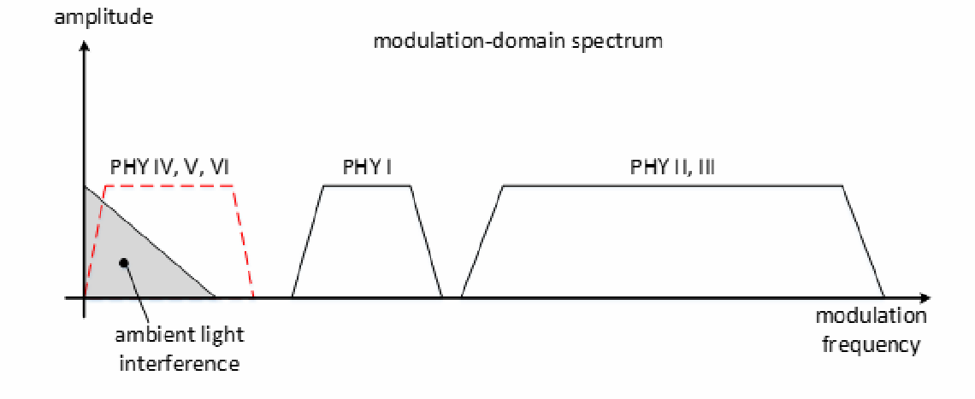

##### Figure 4—FDM separation of the PHY types in the modulation domain

##### MAC sublayer

The MAC sublayer provides two services accessed through two SAPs. MAC data is accessed through the MAC common part sublayer SAP (MCPS-SAP), while MAC management is accessed through the MAC (sub)layer management entity SAP (MLME-SAP). The MAC data service enables the transmission and reception of MPDUs across the PHY data service.

The features of the MAC sublayer are beacon management, channel access, guaranteed time slot (GTS) management, frame validation, acknowledged frame delivery, association, and disassociation. The MAC sublayer provides hooks for implementing application-appropriate security mechanisms. The MAC sublayer also provides color function, visibility, color stabilization, and dimming support.

Clause 5 describes the specifications for the MAC sublayer.

Use of over-the-air MAC frame configuration is forbidden for PHY IV, PHY V, and PHY VI. It is mandatory that MAC frame configuration be done via the MAC PAN information based (MAC PIB). This is due to the fact that unlike traditional wireless LAN/PAN, the data rates associated with OCC are such that the configuration overhead cannot be tolerated. In other words, there is no “base default” transmission mode. In addition, it is anticipated that configuration will be with application layer “APPs” that are specifically loaded to support a particular OCC PHY mode. The MAC PIB is not transmitted; rather, it is written by the DME and is read by the MAC sublayer.

##### Dimming and flicker-mitigation support

This subclause outlines the methods for dimming and flicker-mitigation support. For PHY I, PHY II, and PHY III, an idle pattern can be transmitted during MAC idle or RX states for infrastructure light sources for dimming support. This is important since it is desired to maintain visibility and flicker-free operation during idle or RX periods at the infrastructure. The idle pattern has the same duty cycle that is used during the active data communication so that there is no flicker seen during idle periods. This idle pattern and its dependence on the dimmer setting is shown in Figure 5. The transition of active operation and idle/RX operation can be in large time-scale (block active/idle/RX) or in a small time-scale (within a communication session). In the large time-scale block session activity, when the OWC activity is ON, there can be a small time-scaled transition of active mode and idle/RX mode. Dimmer setting for high brightness, in Figure 5a, illustrates a higher duty cycle for higher brightness. Dimmer setting for low brightness, in Figure 5b, illustrates a lower duty cycle for lower brightness. The data and the idle pattern should have the same duty cycle in order to minimize flicker.

##### Flicker mitigation

Flicker is the temporal modulation of lighting at frequencies higher than the critical fusion frequency that can affect human efficiency in diverse ways. This standard strives for the mitigation of flicker that may be caused due to modulation of the light sources for communication. The maximum flickering time period (MFTP) is defined as the maximum time period over which the light intensity can be changing, but for which the resulting flicker is not perceivable by the human eye (Berman et al. [B1]).6 To avoid flicker, any brightness changes over periods longer than MFTP must be avoided.

The flicker in OWC is classified into two categories according to its generation mechanism: intraframe flicker and interframe flicker. Intraframe flicker is defined as the perceivable brightness fluctuation within a frame. Interframe flicker is defined as the perceivable brightness fluctuation between adjacent frame transmissions.

6 Number in brackets correspond to the numbers in the bibliography in Annex A.

brightness

block active

on OWC activity

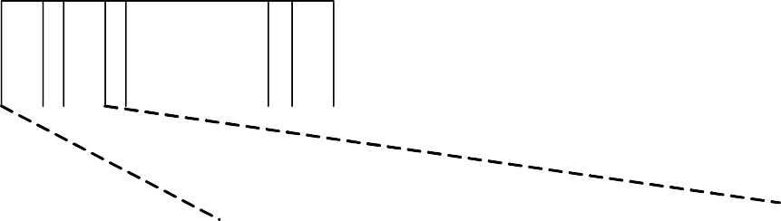

time

active

idle/RX

active



|  |  |  |  |  |  |  |
| --- | --- | --- | --- | --- | --- | --- |
| A : active I: idle / RX | | | | | | |
| A I | A I | ……. | I A | block idle / RX | block active |  |

off

MAC scheduled TX

idle pattern

infrastructure TX output

Dimmer setting for high brightness (a)

MAC scheduled TX

idle pattern

active

|  |  |  |  |  |  |  |  |
| --- | --- | --- | --- | --- | --- | --- | --- |
|  |  |  |  |  |  |  |  |

idle/RX

active

|  |  |  |  |  |  |  |  |
| --- | --- | --- | --- | --- | --- | --- | --- |
|  |  |  |  |  |  |  |  |

infrastructure TX output

|  |  |  |  |  |  |  |  |
| --- | --- | --- | --- | --- | --- | --- | --- |
|  |  |  |  |  |  |  |  |

|  |  |  |  |  |  |  |  |
| --- | --- | --- | --- | --- | --- | --- | --- |
|  |  |  |  |  |  |  |  |

Dimmer setting for low brightness (b)

##### Figure 5—Adapting dimmer pattern and data duty cycle depending on dimmer setting

* + - * 1. **Intraframe flicker mitigation**

Intraframe flicker mitigation is accomplished by either the use of run-length limited (RLL) coding, modulation scheme, or both.

##### Interframe flicker mitigation

The scheme used for interframe flicker mitigation is the transmission of an idle pattern between data frames whose average brightness is equal to that of the data frames, as defined in 8.5.1.1. See Figure 6.

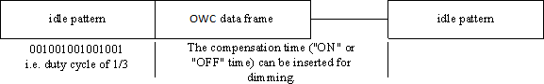

##### Figure 6—Example of idle pattern and compensation time dimming

* + - 1. **Light dimming**

Light dimming is defined as controlling the perceived brightness of the light source according to the user’s requirement and is a cross layer function between the PHY and MAC. The details on the light dimming function of MAC sublayer are discussed in 5.3.10.

Three major dimming methods can be applied to control the light brightness: (1) adding compensation symbols, (2) controlling pulse width, and (3) controlling the amplitude of the signal. The selection of a proper dimming method follows the selection of the modulation. Details on dimming during data transmission of individual modulation is described in 8.5.

##### Dimming by adding compensation symbols

Since OOK modulation and mirror pulse modulation (MPM) are always sent with a constant brightness within a symbol (e.g., a symmetric Manchester symbol or MPM symbol), compensation time may need to be inserted into the data frame to adjust the average intensity of the perceived source. The frame structure for the dimming method of inserting compensation symbols is as shown in Figure 7.

|  |  |  |  |  |  |
| --- | --- | --- | --- | --- | --- |
|  | | | | | |
|  |  |  |  |  |  |

##### Figure 7—OOK dimming structure

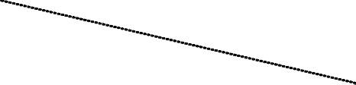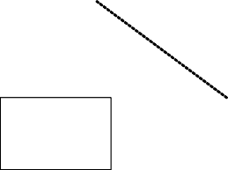

frame length

data subframe

resync field

i.e. 1010 pattern

compensation symbols

dimmed OOK

extension

PHY

header

preamble

This process breaks the frame into subframes, and each subframe can be preceded by a resync field that aids in readjusting the data clock after the compensation time. The data frame is fragmented into subframes of the appropriate length after the frame check sequence (FCS) has been calculated and the forward error

correction (FEC) has been applied. An example of OOK dimming to increase average brightness (AB) by N% by adding compensation symbols is as shown in Figure 8.

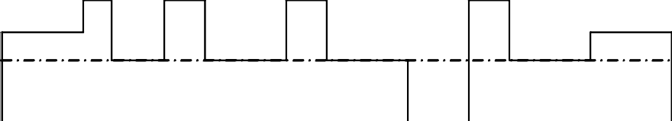

brightness

AB = N% AB = N%

AB = N% AB = N% AB = N%

AB = N%

N%

50%

idle patterns

frame length

time

PHY frame

DS

RF

DS

RF

DS

RF

H

P

idle patterns

CS

CS

CS

CS

P: preambles

H: PHY headers & extension CS: compensation symbols RF: resync field

subframe

DS: data symbol

##### Figure 8—Example of OOK dimming to increase brightness

An example of MPM dimming to increase average brightness (AB) by adding compensation symbols (CS) is as shown in Figure 9.

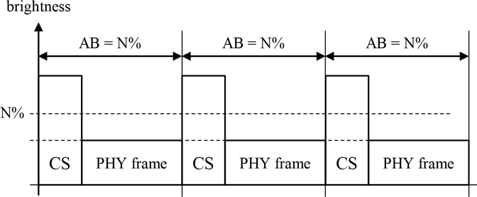

##### Figure 9—Example of MPM dimming by adding compensation symbols

* + - * 1. **Dimming by controlling pulse width**

Dimming by controlling the pulse width is illustrated in Figure 10.

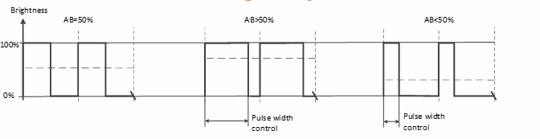

##### Figure 10—Pulse width dimming

VPPM is adapted for pulse-width-based light dimming and offers protection from intraframe flicker. The pulse amplitude in VPPM is always constant, and the dimming control is performed by the pulse width, not the amplitude. An example of VPPM dimming to increase brightness by controlling pulse width modulation (PWM) is as shown in Figure 11.

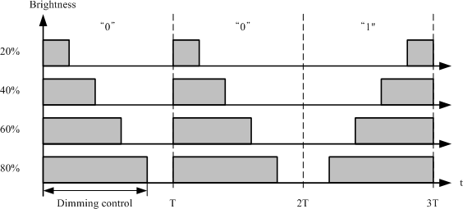

##### Figure 11—Example of VPPM dimming

Frequency shift keying (FSK) at a frequency that does not cause flicker during a symbol time uses a constant pulse amplitude during the transmission of symbols and performs dimming by controlling the duty cycle of the signal, as shown in Figure 12.

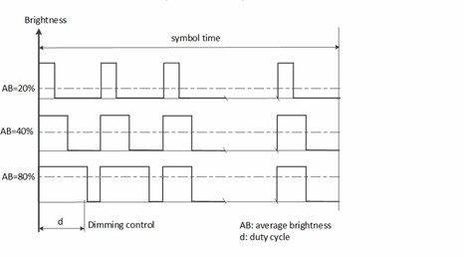

##### Figure 12—Example of FSK dimming by controlling pulse width

* + - * 1. **Dimming by controlling pulse amplitude**

The dimming is performed by controlling the amplitude of ones or zeros or both, as shown in Figure 13.

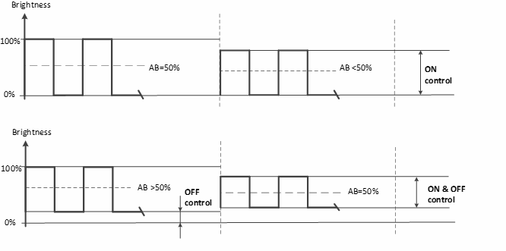

##### Figure 13—Mechanism for amplitude dimming

* + - * 1. **Dimming by controlling brightness in out-of-band frequency**

The apparent average pulse brightness can be controlled by representing the pulse as a high-frequency, controllable duty cycle waveform, as shown in Figure 14. The frequency is selected so that only the amplitude envelop survives the signal processing with the duty cycle controlling the pulse average.

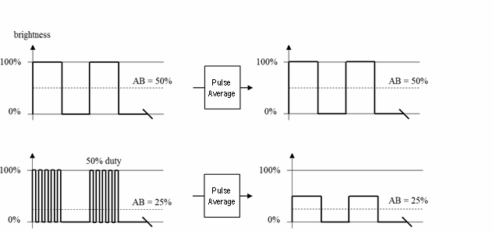

##### Figure 14—Out-of-band dimming

#### Functional overview

This subclause provides a brief overview of the general functions of a OWPAN MAC sublayer and includes information on the superframe structure, data transfer model, data frame structure, acknowledgments, and security.

##### Superframe structure

This standard allows the optional use of a superframe structure. The format of the superframe is defined by the coordinator and varies with the network topologies. The superframe is bounded by beacons sent by the coordinator, as shown in Figure 15a, and is divided into slots of equal size. Optionally, the superframe can have an active and an inactive portion, as shown in Figure 15b. The beacon frame is transmitted in the first slot of each superframe. If a coordinator does not wish to use a superframe structure, it will turn off the beacon transmissions. Each superframe can have two or three portions: beacon period (BP), contention access period (CAP) and optional contention-free period (CFP), as shown in Figure 15. The beacons are sent in the BP and are used to synchronize the attached devices, to identify the OWPAN, and to describe the structure of the superframes. Any device wishing to communicate during the CAP between two beacons competes with other devices via slotted random access. The standard defines four random access methods: unslotted random access, slotted random access, unslotted carrier sense multiple access with collision avoidance (CSMA/CA), and slotted CSMA/CA. These methods are described in 5.1.2.2.

All transactions are completed by the time of the next BP.

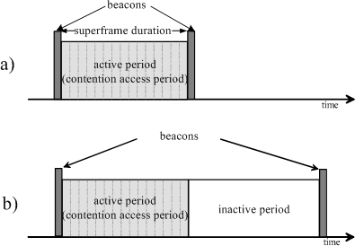

##### Figure 15—Superframe structure without GTSs

For low-latency applications or applications requiring specific data bandwidth, the coordinator is allowed to dedicate portions of the active superframe to that application. These portions are called guaranteed time slots (GTSs). The GTSs form the CFP, which always appears at the end of the active superframe starting at a slot boundary immediately following the CAP. More information on the GTS structure is provided in Figure 17. The coordinator is allowed to allocate a number of these GTSs, and a GTS may occupy more than one slot period. More information on the GTS slots and the maximum number available can be found in 5.2.2.1. All contention-based transactions are completed before the CFP begins. Also each device transmitting in a GTS determines that its transaction is complete before the time of the next GTS or the end of the CFP. More information on the superframe structure is described in 5.1.1.1.

##### Data transfer model

Three types of data transfer transactions exist:

* + - 1. The data transfer to a coordinator in which a device transmits the data.
      2. The data transfer from a coordinator in which the device receives the data.
      3. The data transfer between two peer devices.

In a star or broadcast topology, only the first two transaction types are used, while in a peer-to-peer topology, all three transaction types are allowed.

The mechanisms for each transfer type depend on whether the network supports the transmission of beacons. A beacon-enabled OWPAN is used in networks that require either synchronization or support for low-latency devices. If the network does not need synchronization or support for low-latency devices, it can elect not to use the beacon for normal transfers. However, the beacon is still required for network discovery. The structure of the frames used for data transfer is specified in 5.2.

##### Data transfer to a coordinator

When a device wishes to transfer data to a coordinator in a beacon-enabled OWPAN, it first listens for the beacon. When the beacon is found, the device synchronizes to the superframe structure. At the appropriate time, the device transmits its data frame, using slotted random access, to the coordinator. The coordinator has the option to acknowledge the successful reception of the data by transmitting an acknowledgment frame.

When a device wishes to transfer data in a nonbeacon-enabled OWPAN, it simply transmits its data frame, using unslotted random access, to the coordinator. The coordinator acknowledges the successful reception of the data by transmitting an optional acknowledgment frame. The transaction is now complete.

##### Data transfer from a coordinator

When the coordinator wishes to transfer data to a device in a beacon-enabled OWPAN, it indicates in the beacon that the data message is pending. The device periodically listens to the beacon and, if a message is pending, transmits a MAC command requesting the data, using slotted random access. The coordinator acknowledges the successful reception of the data request by transmitting an acknowledgment frame. The pending data frame is then sent using slotted random access, or; if possible, immediately after the acknowledgment as described in 5.1.7.3. The device is allowed to acknowledge the successful reception of the data by transmitting an optional acknowledgment frame. The transaction is now complete. Upon successful completion of the data transaction, the message is removed from the list of pending messages in the beacon.

When a coordinator wishes to transfer data to a device in a nonbeacon-enabled OWPAN, it stores the data and waits for the appropriate device to make contact and request the data. A device is allowed to make contact by transmitting a MAC command requesting the data, using unslotted random access, to its coordinator. The coordinator acknowledges the successful reception of the data request by transmitting an acknowledgment frame. If a data frame is pending, the coordinator transmits the data frame, using unslotted random access to the device. If a data frame is not pending, the coordinator indicates this fact either in the acknowledgment frame following the data request or in a data frame with a zero-length payload as described in 5.1.7.3. If requested, the device acknowledges the successful reception of the data frame by transmitting an acknowledgment frame.

##### Peer-to-peer data transfers

In a peer-to-peer OWPAN, every device is allowed to communicate with every other device in its coverage area. In order to do this effectively, the devices wishing to communicate will need to either receive constantly or synchronize with each other. In the former case, the device can simply transmit its data using unslotted random access. In the latter case, other measures need to be taken in order to achieve synchronization. Such measures are beyond the scope of this standard.

##### Clock-rate selection

This standard supports multiple optical clock rates in order to accommodate a wide variety of optical sources and receivers. The standard also supports the use of asymmetric clock rates between two devices since the transmitter and receiver in a device are independent and may support different clock-rate ranges. As an example, the infrastructure transmitter may be unable to switch rapidly but may be able to transmit with high power and require lower error correction, while the mobile device transmitter may be able to switch rapidly but may require higher error correction support due to its lower transmit power. The optical clock rate for communication is established using the MAC and can be communicated to the receiver prior to data transfer. The clock-rate selection and negotiation procedure is described in 6.5.

##### Frame structure

The frame structures have been designed to keep the complexity to a minimum while providing for error protection for transmission on a noisy channel. Each successive protocol layer adds to the structure with layer-specific headers and footers.

* + - 1. A beacon frame, used by a coordinator to transmit beacons.
      2. A data frame, used for all transfers of data.
      3. An acknowledgment frame, used for confirming successful frame reception.
      4. A MAC command frame, used for handling all MAC peer entity control transfer.
      5. A color visibility dimming (CVD) frame, used to maintain the proper light intensity between data frames, to support dimming, and to visually provide information such as communication status and channel quality to the user.

##### Improving probability of successful delivery

This standard employs various mechanisms to improve the probability of successful data transmission. These mechanisms are random access, frame acknowledgment, and data verification.

##### Random access mechanism

This standard uses four types of channel access mechanism, depending on the network configuration. Nonbeacon-enabled OWPANs use an unslotted random channel access mechanism, with or without CSMA/CA, as described in 5.1.2.2. Each time a device wishes to transmit data frames or MAC commands, it waits for a random backoff period. Following the random backoff, the device transmits its frame of data. If the optional carrier sense mechanism is active and the channel is found to be busy following the random backoff, the device waits for another random period before trying to access the channel again. Acknowledgment frames are sent without using a random access mechanism (i.e., scheduled).

Beacon-enabled OWPANs use a slotted random channel access mechanism, with or without CSMA/CA, where the backoff slots are aligned with the start of the beacon transmission. Each time a device wishes to transmit data frames during the CAP, it locates the boundary of the next backoff slot and then waits for a random number of backoff slots. If the optional collision avoidance mechanism is active and the channel is busy, following this random backoff, the device waits for another random number of backoff slots before trying to access the channel again. If the channel is idle or the optional carrier sense mechanism is not active, the device begins transmitting on the next available backoff slot boundary. Acknowledgment and beacon frames are sent without using a random access mechanism (i.e., scheduled).

If the device transmits and receives on the same spectrum and the device is within coverage of any other device, CSMA/CA can be optionally implemented.

##### Frame acknowledgment

A successful reception and validation of a data or MAC command frame can be optionally confirmed with an acknowledgment, as described in 5.1.7.4. If the receiving device is unable to handle the received data frame for any reason, the message is not acknowledged.

If the originator does not receive an acknowledgment after some period, it assumes that the transmission was unsuccessful. When the acknowledgment is not required, the originator assumes the transmission was successful.

##### Data verification

A cyclic redundancy check (CRC) is included in the MAC frame and the PHY header, as defined in Annex C, to verify the validity of the received data.

#### Security

From a security perspective, this standard is slightly different from other wireless networks, due to the fact that the signal will not travel across media such as walls, unlike other radio-frequency-based wireless networks. However, security algorithms are still provided in the standard for features such as data confidentiality, authentication, and replay protection.

Devices can be low-cost and have limited capabilities in terms of computing power, available storage, and power drain; it cannot always be assumed they have a trusted computing base nor a high-quality random number generator aboard. Communications cannot rely on the online availability of a fixed infrastructure and might involve short-term relationships between devices that may never have previously communicated. These constraints limit the choice of cryptographic algorithms and protocols and influence the design of the security architecture because the establishment and maintenance of trust relationships between devices need to be addressed with care. In addition, battery lifetime and cost constraints can put severe limits on the security overhead these networks can tolerate, something that is of far less concern with higher bandwidth networks. Most of these security architectural elements can be implemented at higher layers and may, therefore, be considered to be outside the scope of this standard.

The cryptographic mechanism in this standard is based on symmetric-key cryptography and uses keys that are provided by higher layer processes. The establishment and maintenance of these keys is outside the scope of this standard. The mechanism assumes a secure implementation of cryptographic operations and secure and authentic storage of keying material.

The cryptographic mechanism provides particular combinations of the following security services:

* + 1. *Data confidentiality:* Assurance that transmitted information is only disclosed to parties for whom it is intended.
    2. *Data authenticity:* Assurance of the source of transmitted information (and, thereby, that information was not modified in transit).
    3. *Replay protection:* Assurance that duplicate information is detected.

The actual frame protection provided can be adapted on a frame-by-frame basis and allows for varying levels of data authenticity (to minimize security overhead in transmitted frames where required) and for optional data confidentiality. When nontrivial protection is required, replay protection is always provided.

Cryptographic frame protection is allowed to use a key shared between two peer devices (link key) or a key shared among a group of devices (group key), thus allowing some flexibility and application-specific tradeoff between key storage and key maintenance costs versus the cryptographic protection provided. If a

group key is used for peer-to-peer communication, protection is provided only against outsider devices and not against potential malicious devices in the key-sharing group.

The cryptographic security mechanisms used for protected MAC frames are described in Clause 7.

#### Concept of primitives

This subclause provides a brief overview of the concept of service primitives. The services of a layer are the capabilities it offers to the next higher layer or sublayer by building its functions on the services of the next lower layer. This concept is illustrated in Figure 16, showing the service hierarchy and the relationship of the two correspondent users and their associated layer (or sublayer) peer protocol entities.

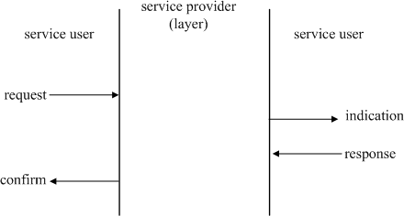

##### Figure 16—Service primitives

The services are specified by describing the information flow between the user and the layer. This information flow is modeled by discrete, instantaneous events, which characterize the provision of a service. Each event consists of passing a service primitive from one layer to the other through a layer SAP associated with an user. Service primitives convey the required information by providing a particular service. These service primitives are an abstraction because they specify only the provided service rather than the means by which it is provided. This definition is independent of any interface implementation.

Services are specified by describing the service primitives and parameters that characterize it. A service may have one or more related primitives that constitute the activity that is related to that particular service. Each service primitive may have zero or more parameters that convey the information required to provide the service.

A primitive can be one of the following four generic types:

* + 1. *Request:* The request primitive is used to request a service to be initiated.
    2. *Confirm:* The confirm primitive is used to convey the results of one or more associated previous service requests.
    3. *Indication:* The indication primitive is used to indicate the next higher layer of an internal event.
    4. *Response:* The response primitive is used to complete a procedure previously invoked by an indication primitive.

#### Some media access mechanisms by PHY types

The following transmitter schemes use unslotted ALOHA:

* Undersampled frequency shift ON-OFF keying (UFSOOK)
* Twinkle variable pulse position modulation (Twinkle VPPM)
* Offset variable pulse width modulation (Offset-VPWM)
* Mirror pulse modulation (MPM)
* Variable transparent amplitude-shape-color (VTASC)
* Sequential scalable two-dimensional (2D) color (SS2DC)
* Invisible data embedding (IDE)

In other words, when the transmitter has a packet to send, it just sends it. There is no beacon, and the transmitter does not do a listen-before-talk channel activity check. The superframe structure as shown in Figure 17 (in 5.1.1.1) consists of only the CAP.

#### Decoding

This standard defines PHY and MAC sublayer protocols; how to decode them is not in the normative scope of the standard.

## MAC protocol specifications

This clause specifies the MAC sublayer of this standard. The MAC sublayer handles all access to the physical layer and is responsible for the following tasks:

1. Generating network beacons if the device is a coordinator
2. Synchronizing to network beacons
3. Supporting OWPAN association and disassociation
4. Supporting color function
5. Supporting visibility
6. Supporting dimming
7. Flicker-mitigation scheme
8. Supporting visual indication of device status and channel quality
9. Supporting device security
10. Providing a reliable link between two peer MAC entities
11. Supporting mobility

Peer-to-peer, star, and broadcasting, as shown in Figure 1, are provided with a single MAC frame structure.

Constants and attributes that are specified and maintained by the MAC sublayer are written in the text of this clause in italics. Constants have a general prefix of “a”, e.g., *aBaseSlotDuration*, and are listed in Table 61 (see 6.4.1). Attributes have a general prefix of “mac”, e.g., *macAckWaitDuration*, and are listed either in Table 62 (see 6.4.2) or in Table 69 (see 7.5.1).

#### MAC functional description

This subclause provides a detailed description of the MAC functionality. Subclause 5.1.1 describes the following two mechanisms for channel access: contention based and contention free. Contention-based access allows devices to access the channel in a distributed fashion using an unslotted random access backoff algorithm. Contention-free access is controlled entirely by the coordinator through the use of GTSs.

The mechanisms used for starting and maintaining a OWPAN are respectively described in 5.1.2 and 5.1.3. Channel scanning is used by a device to assess the current state of a channel (or channels), locate all beacons within its operating space, or locate a particular beacon with which it has lost synchronization. Before starting a new OWPAN, the results of a channel scan can be used to select an appropriate logical channel, as well as a OWPAN identifier that is not being used by any other OWPAN in the area. Because it is still possible for the operating space of two OWPANs with the same OWPAN identifier to overlap, a procedure exists to detect and resolve this situation. Operation as a coordinator commences following a channel scan and suitable OWPAN identifier selection. Also described in the subclause is a method to allow coordinator beaconing to discover other such devices during normal operations, i.e., when not scanning.

The mechanisms to allow devices to join or leave a OWPAN are defined in 5.1.4. The association procedure describes the conditions under which a device may join a OWPAN and the conditions necessary for a coordinator to permit devices to join. Also described is the disassociation procedure, which can be initiated by the associated device or its coordinator.

The mechanisms to allow devices to acquire and maintain synchronization with a coordinator are described in 5.1.5. Synchronization on a beacon-enabled OWPAN is described after first explaining how a coordinator generates beacon frames. Following this explanation, synchronization on a nonbeacon-enabled OWPAN is described. Also described is a procedure to reestablish communication between a device and its coordinator, as it is possible that a device may lose synchronization in the case of either a beacon-enabled or a nonbeacon-enabled OWPAN.

This standard has been designed so that application data transfers can be controlled by the devices on a OWPAN rather than by the coordinator. The procedures the coordinator uses to handle multiple transactions while preserving this requirement are described in 5.1.6.

The mechanisms for transmitting, receiving, and acknowledging frames, including frames sent using indirect transmission, are described in 5.1.7. In addition, methods for retransmitting frames are also described.

The mechanisms for allocating and deallocating a GTS are described in 5.1.8. The deallocation process may result in the fragmentation of the GTS space, i.e., an unused slot or slots. The subclause describes a mechanism to resolve fragmentation.

The MAC sublayer uses the mechanisms described in Clause 7 for all incoming and outgoing frames.

Throughout this subclause, the receipt of a frame is defined as the successful receipt of the frame by the PHY and the successful verification of the FCS by the MAC sublayer, as described in 5.2.1.9.

The mechanisms to allow devices to recover quickly in case of temporary interference using a fast link recovery process are defined in 5.1.9. The fast link recovery process also enables devices to save power by letting the infrastructure initiate the link recovery.

The mechanisms to allow devices to use multiple channels in case of limited time resources or interference are defined in 5.1.10. Multiple channel resource assignment uses information about multiple channel support and band hopping in order to support more users or improve performance.

The mechanisms to support mobility of the device under an infrastructure that supports multiple optical elements over a wide coverage area are defined in 5.1.11. The concept of a cell is introduced and the support for mobility across multiple cells supported by the infrastructure is presented.

The mechanisms to visually indicate to the user the various states using various colors are defined in 5.1.12. The various states such as device discovery (scan, association, disassociation), file transfer status, wavelength quality indication and acknowledgments can be visually indicated to the user to help with device alignment for communication.

The mechanisms to stabilize the optical color emitted by the transmitter are defined in 5.1.13. The CVD frames are used to estimate the change in color and this information can be provided as feedback to the transmitter to stabilize its color.

The mechanisms for using the visibility and dimming information in the MAC are defined in 5.1.14. Features such as an extended preamble mode for providing visibility with improved synchronization performance, dimming overrides, adjusting the MAC sublayer transmission schedule to accommodate dimming, association and link adaptation in the presence of dimming are provided.

##### Channel access

This subclause describes the mechanisms for accessing the physical optical channel. The standard provides a single OWC MAC frame structure that can be configured for multiple modes. The frame is composed of a variable number of slots. A slot can be defined as the fixed minimum time needed to communicate to send the smallest data to a device and is fixed.

##### Superframe structure

A coordinator on a OWPAN can optionally bound its channel time using a superframe structure. A superframe is bounded by the transmission of a beacon frame and can have an active portion and an inactive portion. The coordinator may enter a low-power (sleep) mode during the inactive portion.

The structure of this superframe is controlled by the values of *macBeaconOrder* and *macSuperframeOrder.* The MAC PIB attribute *macBeaconOrder*, describes the interval at which the coordinator transmits its beacon frames when a coordinator is using a superframe structure, it shall transmit beacon frames based on the value of macBeasconOrder. The value of *macBeaconOrder*, *BO*, and the beacon interval, *BI*, are related as follows: for 0  *BO*  14, *BI* = *aBaseSuperframeDuration*  2*BO* optical clocks. When macBeaconOrder is set to 15, superframe structure shall not be used and the value of *macSuperframeOrder* shall be ignored.

The MAC PIB attribute *macSuperframeOrder* describes the length of the active portion of the superframe, which includes the beacon frame. The value of *macSuperframeOrder*, *SO*, and the superframe duration, *SD*, are related as follows: for 0  *SO*  *BO*  , *SD* = *aBaseSuperframeDuration*  2*SO* optical clocks. If *SO* = 15, the active period of the superframe shall be zero duration. If *BO* = 15, the superframe shall not exist (the value of *macSuperframeOrder* shall be ignored), and when *macRxOnWhenIdle* is TRUE, the receiver shall be capable of receiving an incoming frame during periods of transceiver inactivity.

The active portion of each superframe shall be divided into *aNumSuperframeSlots* equally spaced slots of duration 2*SO*  *aBaseSlotDuration* and is composed of three parts: a beacon, a CAP, and a CFP. The beacon frame initiating a superframe shall be transmitted without use of the random access algorithm defined in

5.1.1.3. If BP exits, beacon is transmitted without the use of any random access, in one beacon slot of BP. The CAP shall commence immediately following the beacon. The CFP, if present, follows immediately after the CAP and extends to the end of the active portion of the superframe. Any allocated GTSs shall be located within the CFP.

The MAC sublayer maintains the integrity of the superframe by compensating for clock drift error, etc. OWPANs that wish to use the superframe structure (referred to as beacon-enabled OWPANs) shall set

*macBeaconOrder* to a value between 0 and 14, both inclusive, and *macSuperframeOrder* to a value between

0 and the value of *macBeaconOrder*, both inclusive.

OWPANs that do not wish to use the superframe structure (referred to as nonbeacon-enabled OWPANs) shall set both *macBeaconOrder* and *macSuperframeOrder* to 15. In this case a coordinator shall not transmit periodic beacons; all transmissions in a nonbeacon-enabled OWPAN, with the exception of acknowledgment frames and any data frame that quickly follows the acknowledgment of a data request command (see 5.1.7.3), shall use an unslotted random access mechanism to access the channel (see 5.1.1.3).

An example of a superframe structure is shown in Figure 17. In this case, the beacon interval, *BI*, is twice as long as the active superframe duration, *SD*, and the CFP contains two GTSs.

Figure 18 provides an example usage of superframe structure configuration for multiple topologies such as peer-to-peer, star, broadcast, and visibility modes. The beacon slots are used for the beacons and the contention slots are used in the CAP. The uplink and downlink GTS slots are used in the CFPs. Visibility or idle patterns can be sent in the visibility slots during idle or RX modes of the infrastructure to provide continuous output and mitigate flicker and are also used for point-and-shoot mode to provide visibility.

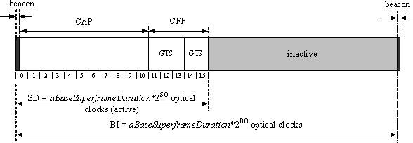

##### Figure 17—An example of the superframe structure

peer-to-peer mode

star

|  |  |  |  |  |  |  |  |  |  |  |
| --- | --- | --- | --- | --- | --- | --- | --- | --- | --- | --- |
|  |  |  |  |  |  |  |  |  |  |  |

(a ) all slots in frame used for same data

|  |  |  |  |  |  |  |  |  |  |  |
| --- | --- | --- | --- | --- | --- | --- | --- | --- | --- | --- |
|  |  |  |  |  |  |  |  |  |  |  |

1. beacon, contention, uplink, downlink slots

broadcast

|  |  |  |  |  |  |  |  |  |  |  |
| --- | --- | --- | --- | --- | --- | --- | --- | --- | --- | --- |
|  |  |  |  |  |  |  |  |  |  |  |

1. broadcast slots (beacon, downlink)

visibility mode

|  |  |  |  |  |  |  |  |  |  |  |
| --- | --- | --- | --- | --- | --- | --- | --- | --- | --- | --- |
|  |  |  |  |  |  |  |  |  |  |  |

( d ) visibility slots

legend for slot indication

data beacon contention uplink downlink visibility

##### Figure 18—Example usage of frame structure for multiple topologies

**5.1.1.1.1 Visibility support during channel access**

The visibility slots can be used during contention and uplink slots in star topology mode and unused slots in all modes to maintain visibility, reduce flicker and keep the transmitter always ON for the infrastructure. This is shown in Figure 19. Visibility support is a very important distinguishing feature for OWC. One may need to transmit idle patterns during receive and idle modes. This can be done by simultaneous reception of data and the transmission of visibility or idle patterns. This is possible due to spatial separation of the light source and the receiving circuitry. As shown in Figure 19, idle patterns are sent during contention, uplink slots and unused downlink slots by the infrastructure to maintain visibility. Idle patterns are also sent during unused slots by the mobile device to help with pointing and alignment for optimal data transfer.

If the continuous visibility bit is set in the Capabilities Information field shown in Table 18 (in 5.3.19.1.1), then infrastructure devices shall provide continuous visibility.

star topology (infrastructure)

full-duplex for visibility

|  |  |  |  |  |  |  |  |  |  |  |
| --- | --- | --- | --- | --- | --- | --- | --- | --- | --- | --- |
|  |  |  |  |  |  |  |  |  |  |  |



(a)



beacon contention

uplink

downlink

visibility for

infrastructure (downlink)

send visibility pattern during contention/uplink/unused slots in star toplogy

unused slots unused slots

all modes



full-duplex for visibility

visibility for point-and-shoot (uplink) and for infrastructure (downlink)

|  |  |  |  |  |  |  |  |  |  |  |
| --- | --- | --- | --- | --- | --- | --- | --- | --- | --- | --- |
|  |  |  |  |  |  |  |  |  |  |  |

send visibility pattern during unused slots in all applications

(b)

##### Figure 19—Usage of CVD frames during idle or RX modes of operation

* + - 1. **Interframe space (IFS)**

The MAC sublayer needs a finite amount of time to process data received by the PHY. To allow for this, two successive frames transmitted from a device shall be separated by at least an IFS period; if the first transmission requires an acknowledgment, the separation between the acknowledgment (ACK) frame and the second transmission shall be at least an IFS period. The length of the IFS period is dependent on the size of the frame that has just been transmitted. Frames (i.e., MPDUs) of up to *aMaxSIFSFrameSize* octets in length shall be followed by a short interframe space (SIFS) period of a duration of at least *macMinSIFSPeriod* optical clocks. Frames (i.e., MPDUs) with lengths greater than *aMaxSIFSFrameSize* octets shall be followed by a long interframe space (LIFS) period of a duration of at least *macMinLIFSPeriod* optical clocks. Burst frames shall have a reduced interframe space (RIFS) given by *macMinRIFSPeriod*. The IFS for the different modes are defined in 8.3.4, and the concepts are illustrated in Figure 20.

acknowledged transmission

long frame

ACK

short frame

ACK

*t*ack LIFS *t*ack SIFS

unacknowledged transmission

long frame

short frame

LIFS SIFS

burst transmission

long frame

burst frame

burst frame

burst frame

LIFS

RIFS

RIFS

##### Figure 20—Interframe spacing

* + - 1. **Random access algorithm**

The slotted random access algorithm shall be used before the transmission of data or MAC command frames transmitted within the CAP, unless the frame can be quickly transmitted following the acknowledgment of a data request command (as defined in 5.1.7.3 for timing requirements) or periodic beacons are being used. None of the random access algorithms shall be used for the transmission of beacon frames in a beacon- enabled OWPAN, acknowledgment (ACK) frames, or data frames transmitted in the CFP.

If periodic beacons are being used in the OWPAN, the MAC sublayer shall employ the slotted version of the random access algorithm for transmissions in the CAP of the superframe. Conversely, if periodic beacons are not being used in the OWPAN or if a beacon could not be located in a beacon-enabled OWPAN, the MAC sublayer shall transmit using the unslotted version of the random access algorithm. In both cases, the algorithm is implemented using units of time called backoff periods, where one backoff period shall be equal to *aUnitBackoffPeriod* optical clocks.

In slotted random access, the backoff period boundaries of every device in the OWPAN shall be aligned with the superframe slot boundaries of the coordinator, i.e., the start of the first backoff period of each device is aligned with the start of the beacon transmission. In slotted random access, the MAC sublayer shall determine that the PHY commences all of its transmissions on the boundary of a backoff period. In unslotted random access, the backoff periods of one device are not related in time to the backoff periods of any other device in the OWPAN. When a polling mechanism is used, each poll by the coordinator node simultaneously addressed to all device nodes will indicate the beginning of the next transmission slot.

Each device shall maintain two variables for each transmission attempt: *NB* and *BE*. *NB* is the number of times the access algorithm was required to backoff while attempting the current transmission; this value shall be initialized to zero before each new transmission attempt. The variable *BE* is the backoff exponent, which is related to how many backoff periods a device shall wait before attempting to access/assess a channel. *BE* shall be initialized to the value of *macMinBE*.

Figure 21 illustrates the steps of the access algorithm.

random access

no

slotted?

yes

no

carrier sense active?

yes

channel idle?

no

yes

no

ACK required?

*NB*

≤*macMaxRABackoffs*?

yes

yes

ACK received within *NB*=*NB*+1, *macAckWaitDuration*? *BE*=min(*BE*+1,*macMaxBE*)

yes success

failure

transmit

perform CCA

delay for

random (2*BE*-1) unit backoff periods

locate backoff period boundary

*NB*=0

*BE*=*macMinBE*

##### Figure 21—Random access flowchart

The MAC sublayer shall first initialize NB and BE for slotted random access then locate the boundary of the next backoff period. The MAC sublayer shall delay for a random number of complete backoff periods in the range 0 to 2*BE* – 1 [step (2)] and then request that the PHY perform a transmission or optionally a CCA. In a slotted random access system, the transmission, or CCA if active, shall start on a backoff period boundary. In an unslotted system, the transmission, or CCA if active, shall start immediately.

In a slotted random access system, the MAC sublayer shall determine that, after the random backoff, the remaining slotted random access operations can be undertaken and the entire transaction can be transmitted before the end of the CAP. Calculation of the transaction duration shall include any bit padding that may be added by the chosen PHY. If the number of backoff periods is greater than the remaining number of backoff periods in the CAP, the MAC sublayer shall pause the backoff countdown at the end of the CAP and resume it at the start of the CAP in the next superframe. If the number of backoff periods is less than or equal to the remaining number of backoff periods in the CAP, the MAC sublayer shall apply its backoff delay and then evaluate whether it can proceed. The MAC sublayer shall proceed if the remaining unslotted random access algorithm steps, the frame transmission, and any acknowledgment can be completed before the end of the CAP. If the MAC sublayer can proceed and CCA is active, it shall request that the PHY perform the CCA in the current superframe. If the MAC sublayer cannot proceed, it shall wait until the start of the CAP in the next superframe and apply a further random backoff delay before evaluating whether it can proceed again.

If CCA is active and the channel is assessed to be busy, the MAC sublayer shall increment both *NB* and *BE* by one, ensuring that *BE* shall be no more than *macMaxBE*. If the value of *NB* is less than or equal to *macMaxRABackoffs*, the access algorithm shall return to perform a random backoff as shown in Figure 21. If the value of *NB* is greater than *macMaxRABackoffs*, the access algorithm shall terminate with a channel access failure status.

##### Starting a OWPAN

* + - 1. **Scanning through channels**

All devices shall be capable of performing passive scans across a specified list of channels. In addition, a coordinator shall be able to perform active scans. A device is instructed to begin a channel scan through the MLME-SCAN.request primitive. For the duration of the scan, the device shall suspend beacon transmissions, if applicable, and may accept frames received over the PHY data service that are relevant to the scan being performed. Upon the conclusion of the scan, the device shall recommence beacon transmissions. The results of the scan shall be returned via the MLME-SCAN.confirm primitive.

##### Active channel scan

It is anticipated that the active channel scan is used with the peer-to-peer topology.

An active scan allows a device to locate any coordinator transmitting beacon frames within its coverage area. This could be used by a prospective OWPAN coordinator to select a OWPAN identifier prior to starting a new OWPAN, or it could be used by a device prior to association.

During an active scan, the MAC sublayer may discard all frames received over the PHY data service that are not beacon frames. If a beacon frame is received that contains the address of the scanning device in its list of pending addresses, the scanning device shall not attempt to extract the pending data.

Before commencing an active scan, the MAC sublayer shall store the value of *macOWPANId* and then set it to 0xffff for the duration of the scan. This enables the receive filter to accept all beacons rather than just the beacons from its current OWPAN (see 5.1.7.2). On completion of the scan, the MAC sublayer shall restore the value of *macOWPANId* to the value stored before the scan began. An active scan over a specified set of logical channels is requested using the MLME-SCAN.request primitive with the ScanType parameter set to indicate an active scan. For each logical channel, the device shall first switch to the channel, by setting

*phyCurrentChannel* accordingly, and send a beacon request command (see 5.3.6). Upon successful transmission of the beacon request command, the device shall enable its receiver for at most [*aBaseSuperframeDuration* × (2*n* + 1)] optical clocks, where *n* is the value of the ScanDuration parameter. During this time, the device may reject all nonbeacon frames and record the information contained in all unique beacons in a OWPAN descriptor structure (see 6.3.3.1), including the channel information and the preamble code. If a beacon frame is received when *macAutoRequest* is set to TRUE, the list of OWPAN descriptor structures shall be stored by the MAC sublayer until the scan is complete; at this time, the list shall be sent to the next higher layer in the OWPANDescriptorList parameter of the MLME-SCAN.confirm primitive. A device shall be able to store between one and an implementation-specified maximum number of OWPAN descriptors. A beacon frame shall be determined to be unique if it contains both a OWPAN identifier and a source address that has not been seen before during the scan of the current channel. If a beacon frame is received when *macAutoRequest* is set to FALSE, each recorded OWPAN descriptor is sent to the next higher layer in a separate MLME-BEACON-NOTIFY. indication primitive. A received beacon frame containing one or more octets of payload shall also cause the OWPAN descriptor to be sent to the next higher layer via the MLME-BEACON-NOTIFY.indication primitive. If a protected beacon frame is received, i.e., the Security Enabled subfield in the Frame Control field is set to one, the device shall perform the unsecuring process described in 7.2.3. The security-related elements of the OWPAN descriptor corresponding to the beacon (see 6.3.3.1) shall be set to the corresponding parameters returned by the unsecuring process. The SecurityFailure element of the OWPAN descriptor shall be set to SUCCESS if the status from the unsecuring process is SUCCESS and set to one of the other status codes indicating an error in the security processing otherwise. The information from the unsecured frame shall be recorded in the OWPAN descriptor even if the status from the unsecuring process indicated an error. If a coordinator of a beacon-enabled OWPAN receives the beacon request command, it shall ignore the command and continue transmitting its periodic beacons as usual. If a coordinator of a nonbeacon-enabled OWPAN receives this command, it shall transmit a single beacon frame using unslotted random access or unslotted CSMA-CA.

If *macAutoRequest* is set to TRUE, the active scan on a particular channel shall terminate when the number of beacons found equals the implementation-specified limit or the channel has been scanned for the full time, as specified in 5.1.2.1.1. If *macAutoRequest* is set to FALSE, the active scan on a particular channel shall terminate when the channel has been scanned for the full time. If a channel was not scanned for the full time, it is considered to be unscanned.

If *macAutoRequest* is set to TRUE, the entire scan procedure shall terminate when the number of OWPAN descriptors stored equals the implementation-specified maximum or every channel in the set of available channels has been scanned. If *macAutoRequest* is set to FALSE, the entire scan procedure shall only terminate when every channel in the set of available channels has been scanned.

##### Passive channel scan

It is anticipated that the passive channel scan is used with the star or broadcast topology.

A passive scan, like an active scan, allows a device to locate any coordinator transmitting beacon frames within its coverage area. The beacon request command, however, is not transmitted. This type of scan could be used by a device prior to association. During a passive scan, the MAC sublayer may discard all frames received over the PHY data service that are not beacon frames. If a beacon frame is received that contains the address of the scanning device in its list of pending addresses, the scanning device shall not attempt to extract the pending data.

Before commencing a passive scan, the MAC sublayer shall store the value of *macOWPANId* and then set it to 0xffff for the duration of the scan. This enables the receive filter to accept all beacons rather than just the beacons from its current OWPAN (see 5.1.7.2). On completion of the scan, the MAC sublayer shall restore the value of *macOWPANId* to the value stored before the scan began. A passive scan over a specified set of logical channels is requested using the MLME-SCAN.request primitive with the ScanType parameter set to indicate a passive scan. For each logical channel, the device shall first switch to the channel, by setting

*phyCurrentChannel* accordingly, and then enable its receiver for at most [*aBaseSuperframeDuration* × (2*n* + 1)] optical clocks, where *n* is the value of the ScanDuration parameter. During this time, the device may reject all nonbeacon frames and record the information contained in all unique beacons in a OWPAN descriptor structure (see 6.3.3.1). If a beacon frame is received when *macAutoRequest* is set to TRUE, the list of OWPAN descriptor structures shall be stored by the MAC sublayer until the scan is complete; at this time, the list shall be sent to the next higher layer in the OWPANDescriptorList parameter of the MLME- SCAN.confirm primitive. A device shall be able to store between one and an implementation-specified maximum number of OWPAN descriptors. A beacon frame shall be determined to be unique if it contains both a OWPAN identifier and a source address that has not been seen before during the scan of the current channel. If a beacon frame is received when *macAutoRequest* is set to FALSE, each recorded OWPAN descriptor is sent to the next higher layer in a separate MLME-BEACON-NOTIFY. indication primitive. Once the scan is complete, the MLME-SCAN.confirm shall be issued to the next higher layer with a null OWPANDescriptorList. A received beacon frame containing one or more octets of payload shall also cause the OWPAN descriptor to be sent to the next higher layer via the MLME-BEACON-NOTIFY.indication primitive.

If a protected beacon frame is received (i.e., the Security Enabled subfield in the Frame Control field is set to one), the device shall perform the unsecuring process described in 7.2.3.

The security-related elements of the OWPAN descriptor corresponding to the beacon, as shown in 6.3.3.1, shall be set to the corresponding parameters returned by the unsecuring process. The SecurityFailure element of the OWPAN descriptor shall be set to SUCCESS if the status from the unsecuring process is SUCCESS and set to one of the other status codes indicating an error in the security processing otherwise.

The information from the unsecured frame shall be recorded in the OWPAN descriptor even if the status from the unsecuring process indicated an error.

If *macAutoRequest* is set to TRUE, the passive scan on a particular channel shall terminate when the number of beacons found equals the implementation specified limit or the channel has been scanned for the full time. If *macAutoRequest* is set to FALSE, the passive scan on a particular channel shall terminate when the channel has been scanned for the full time. If a channel was not scanned for the full time, it is considered to be unscanned.

If *macAutoRequest* is set to TRUE, the entire scan procedure shall terminate when the number of OWPAN descriptors stored equals the implementation-specified maximum or every channel in the set of available channels has been scanned. If *macAutoRequest* is set to FALSE, the entire scan procedure shall terminate only when every channel in the set of available channels has been scanned.

##### OWPAN initiation

Capability exchange should occur for all bidirectional communication during device discovery. If a device supports multiple transmit color channels, it can exchange the WQI metrics for channel selection. There is no channel selection process requirement if the device supports only a single color channel. For a star topology, the coordinator establishes the OWPAN by sending beacon frames. For peer-to-peer topology, a device can utilize an active scan to initiate communication with the peer device by sending an association command. See Figure 22.

coordinator device

device 1 – *M1* colors device 2 – *M2* colors

*K* = *M1*∩*M2* – common colors

WQI – wavelength quality indicator report

transmit on *M1* channels

send channel colors supported guard channels, device requirements transmit on *K* channels

send channel colors supported guard channels, device requirements send RX WQI report for *K* channels

send TX WQI report for *K* channels information channel(s) used for TX and RX and access

data transfer on agreed channel(s)

exchange capabilities

channel selection





##### Figure 22—OWPAN initiation

Let device 1 support *M1* color channels and let device 2 support *M2* color channels. Let *K* be the number of channels shared between device 1 and device 2, where *K*  1 for communication. For a peer-to-peer network, the first device, which may be the device or coordinator, initiates the communications and transmits on all supported *M1* channels. If there is independent hardware for each color at the transmitter and receiver, parallel transmissions are possible as long as guard color channels are not used for any particular color choice. Each device communicates the capabilities of each device and application requirements via the MAC and PHY Capabilities information element provided. The MAC also reports the number of supported aggregated channels and the associated guard colors for each channel. Next, the other device attempts to receive and synchronize on all *K* channels shared between the devices. However, it may be able to receive on only *x* channels, where 1  *x*  *K*, due to interference with other light sources. The second device shall receive on at least one channel in order to communicate. The *K* channels and device capabilities are obtained from the mentioned information. Based on the interference energy from ambient light and the energy received during transmission, a WQI is calculated for all *K* channels. The second device then transmits on all *K* common channels to the first device. The second device also provides its supported channels, guard channels and application requirements as part of its capabilities information exchange. Next, the first device attempts to receive and synchronize on all *K* channels. It may receive on only *y* channels, where 1  *y*  *K*, due to interference. Since visible-light communication is very directional, it is possible that *x* and *y* may be different. For example, if first device is closer to a window, it may receive more ambient light interference than the second device. The first device calculates its RX WQI for all *K* channels as well and transmits the WQI report back to the second device.

Simultaneously, the second device calculates the WQI metrics based on the received information from the first device. Channels where reception is not possible or where other piconets are known to operate by the second device will be tagged unusable with a reception WQI of 0. The second device then reports this RX WQI for all *K* channels back to the first device.

The initiating device collects the information for the transmission such as the transmission and reception capabilities of the two devices, the WQI reports, the selected guard color channels for each channel and the requirements of the application. Based on this information, the first device determines a single or multiple channels for communication. The first device then reports the communication channels to the second device. Thus, at the end of this exchange, both devices have an estimate of the WQI for their transmissions that is most suitable for reception at the other end. From that point, both devices can communicate on the agreed channel or channels.

The support for wavelength quality indication is provided in the PHY and shall be passed to the MAC via the PHY data SAP (PD-SAP) interface as shown in Table 112 (in 9.3.3).

For a star topology network, the coordinator acts as the initiator for device discovery and association and uses the CAP for association requests and the beacon/management frames to broadcast its association grants.

##### Broadcast mode

Starting a OWPAN is only applicable to bidirectional communication modes and not for broadcasting. The broadcast mode does not have any requirements for starting a OWPAN.

##### Beacon generation

A device shall be permitted to transmit beacon frames only if *macShortAddress* is not equal to 0xffff.

A coordinator shall use the MLME-START.request primitive to begin transmitting beacons only if the BeaconOrder parameter is less than 15. The coordinator may begin beacon transmission either as the coordinator of a new OWPAN or as a device on a previously established OWPAN, depending upon the setting of the OWPANCoordinator parameter, as shown in 6.3.11.1. The coordinator shall begin beacon transmission on a previously established OWPAN only once it has successfully associated with that OWPAN.

For the coordinator (i.e., the OWPANCoordinator parameter is set to TRUE), the MAC sublayer shall ignore the StartTime parameter and begin beacon transmissions immediately. Setting the StartTime parameter to zero shall also cause the MAC sublayer to begin beacon transmissions immediately. If not acting as the coordinator and the StartTime parameter is nonzero, the time to begin beacon transmissions shall be calculated using the following method. The StartTime parameter, which is rounded to a backoff slot boundary, shall be added to the time, obtained from the local clock, when the MAC sublayer receives the beacon of the coordinator through which it is associated. The MAC sublayer shall then begin beacon transmissions when the current time, obtained from the local clock, equals the number of calculated optical clocks. In order for the beacon transmission time to be calculated by the MAC sublayer, the MAC sublayer shall first track the beacon of the coordinator through which it is associated. If the MLME-START.request primitive is issued with a nonzero StartTime parameter and the MAC sublayer is not currently tracking the beacon of its coordinator, the MLME shall not begin beacon transmissions but shall instead issue the MLME-START.confirm primitive with a status of TRACKING_OFF.

If a device misses between one and (*aMaxLostBeacons*–1) consecutive beacon frames from its coordinator, the device shall continue to transmit its own beacons based on both *macBeaconOrder* (see 5.1.3.5) and its local clock. If the device then receives a beacon frame from its coordinator and, therefore, does not lose synchronization, the device shall resume transmitting its own beacons based on the StartTime parameter and the incoming beacon. If a device does lose synchronization with its coordinator, the MLME of the device shall issue the MLME-SYNC-LOSS.indication primitive to the next higher layer and immediately stop transmitting its own beacons. The next higher layer may, at any time following the reception of the MLME- SYNC-LOSS.indication primitive, resume beacon transmissions by issuing a new MLME-START.request primitive.

On receipt of the MLME-START.request primitive, the MAC sublayer shall set the OWPAN identifier in *macOWPANId* and use this value in the Source OWPAN Identifier field of the beacon frame. The address used in the Source Address field of the beacon frame shall contain the value of *aExtendedAddress* if *macShortAddress* is equal to 0xfffe or *macShortAddress* otherwise.

The time of transmission of the most recent beacon shall be recorded in *macBeaconTxTime* and shall be computed so that its value is taken at the same position in each beacon frame, the location of which is implementation specific. The position, which is specified by the *macTimeStampOffset* attribute, is the same as that used in the timestamp of the incoming beacon frame, as described in 5.1.5.1.

All beacon frames shall be transmitted at the beginning of each superframe at an interval equal to *aBaseSuperframeDuration*  2*n* optical clocks, where *n* is the value of *macBeaconOrder* (the construction of the beacon frame is specified in 5.2.2.1).

Beacon transmissions shall be given priority over all other transmit and receive operations.

##### Device discovery

The coordinator indicates its presence on a OWPAN to other devices by transmitting beacon frames. This allows the other devices to perform device discovery.

##### PHY I, PHY II, and PHY III

Device discovery shall be performed at 11.67 kbps with a 200 kHz optical clock for PHY I and at 1.25 Mbps with a 3.75 MHz optical clock for PHY II. PHY III does not provide device discovery support and shall rely on device discovery using PHY II before operating in that mode. The dimmed OOK mode can be used to support dimming in the device discovery process. This mode is indicated using the MAC PIB attribute, *macUseDimmedOOKmode*, as defined in Table 62 (in 6.4.2). The MAC and PHY capabilities are exchanged in the device discovery process. The clock rate support capabilities are also exchanged. Once the capabilities are exchanged, regular data transmission mode resumes for all three PHY types. Device discovery requires bidirectional communication and is not applicable for broadcasting.

##### PHY IV, PHY V, and PHY VI

Device types PHY IV, PHY V, and PHY VI are not interoperable.

##### Guard and aggregation color channels

The bandplan provides support for seven logical channels in the MAC. However, in order to support association without knowledge of receiver capabilities and to support unidirectional broadcasting, the visible-light communication receiver shall support reception on the entire visible light spectrum with any type of optical light source.

Channel aggregation is used to indicate optical sources that span multiple (>1) bands in the proposed bandplan and are intentionally transmitting on multiple bands due to the choice of optical light source. Guard channels are used to indicate optical sources that unintentionally leak into other bands, whose information can be discarded at the receiver for better performance. See Figure 23.

band i band j

band i

band p

band q

spectral power

spectral power

intentional transmission

indicate merged band in MAC capabilities (channel aggregation)

(A)

unintentional transmission indicate guard band(s) in MAC capabilities,

depending on leakage amount (guard channel)

(B)

##### Figure 23—Concept of aggregation channel and guard channel

If multiple bands are aggregated or multiple optical sources are transmitting simultaneously, the same data shall be sent on all optical sources during the preamble and header during device discovery since it is not known what the receiver capabilities are. The details on channel aggregation and guard channel support are provided in the PHY Capabilities information element of the MAC. The criterion used for defining a guard color channel or aggregated channel is based on out-of-band leakage exceeding 20 dB over maximum in- channel value. The transmitting device shall indicate channel aggregation and guard channel support using the PHY capabilities during device discovery and association for bidirectional communication modes.

##### Maintaining OWPANs

In some instances a situation could occur in which two OWPANs exist in the same operating space with the same OWPAN identifier. If this conflict happens, the coordinator and its devices shall perform the OWPAN identifier conflict resolution procedure.

This procedure is optional for a device.

##### Detection

The OWPAN coordinator shall conclude that a OWPAN identifier conflict is present if either of the following apply:

* + - * + A beacon frame is received by the OWPAN coordinator with the OWPAN Coordinator subfield (see 5.2.2.1.2) set to one and the OWPAN identifier equal to *macOWPANId*.
        + A OWPAN ID conflict notification command (see 5.3.5) is received by the OWPAN coordinator from an associated device on its OWPAN.

A device that is associated through the OWPAN coordinator (i.e., *macAssociatedOWPANCoord* is set to TRUE) shall conclude that a OWPAN identifier conflict is present if the following applies:

* + - * + A beacon frame is received by the device with the OWPAN Coordinator subfield set to one, the OWPAN identifier equal to *macOWPANId*, and an address that is equal to neither *macCoordShortAddress* nor *macCoordExtendedAddress*.

##### Resolution

On the detection of a OWPAN identifier conflict by a device, it shall generate the OWPAN ID conflict notification command, defined in 5.3.5, and send it to its coordinator. Since the OWPAN ID conflict notification command contains an acknowledgment request (see 5.3.3.1), the coordinator shall confirm its receipt by sending an acknowledgment frame. Once the device has received the acknowledgment frame from the coordinator, the MLME shall issue an MLME-SYNC-LOSS.indication primitive with the LossReason parameter set to OWPAN_ID_CONFLICT. If the device does not receive an acknowledgment frame, the MLME shall not inform the next higher layer of the OWPAN identifier conflict.

On the detection of a OWPAN identifier conflict by the coordinator, the MLME shall issue an MLME- SYNC-LOSS.indication to the next higher layer with the LossReason parameter set to OWPAN_ID_CONFLICT. The next higher layer of the coordinator may then perform an active scan and, using the information from the scan, select a new OWPAN identifier. The algorithm for selecting a suitable OWPAN identifier is out of the scope of this standard. If the next higher layer does select a new OWPAN identifier, it may then issue an MLME-START.request with the CoordRealignment parameter set to TRUE in order to realign the OWPAN, as described in 5.1.3.3.

##### Realigning a OWPAN

If a coordinator receives the MLME-START.request primitive (see 6.3.11.1) with the CoordRealignment parameter set to TRUE, the coordinator shall attempt to transmit a coordinator realignment command containing the new parameters for OWPANId, LogicalChannel.

When the coordinator is already transmitting beacons and the CoordRealignment parameter is set to TRUE, the next scheduled beacon shall be transmitted on the current channel using the current superframe configuration, with the Frame Pending subfield of the Frame Control field set to one. Immediately following the transmission of the beacon, the coordinator realignment command shall also be transmitted on the current channel using unslotted random access.

When the coordinator is not already transmitting beacons and the CoordRealignment parameter is set to TRUE, the coordinator realignment command shall be transmitted immediately on the current channel using unslotted random access.

If the transmission of the coordinator realignment command fails due to a channel access failure, the MLME shall notify the next higher layer by issuing the MLME-START.confirm primitive with a status of CHANNEL_ACCESS_FAILURE. The next higher layer may then choose to issue the MLME- START.request primitive again.

Upon successful transmission of the coordinator realignment command, the new superframe configuration and channel parameters shall be put into operation as described in 5.1.3.5 at the subsequent scheduled beacon, or immediately if the coordinator is not already transmitting beacons, and the MAC sublayer shall issue the MLME-START.confirm primitive with a status of SUCCESS.

##### Realignment in a OWPAN

If a device has received the coordinator realignment command (see 5.3.7) from the coordinator through which it is associated, the MLME shall issue the MLME-SYNC-LOSS.indication primitive with the LossReason parameter set to REALIGNMENT and the OWPANId, LogicalChannel, and the security- related parameters set to the respective fields in the coordinator realignment command. The next higher layer of a coordinator may then issue an MLME-START.request primitive with the CoordRealignment parameter set to TRUE. The next higher layer of a device that is not a coordinator may instead change the superframe configuration or channel parameters through use of the MLME-SET.request primitive.

##### Updating superframe configuration and channel PIB attributes

To update the superframe configuration and channel attributes, the MLME updates the PIB attributes that control the superframe configuration using the parameters provided as follows. The MLME shall set macBeaconOrder to the value of the BeaconOrder parameter. If macBeaconOrder is equal to 15, the MLME will also set macSuperframeOrder to 15. In this case, this primitive configures a nonbeacon-enabled OWPAN. If macBeaconOrder is less than 15, the MAC sublayer will set macSuperframeOrder to the value of the SuperframeOrder parameter. The MAC sublayer shall also update macOWPANId with the value of the OWPANId parameter and update *phyCurrentChannel* with the values of the LogicalChannel parameters by issuing the PLME-SET.request primitive.

##### Association and disassociation

This subclause specifies the procedures for association and disassociation.

##### Association

A device shall associate only after having first performed a MAC sublayer reset, by issuing the MLME- RESET.request primitive with the SetDefaultPIB parameter set to TRUE, and then having completed either an active channel scan (see 5.1.2.1.1) or a passive channel scan as shown in 5.1.2.1.2. The results of the channel scan would have then been used to choose a suitable OWPAN. The algorithm for selecting a suitable OWPAN with which to associate from the list of OWPAN descriptors returned from the channel scan procedure is out of the scope of this standard.

Following the selection of a OWPAN with which to associate, the next higher layers shall request through the MLME-ASSOCIATE.request primitive that the MLME configures the following PHY and MAC PIB attributes to the values necessary for association:

* + - * + *phyCurrentChannel* shall be set equal to the LogicalChannel parameter of the MLME- ASSOCIATE.request primitive.
        + *macOWPANId* shall be set equal to the CoordOWPANId parameter of the MLME- ASSOCIATE.request primitive.
        + *macCoordExtendedAddress* or *macCoordShortAddress*, depending on which is known from the beacon frame from the coordinator through which it wishes to associate, shall be set equal to the CoordAddress parameter of the MLME-ASSOCIATE.request primitive.

A coordinator shall allow association only if *macAssociationPermit* is set to TRUE. Similarly, a device should attempt to associate only with a OWPAN through a coordinator that is currently allowing association, as indicated in the results of the scanning procedure. If a coordinator with *macAssociationPermit* set to FALSE receives an association request command from a device, the command shall be ignored.

In order to optimize the association procedure on a beacon-enabled OWPAN, a device may begin tracking the beacon of the coordinator through which it wishes to associate. This is achieved by the next higher layer issuing the MLME-SYNC.request primitive with the TrackBeacon parameter set to TRUE.

A device that is instructed to associate with a OWPAN, through the MLME-ASSOCIATE.request primitive, shall to associate only with an existing OWPAN and shall not start its own OWPAN.

The MAC sublayer of an unassociated device shall initiate the association procedure by sending an association request command (see 5.3.1) to the coordinator of an existing OWPAN; if the association request command cannot be sent due to a channel access failure, the MAC sublayer shall notify the next higher layer. Because the association request command contains an acknowledgment request (see 5.3.1.1), the coordinator confirms its receipt by sending an acknowledgment frame.

The acknowledgment to an association request command does not mean that the device has associated. The next higher layer of the coordinator needs time to determine whether the current resources available on the OWPAN are sufficient to allow another device to associate. The next higher layer should make this decision within *macResponseWaitTime* optical clocks. If the next higher layer of the coordinator finds that the device was previously associated on its OWPAN, all previously obtained device-specific information should be removed. If sufficient resources are available, the next higher layer should allocate a 16-bit short address to the device, and the MAC sublayer shall generate an association response command (see 5.3.2) containing the new address and a status indicating a successful association. If sufficient resources are not available, the next higher layer of the coordinator should inform the MAC sublayer, and the MLME shall generate an association response command containing a status indicating a failure as shown in Table 13. The association response command shall be sent to the device requesting association using indirect transmission, i.e., the

association response command frame shall be added to the list of pending transactions stored on the coordinator and extracted at the discretion of the device concerned using the method described in 5.1.7.3.

If the allocate address subfield of the Capability Information field (see 5.3.19.1.1) of the association request command is set to one, the next higher layer of the coordinator shall allocate a 16-bit address with a range depending on the addressing mode supported by the coordinator, as described in Table 2. If the Allocate Address subfield of the association request command is set to zero, the 16-bit short address shall be equal to 0xfffe. A short address of 0xfffe is a special case that indicates that the device has associated, but has not been allocated a short address by the coordinator. In this case, the device shall use only its 64-bit extended address to operate on the network.

On receipt of the acknowledgment to the association request command, the device shall wait for at most *macResponseWaitTime* optical clocks for the coordinator to make its association decision; the PIB attribute *macResponseWaitTime* is a network-topology-dependent parameter and may be set to match the specific requirements of the network that a device is trying to join. If the device is tracking the beacon, it shall attempt to extract the association response command from the coordinator whenever it is indicated in the beacon frame. If the device is not tracking the beacon, it shall attempt to extract the association response command from the coordinator after *macResponseWaitTime* optical clocks. If the device does not extract an association response command frame from the coordinator within *macResponseWaitTime* optical clocks, the MLME shall issue the MLME-ASSOCIATE.confirm primitive with a status of NO_DATA, and the association attempt shall be deemed a failure. In this case, the next higher layer shall terminate any tracking of the beacon. This is achieved by issuing the MLME-SYNC.request primitive with the TrackBeacon parameter set to FALSE.

The MLME-ASSOCIATE.response and the subsequent Association response (see 5.3.2) also contain information about what capabilities the device and the coordinator will and will not use during future communication.

Because the association response command contains an acknowledgment request (see 5.3.2.1), the device requesting association shall confirm its receipt by sending an acknowledgment frame. If the Association Status field of the command indicates that the association was successful, the device shall store the address contained in the 16-bit Short Address field of the command in *macShortAddress*; communication on the OWPAN using this short address shall depend on the VALUE of the received short address, as described in Table 2. If the original beacon selected for association following a scan contained the short address of the coordinator, the extended address of the coordinator, contained in the MAC header (MHR) of the association response command frame, shall be stored in *macCoordExtendedAddress.*

##### Table 2—Usage of the 16-bit short address

|  |  |
| --- | --- |
| **Value of *macShortAddress*** | **Description** |
| 0x0000–0xfffd | If a source address is included, the device shall use short source addressing mode for beacon and data frames and the appropriate source addressing mode specified in 5.3 for MAC command frames. |
| 0xfffe | If a source address is included, the device shall use extended source addressing mode for beacon and data frames and the appropriate source addressing mode specified in 5.3 for MAC command frames. |
| 0xffff | The device is not associated and, therefore, shall not perform any data frame communication. The device shall use the appropriate source addressing mode specified in 5.3 for MAC command frames. |

If the Association Status field of the command indicates that the association was unsuccessful, the device shall set *macOWPANId* to the default value (0xffff).

##### Disassociation

The disassociation procedure is initiated by the next higher layer by issuing the MLME- DISASSOCIATE.request primitive to the MLME.

When a coordinator wants one of its associated devices to leave the OWPAN, the MLME of the coordinator shall send the disassociation notification command in the manner specified by the TxIndirect parameter of the MLME-DISASSOCIATE.request primitive previously sent by the next higher layer. If TxIndirect is TRUE, the MLME of the coordinator shall send the disassociation notification command to the device using indirect transmission, i.e., the disassociation notification command frame shall be added to the list of pending transactions stored on the coordinator and extracted at the discretion of the device concerned using the method described in 5.1.7.3. If the command frame is not successfully extracted by the device, the coordinator should consider the device disassociated. Otherwise, the MLME shall send the disassociation notification command to the device directly. In this case, if the disassociation notification command cannot be sent due to a channel access failure, the MAC sublayer shall notify the next higher layer.

Because the disassociation command contains an acknowledgment request (see 5.3.3.1), the receiving device shall confirm its receipt by sending an acknowledgment frame. If the direct or indirect transmission fails, the coordinator should consider the device disassociated.

If an associated device wants to leave the OWPAN, the MLME of the device shall send a disassociation notification command to its coordinator. If the disassociation notification command cannot be sent due to a channel access failure, the MAC sublayer shall notify the next higher layer. Because the disassociation command contains an acknowledgment request (see 5.3.3.1), the coordinator shall confirm its receipt by sending an acknowledgment frame. However, even if the acknowledgment is not received, the device should consider itself disassociated.

If the source address contained in the disassociation notification command is equal to *macCoordExtendedAddress*, the device should consider itself disassociated. If the command is received by a coordinator and the source is not equal to *macCoordExtendedAddress*, it shall verify that the source address corresponds to one of its associated devices; if so, the coordinator should consider the device disassociated.

An associated device shall disassociate itself by removing all references to the OWPAN; the MLME shall set *macOWPANId*, *macShortAddress*, *macAssociatedOWPANCoord*, *macCoordShortAddress*, and *macCoordExtendedAddress* to the default values. The next higher layer of a coordinator should disassociate a device by removing all references to that device.

The next higher layer of the requesting device shall be notified of the result of the disassociation procedure through the MLME-DISASSOCIATE.confirm primitive.

##### Synchronization

This subclause specifies the procedures for coordinators to generate beacon frames and for devices to synchronize with a coordinator. For OWPANs supporting beacons, synchronization is performed by receiving and decoding the beacon frames. For OWPANs not supporting beacons, synchronization is performed by polling the coordinator for data.

##### Synchronization with beacons

All devices operating on a beacon-enabled OWPAN (i.e., *macBeaconOrder* < 15) shall be able to acquire beacon synchronization in order to detect any pending messages or to track the beacon. Devices shall be permitted to acquire beacon synchronization only with beacons containing the OWPAN identifier specified in *macOWPANId*. If *macOWPANId* specifies the broadcast OWPAN identifier (0xffff), a device shall not attempt to acquire beacon synchronization.

A device is instructed to attempt to acquire the beacon through the MLME-SYNC.request primitive. If tracking is specified in the MLME-SYNC.request primitive, the device shall attempt to acquire the beacon and keep track of it by regular and timely activation of its receiver. If tracking is not specified, the device shall either attempt to acquire the beacon only once or terminate the tracking after the next beacon if tracking was enabled through a previous request.

To acquire beacon synchronization, a device shall enable its receiver and search for at most [*aBaseSuperframeDuration*  (2*n* + 1)] optical clocks, where *n* is the value of *macBeaconOrder*. If a beacon frame containing the current OWPAN identifier of the device is not received, the MLME shall repeat this search. Once the number of missed beacons reaches *aMaxLostBeacons*, the MLME shall notify the next higher layer by issuing the MLME-SYNC-LOSS.indication primitive with a loss reason of BEACON_LOSS.

The MLME shall timestamp each received beacon frame at the same symbol boundary within each frame, the location of which is described by the *macTimeStampOffset* attribute. The position shall be the same as that used in the timestamp of the outgoing beacon frame, stored in *macBeaconTxTime*. The timestamp value shall be that of the local clock of the device at this position. The timestamp is intended to be a relative time measurement that may or may not be made absolute, at the discretion of the implementer.

If a protected beacon frame is received (i.e., the Security Enabled subfield in the Frame Control field is set to one), the device shall perform the unsecuring process described in 7.2.3.

If the status from the unsecuring process is not SUCCESS, the MLME shall issue an MLME-COMM- STATUS.indication primitive with the status parameter set to the status from the unsecuring process, indicating the error.

The security-related elements of the OWPAN descriptor corresponding to the beacon (see Table 40) shall be set to the corresponding parameters returned by the unsecuring process. The SecurityFailure element of the OWPAN descriptor shall be set to SUCCESS if the status from the unsecuring process is SUCCESS and set to one of the other status codes indicating an error in the security processing otherwise.

If a beacon frame is received, the MLME shall discard the beacon frame if the Source Address and the Source OWPAN Identifier fields of the MHR of the beacon frame do not match the coordinator source address (*macCoordShortAddress* or *macCoordExtendedAddress*, depending on the addressing mode) and the identifier of the device (*macOWPANId*).

If a valid beacon frame is received and *macAutoRequest* is set to FALSE, the MLME shall indicate the beacon parameters to the next higher layer by issuing the MLME-BEACON-NOTIFY.indication primitive. If a beacon frame is received and *macAutoRequest* is set to TRUE, the MLME shall first issue the MLME- BEACON-NOTIFY.indication primitive if the beacon contains any payload. The MLME shall then compare its address with those addresses in the Address List field of the beacon frame. If the Address List field contains the 16-bit short or 64-bit extended address of the device and the source OWPAN identifier matches *macOWPANId*, the MLME shall follow the procedure for extracting pending data from the coordinator as shown in 5.1.7.3.

If beacon tracking is activated, the MLME shall enable its receiver at a time prior to the next expected beacon frame transmission, i.e., just before the known start of the next superframe. If the number of consecutive beacons missed by the MLME reaches *aMaxLostBeacons*, the MLME shall respond with the MLME-SYNC-LOSS.indication primitive with a loss reason of BEACON_LOST.

##### Synchronization without beacons

All devices operating on a nonbeacon-enabled OWPAN (*macBeaconOrder* = 15) shall be able to poll the coordinator for data at the discretion of the next higher layer.

A device is instructed to poll the coordinator when the MLME receives the MLME-POLL.request primitive. On receipt of this primitive, the MLME shall follow the procedure for extracting pending data from the coordinator as shown in 5.1.7.3.

##### Transaction handling

Transactions can be instigated from the devices themselves rather than from the coordinator. In other words, either the coordinator needs to indicate in its beacon when messages are pending for devices or the devices themselves need to poll the coordinator to determine whether they have any messages pending. Such transfers are called indirect transmissions.

The coordinator shall begin handling a transaction on receipt of an indirect transmission request either via the MCPS-DATA.request primitive or via a request from the MLME to send a MAC command instigated by a primitive from the next higher layer, such as the MLME-ASSOCIATE.response primitive as shown in

6.3.1.3. On completion of the transaction, the MAC sublayer shall indicate a status value to the next higher layer. If a request primitive instigated the indirect transmission, the corresponding confirm primitive shall be used to convey the appropriate status value. Conversely, if a response primitive instigated the indirect transmission, the MLME-COMM-STATUS.indication primitive shall be used to convey the appropriate status value. The MLME-COMM-STATUS.indication primitive can be related to its corresponding response primitive by examining the Destination Address field.

The information contained in the indirect transmission request forms a transaction, and the coordinator shall be capable of storing at least one transaction. On receipt of an indirect transmission request, if there is no capacity to store another transaction, the MAC sublayer shall indicate to the next higher layer a status of TRANSACTION_OVERFLOW in the appropriate corresponding primitive.

If the coordinator is capable of storing more than one transaction, it shall determine that all the transactions for the same device are sent in the order in which they arrived at the MAC sublayer. For each transaction sent, if another exists for the same device, the MAC sublayer shall set its Frame Pending subfield to one, indicating the additional pending data.

Each transaction shall persist in the coordinator for at most *macTransactionPersistenceTime*. If the transaction is not successfully extracted by the appropriate device within this time, the transaction information shall be discarded and the MAC sublayer shall indicate to the next higher layer a status of TRANSACTION_EXPIRED in the appropriate corresponding primitive. In order to be successfully extracted, an acknowledgment shall be received if one was requested.

If the transaction was successful, the transaction information shall be discarded, and the MAC sublayer shall indicate to the next higher layer a status of SUCCESS in the appropriate corresponding primitive.

If the coordinator transmits beacons, it shall list the addresses of the devices to which each transaction is associated in the Address List field and indicate the number of addresses in the Pending Address Specification field of the beacon frame. If the coordinator is able to store more than seven pending transactions, it shall indicate them in its beacon on a first-come-first-served basis, ensuring that the beacon frame contains at most seven addresses. For transactions requiring a GTS, the coordinator shall not add the address of the recipient to its list of pending addresses in the beacon frame. Instead it shall transmit the transaction in the GTS allocated for the device as shown in 5.1.8.3.

On a beacon-enabled OWPAN, if there is a transaction pending for the broadcast address, the Frame Pending subfield of the Frame Control field in the beacon frame shall be set to one, and the pending message shall be transmitted immediately following the beacon using the unslotted random access algorithm. If there is a second message pending for the broadcast address, its transmission shall be delayed until the following superframe. Only one broadcast message shall be allowed to be sent indirectly per superframe.

On a beacon-enabled OWPAN, a device that receives a beacon containing its address in the list of pending addresses shall attempt to extract the data from the coordinator. On a nonbeacon-enabled OWPAN, a device shall attempt to extract the data from the coordinator on receipt of the MLME-POLL.request primitive. The procedure for extracting pending data from the coordinator is described in 5.1.7.3. If a device receives a beacon with the Frame Pending subfield set to one, it shall leave its receiver enabled for up to *macMaxFrameTotalWaitTime* optical clocks to receive the broadcast data frame from the coordinator.

##### Transmission, reception, and acknowledgment

This subclause describes the fundamental procedures for transmission, reception, and acknowledgment.

##### Transmission

Each device shall store its current data-sequence number (DSN) value in the MAC PIB attribute *macDSN* and initialize it to a random value; the algorithm for choosing a random number is out of the scope of this standard. Each time a data or a MAC command frame is generated, the MAC sublayer shall copy the value of *macDSN* into the Sequence Number field of the MHR of the outgoing frame and then increment it by one. Each device shall generate exactly one DSN regardless of the number of unique devices with which it wishes to communicate. The value of *macDSN* shall be permitted to roll over.

Each coordinator shall store its current beacon-sequence number (BSN) value in the MAC PIB attribute *macBSN* and initialize it to a random value; the algorithm for choosing a random number is out of the scope of this standard. Each time a beacon frame is generated, the MAC sublayer shall copy the value of *macBSN* into the Sequence Number field of the MHR of the outgoing frame and then increment it by one. The value of *macBSN* shall be permitted to roll over.

It should be noted that both the DSN and BSN are 8-bit values and, therefore, have limited use to the next higher layer (e.g., in the case of the DSN, in detecting retransmitted frames).

The Source Address field, if present, shall contain the address of the device sending the frame. When a device has associated and has been allocated a 16-bit short address (i.e., *macShortAddress* is not equal to 0xfffe or 0xffff), it shall use that address in preference to its 64-bit extended address (i.e., *aExtendedAddress*) wherever possible. When a device has not yet associated to a OWPAN or *macShortAddress* is equal to 0xffff, it shall use its 64-bit extended address in all communications requiring the Source Address field. If the Source Address field is not present, the originator of the frame shall be determined to be the coordinator, and the Destination Address field shall contain the address of the recipient.

The Destination Address field, if present, shall contain the address of the intended recipient of the frame, which may be either a 16-bit short address or a 64-bit extended address. If the Destination Address field is not present, the recipient of the frame shall be determined to be the coordinator, and the Source Address field shall contain the address of the originator.

If both destination and source addressing information is present, the MAC sublayer shall compare the destination and source OWPAN identifiers. If the OWPAN identifiers are identical the source OWPAN identifier shall be omitted from the transmitted frame. If the OWPAN identifiers are different, both the Destination OWPAN Identifier and Source OWPAN Identifier fields shall be included in the transmitted frame. If only either the destination or the source addressing information is present the OWPAN identifier field of the single address shall be included in the transmitted frame.

If the frame is to be transmitted on a beacon-enabled OWPAN, the transmitting device shall attempt to find the beacon before transmitting. If the beacon is not being tracked, as shown in 5.1.5.1, and hence the device does not know where the beacon will appear, it shall enable its receiver and search for at most [*aBaseSuperframeDuration*  (2*n* + 1)] optical clocks, where *n* is the value of *macBeaconOrder,* in order to find the beacon. If the beacon is not found after this time, the device shall transmit the frame following the

successful application of the unslotted version of the random access algorithm as shown in 5.1.2.2. Once the beacon has been found, either after a search or due to its being tracked, the frame shall be transmitted in the appropriate portion of the superframe. Transmissions in the CAP shall follow a successful application of the slotted version of the random access algorithm (see 5.1.2.2), and transmissions in a GTS shall not use any random access.

If the frame is to be transmitted on a nonbeacon-enabled OWPAN, the frame shall be transmitted following the successful application of the unslotted version of the random access algorithm as shown in 5.1.2.2.

For either a beacon-enabled OWPAN or a nonbeacon-enabled OWPAN, if the transmission is direct and originates due to a primitive issued by the next higher layer and the access algorithm fails, the next higher layer shall be notified. If the transmission is indirect and the access algorithm fails, the frame shall remain in the transaction queue until it is requested again and successfully transmitted or until the transaction expires.

The device shall process the frame using the outgoing frame security procedure described in 7.2.1.

If the status from the outgoing frame security procedure is not SUCCESS, the MLME shall issue the corresponding confirm or MLME-COMM-STATUS.indication primitive with the status parameter set to the status from the outgoing frame security procedure, indicating the error.

To transmit the frame, the MAC sublayer shall first enable the transmitter by issuing the PLME-SET- TRX-STATE.request primitive with a state of TX_ON to the PHY. On receipt of the PLME-SET-TRX- STATE.confirm primitive with a status of either SUCCESS or TX_ON, the constructed frame shall then be transmitted by issuing the PD-DATA.request primitive. Finally, on receipt of the PD-DATA.confirm primitive, the MAC sublayer shall disable the transmitter by issuing the PLME-SET-TRX-STATE.request primitive with a state of RX_ON or TRX_OFF to the PHY, depending on whether the receiver is to be enabled following the transmission. In the case where the Acknowledgment Request subfield of the Frame Control field is set to one, the MAC sublayer shall enable the receiver immediately following the transmission of the frame by issuing the PLME-SET-TRX-STATE.request primitive with a state of RX_ON to the PHY.

##### Reception and rejection

Each device may choose whether the MAC sublayer is to enable its receiver during idle periods. During these idle periods, the MAC sublayer shall still service transceiver task requests from the next higher layer. A transceiver task shall be defined as a transmission request with acknowledgment reception, if required, or a reception request. On completion of each transceiver task, the MAC sublayer shall request that the PHY enables or disables its receiver, depending on the values of *macBeaconOrder* and *macRxOnWhenIdle.* If *macBeaconOrder* is less than 15, the value of *macRxOnWhenIdle* is considered relevant only during idle periods of the CAP of the incoming superframe. If *macBeaconOrder* is equal to 15, the value of *macRxOnWhenIdle* is considered relevant at all times.

A device with its receiver enabled will be able to receive and decode transmissions from all devices complying with this standard that are currently operating on the same channel and are in its operating space, along with interference from other sources. The MAC sublayer shall, therefore, be able to filter incoming frames and present only the frames that are of interest to the upper layers.

The MAC sublayer shall discard all received frames that do not contain a correct value in their FCS field in the MAC footer (MFR) (see 5.2.1.9). The FCS field shall be verified on reception by recalculating the purported FCS over the MHR and MAC service data unit (MSDU) of the received frame and by subsequently comparing this value with the received FCS field. The FCS field of the received frame is correct if these values are the same and incorrect otherwise.

The MAC sublayer shall accept only frames that satisfy all of the following filtering requirements:

* The Frame Type subfield shall not contain a reserved frame type.
* If a destination OWPAN identifier is included in the frame, it shall match *macOWPANId* or shall be the broadcast OWPAN identifier (0xffff).
* If a short destination address is included in the frame, it shall match either *macShortAddress* or the broadcast address (0xffff). Otherwise, if an extended destination address is included in the frame, it shall match *aExtendedAddress*.
* If the frame type indicates that the frame is a beacon frame, the source OWPAN identifier shall match *macOWPANId* unless *macOWPANId* is equal to 0xffff, in which case the beacon frame shall be accepted regardless of the source OWPAN identifier.
* If only source addressing fields are included in a data or MAC command frame, the frame shall be accepted only if the device is the coordinator and the source OWPAN identifier matches *macOWPANId*.

If any of the third-level filtering requirements are not satisfied, the MAC sublayer shall discard the incoming frame without processing it further. If all of the third-level filtering requirements are satisfied, the frame shall be processed further. For valid frames that are not broadcast, if the Frame Type subfield indicates a data or MAC command frame and the Acknowledgment Request subfield of the Frame Control field is set to one, the MAC sublayer shall send an acknowledgment frame. Prior to the transmission of the acknowledgment frame, the sequence number included in the received data or MAC command frame shall be copied into the Sequence Number field of the acknowledgment frame. This step will allow the transaction originator to know that it has received the appropriate acknowledgment frame.

If both the destination and source addressing information is included in the frame, the MAC sublayer shall assume that the omitted Source OWPAN Identifier field is identical to the Destination OWPAN Identifier field.

The device shall process the frame using the incoming frame security procedure described in 7.2.3.

If the status from the incoming frame security procedure is not SUCCESS, the MLME shall issue the corresponding confirm or MLME-COMM-STATUS.indication primitive with the status parameter set to the status from the incoming frame security procedure, indicating the error, and with the security-related parameters set to the corresponding parameters returned by the unsecuring process.

If the valid frame is a data frame, the MAC sublayer shall pass the frame to the next higher layer. This is achieved by issuing the MCPS-DATA.indication primitive containing the frame information. The security- related parameters of the MCPS-DATA.indication primitive shall be set to the corresponding parameters returned by the unsecuring process.

If the valid frame is a MAC command or beacon frame, it shall be processed by the MAC sublayer accordingly, and a corresponding confirm or indication primitive may be sent to the next higher layer. The security-related parameters of the corresponding confirm or indication primitive shall be set to the corresponding parameters returned by the unsecuring process.

##### Extracting pending data from a coordinator

A device on a beacon-enabled OWPAN can determine whether any frames are pending for it by examining the contents of the received beacon frame, as described in 5.1.5.1. If the address of the device is contained in the Address List field of the beacon frame and *macAutoRequest* is TRUE, the MLME of the device shall send a data request command (see 5.3.4) to the coordinator during the CAP with the Acknowledgment Request subfield of the Frame Control field set to one; the only exception to this is if the beacon frame is received while performing an active or passive scan as shown in 5.1.3.1. There are two other cases for which the MLME shall send a data request command to the coordinator. The first case is when the MLME receives

the MLME-POLL.request primitive. In the second case, a device may send a data request command *macResponseWaitTime* optical clocks after the acknowledgment to a request command frame, such as during the association procedure. If the data request is intended for the coordinator, the destination address information may be omitted.

If the data request command originated from an MLME-POLL.request primitive, the MLME shall perform the security process on the data request command based on the SecurityLevel, KeyIdMode, KeySource, and KeyIndex parameters of the MLME-POLL.request primitive, according to 7.2.1. Otherwise, the MLME shall perform the security process on the data request command based on the PIB attributes *macAutoRequestSecurityLevel*, *macAutoRequestKeyIdMode*, *macAutoRequestKeySource,* and *macAutoRequestKeyIndex*, according to 7.2.1.

On successfully receiving a data request command, the coordinator shall send an acknowledgment frame, thus confirming its receipt. If the coordinator has enough time to determine whether the device has a frame pending before sending the acknowledgment frame (see 5.1.7.4.2), it shall set the Frame Pending subfield of the Frame Control field of the acknowledgment frame accordingly to indicate whether a frame is actually pending for the device. If this is not possible, the coordinator shall set the Frame Pending subfield of the acknowledgment frame to one.

On receipt of the acknowledgment frame with the Frame Pending subfield set to zero, the device shall conclude that there are no data pending at the coordinator.

On receipt of the acknowledgment frame with the Frame Pending subfield set to one, a device shall enable its receiver for at most *macMaxFrameTotalWaitTime* CAP optical clocks in a beacon-enabled OWPAN, or in a nonbeacon-enabled OWPAN, to receive the corresponding data frame from the coordinator. If there is an actual data frame pending within the coordinator for the requesting device, the coordinator shall send the frame to the device using one of the mechanisms described in this subclause. If there is no data frame pending for the requesting device, the coordinator shall send a data frame without requesting acknowledgment to the device containing a zero length payload, indicating that no data are present, using one of the mechanisms described in this subclause.

The data frame following the acknowledgment of the data request command shall be transmitted using one of the following mechanisms:

* Without using slotted random access, if the MAC sublayer can commence transmission of the data frame between *aTurnaroundTime-RX-TX* and (*aTurnaroundTime-RX-TX* + *aUnitBackoffPeriod*) optical clocks, on a backoff slot boundary, and there is time remaining in the CAP for the message, appropriate IFS, and acknowledgment as defined in 9.5.1. If a requested acknowledgment frame is not received following this data frame, the process shall begin anew following the receipt of a new data request command.
* Using slotted random access, otherwise.

If the requesting device does not receive a data frame from the coordinator within *macMaxFrameTotalWaitTime* CAP optical clocks in a beacon-enabled OWPAN, or in a nonbeacon-enabled OWPAN, or if the requesting device receives a data frame from the coordinator with a zero length payload, it shall conclude that there are no data pending at the coordinator. If the requesting device does receive a data frame from the coordinator, it shall send an acknowledgment frame, if requested, thus confirming receipt.

If the Frame Pending subfield of the Frame Control field of the data frame received from the coordinator is set to one, the device still has more data pending with the coordinator. In this case it may extract the data by sending a new data request command to the coordinator.

##### Use of acknowledgments and retransmissions

A data or MAC command frame shall be sent with the Acknowledgment Request subfield of its Frame Control field set appropriately for the frame. A beacon or acknowledgment frame shall always be sent with the Acknowledgment Request subfield set to zero. Similarly, any frame that is broadcast shall be sent with its Acknowledgment Request subfield set to zero.

##### No acknowledgment

A frame transmitted with its Acknowledgment Request subfield set to zero shall not be acknowledged by its intended recipient. The originating device shall assume that the transmission of the frame was successful.

The message sequence chart in Figure 24 shows the scenario for transmitting a single frame of data from an originator to a recipient without requiring an acknowledgment. In this case, the originator transmits the data frame with the Acknowledgment Request (AR) subfield of the Frame Control field equal to zero.

originator next higher layer

originator MAC

recipient MAC

recipient next higher layer

MCPS-DATA.request (AR=0)

Data (AR=0)

MCPS-DATA.indication

MCPS-DATA.confirm

##### Figure 24—Successful data transmission without an acknowledgment

* + - * 1. **Acknowledgment**

A frame transmitted with the Acknowledgment Request subfield of its Frame Control field set to one shall be acknowledged by the recipient. If the intended recipient correctly receives the frame, it shall generate and send an acknowledgment frame containing the same DSN from the data or MAC command frame that is being acknowledged.

The transmission of an acknowledgment frame in a nonbeacon-enabled OWPAN or in the CFP shall commence *aTurnaroundTime-RX-TX* optical clocks after the last optical clock of the data or MAC command frame. The transmission of an acknowledgment frame in the CAP shall commence either *aTurnaroundTime- RX-TX* optical clocks after the reception of the last optical clock of the data or MAC command frame or at a backoff slot boundary. In the latter case, the transmission of an acknowledgment frame shall commence between *aTurnaroundTime-RX-TX* and (*aTurnaroundTime-RX-TX* + *aUnitBackoffPeriod*) optical clocks after the reception of the last optical clock of the data or MAC command frame. The constants *aTurnaroundTime-RX-TX* and *aTurnaroundTime-TX-RX* are defined in Table 114.

The message sequence chart in Figure 25 shows the scenario for transmitting a single frame of data from an originator to a recipient with an acknowledgment. In this case, the originator indicates to the recipient that it requires an acknowledgment by transmitting the data frame with the Acknowledgment Request (AR) subfield of the Frame Control field set to one.

originator next higher layer

originator MAC

recipient MAC

recipient next higher layer

MCPS-DATA.request (AR=1)

*data* (AR=1)

*acknowledgment*

MCPS-DATA.indication

MCPS-DATA.confirm

##### Figure 25—Successful data transmission with an acknowledgment

* + - * 1. **Retransmissions**

The retransmission procedure is performed only when the Acknowledge Request field is set to one in the transmitted frame.

A device that sends a data or MAC command frame with its Acknowledgment Request subfield set to one shall wait for at most *macAckWaitDuration* optical clocks for the corresponding acknowledgment frame to be received. If an acknowledgment frame is received within *macAckWaitDuration* optical clocks and contains the same DSN as the original transmission, the transmission is considered successful, and no further action regarding retransmission shall be taken by the device. If an acknowledgment is not received within *macAckWaitDuration* optical clocks or an acknowledgment is received containing a DSN that was not the same as the original transmission, the device shall conclude that the single transmission attempt has failed.

If a single transmission attempt has failed and the transmission was indirect, the coordinator shall not retransmit the data or MAC command frame. Instead, the frame shall remain in the transaction queue of the coordinator and can only be extracted following the reception of a new data request command. If a new data request command is received, the originating device shall transmit the frame using the same DSN as was used in the original transmission.

If a single transmission attempt has failed and the transmission was direct, the device shall repeat the process of transmitting the data or MAC command frame and waiting for the acknowledgment, up to a maximum of *macMaxFrameRetries* times. The retransmitted frame shall contain the same DSN as was used in the original transmission. Each retransmission shall only be attempted if it can be completed within the same portion of the superframe, i.e., the CAP or a GTS in which the original transmission was attempted. If this timing is not possible, the retransmission shall be deferred until the same portion in the next superframe. If an acknowledgment is still not received after *macMaxFrameRetries* retransmissions, the transmission has failed and the MAC sublayer shall notify the next higher layer of the failure in the MCPS-Data.confirm.

##### Transmission scenarios

Due to the imperfect nature of the wireless medium, a transmitted frame does not always reach its intended destination. Figure 26 illustrates three different data transmission scenarios:

* + - * + *Successful data transmission.* The originator MAC sublayer transmits the data frame to the recipient via the PHY data service. In waiting for an acknowledgment, the originator MAC sublayer starts a timer that will expire after *macAckWaitDuration* optical clocks. The recipient MAC sublayer receives the data frame, sends an acknowledgment back to the originator, and passes the data frame to the next higher layer. The originator MAC sublayer receives the acknowledgment from the

recipient before its timer expires and then disables and resets the timer. The data transfer is now complete, and the originator MAC sublayer issues a success confirmation to the next higher layer.

* + - * + *Lost data frame.* The originator MAC sublayer transmits the data frame to the recipient via the PHY data service. In waiting for an acknowledgment, the originator MAC sublayer starts a timer that will expire after *macAckWaitDuration* optical clocks. The recipient MAC sublayer does not receive the data frame and so does not respond with an acknowledgment. The timer of the originator MAC sublayer expires before an acknowledgment is received; therefore, the data transfer has failed. If the transmission was direct, the originator retransmits the data, and this entire sequence may be repeated up to a maximum of *macMaxFrameRetries* times; if a data transfer attempt fails a total of (1 + *macMaxFrameRetries*) times, the originator MAC sublayer will issue a failure confirmation to the next higher layer. If the transmission was indirect, the data frame will remain in the transaction queue until either another request for the data is received and correctly acknowledged or until *macTransactionPersistenceTime* is reached. If *macTransactionPersistenceTime* is reached, the transaction information will be discarded, and the MAC sublayer will issue a failure confirmation to the next higher layer.
        + *Lost acknowledgment frame.* The originator MAC sublayer transmits the data frame to the recipient via the PHY data service. In waiting for an acknowledgment, the originator MAC sublayer starts a timer that will expire after *macAckWaitDuration* optical clocks. The recipient MAC sublayer receives the data frame, sends an acknowledgment back to the originator, and passes the data frame to the next higher layer. The originator MAC sublayer does not receive the acknowledgment frame, and its timer expires. Therefore, the data transfer has failed. If the transmission was direct, the originator retransmits the data, and this entire sequence may be repeated up to a maximum of *macMaxFrameRetries* times. If a data transfer attempt fails a total of (1 + *macMaxFrameRetries*) times, the originator MAC sublayer will issue a failure confirmation to the next higher layer. If the transmission was indirect, the data frame will remain in the transaction queue either until another request for the data is received and correctly acknowledged or until *macTransactionPersistenceTime* is reached. If *macTransactionPersistenceTime* is reached, the transaction information will be discarded, and the MAC sublayer will issue a failure confirmation to the next higher layer.

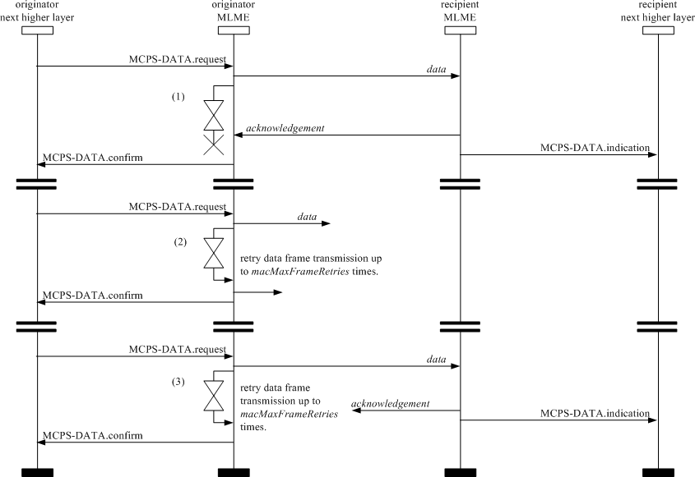

##### Figure 26—Transmission scenarios, using direct transmission, for frame reliability

##### GTS allocation and management

A GTS allows a device to operate on the channel within a portion of the superframe that is dedicated (on the OWPAN) exclusively to that device. A GTS shall be allocated only by the coordinator, and it shall be used only for communications between the coordinator and a device associated with the OWPAN through the coordinator. A single GTS may extend over one or more superframe slots. The coordinator may allocate a number of GTSs at the same time, provided there is sufficient capacity in the superframe.

A GTS shall be allocated before use, with the coordinator deciding whether to allocate a GTS based on the requirements of the GTS request and the current available capacity in the superframe. GTSs shall be allocated on a first-come-first-served basis, and all GTSs shall be placed contiguously at the end of the superframe and after the CAP. Each GTS shall be deallocated when the GTS is no longer required, and a GTS can be deallocated at any time at the discretion of the coordinator or by the device that originally requested the GTS. A device that has been allocated a GTS may also operate in the CAP.

A data frame transmitted in an allocated GTS shall use only short addressing.

The management of GTSs shall be undertaken by the coordinator only. To facilitate GTS management, the coordinator shall be able to store all the information necessary to manage seven GTSs. For each GTS, the coordinator shall be able to store its starting slot, length, direction, and associated device address.

The GTS direction, which is relative to the data flow from the device that owns the GTS, is specified as either transmit or receive. The device address and direction uniquely identify each GTS. Each device may request one transmit GTS and/or one receive GTS. For each allocated GTS, the device shall be able to store its starting slot, length, and direction. If a device has been allocated a receive GTS, it shall enable its receiver for the entirety of the GTS. In the same way, the coordinator shall enable its receiver for the entirety of the GTS if a device has been allocated a transmit GTS. If a data frame is received during a receive GTS and an acknowledgment is requested, the device shall transmit the acknowledgment frame as usual. Similarly, a device shall be able to receive an acknowledgment frame during a transmit GTS.

A device shall attempt to allocate and use a GTS only if it is currently tracking the beacons. The MLME is instructed to track beacons by issuing the MLME-SYNC.request primitive with the TrackBeacon parameter set to TRUE. If a device loses synchronization with the coordinator, it shall cease GTS transmissions.

The use of GTSs is optional.

##### CAP maintenance

The coordinator shall preserve the minimum CAP length of *aMinCAPLength* and take preventative action if the minimum CAP is not satisfied. However, an exception shall be allowed for the accommodation of the temporary increase in the beacon frame length needed to perform GTS maintenance. If preventative action becomes necessary, the action chosen is left up to the implementation, but may include one or more of the following:

* + - * + Limiting the number of pending addresses included in the beacon.
        + Not including a payload field in the beacon frame.
        + Deallocating one or more of the GTSs.

##### GTS allocation

A device is instructed to request the allocation of a new GTS through the MLME-GTS.request primitive, with GTS characteristics set according to the requirements of the intended application.

To request the allocation of a new GTS, the MLME shall send the GTS request command (see 5.3.13) to the coordinator. The Characteristics Type subfield of the GTS Characteristics field of the request shall be set to one (GTS allocation), and the length and direction subfields shall be set according to the desired characteristics of the required GTS. Because the GTS request command contains an acknowledgment request (see 5.3.3.1), the coordinator shall confirm its receipt by sending an acknowledgment frame.

On receipt of a GTS request command indicating a GTS allocation request, the coordinator shall first check if there is available capacity in the current superframe, based on the remaining length of the CAP and the desired length of the requested GTS. The superframe shall have available capacity if the maximum number of GTSs has not been reached and allocating a GTS of the desired length would not reduce the length of the CAP to less than *aMinCAPLength*. GTSs shall be allocated on a first-come-first-served basis by the coordinator provided there is sufficient bandwidth available. The coordinator shall make this decision within *aGTSDescPersistenceTime* superframes.

On receipt of the acknowledgment to the GTS request command, the device shall continue to track beacons and wait for at most *aGTSDescPersistenceTime* superframes. If no GTS descriptor for the device appears in the beacon within this time, the MLME of the device shall notify the next higher layer of the failure. This notification is achieved when the MLME issues the MLME-GTS.confirm primitive (see 6.3.5.3) with a status of NO_DATA.

When the coordinator determines whether capacity is available for the requested GTS, it shall generate a GTS descriptor with the requested specifications and the 16-bit short address of the requesting device. If the GTS was allocated successfully, the coordinator shall set the start slot in the GTS descriptor to the superframe slot at which the GTS begins and the length in the GTS descriptor to the length of the GTS. In addition, the coordinator shall notify the next higher layer of the new GTS. This notification is achieved when the MLME of the coordinator issues the MLME-GTS.indication primitive (see 6.3.5.2) with the characteristics of the allocated GTS. If there was not sufficient capacity to allocate the requested GTS, the start slot shall be set to zero and the length to the largest GTS length that can currently be supported. The coordinator shall then include this GTS descriptor in its beacon and update the GTS Specification field of the beacon frame accordingly. The coordinator shall also update the Final CAP Slot subfield of the Superframe Specification field of the beacon frame, indicating the final superframe slot utilized by the decreased CAP. The GTS descriptor shall remain in the beacon frame for *aGTSDescPersistenceTime* superframes, after which it shall be removed. The coordinator shall be allowed to reduce its CAP below *aMinCAPLength* to accommodate the temporary increase in the beacon frame length due to the inclusion of the GTS descriptor.

On receipt of a beacon frame containing a GTS descriptor corresponding to *macShortAddress*, the device shall process the descriptor. The MLME of the device shall then notify the next higher layer of whether the GTS allocation request was successful. This notification is achieved when the MLME issues the MLME- GTS.confirm primitive with a status of SUCCESS (if the start slot in the GTS descriptor was greater than zero) or DENIED (if the start slot was equal to zero or if the length did not match the requested length).

##### GTS usage

When the MAC sublayer of a device that is not the coordinator receives an MCPS-DATA.request primitive (see 6.2.1) with the TxOptions parameter indicating a GTS transmission, it shall determine whether it has a valid transmit GTS. If a valid GTS is found, the MAC sublayer shall transmit the data during the GTS, i.e., between its starting slot and its starting slot plus its length. At this time, the MAC sublayer shall transmit the MPDU immediately without using any random access, provided the requested transaction can be completed before the end of the GTS. If the requested transaction cannot be completed before the end of the current GTS, the MAC sublayer shall defer the transmission until the specified GTS in the next superframe. Note that the MAC shall allow for the PHY overhead in making this determination.

If the device has any receive GTSs, the MAC sublayer of the device shall determine that the receiver is enabled at a time prior to the start of the GTS and for the duration of the GTS, as indicated by its starting slot and its length.

When the MAC sublayer of the coordinator receives an MCPS-DATA.request primitive with the TxOptions parameter indicating a GTS transmission, it shall determine whether it has a valid receive GTS corresponding to the device with the requested destination address. If a valid GTS is found, the coordinator shall defer the transmission until the start of the receive GTS. In this case, the address of the device with the message requiring a GTS transmission shall not be added to the list of pending addresses in the beacon frame as shown in 5.1.6. At the start of the receive GTS, the MAC sublayer shall transmit the data without using any random access, provided the requested transaction can be completed before the end of the GTS. If the requested transaction cannot be completed before the end of the current GTS, the MAC sublayer shall defer the transmission until the specified GTS in the next superframe.

For all allocated transmit GTSs (relative to the device), the MAC sublayer of the coordinator shall determine that its receiver is enabled at a time prior to the start and for the duration of each GTS.

Before commencing transmission in a GTS, each device shall determine that the data transmission, the acknowledgment, if requested, and the IFS, suitable to the size of the data frame, can be completed before the end of the GTS.

If a device misses the beacon at the beginning of a superframe, it shall not use its GTSs until it receives a subsequent beacon correctly. If a loss of synchronization occurs due to the loss of the beacon, the device shall consider all of its GTSs deallocated.

##### GTS deallocation

A device is instructed to request the deallocation of an existing GTS through the MLME-GTS.request primitive specified in 6.3.5.1, using the characteristics of the GTS it wishes to deallocate. From this point onward, the GTS to be deallocated shall not be used by the device, and its stored characteristics shall be reset.

To request the deallocation of an existing GTS, the MLME shall send the GTS request command, specified in 5.3.13, to the coordinator. The Characteristics Type subfield of the GTS Characteristics field of the request shall be set to zero (i.e., GTS deallocation), and the length and direction subfields shall be set according to the characteristics of the GTS to deallocate. Because the GTS request command contains an acknowledgment request, specified in 5.3.3.1, the coordinator shall confirm its receipt by sending an acknowledgment frame. On receipt of the acknowledgment to the GTS request command, the MLME shall notify the next higher layer of the deallocation. This notification is achieved when the MLME issues the MLME-GTS.confirm primitive (see 6.3.5.3) with a status of SUCCESS and a GTSCharacteristics parameter with its Characteristics Type subfield set to zero. If the GTS request command is not received correctly by the coordinator, it shall determine that the device has stopped using its GTS by the procedure described in 5.1.8.6.

On receipt of a GTS request command with the Characteristics Type subfield of the GTS Characteristics field set to zero (GTS deallocation), the coordinator shall attempt to deallocate the GTS. If the GTS characteristics contained in the GTS request command do not match the characteristics of a known GTS, the coordinator shall ignore the request. If the GTS characteristics contained in the GTS request command match the characteristics of a known GTS, the MLME of the coordinator shall deallocate the specified GTS and notify the next higher layer of the change. This notification is achieved when the MLME issues the MLME-GTS.indication primitive (see 6.3.5.2) with a GTSCharacteristics parameter containing the characteristics of the deallocated GTS and a Characteristics Type subfield set to zero. The coordinator shall also update the Final CAP Slot subfield of the Superframe Specification field of the beacon frame,

indicating the final superframe slot utilized by the increased CAP. It shall not add a descriptor to the beacon frame to describe the deallocation.

GTS deallocation may be initiated by the coordinator due to a deallocation request from the next higher layer, the expiration of the GTS (see 5.1.8.6), or maintenance required to maintain the minimum CAP length, *aMinCAPLength* (see 5.1.8.1).

When a GTS deallocation is initiated by the next higher layer of the coordinator, the MLME shall receive the MLME-GTS.request primitive with the GTS Characteristics field of the request set to zero (i.e., GTS deallocation) and the length and direction subfields set according to the characteristics of the GTS to deallocate.

When a GTS deallocation is initiated by the coordinator either due to the GTS expiring or due to CAP maintenance, the MLME shall notify the next higher layer of the change. This notification is achieved when the MLME issues the MLME-GTS.indication primitive with a GTSCharacteristics parameter containing the characteristics of the deallocated GTS and a Characteristics Type subfield set to zero.

In the case of any deallocation initiated by coordinator, the coordinator shall deallocate the GTS and add a GTS descriptor into its beacon frame corresponding to the deallocated GTS, but with its starting slot set to zero. The descriptor shall remain in the beacon frame for *aGTSDescPersistenceTime* superframes. The coordinator shall be allowed to reduce its CAP below *aMinCAPLength* to accommodate the temporary increase in the beacon frame length due to the inclusion of the GTS descriptor.

On receipt of a beacon frame containing a GTS descriptor corresponding to *macShortAddress* and a start slot equal to zero, the device shall immediately stop using the GTS. The MLME of the device shall then notify the next higher layer of the deallocation. This notification is achieved when the MLME issues the MLME- GTS.indication primitive with a GTSCharacteristics parameter containing the characteristics of the deallocated GTS and a Characteristics Type subfield set to zero.

##### GTS reallocation

The deallocation of a GTS may result in the superframe becoming fragmented. For example, Figure 27 shows three stages of a superframe with allocated GTSs. In stage 1, three GTSs are allocated starting at slots 14, 10, and 8, respectively. If GTS 2 is now deallocated (stage 2), there will be a gap in the superframe during which nothing can happen. To solve this, GTS 3 will have to be shifted to fill the gap, thus increasing the size of the CAP (stage 3).

The coordinator shall determine that any gaps occurring in the CFP, appearing due to the deallocation of a GTS, are removed to maximize the length of the CAP.

When a GTS is deallocated by the coordinator, it shall add a GTS descriptor into its beacon frame indicating that the GTS has been deallocated. If the deallocation is initiated by a device, the coordinator shall not add a GTS descriptor into its beacon frame to indicate the deallocation. For each device with an allocated GTS having a starting slot lower than the GTS being deallocated, the coordinator shall update the GTS with the new starting slot and add a GTS descriptor to its beacon corresponding to this adjusted GTS. The new starting slot is computed so that no space is left between this GTS and either the end of the CFP, if the GTS appears at the end of the CFP, or the start of the next GTS in the CFP.

In situations where multiple reallocations occur at the same time, the coordinator may choose to perform the reallocation in stages. The coordinator shall keep each GTS descriptor in its beacon for *aGTSDescPersistenceTime* superframes.

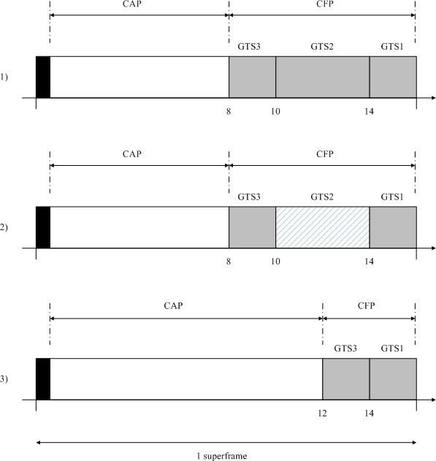

##### Figure 27—CFP defragmentation on GTS deallocations

On receipt of a beacon frame containing a GTS descriptor corresponding to *macShortAddress* and a direction and length corresponding to one of its GTSs, the device shall adjust the starting slot of the GTS corresponding to the GTS descriptor and start using it immediately.

In cases where it is necessary for the coordinator to include a GTS descriptor in its beacon, it shall be allowed to reduce its CAP below *aMinCAPLength* to accommodate the temporary increase in the beacon frame length. After *aGTSDescPersistenceTime* superframes, the coordinator shall remove the GTS descriptor from the beacon.

##### GTS expiration

The MLME of the coordinator shall attempt to detect when a device has stopped using a GTS using the following rules:

* + - * + For a transmit GTS, the MLME of the coordinator shall assume that a device is no longer using its GTS if a data frame is not received from the device in the GTS at least every 2*n* superframes, where *n* is defined below.
        + For receive GTSs, the MLME of the coordinator shall assume that a device is no longer using its GTS if an acknowledgment frame is not received from the device at least every 2*n* superframes, where *n* is defined below. If the data frames sent in the GTS do not require acknowledgment frames, the MLME of the coordinator will not be able to detect whether a device is using its receive GTS. However, the coordinator is capable of deallocating the GTS at any time.

The value of *n* is defined as follows:

*n* = 2(8-*macBeaconOrder*) 0  *macBeaconOrder*  8

*n* = 1 9  *macBeaconOrder*  14

##### Fast link recovery

In the star topology, a fast link recovery process may be triggered at the device end during communication. The trigger may be initiated when the device does not receive acknowledgments for a number of times given by the MAC PIB attribute *macNumAcks,* as defined in Table 62. In the fast link recovery process, the device may decide on its own to stop sending data. The device may also send the fast link recovery signal repeatedly (within the allocated resource) to the coordinator if the device is connected to mains power. Upon receiving the fast link recovery signal, the coordinator shall send a fast link recovery response to the device. The communication resumes after the device receives the response. If there is bidirectional data transfer during communication, the device may wait after stopping sending data. If the device does not receive any fast link recovery response signal within a timer given by the MAC PIB attribute *macLinkTimeOut*, the device may assume the link is broken and may disassociate.

The fast link recovery signal and fast link recovery response are defined in 5.3.11. The fast link recovery signal and fast link recovery response shall be sent at the lowest data rate corresponding to the currently negotiated optical rate.

Figure 28 shows an example of the process of device stopping sending data based on the retransmission count.

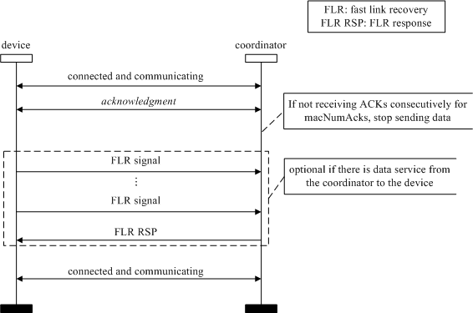

##### Figure 28—An example of the process of device stopping data transmission based on the retransmission count, and triggering fast link recovery

In the star topology, a fast link recovery may also be triggered by the coordinator. The trigger may be initiated when the coordinator does not receive contiguous acknowledgments for a number of times given by the MAC PIB attribute *macNumAcks*. In the fast link recovery process, the coordinator may stop sending data to the device. The coordinator then sends fast link recovery signals repeatedly to the device. The coordinator may hold the uplink grant allocated to the device. Upon receiving a fast link recovery signal, the

device shall send a fast link recovery response to the coordinator. The communication resumes after the device receives the response.

Figure 29 shows an example of the process of the coordinator stopping sending data based on the retransmission count.

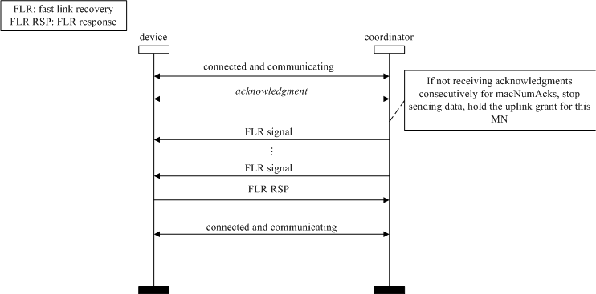

##### Figure 29—An example of the process of the coordinator stopping sending data based on the retransmission count, and triggering fast link recovery

In peer-to-peer OWC, the devices may let each other know their battery life. If the conditions to trigger the fast link recovery process are satisfied, the device may further compare its own battery life with the battery life of its peer (the one it is communicating). If the battery life of the device is shorter than its peer’s, then the device stops sending data, and waits. If the battery life of the device is longer than its peer’s, then the device stops sending data and initiates the fast link recovery process.

When the fast link recovery is triggered, and if the device has spare wavelength bands, some or all of the spare bands may also start sending fast link recovery signals to recover the link. The device then shall choose a band that gets the fast link recovery response to continue the communication.

The address field of MHR in a fast link recovery signal and fast link recovery response may include the address or the identifier of the color bands.

Figure 30 shows a flowchart of the process for color band assisted fast link recovery.

When the fast link recovery is triggered, if the device has other communication directions/angles (e.g., a light with multiple LEDs with different angles) some or all of the other angles may also start sending fast link recovery signaling to recover the link. The device then shall choose an angle that gets the fast link recovery response to continue the communication. The process of fast link recovery on other directions/ angles is done successively (i.e., one direction after another). The direction is indicated in the link recovery mechanism provided by the command frame structure.

The address field of MHR in a fast link recovery signal and fast link recovery response may include the address or the identifier of the angles or directions.

Figure 31 shows a flowchart of the process for multiple angle assisted fast link recovery.

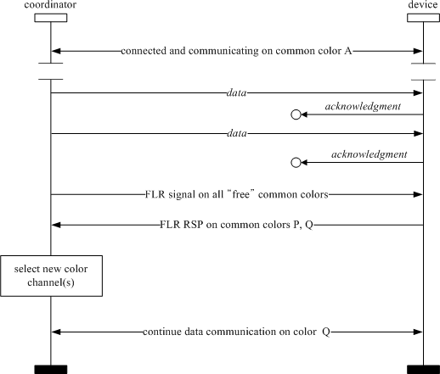

FLR: fast link recovery

FLR RSP: fast link recovery response

##### Figure 30—Flowchart of process for color band assisted fast link recovery

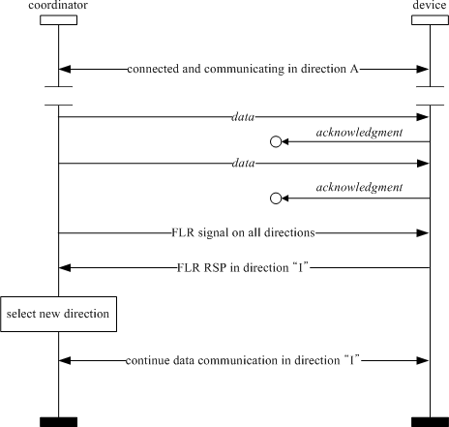

**Figure 31—Flowchart showing process of multiple angles assisted fast link recovery**

##### Multiple channel resource assignment

* + - 1. **Multiple channel information**

When the coordinator does not have time slot resources to assign for new user, the coordinator should extend the resource by using multiple bands. Figure 32 shows one example of multiple band usage.

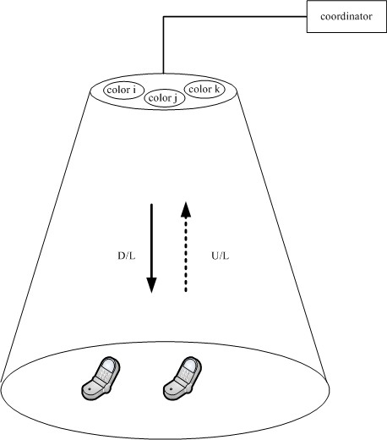

##### Figure 32—Example of multiple channel usage

Figure 33 describes the procedure of multiple band usage when the multiple band function is needed. When device 2 tries to initially access the coordinator for communication and no time slot is available but other bands are available for device 2, the coordinator can assign another band except the default band. Capability exchange should occur for all bidirectional communication during device discovery (see 5.1.2.4). If multiple bands are used, the coordinator should transmit to the device the “Src_multi_info” in the MAC command payload field which is defined in Table 3 to the device. Then the device 2 shall respond to the coordinator using the “Des_multi_info,” which is defined in Table 3, informing the device of available multiple bands of the device.

If the coordinator does not support multiple bands, because the coordinator has a single band light source, or does not want to use multiple bands, the coordinator should transmit Src_multi_info set with code '0000000' as shown in Annex D.

If the device also cannot support multiple bands due to hardware limitations, such as a single band light source or an interference situation, or does not want to use multiple bands, the device should respond with Des_multi_info set to code '0000000' as shown in Annex D.

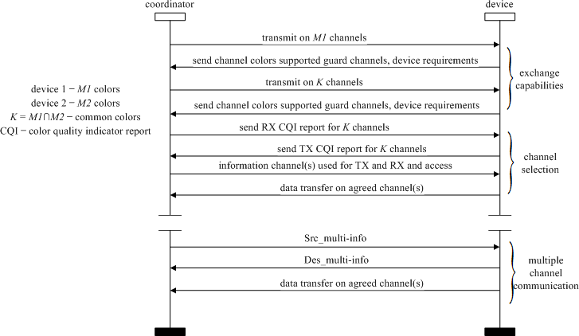

##### Figure 33—MSC for multi-band information

**Table 3—Command frame payload for multiple bands**

|  |  |  |  |
| --- | --- | --- | --- |
| **MAC command frame payload** | **Bits** | **Usage/Description** | **Down/Up link** |
| Src_multi_info | b0...b7 | Bitmap that indicates the available channels to the coordinator  ex: 0000000: No multiple channel mode ex: 0000001: using channel “Band 7”  ex: 0000101: using channel “Band 5” and “Band 7” | downlink |
| Des_multi_info | b0...b7 | Bitmap that indicates the available channels to the mobile device  ex: 0000000: No multiple channel mode ex: 0000001: using channel “Band 7”  ex: 0000101: using channel “Band 5” and “Band 7” | uplink |

* + - 1. **Band hopping for interference avoidance**

A single coordinator can service multiple cells.

If interference is being experienced from an adjacent light then hopping can be used to mitigate the interference. When spatial reuse due to direction optics is not present, and when the OWC communications system uses the same time slot between the adjacent light sources or cells with multiple band communication, and when multiple bands are supported by the PHY, band hopping can be used. In order to avoid interference and increase system capacity, pre-assigned hopping patterns should be adopted.

The hopping pattern should be assigned to the device and then the device should operate and hop based on the assigned hopping pattern. The coordinator shall transmit to the device the 'H_pattern' using the MAC command frame payload that is defined in Table 4.

If the OWC system does not use multiple bands (Src_multi_info is set to code '0000000'), then the hopping function is not supported. The hopping patterns shall be structured so as not to change the visual perception of the light. For example, the patterns could hop between red, green, blue (RGB) in the proper time averaged portion so as to appear white.

##### Table 4—Command frame payload for channel hopping

|  |  |  |  |
| --- | --- | --- | --- |
| **MAC command frame payload** | **Bit** | **Usage/Description** | **Down/Up link** |
| H_pattern | b0, b1, b2, b3, b4 | Band hopping information | downlink |

##### OWC cell design and mobility support

There may be a need to support link switching due to physical movement or interference. Mobility can be of two types: physical and logical. Physical mobility occurs when the OWC device M1 changes its position due to the movement within the coverage area of infrastructure I1, while logical mobility occurs when the device M1 changes its communication link from a link with infrastructure I2 to one with infrastructure I3 due to interference or deliberate channel switching, as shown in Figure 34.

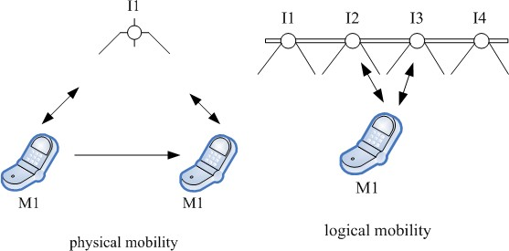

##### Figure 34—Physical and logical mobility

A coordinator DME can separate the optical media into multiple cells for supporting applications such as location-based services.

##### Mobility using boundary information

A single coordinator can support mobility of the device through multiple cells using the PHY switch, controlled by the DME, as shown in Figure 35. Each optical element in a cell is denoted by *cell_ID(i,j),* where *j* is the index of the element in the *i*th cell. The size and the position of the cell in the optical media shown in Figure 3 can be variable and can be programmed by the DME. The actual size and position determination for the cell by the coordinator DME is not defined in the standard. If device 1 moves to the next cell, for example, from *cell_ID(i,j)* to *cell_ID(i+1,j)*, the coordinator can detect the mobility of the device using the uplink signal (i.e., acknowledgment frame).

|  |  |  |  |
| --- | --- | --- | --- |
| time slot *n* for device 1 | | | PHY switch |
|  | Cell_ID(*i*+1,*j*) |  |
| Cell_ID(*i*+2,*j*) | |

Cell_ID(*i,j*)



D/L

U/L

D/L

U/L

device 1



##### Figure 35—Cell configuration for OWC mobility

Figure 36 shows the mobility support for a device through multiple cells. When device 1 moves out from *Cell_ID(i,j)* to *Cell_ID(i+1,j)*, the coordinator may not receive the uplink transmission (for example, acknowledgment frame or CVD frame) from *Cell_ID(i,j)*. The coordinator may then search for the device through the adjacent cells such as *Cell_ID(i+1,j)* and *Cell_ID(i-1,j)* during the same time slots assigned to device 1 in the superframe. The other devices in *cell_ID(i,j)* will continue communication in the same cell. The coordinator may also expand the cell size in order to provide coverage for mobility of the device. The coordinator can decide on the new cell selection for the device on receiving the uplink transmission from device 1. Thus, if the coordinator can resume communication with the device in *cell_ID(i+1,j)*, the coordinator DME may set the PHY switch to use *cell_ID(i+1,j)* for device 1 during the time slots allocated

for device 1 and then switch back to *cell_ID(i,j)* to service any existing devices in *cell_ID(i,j)* in the remaining time slots. The searching process can be terminated if the device is not found within the link timeout period, defined in MAC PIB attribute *macLinkTimeOut* in Table 62, and the device can then be considered to be disassociated from the coordinator.



Cell_ID (*i,j*)

Cell_ID (*i*+2,*j*)

Cell_ID (*i*,1) Cell_ID (*i*,2) Cell_ID (*i*,3)

Cell_ID (*i*+2,1) Cell_ID (*i*+2,2) Cell_ID (*i*+2,3) Cell_ID (*i*+2,4)

Cell_ID (*i*,4) Cell_ID (*i*,5) Cell_ID (*i*,6)

Cell_ID (*i*+2,5) Cell_ID (*i*+2,6) Cell_ID (*i*+2,7) Cell_ID (*i*+2,8)

**Device 2**

**Device 1 D**

Time slot n Time slot n+1

Cell_ID (*i*,7) Cell_ID (*i*,8) Cell_ID (*i*,9) Cell_ID (*i*+2,9) Cell_ID (*i*+2,10) Cell_ID (*i*+2,11) Cell_ID (*i*+2,12)

Time slot n+2

Cell_ID (*i*+1,5) Cell_ID (*i*+1,6)

Cell_ID (*i*+1,3) Cell_ID (*i*+1,4)

**evice 1**

Cell_ID (*i*+1,1) Cell_ID (*i*+1,2)

Cell_ID (*i*+1,*j*)

coordinator

##### Figure 36—Mobility support for a device through multiple cells

* + - 1. **Cell configuration during superframe**

In order to support access for new devices through the entire superframe, the entire optical media shall be configured to a single macro cell during the beacon period and CAP. Once devices are discovered and associated, the cell sizes and positions can be determined and the cell structure can be applied to the individual device(s) for communication, as shown in Figure 37.



**Cell_ID (4,*j*)**

**Cell_ID (3,*j*)**

**Cell_ID (1,*j*)**

**Cell_ID (2,*j*)**

**Cell_ID (4,*j*)**

**Cell_ID (2,*j*)**

**Cell_ID (1,*j*)**

**Cell_ID (3,*j*)**

|  |  |  |  |  |  |  |
| --- | --- | --- | --- | --- | --- | --- |
|  | | CFP | | | | |
| beacon | CAP |  |  |  |  |  |



macro cell

**device 2**

**device 1**

**Cell_ID (*i,j*)**

**device 1**

**device 2**

##### Figure 37—Superframe configuration for mobility support

device 1

device 1

device 1

device 1

* + - 1. **Cell size and location search procedure**

Once a device is associated with a coordinator using the beacon period and CAP, the coordinator may establish the size and location of the cell in order to service the new device in the CFP with a smaller cell size. In order to determine the size and location of the cell, the coordinator first sets the *cellSearchEn* bit in the Superframe Specification field of the beacon frame as defined in Figure 54. If the *cellSearchEn* bit is set, the *cellSearchLength* is transmitted as an additional field in the beacon frame, as shown in Figure 51. If the *cellSearchEn* bit is set, the coordinator readjusts its superframe GTS allocation to determine the first *cellSearchLength* slots of the CFP are allocated for cell size and location search.

The first *cellSearchLength* slots are used as visibility slots by the coordinator and the devices. During the first *cellSearchLength* slots, the coordinator sequentially cycles through the *cellSearchLength* cells and transmits CVD frames in all the cells. Figure 38 shows an example of the sequential search for 4 cells. CS1 to CS4 are the 4 cell search slots that are made available for searching via setting the *cellSearchLength* to 4 and setting the *cellSearchEn* bit in the beacon frame.

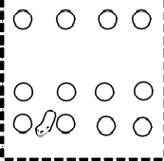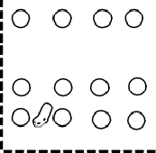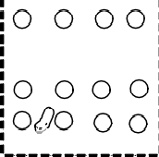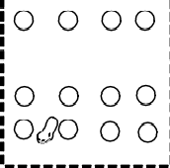

CFP

cell search

macro cell

Cell_ID (2,*j*)

Cell_ID ( 1, *j*)

Cell_ID (1,*j*)

Cell_ID (2,*j*)

Cell_ID (1,*j*) Cell_ID (2,*j*)

Cell_ID (4,*j*)

Cell_ID (4,*j*)

Cell_ID (4,*j*)

Cell_ID (3,*j*)

Cell_ID (3,*j*)

Cell_ID (3,*j*)

Cell_ID (3,*j*)

CS4

CS3

CS2

CS1

CAP

beacon

Cell_ID (4,*j*)

Cell_ID (2,*j*)

Cell_ID (1, *j*)

**device 2**

**device 1**

**Cell_ID (*i,j*)**

##### Figure 38—Cell size and location search procedure

If a device receives a beacon with the *cellSearchEn* bit set to 1, the device shall also continuously transmit CVD frames during the *cellSearchEn* slots while also monitoring the CVD frame reception from the coordinator. The device shall report the measured WQI during each of the cellSearchLength slots to the coordinator using the mobility notification command frame, as described in 5.3.12.

The coordinator makes the determination of the cell sizes and location based on the information from the mobility notification command and its own reception of the CVD frames from the device during the cell search slots.

##### Color function support

The CVD frame, using various colors, can be used to display various statuses of a device. The colors mapped for each status of the devices are based on the *phyColorFunction* (see Table 115). The colors chosen for different statuses are left to the discretion of the implementer. Multiple statuses may choose the same color, depending on the number of colors supported by the device. The use of color function through the CVD frame has the potential to change the color of the emitted light.

##### CVD frame usage for MAC state indication

The CVD frames are used between state changes to provide visual information to the user regarding the communication status. The MLME primitives for association (see 6.3.1.1), scan (see 6.3.8.1), and disassociation (see 6.3.2.1) are used to support this functionality. The corresponding colors, as described in Table 5 can be used to display various states of a device. The MAC PIB attributes *macDuringASSOCColor*, *macDuringDISASSOCColor*, and *macDuringSCANColor*, as shown in Table 62, are used for the color assignment of the CVD frame when the CVD frame is sent to indicate the MAC state during the association, disassociation, or scan process.

##### Table 5—Color table for MAC state indication

|  |  |  |
| --- | --- | --- |
| **State** | **Color choice** | **Color resolution range** |
| scan | Color “A” | 0–255 |
| association | Color “B” | 0–255 |
| disassociation | Color “C” | 0–255 |

For example, the device sends an association request to the coordinator (see Figure 39) and indicates this to the user with a chosen color. This information about the color choice is communicated using the MLME- ASSOCIATE.request primitive as in 6.3.1.1.

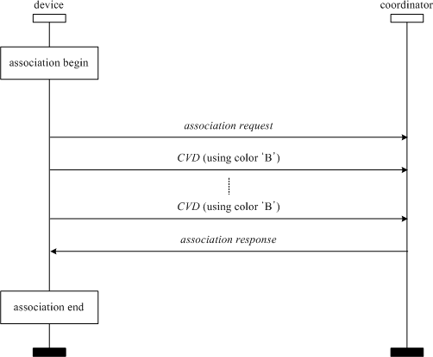

##### Figure 39—MSC when color function for association indication is invoked

* + - 1. **CVD frame usage for acknowledgment indication**

Figure 40 shows an example of how the user can infer whether a receiver successfully receives data or not. According to this figure, the device sends a CVD frame after the acknowledgment frame has been sent. The CVD frame can indicate that the received data has errors or is error-free, based on the choice of colors. The MAC PIB attribute, *macColorReceived* as shown in Table 62, is used for the color assignment of the CVD frame when the acknowledgment frame is sent and the color function for the ACK state indication is achieved by the CVD frame. The MAC PIB attribute, *macColorNotReceived* as shown in Table 62, is used for the color assignment of the CVD frame when the acknowledgment frame is not sent but the color function for the non-ACK state indication is achieved by the CVD frame.

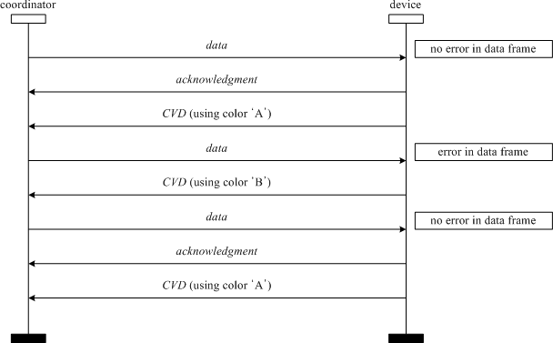

##### Figure 40—CVD frame usage for acknowledgment indication

* + - 1. **CVD frame usage for channel quality indication**

Table 6 describes how the user can infer the quality of the data transmission or the communication quality through the CVD frame. The communication quality may be obtained by various metrics. For example, frame-error ratio (FER) statistics can be averaged over multiple frames. The *ppduLinkQuality* of 9.3.3 (PD-DATA.indication) can also be used for this purpose. This information can help provide misalignment indication to the user. Different colors can be used to indicate different states of misalignment. The choice of the colors and the FER range is left to the implementer and is out of the scope of the standard.

##### Table 6—Color table for channel quality indication

|  |  |
| --- | --- |
| **Color of CVD frame** | **Channel quality** |
| Color “A” | Current FER < FER #1 |
| Color “B” | FER #1  FER  FER #2 |
| Color “C” | Current FER  FER #2 |

* + - 1. **CVD frame usage for file-transfer status indication**

Figure 41 shows an example of how the user can infer the remaining or transferred file size through the color of the CVD frame. As shown in the example of Figure 41, the coordinator transfers files to the device. Different stages of the file transfer process can be represented with different choices of colors. In order to use this indication, the device needs to know the total file size to be transmitted. The remaining file size can be obtained by subtracting the transferred file size from the total file size. The MAC PIB attribute, *macCFAppColor* as shown in Table 62, is used for the color assignment of the CVD frame when the CVD frame is sent to indicate the application-dependent information, such as the file-transfer status.

coordinator device

remaining or transferred file size ≤ *L* bytes and

remained file size

> *M* bytes

remaining or transferred file size > *L* bytes

|  |  |  |
| --- | --- | --- |
| *data* (#*K*+2) *data* (#*K*+1) *data* (#*K*) | | |
| *data* (#*L*) | *CVD* (using color ‘A’) | *data* (#*L*+1) |
| *data* (#*M*+2) | *data* (#*M*+1) | *data* (#*M*) |
| *data* (#*N*) | *CVD* (using color‘B’) | *data* (#*N*+1) |
| *data* (#*O*+2) | *data* (#*O*+1) | *data* (#*O*) |
| *data* (#*P*) | *CVD* (using color‘C’) | *data* (#*P*+1) |

##### Figure 41—MSC for CVD frame usage for file-transfer status indication

remaining or transferred file size ≤ *N* bytes

* + - 1. **Generic color assignment mechanism**

The color function can be used beyond the applications as described from 5.1.12.1 to 5.1.12.4. The colors to support the various color functions shall be chosen from the PHY PIB attribute *phyColorFunction* as shown in Table 115, using the MLME-SET.request and PLME-SET.request primitives available to the DME shown in Figure 3.

##### Color stabilization

When a device joins a network (administrated by a coordinator), it advertises its capability of color stabilization in CSK links as shown in Table 18. It is assumed that at least one link is functioning as a CSK bidirectional link. Otherwise, no color stabilization functionality is invoked in the network. Also, for the sake of simplicity, it is assumed that only the device will be requested to send color stabilization updates.

The device and the coordinator go through the steps of association as in 5.1.4. Upon the issuance of a MLME-ASSOCIATE.request the device sends an Association request, among other things advertising its capability for RX-side CSK-color stabilization. Upon reception of this request, the coordinator MLME creates an MLME-ASSOCIATE.indication to the next higher layer in the coordinator. There, a decision is made whether and where color stabilization will be invoked. If the link to be established is a duplex CSK

link, the coordinator can also choose to stabilize the color of the device TX. (As already mentioned, we are describing the case of color stabilization of the coordinator, but the other possible cases can be inferred from the description in a straight-forward manner). After this decision has been made, the pertinent Capability Negotiation Response field in the MLME-ASSOCIATE.response is set according to Table 34 and the pertinent information is then translated by the coordinator MLME into the MAC association response message. Upon reception of this message, the device MLME creates the MLME-ASSOCIATE.confirm and sends it to the next higher layer in the device for further processing.

When the coordinator starts sending CVD frames to the device (identified by the pertinent MHR as shown in 5.1.12), the device sends color stabilization information back to the coordinator. The MAC command frame used for this can be found in 5.3.17. After a time set in the variable *macColorStabilizationTimer*, as shown in Table 62, the current information is sent again from the device to the coordinator. If the coordinator wants to change the time between two such updates, it can send a color stabilization timer notification command (see 5.3.16) to the device, upon which the device MLME sets the pertinent timer, which is not further described in this standard.

Upon dissociation, the *macColorStabilization* variable is set back to its default value '00'.

##### Visibility and dimming support

The standard supports visibility for the following purposes:

* + - 1. Alignment (device discovery, negotiation, connection)
      2. Visible guiding for user alignment
      3. Infrastructure continuous light output
      4. Blinking for unexpected interference, disconnection warnings

##### Visibility pattern

The MAC passes the visibility pattern requirement to the PHY via the PLME interface using the PIB attribute *phyDim* as shown in Table 115. Sending an idle pattern is a mandatory requirement for infrastructure during idle or receive operation to provide continuous illumination. Sending an idle pattern is optional for the mobile device.

##### Extended preamble mode for visibility

The MAC provides an extended preamble mode for visibility. The advantage of this mode is to provide additional time for synchronization while simultaneously providing visibility. See Figure 42.

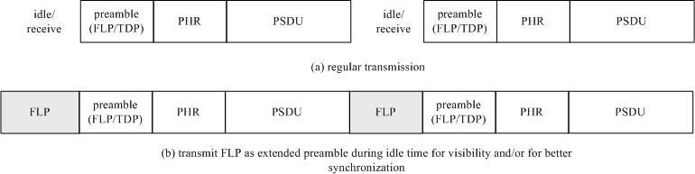

##### Figure 42—Extended preamble mode provided by the MAC

The MAC uses the knowledge of the idle time and may increase the number of preamble repetitions during the frame transmission to cover the idle time period. The extended preamble is made continuous to the existing preamble of the next frame transmission. There is a possibility that the idle time may not be an integral multiple of the preamble length. In such cases, it is acceptable to transmit a fraction of the preamble (the latter part) in order to maintain visibility. This fraction of the preamble can be called a truncated preamble.

The MAC can choose to either transmit a idle pattern or an extended preamble in the idle mode during regular operation. The choice is made by the DME and is indicated to the PHY via PLME access to the PHY PIB attribute *phyUseExtendedMode* (see Table 115).

The fast locking pattern (FLP) part of the preamble sequence (1010...) shall be used in the extended preamble mode, as shown in Figure 43. Since idle time is not an integral multiple of the preamble, only a fraction of the preamble pattern such as '010' can be sent to complete the idle time.

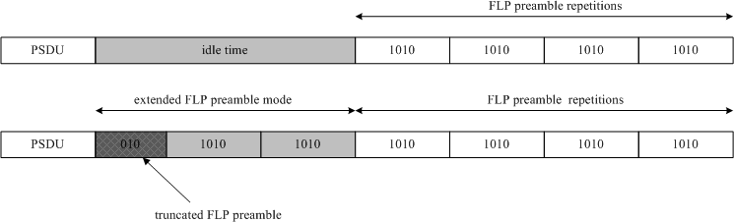

##### Figure 43—Truncated preamble in extended preamble mode for utilizing idle time for visibility

* + - 1. **Transmitting visibility pattern during uplink for star topology mode**

For the star topology mode, assuming the visibility pattern is sent “in-band” as described in the modulation domain (see 4.3), the point-and-shoot visibility signal from the mobile device cannot be transmitted continuously since multiple users could be pointing to the infrastructure fixed coordinator. This makes the visibility signal difficult to attain due to the low duty cycle. Hence, the knowledge of idle periods (unused slots) is transmitted by the beacons and the mobile device uses the idle periods for transmitting the visibility pattern to the fixed coordinator. All mobile devices talking to a coordinator can share the empty slots for the CVD frame transmission during uplink. See Figure 44.

##### Dimming override capability

This standard supports bypassing the dimmer functionality during OWC operation. The dimmer control can be set to maximum brightness to facilitate OWC communication. As soon as the OWC communication is completed, the dimmer regains control of the optical source driver and resumes normal operation.

A dimmer override capability request signal is added to the MLME-SAP and provided to the external dimmer interface, using the MAC PIB attribute, *macDimOverrideRequest*, as shown in Table 62. This dimmer override request attribute shall be set to 1 during OWC operation and shall be set to 0 after the communication has been completed. The dimmer circuit can decide whether to accept or reject this request. The response to this dimmer override request signal by the external dimmer circuit is out of the scope of this standard. The MLME-GET (see 6.3.4) and MLME-SET(see 6.3.10) primitives are used to read and write PIB attributes for dimming.

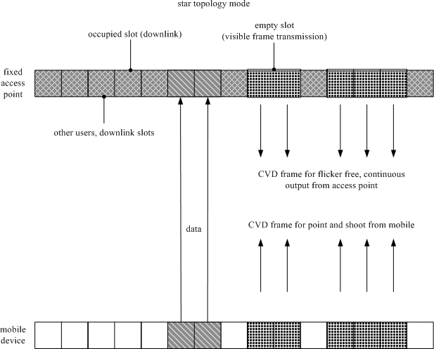

##### Figure 44—Usage of CVD frames during star topology operation

* + - 1. **PWM signal override**

A PWM signal override request signal is added to the MLME-SAP, using the MAC PIB attribute, *macDimPWMOverrideRequest*, as defined in Table 62 and provided to the external dimmer interface. This PWM override request attribute shall be set to 1 to inform the dimmer circuit that the OWC PHY will be responsible for dimming and to disable any PWM circuit present in the dimmer. The duty cycle for dimming is then driven by modulation mode provided by the OWC PHY (such as VPPM). The response to this PWM override request signal by the external dimmer circuit is out of the scope of this standard. The MLME-GET (see 6.3.4) and MLME-SET (see 6.3.10) primitives are used to read and write PIB attributes for dimming.

##### MAC sublayer transmission adjustment for dimming

Referring to Figure 45, the infrastructure MAC adjusts the data transmission to match the duty cycle requirements from the dimmer.

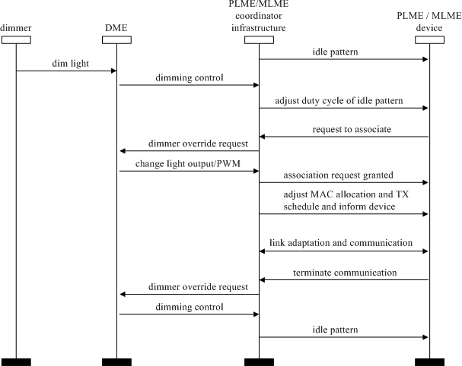

##### Figure 45—MSC for dimming

* + - 1. **Device discovery and association in the presence of dimming and visibility**

The visibility pattern can help with device discovery when the idle pattern or the data has been modified because of the PHY and MAC sublayer modulation changes to support dimming. Based on the dimming pattern change and duty cycle, the OWC device may choose to associate with a different coordinator that is currently not being dimmed or has a higher duty cycle (more illumination). The visibility pattern is uncoded as shown in Figure 64. The header for the CVD frame is sent at the lowest data rate corresponding to the currently negotiated clock rate. Figure 46 shows an example of using the visibility pattern as a signal to establish the best connectivity to an infrastructure device.

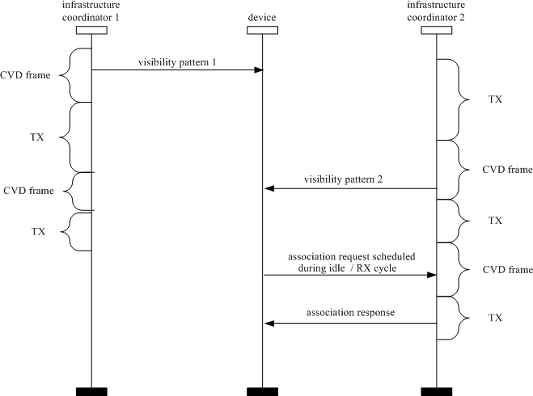

##### Figure 46—Example of using the visibility pattern to establish best connectivity to an infrastructure device

* + - 1. **Link adaptation for dimming support**

Dimming requirements of the infrastructure should be notified to OWC RX device, so that the OWC receiver can adapt to the dimming pattern of the data when VPPM is used. The infrastructure coordinator may receive an external dimming request. A dimming adaptation timer is used that delays the time between the dimming request and the actual dimming of the light source. With this knowledge of an incoming dimming, the link between the devices can be adapted to work at a new (lower) data rate (if dimmed) without requiring the link to be interrupted or possible link failure. This dimming adaptation is indicated and supported by the MAC dimming notification command frame in 5.3.10. Figure 47 shows an example of delay dimming and adapt resources for uninterrupted link.

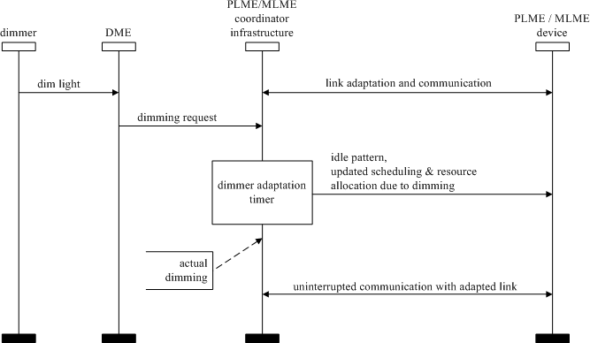

##### Figure 47—Usage of MAC sublayer to delay dimming and adapt resources for uninterrupted link

#### MAC frame formats

This subclause specifies the format of the MAC frame (MPDU). Each MAC frame consists of the following basic components:

* + 1. A MHR, which comprises frame control, sequence number, address information, and security- related information.
    2. A MAC Payload, of variable length, which contains information specific to the frame type. Acknowledgment frames do not contain a payload.
    3. A MFR, which contains a FCS.

The frames in the MAC sublayer are described as a sequence of fields in a specific order. All frame formats in this subclause are depicted in the order in which they are transmitted by the PHY, from left to right, where the leftmost bit is transmitted first in time. Bits within each field are numbered from 0 (leftmost and least significant) to *k* – 1 (rightmost and most significant), where the length of the field is *k* bits. Fields that are longer than a single octet are sent to the PHY in the order from the octet containing the lowest numbered bits to the octet containing the highest numbered bits.

For every MAC frame, all reserved bits shall be ignored upon receipt.

Use of over-the-air MAC frame configuration shall not be done for PHY IV, PHY V, and PHY VI, which shall accomplish MAC frame configuration via the MAC PIB. There shall be no “base default” transmission mode for PHY IV, PHY V, and PHY VI. The MAC PIB shall not be transmitted; rather, it shall be written by the DME and shall be read by the MAC sublayer.

##### General MAC frame formats

The MAC frame format is composed of a MHR, a MAC Payload, and a MFR. The fields of the MHR appear in a fixed order; however, the addressing fields may not be included in all frames. The general MAC frame shall be formatted as illustrated in Figure 48.

Octets:

2 1 0/2 0/2/8 0/2 0/2/8 0/5/6/10/14 variable 2

|  |  |  |  |  |  |  |  |  |
| --- | --- | --- | --- | --- | --- | --- | --- | --- |
| Frame Control (5.2.1.1) | Sequence Number (5.2.1.2) | Destination OWPAN  Identifier (5.2.1.3) | Destination Address (5.2.1.4) | Source OWPAN  Identifier (5.2.1.5) | Source Address (5.2.1.6) | Auxiliary Security Header (5.2.1.7) | Frame Payload (5.2.1.8) | FCS (5.2.1.9) |
| Addressing fields | | | |
| MHR | | | | | | | MAC  Payload | MFR |

##### Figure 48—General MAC frame format

* + - 1. **Frame Control field**

The Frame Control field is 2 octets in length and contains information defining the frame type, addressing fields, and other control flags. The Frame Control field shall be formatted as illustrated in Figure 49. Reserved bits are set to zero on transmission and ignored on reception.

Bits: 0–1

2–5 6–8 9 10 11 12–13 14–15

|  |  |  |  |  |  |  |  |
| --- | --- | --- | --- | --- | --- | --- | --- |
| Frame Version | Reserved | Frame Type | Security Enabled | Frame Pending | Acknowledgment Request | Destination Addressing Mode | Source Addressing Mode |

##### Figure 49—Format of the Frame Control field

* + - * 1. **PHY I, PHY II, and PHY III**

**Frame Version subfield.** The Frame Version subfield specifies the version number corresponding to the frame. This subfield shall be set to 0b00 to indicate a frame compatible with IEEE Std 802.15.7- 2011 and set to 0b01 to indicate a frame compatible with this standard. All other subfield values shall be reserved for future use.

**Frame Type subfield.** The Frame Type subfield shall be set to one of the nonreserved values listed in Table 7.

##### Table 7—Values of the Frame Type subfield

|  |  |
| --- | --- |
| **Frame type value b2 b1 b0** | **Description** |
| 000 | Beacon |
| 001 | Data |
| 010 | Acknowledgment |
| 011 | Command |
| 100 | CVD |
| 101–111 | Reserved |

**Security Enabled subfield.** The Security Enabled subfield is 1 bit in length, and it shall be set to one if the frame is protected by the MAC sublayer. This subfield shall be set to zero otherwise. The Auxiliary Security Header field of the MHR shall be present only if the Security Enabled subfield is set to one.

**Frame Pending subfield.** The Frame Pending subfield is 1 bit in length and shall be set to one if the device sending the frame has more data for the recipient. This subfield shall be set to zero otherwise (see 5.1.7.3).

The Frame Pending subfield shall be used only in beacon frames or frames transmitted either during the CAP by devices operating on a beacon-enabled OWPAN or at any time by devices operating on a nonbeacon-enabled OWPAN.

At all other times, it shall be set to zero on transmission and ignored on reception.

**Acknowledgment Request subfield.** The Acknowledgment Request subfield is 1 bit in length and specifies whether an acknowledgment is required from the recipient device on receipt of a data or MAC command frame. If this subfield is set to one, the recipient device shall send an acknowledgment frame only if, upon reception, the frame passes the third level of filtering as shown in 5.1.7.2. If this subfield is set to zero, the recipient device shall not send an acknowledgment frame.

**Destination Addressing Mode subfield.** The Destination Addressing Mode subfield shall be set to one of the nonreserved values listed in Table 8.

##### Table 8—Possible values of the Destination Addressing Mode and Source Addressing Mode subfields

|  |  |
| --- | --- |
| **Addressing mode value b1 b0** | **Description** |
| 00 | OWPAN identifier and address fields are not present. |
| 01 | No address field (broadcast only mode with no address fields present). Addresses with all ones of 16 bits or 64 bits are defined as broadcast. |
| 10 | Address field contains a 16-bit short address. |
| 11 | Address field contains a 64-bit extended address. |

If this subfield is equal to zero and the Frame Type subfield does not specify that this frame is an acknowledgment or beacon frame, the Source Addressing Mode subfield shall be nonzero, implying that the frame is directed to the OWC coordinator with the OWPAN identifier as specified in the

Source OWPAN Identifier field. If this subfield is equal to 01, the Source Addressing Mode subfield shall be equal to 01, implying that the frame is a broadcast frame, and no source or destination address fields are present in the frame.

**Source Addressing Mode subfield.** The Source Addressing Mode subfield shall be set to one of the nonreserved values listed in Table 8.

If this subfield is equal to zero and the Frame Type subfield does not specify that this frame is an acknowledgment frame, the Destination Addressing Mode subfield shall be nonzero, implying that the frame has originated from the coordinator with the OWPAN identifier as specified in the Destination OWPAN Identifier field.

If this subfield is equal to 01, the Source Addressing Mode subfield shall be equal to 01, implying that the frame is a broadcast frame, and no source or destination address fields are present in the frame.

##### PHY IV

Not used.

##### PHY V

Not used except in the rolling shutter frequency shift keying (RS-FSK) PHY mode.

The RS-FSK Frame Control field shall be formatted as illustrated in Figure 50. Reserved bits are set to zero on transmission and ignored on reception.

Bits: 0–2 3 4 5 6 7

|  |  |  |  |  |  |
| --- | --- | --- | --- | --- | --- |
| Frame Type | Reserved | Security Enabled | Frame Pending | Destination OWPAN  Address | Source OWPAN  Address |

##### Figure 50—Format of the RS-FSK Frame Control field

**Frame Type subfield.** The Frame Type subfield shall be set to one of the nonreserved values listed in Table 9.

##### Table 9—Values of the RS-FSK Frame Type subfield

|  |  |
| --- | --- |
| **Frame type value b2 b1 b0** | **Description** |
| 000 | Reserved |
| 001 | Data |
| 010 | Command |
| 011–111 | Reserved |

**Security Enabled subfield.** The Security Enabled subfield is 1 bit in length, and it shall be set to one if the frame is protected by the MAC sublayer. This subfield shall be set to zero otherwise.

**Frame Pending subfield.** The Frame Pending subfield is 1 bit in length and shall be set to one if the device sending the frame has more data for the recipients. This subfield shall be set to zero otherwise. The Frame Pending subfield shall be used only during the data frame; at synchronization frame, it shall be set to zero on transmission and ignored on reception.

**Destination OWPAN Address subfield.** If the Destination OWPAN Address is equal to zero, then it shall not be included.

**Source OWPAN Address subfield.** If the Source OWPAN Address is equal to zero, then it shall not be included.

##### PHY VI

Not used except in the VTASC, SS2DC, and IDE PHY modes.

**Frame Version subfield.** The Frame Version subfield specifies the version number corresponding to the frame. This subfield shall be set to 0b01 to indicate a frame compatible with IEEE Std 802.15.7- 2011, and all other subfield values shall be reserved for future use.

**Frame Type subfield.** The Frame Type subfield specifies the frame type used in PHY VI modes MAC frame. This field shall be set to one of the nonreserved values listed in Table 10.

##### Table 10—PHY VI Frame Type subfield

|  |  |
| --- | --- |
| **Frame type value b2 b1 b0** | **Description** |
| 000 | Beacon |
| 001 | Data |
| 010 | Acknowledgment |
| 011 | Command |
| 100–111 | Reserved |

**Security Enabled subfield.** The Security Enabled subfield specifies that security on data frame is enable or not on transmission. This field is 1 bit in length, and it shall be set to one if the frame is protected by the MAC sublayer. This subfield shall be set to zero otherwise. The Auxiliary Security Header field of the MHR shall be present only if the Security Enabled subfield is set to one.

**Frame Pending subfield.** The Frame Pending subfield specifies that pending on data frame is available or not on transmission. This field is 1 bit in length and shall be set to one if the device sending the frame has more data for the recipient. This subfield shall be set to zero otherwise.

**Acknowledgment Request subfield.** The Acknowledgment Request subfield specifies whether an acknowledgment is required from the recipient device on receipt of a data or MAC command frame. This field is 1 bit in length. If this subfield is set to one, the recipient device shall send an acknowledgment frame. If this subfield is set to zero, the recipient device shall not send an acknowledgment frame.

**Destination Addressing Mode subfield.** If this subfield is equal to zero, then the destination address subfield is not used.

**Source Addressing Mode subfield.** If this subfield is equal to zero, then the source address subfield is not used.

##### Sequence Number field

* + - * 1. **PHY I, PHY II, and PHY III**

The Sequence Number field is 1 octet in length and specifies the sequence identifier for the frame.

For a beacon frame, the Sequence Number field shall specify a BSN. For a data, acknowledgment, or MAC command frame, the Sequence Number field shall specify a DSN that is used to match an acknowledgment frame to the data or MAC command frame.

##### PHY IV

Not used.

##### PHY V

Not used except in the RS-FSK PHY mode.

The Sequence Number field is 1 octet in length and specifies the sequence identifier for the frame.

##### PHY VI

Not used except in the VTASC, SS2DC, and IDE PHY modes.

The Sequence Number field is 1 octet in length and specifies the sequence identifier for the frame.

##### Destination OWPAN Identifier field

* + - * 1. **PHY I, PHY II, and PHY III**

The Destination OWPAN Identifier field, when present, is 2 octets in length and specifies the unique OWPAN identifier of the intended recipient of the frame. A value of 0xffff in this field shall represent the broadcast OWPAN identifier, which shall be accepted as a valid OWPAN identifier by all devices currently listening to the channel.

This field shall be included in the MAC frame only if the Destination Addressing Mode subfield of the Frame Control field is 10 or 11.

##### PHY IV

Not used.

##### PHY V

Not used.

##### PHY VI

Not used.

##### Destination Address field

* + - * 1. **PHY I, PHY II, and PHY III**

The Destination Address field, when present, is either 2 octets or 8 octets in length, according to the value specified in the Destination Addressing Mode subfield of the Frame Control field [see 5.2.1.1.1 f)], and specifies the address of the intended recipient of the frame. A 16-bit value of 0xffff in this field shall represent the broadcast short address, which shall be accepted as a valid 16-bit short address by all devices currently listening to the channel.

This field shall be included in the MAC frame only if the Destination Addressing Mode subfield of the Frame Control field is nonzero.

##### PHY IV

Not used.

##### PHY V

Not used except in the RS-FSK PHY mode.

The Destination OWPAN Address, when present, is 2 octets in length and specifies the address of the intended recipient of the frame. A 16-bit value of 0xFFFF in this field shall represent the broadcast address, which shall be accepted as a valid 16-bit address by all devices currently listening to the channel.

This field shall be included in the MAC frame only if the Destination Addressing Mode subfield of the Frame Control field is nonzero.

##### PHY VI

Not used except in the VTASC, SS2DC, and IDE PHY modes.

The Destination Address field, when present, is either 2 octets or 8 octets in length, according to the value specified in the Destination Addressing Mode subfield of the Frame Control field, and specifies the address of the intended recipient of the frame.

A 16-bit value of 0xffff in this field shall represent the broadcast short address, which shall be accepted as a valid 16-bit short address by all devices currently listening to the channel.

This field shall be included in the MAC frame only if the Destination Addressing Mode subfield of the Frame Control field is nonzero.

##### Source OWPAN Identifier field

* + - * 1. **PHY I, PHY II, and PHY III**

The Source OWPAN Identifier field, when present, is 2 octets in length and specifies the unique OWPAN identifier of the originator of the frame. This field shall be included in the MAC frame only if the Source Addressing Mode is nonzero.

The OWPAN identifier of a device is initially determined during association on a OWPAN, but may change following a OWPAN identifier conflict resolution as discussed in 5.1.3.

##### PHY IV

Not used.

##### PHY V

Not used.

##### PHY VI

Not used.

##### Source Address field

* + - * 1. **PHY I, PHY II, and PHY III**

The Source Address field, when present, is either 2 octets or 8 octets in length, according to the value specified in the Source Addressing Mode subfield of the Frame Control field [see 5.2.1.1.1 g)], and specifies the address of the originator of the frame. This field shall be included in the MAC frame only if the Source Addressing Mode subfield of the Frame Control field is 10 or 11.

##### PHY IV

Not used except in the Twinkle VPPM PHY mode.

The Source PAN Address, when present, is 2 octets in length and specifies the address of the originator of the frame. This field shall be included in the MAC frame only if the Source Addressing Mode subfield of the Frame Control field is nonzero.

##### PHY V

Not used except in the RS-FSK PHY mode.

The Source PAN Address, when present, is 2 octets in length and specifies the address of the originator of the frame. This field shall be included in the MAC frame only if the Source Addressing Mode subfield of the Frame Control field is nonzero.

##### PHY VI

Not used except in the VTASC, SS2DC, and IDE PHY modes.

The Source Address field, when present, is either 2 octets or 8 octets in length, according to the value specified in the Source Addressing Mode subfield of the Frame Control field, and specifies the address of the originator of the frame.

This field shall be included in the MAC frame only if the Source Addressing Mode subfield of the Frame Control field is 10 or 11.

##### Auxiliary Security Header field

* + - * 1. **PHY I, PHY II, and PHY III**

The Auxiliary Security Header field has a variable length and specifies information required for security processing, including how the frame is actually protected (security level) and which keying material from the MAC security PIB is used (see 7.5.1). This field shall be present only if the Security Enabled subfield is set to one. For details on formatting, see 7.4.

##### PHY IV

Not used.

##### PHY V

Not used.

##### PHY VI

Not used.

##### Frame Payload field

* + - * 1. **PHY I, PHY II, and PHY III**

The Frame Payload field has a variable length and contains information specific to individual frame types. If the Security Enabled subfield is set to one in the Frame Control field, the frame payload is protected as defined by the security suite selected for that frame.

##### PHY IV

Not used except in the Twinkle VPPM and Offset-VPWM PHY modes.

The Twinkle VPPM and Offset-VPWM PHY modes use only the frame payload. The Frame Payload field has a variable length and contains information specific to individual frame types. If the security is enabled, then the frame payload is protected as defined by the security suite selected for that frame.

##### PHY V

Not used except in the RS-FSK and MPM PHY modes.

The MFDU contains the frame payload, which has a variable length and contains information specific to individual frame types. If the frame control is configured to Security Enabled previously, then the frame payload is protected as defined by the security suite selected at that time. The bit length of the payload is specified by *macMsduLength*.

##### PHY VI

Not used except in the VTASC, SS2DC, and IDE PHY modes.

The Frame Payload field has a variable length and contains information specific to individual frame types. If the Security Enabled subfield is set to one in the Frame Control field, the frame payload is protected as defined by the security suite selected for that frame.

##### FCS field

* + - * 1. **PHY I, PHY II, and PHY III**

The FCS field is 2 octets in length and is explained in Annex C.

##### PHY IV

Not used except in the UFSOOK, Offset-VPWM PHY, and Twinkle VPPM PHY modes.

**UFSOOK.** The UFSOOK FCS field is optional and is CRC-3.

**Offset-VPWM and Twinkle VPPM.** For the Offset-VPWM and Twinkle VPPM PHY modes, the FCS field is 2 octets in length, and the FCS is calculated over the MHR and MAC Payload parts of the frame. The FCS shall be generated only for payloads greater than zero bytes. The FCS is optional and is given in Annex C.

##### PHY V

Not used except in the RS-FSK PHY mode.

The RS-FSK FCS field is 2 octets in length, and the FCS is calculated over the MHR and MAC Payload parts of the frame. The FCS shall be generated only for payloads greater than zero bytes.

##### PHY VI

Not used except in the VTASC, SS2DC, and IDE PHY modes.

For the VTASC, SS2DC, and IDE PHY modes, the FCS field is 2 octets in length, and the FCS is calculated over the MHR and MAC Payload parts of the frame. The FCS shall be generated only for payloads greater than zero bytes. The FCS is an optional filed and is given in Annex C.

##### Format of individual frame types

Six frame types are defined: beacon, data, acknowledgment, command, control, and CVD. These frame types are discussed in 5.2.2.1 through 5.2.2.4.3.

##### Beacon frame format

The beacon frame shall be formatted as illustrated in Figure 51.

Octets:

2 1 4/10 0/5/6/10/14 3 variable variable 0/1 variable 2

|  |  |  |  |  |  |  |  |  |  |
| --- | --- | --- | --- | --- | --- | --- | --- | --- | --- |
| Frame Control | Sequence Number | Addressing fields | Auxiliary Security Header | Superframe Specification | GTS  fields (Figure 52) | Pending address fields (Figure 53) | cellSearch Length | Beacon Payload | FCS |
| MHR | | | | MAC Payload | | | | | MFR |

##### Figure 51—Beacon frame format

The GTS fields shall be formatted as illustrated in Figure 52, and the pending address fields shall be formatted as illustrated in Figure 53.

Octets: 1 0/1 variable

|  |  |  |
| --- | --- | --- |
| GTS Specification | GTS Directions | GTS List |

##### Figure 52—Format of the GTS information fields

Octets: 1 variable

Pending Address Specification

Address List

##### Figure 53—Format of the pending address information fields

The order of the fields of the beacon frame shall conform to the order of the general MAC frame as illustrated in Figure 48.

##### Beacon frame MHR fields

The MHR for a beacon frame shall contain the Frame Control field, the Sequence Number field, the Source OWPAN Identifier field, and the Source Address field.

In the Frame Control field, the Frame Type subfield shall contain the value that indicates a beacon frame, as shown in Table 7, and the Source Addressing Mode subfield shall be set as appropriate for the address of the coordinator transmitting the beacon frame. If protection is used for the beacon, the Security Enabled subfield shall be set to one. If a broadcast data or command frame is pending, the Frame Pending subfield shall be set to one. All other subfields shall be set to zero by the sender and ignored on reception.

The Sequence Number field shall contain the current value of *macBSN*.

The addressing fields shall comprise only the source address fields. The Source OWPAN Identifier and Source Address fields shall contain the OWPAN identifier and address, respectively, of the device transmitting the beacon.

The Auxiliary Security Header field, if present, shall contain the information required for security processing of the beacon frame, as specified in 5.2.1.7.

##### Superframe Specification field

The Superframe Specification field shall be formatted as illustrated in Figure 54.

Bits: 0–3 4–7 8–11 12 13 14 15

|  |  |  |  |  |  |  |
| --- | --- | --- | --- | --- | --- | --- |
| Beacon Order | Superframe Order | Final CAP Slot | Reserved | OWPAN  Coordinator | Association Permit | cellSearchEn |

##### Figure 54—Format of the Superframe Specification field

The Beacon Order subfield shall specify the transmission interval of the beacon. Refer to 5.1.1.1 for an explanation of the relationship between the beacon order and the beacon interval.

The Superframe Order subfield shall specify the length of time during which the superframe is active (i.e., receiver enabled), including the beacon frame transmission time. Refer to 5.1.1.1 for an explanation of the relationship between the superframe order and the superframe duration.

The Final CAP Slot subfield specifies the final superframe slot utilized by the CAP. The duration of the CAP, as implied by this subfield, shall be greater than or equal to the value specified by *aMinCAPLength*. However, an exception is allowed for the accommodation of the temporary increase in the beacon frame length needed to perform GTS maintenance, as in 5.2.2.1.3.

The OWPAN Coordinator subfield shall be set to one if the beacon frame is being transmitted by the coordinator. Otherwise, the OWPAN Coordinator subfield shall be set to zero.

The Association Permit subfield shall be set to one if *macAssociationPermit* is set to TRUE (i.e., the coordinator is accepting association to the OWPAN). The association permit bit shall be set to zero if the coordinator is currently not accepting association requests on its network.

If the cellSearchEn bit is set, the cellSearchLength is transmitted as an additional field in the beacon frame, as shown in Figure 51.

##### GTS Specification field

The GTS Specification field shall be formatted as illustrated in Figure 55.

Bits: 0–2 3–6 7

|  |  |  |
| --- | --- | --- |
| GTS Descriptor Count | Reserved | GTS Permit |

##### Figure 55—Format of the GTS Specification field

The GTS Descriptor Count subfield specifies the number of 3-octet GTS descriptors contained in the GTS List field of the beacon frame. If the value of this subfield is greater than zero, the size of the CAP shall be allowed to dip below *aMinCAPLength* to accommodate the temporary increase in the beacon frame length caused by the inclusion of the subfield. If the value of this subfield is zero, the GTS Directions field and GTS List field of the beacon frame are not present.

The GTS Permit subfield shall be set to one if *macGTSPermit* is equal to TRUE (i.e., the coordinator is accepting GTS requests). Otherwise, the GTS Permit field shall be set to zero.

##### GTS Directions field

The GTS Directions field shall be formatted as illustrated in Figure 56.

Bits: 0–6 7

Reserved

GTS Directions Mask

##### Figure 56—Format of the GTS Directions field

The GTS Directions Mask subfield contains a mask identifying the directions of the GTSs in the superframe. The lowest bit in the mask corresponds to the direction of the first GTS contained in the GTS List field of the beacon frame, with the remainder appearing in the order that they appear in the list. Each bit shall be set to one if the GTS is a receive-only GTS or to zero if the GTS is a transmit-only GTS. GTS direction is defined relative to the direction of the data frame transmission by the device.

##### GTS List field

The size of the GTS List field is defined by the values specified in the GTS Specification field of the beacon frame and contains the list of GTS descriptors that represents the GTSs that are being maintained. The maximum number of GTS descriptors shall be limited to seven.

Each GTS descriptor shall be formatted as illustrated in Figure 57.

Bits: 0–15 16–19 20–23

|  |  |  |
| --- | --- | --- |
| Device Short Address | GTS Starting Slot | GTS Length |

##### Figure 57—Format of the GTS descriptor

The Device Short Address subfield shall contain the short address of the device for which the GTS descriptor is intended.

The GTS Starting Slot subfield contains the superframe slot at which the GTS is to begin.

The GTS Length subfield contains the number of contiguous superframe slots over which the GTS is active.

##### Pending Address Specification field

The Pending Address Specification field shall be formatted as illustrated in Figure 58.

Bits: 0–2 3 4–6 7

|  |  |  |  |
| --- | --- | --- | --- |
| Number of Short Addresses Pending | Reserved | Number of Extended Addresses Pending | Reserved |

##### Figure 58—Format of the Pending Address Specification field

The Number of Short Addresses Pending subfield indicates the number of 16-bit short addresses contained in the Address List field of the beacon frame.

The Number of Extended Addresses Pending subfield indicates the number of 64-bit extended addresses contained in the Address List field of the beacon frame.

##### Address List field

The size of the Address List field is determined by the values specified in the Pending Address Specification field of the beacon frame and contains the list of addresses of the devices that currently have messages pending with the coordinator. The address list shall not contain the broadcast short address 0xffff.

The maximum number of addresses pending shall be limited to seven and may comprise both short and extended addresses. All pending short addresses shall appear first in the list followed by any extended addresses. If the coordinator is able to store more than seven transactions, it shall indicate them in its beacon on a first-come-first-served basis, ensuring that the beacon frame contains at most seven addresses.

##### Beacon Payload field

The Beacon Payload field is an optional sequence of up to *aMaxBeaconPayloadLength* octets specified to be transmitted in the beacon frame by the next higher layer. The set of octets contained in *macBeaconPayload* shall be copied into this field.

##### Data frame format

The data frame shall be formatted as illustrated in Figure 59.

Octets: 2 1

(As defined in

5.2.2.2.1) 0/5/6/10/14 variable 2

|  |  |  |  |  |  |
| --- | --- | --- | --- | --- | --- |
| Frame Control | Sequence Number | Addressing fields | Auxiliary Security Header | Data Payload | FCS |
| MHR | | | | MAC Payload | MFR |

##### Figure 59—Data frame format

The order of the fields of the data frame shall conform to the order of the general MAC frame as illustrated in Figure 48.

##### Data frame MHR fields

The MHR for a data frame shall contain the Frame Control field, the Sequence Number field, the destination OWPAN identifier/address fields, and/or the source OWPAN identifier/address fields.

In the Frame Control field, the Frame Type subfield shall contain the value that indicates a data frame, as shown in Table 7. If protection is used for the data, the Security Enabled subfield shall be set to one. All other subfields shall be set appropriately according to the intended use of the data frame. All reserved subfields shall be set to zero by the sender and ignored on reception.

The Sequence Number field shall contain the current value of *macDSN*.

The addressing fields shall comprise the destination address fields and/or the source address fields, dependent on the settings in the Frame Control field.

The Auxiliary Security Header field, if present, shall contain the information required for security processing of the data frame, as specified in 5.2.1.7.

##### MSDU field

The payload of a data frame shall contain the sequence of octets that the next higher layer has requested the MAC sublayer to transmit. The data type field is 1 byte and is explained in Table 11.

##### Table 11—MSDU field

|  |  |  |
| --- | --- | --- |
| **Bits 0–1** | **Bits 2–7** | **variable** |
| 00—Single 01—Packed 10—Burst 11—Reserved | Number of PPDUs per data frame | Data payload |

The data type field mentions the format used for sending the data—single, packed, or burst. It also mentions the number of PPDUs that are associated for this data frame.

The payload of a data frame shall contain the sequence of octets that the next higher layer has requested the MAC sub layer to transmit.

##### Acknowledgment frame format

The acknowledgment frame shall be formatted as illustrated in Figure 60.

Octets: 2 1 variable 2

|  |  |  |  |
| --- | --- | --- | --- |
| Frame Control | Sequence Number | B-ACK Frame Payload (optional) | FCS |
| MHR | | MAC Payload | MFR |

##### Figure 60—Acknowledgment frame format

The order of the fields of the acknowledgment frame shall conform to the order of the general MAC frame as illustrated in Figure 48. The sequence number is defined in 5.2.2.1.1.

In block acknowledgment (B-ACK) frames, the DestAddr field is set to the SrcAddr of the frame that requested the B-ACK. The B-ACK frame acknowledges correct or incorrect receipt of the previous sequence of frames and provides information for the transmission of the next sequence of frames as described in 5.2.2.3. The B-ACK frame payload is defined in Figure 61.

Octets: 2 1 1 2 0–*n*

|  |  |  |  |  |
| --- | --- | --- | --- | --- |
| Buffer Size | Frame Count | Reserved | Sequence Control | Frame Bitmap |

##### Figure 61—B-ACK frame payload

The Buffer Size field specifies the maximum number of octets in the sum of the frame payloads of all frames in the next B-ACK sequence. The Frame Count field specifies the maximum number of frames in the next B-ACK sequence. The Sequence Control and Frame Bitmap fields together specify an acknowledgment window of MAC Payload fragments and their reception status. The Sequence Control field specifies the sequence number and fragment number that start the acknowledgment window. See Figure 62 for the format of the Frame Bitmap field.

Bits: b15–b14 b13–b3 b2–b0

|  |  |  |
| --- | --- | --- |
| Reserved | Sequence Number | Fragment Number |

##### Figure 62—B-ACK frame bitmap

The frame bitmap field varies in length. A zero-length frame bitmap field indicates an acknowledgment window of length zero. Otherwise, the least significant octet of the frame bitmap field corresponds to the MAC Payload indicated by the Sequence Control field, and each bit of the octet corresponds to a fragment of that MAC Payload. The least significant bit (LSB) in each octet corresponds to the first fragment and successive bits correspond to successive fragments. Successive octets present in the frame bitmap field correspond to successive MAC Payloads, and each bit corresponds to a fragment of the MAC Payload. The acknowledgment window ends at fragment seven of the MAC Payload that corresponds to the most significant octet in the frame bitmap. For all bits within the frame bitmap, a value of ONE indicates that the corresponding fragment was received in either the current sequence or an earlier one. A value of ZERO indicates that the corresponding fragment was not received in the current sequence (although it may have been received in an earlier one). Bits of the least significant octet of the frame bitmap field corresponding to fragments prior to the start of the acknowledgment window are undefined. Frames with a sequence number earlier than the sequence number indicated in the Sequence Control field were not received in the last B- ACK sequence. Such frames were previously received or are no longer expected.

The B-ACK is applicable to the packed data type. The bitmap and sequence number are repeated for every frame in the burst mode (multiple frames).

The order of the fields of the acknowledgment frame shall conform to the order of the general MAC frame as illustrated.

The MHR for an acknowledgment frame shall contain only the Frame Control field and the Sequence Number field.

In the Frame Control field, the Frame Type subfield shall contain the value that indicates an acknowledgment frame, as shown in Table 7. If the acknowledgment frame is being sent in response to a received data request command, the device sending the acknowledgment frame shall determine whether it has data pending for the recipient. If the device can determine this before sending the acknowledgment frame (see 5.1.7.4.2), it shall set the Frame Pending subfield according to whether there is pending data. Otherwise, the Frame Pending subfield shall be set to one. If the acknowledgment frame is being sent in response to either a data frame or another type of MAC command frame, the device shall set the Frame Pending subfield to zero. All other subfields, except the Security Enabled subfield, shall be set to zero by the sender and ignored on reception.

The Sequence Number field shall contain the value of the sequence number received in the frame for which the acknowledgment is to be sent.

##### Command frame format

The command frame shall be formatted as illustrated in Figure 63.

Octets: 2 1

(As defined in

5.2.2.4.1) 0/5/6/10/14 1 variable 2

|  |  |  |  |  |  |  |
| --- | --- | --- | --- | --- | --- | --- |
| Frame Control | Sequence Number | Addressing fields | Auxiliary Security Header | Command Frame Identifier | Command Payload | FCS |
| MHR | | | | MAC Payload | | MFR |

##### Figure 63—Command frame format

The order of the fields of the MAC command frame shall conform to the order of the general MAC frame as illustrated in Figure 48.

##### MAC command frame MHR fields

The MHR for a MAC command frame shall contain the Frame Control field, the Sequence Number field, the destination OWPAN identifier/address fields and/or the source OWPAN identifier/address fields.

In the Frame Control field, the Frame Type subfield shall contain the value that indicates a MAC command frame, as shown in Table 7. If the frame is to be secured, the Security Enabled subfield of the Frame Control field shall be set to one and the frame secured according to the process described in 7.5.4. Otherwise the Security Enabled subfield of the Frame Control field shall be set to zero. All other subfields shall be set appropriately according to the intended use of the MAC command frame. All reserved subfields shall be set to zero by the sender and ignored on reception.

The Sequence Number field shall contain the current value of *macDSN*.

The addressing fields shall comprise the destination address fields and/or the source address fields, dependent on the settings in the Frame Control field.

The Auxiliary Security Header field, if present, shall contain the information required for security processing of the MAC command frame, as specified in 5.2.1.7.

##### Command Frame Identifier field

The Command Frame Identifier field identifies the MAC command being used. This field shall be set to one of the nonreserved values listed in Table 12.

##### Command Payload field

The Command Payload field contains the MAC command itself. The formats of the individual commands are described in 5.3.

##### CVD frame format

The structure of the CVD frame is as shown in Figure 64. The CVD frame is used to visually provide information on the communication status, such as misalignment between the two devices, transmission direction, or sending data status; the data transmission quality; and the transferred file size and remaining file size. The visibility pattern has no error protection. The length of the visibility pattern shall be set in the PHY header and the FCS shall not include the visibility pattern of the CVD frame. The FCS is only calculated over the Frame Control field (MHR) using the CRC described in Annex C. The visibility pattern will be generated based on the dimming level requirements and is described in 8.5.1.2. The CVD frame is used by the infrastructure to maintain visibility at all times and by the mobile device for point-and-shoot. The CVD frame can also be used for color stabilization for PHY III as explained in 8.5.4. It should be noted that the CVD frame is not used for communicating the dimming level; rather, the dimming notification command is used for this function as described in 5.3.10.

Octets: 2 Octet: 2 variable

|  |  |  |
| --- | --- | --- |
| Frame control | FCS | Visibility pattern |
| MHR | MFR |  |

##### Figure 64—CVD frame

The CVD frame is sent at the currently negotiated optical clock.

##### Data Null Frame

The data null frame is used for acknowledgment and polling when no data or control and/or management information should be exchanged between two communication nodes. The frame header contains the MHR fields defined in 6.4.1, and the frame body is left empty.

#### 5.3 MAC command frames

The command frames defined by the MAC sublayer are listed in Table 12. A coordinator shall be capable of transmitting and receiving all command frame types, with the exception of the GTS request command, while the requirements for a device are indicated by an “X” in Table 12. A peer-to-peer device functioning as a coordinator shall be capable of transmitting and receiving all supported command frames in a device. MAC commands shall only be transmitted in the CAP for beacon-enabled OWPANs or at any time for nonbeacon- enabled OWPANs.

How the MLME shall construct the individual commands for transmission is detailed in 5.3.1 through

5.3.18. MAC command reception shall abide by the procedure described in 5.1.7.2.

##### Table 12—Command frames

|  |  |  |  |  |  |  |
| --- | --- | --- | --- | --- | --- | --- |
| **Command frame identifier** | **Command name** | **Device** | | **Peer-to-peer coordinator** | | **Subclause** |
| **TX** | **RX** | **TX** | **RX** |
| 0x01 | Association request | X |  | X | X | 5.3.1 |
| 0x02 | Association response |  | X | X | X | 5.3.2 |
| 0x03 | Disassociation notification | X | X | X | X | 5.3.3 |
| 0x04 | Data request | X |  | X | X | 5.3.4 |
| 0x05 | OWPAN ID conflict notification | X |  | X | X | 5.3.5 |
| 0x06 | Beacon request |  |  |  |  | 5.3.6 |
| 0x07 | Coordinator realignment |  | X | X | X | 5.3.7 |
| 0x08 | GTS request |  |  |  |  | 5.3.8 |
| 0x09 | Blinking notification |  |  |  |  | 5.3.9 |
| 0x0a | Dimming notification |  | X | X | X | 5.3.10 |
| 0x0b | Fast link recovery |  |  |  |  | 5.3.11 |
| 0x0c | Mobility notification |  |  |  |  | 5.3.12 |
| 0x0d | GTS Response |  |  |  |  | 5.3.13 |
| 0x0e | Clock rate change notification |  | X | X | X | 5.3.14 |
| 0x0f | Multiple channel assignment |  |  |  |  | 5.3.15 |
| 0x10 | Band hopping |  |  |  |  | 5.1.10.2 |
| 0x11 | Color stabilization timer notification | X | X |  |  | 5.3.16 |
| 0x12 | Color stabilization information | X | X |  |  | 5.3.17 |
| 0x13 | CVD disable |  |  |  |  | 5.3.18 |
| 0x14 | Information element | X | X | X | X | 5.3.19 |
| 0x15–0xff | Reserved |  |  |  |  | — |

##### Association request command

The association request command allows a device to request association with a OWPAN through the coordinator. This command shall only be sent by an unassociated device that wishes to associate with a OWPAN. A device shall only associate with a OWPAN through the coordinator as determined through the scan procedure.

All devices shall be capable of transmitting this command, although a device is not required to be capable of receiving it.

The association request command shall be formatted as illustrated in Figure 65.

Octets: (see 5.2.2.4) 1 1

|  |  |  |
| --- | --- | --- |
| MHR fields | Command Frame Identifier (as defined in Table 12) | Capability Information |

##### Figure 65—Association request command format

* + - 1. **MHR fields**

The Source Addressing Mode subfield of the Frame Control field shall be set to three (64-bit extended addressing). The Destination Addressing Mode subfield shall be set to the same mode as indicated in the beacon frame to which the association request command refers.

The Frame Pending subfield of the Frame Control field shall be set to zero and ignored upon reception, and the Acknowledgment Request subfield shall be set to one.

The Destination OWPAN Identifier field shall contain the identifier of the OWPAN to which to associate. The Destination Address field shall contain the address from the beacon frame that was transmitted by the coordinator to which the association request command is being sent. The Source OWPAN Identifier field shall contain the broadcast OWPAN identifier (i.e., 0xffff). The Source Address field shall contain the value of *aExtendedAddress*.

##### Association response command

The association response command allows the coordinator or a coordinator to communicate the results of an association attempt back to the device requesting association.

This command shall only be sent by the coordinator or a coordinator to a device that is currently trying to associate.

All devices shall be capable of receiving this command, although a device is not required to be capable of transmitting it.

The association response command shall be formatted as illustrated in Figure 66.

Octets: (see 5.2.2.4) 1 2 1 1

|  |  |  |  |  |
| --- | --- | --- | --- | --- |
| MHR fields | Command Frame Identifier  (as defined in Table 12) | Short Address | Association Status | Capability Negotiation Response |

##### Figure 66—Association response command format

The capability negotiation response is the same as that of the color stabilization scheme in Table 22.

##### MHR fields

The Destination Addressing Mode and Source Addressing Mode subfields of the Frame Control field shall each be set to three (i.e., 64-bit extended addressing).

The Frame Pending subfield of the Frame Control field shall be set to zero and ignored upon reception, and the Acknowledgment Request subfield shall be set to one.

The Destination OWPAN Identifier field shall contain the value of *macOWPANId*, while the Source OWPAN Identifier field shall be omitted. The Destination Address field shall contain the extended address of the device requesting association. The Source Address field shall contain the value of *aExtendedAddress*.

##### Short Address field

If the coordinator was not able to associate this device to its OWPAN, the Short Address field shall be set to 0xffff, and the Association Status field shall contain the reason for the failure. If the coordinator was able to associate the device to its OWPAN, this field shall contain the short address that the device may use in its communications on the OWPAN until it is disassociated.

A Short Address field value equal to 0xfffe shall indicate that the device has been successfully associated with a OWPAN, but has not been allocated a short address. In this case, the device shall communicate on the OWPAN using only its 64-bit extended address.

##### Association Status field

The Association Status field shall contain one of the nonreserved values listed in Table 13.

##### Table 13—Valid values of the Association Status field

|  |  |
| --- | --- |
| **Association status** | **Description** |
| 0x00 | Association successful |
| 0x01 | OWPAN at capacity |
| 0x02 | OWPAN access denied |
| 0x03–0x7f | Reserved |
| 0x80–0xff | Reserved for MAC primitive enumeration values |

* + - 1. **Capability Negotiation Response field**

The Capability Negotiation Response field describes if and where (device and/or coordinator) color stabilization is performed. All allowed settings are shown in Table 14.

##### Table 14—Capability Negotiation Response field

|  |  |
| --- | --- |
| **Bits: 0–1** | **Bits: 2–7** |
| 00: No color stabilization | Reserved |
| 01: Color stabilization information to be sent from device to coordinator upon reception of CVD frames |
| 10: Color stabilization information to be sent from coordinator to device upon reception of CVD frames |
| 11: Color stabilization information to be sent from device to coordinator and from coordinator to device when either receives CVD frames |

##### Disassociation notification command

The OWC coordinator or an associated device may send the disassociate notification command. All devices shall implement this command.

The disassociation notification command shall be formatted as illustrated in Figure 67.

Octets: (see 5.2.2.4) 1 1

|  |  |  |
| --- | --- | --- |
| MHR fields | Command Frame Identifier (as defined in Table 12) | Disassociation Reason |

##### Figure 67—Disassociation notification command format

* + - 1. **MHR fields**

The Destination Addressing Mode subfield of the Frame Control field shall be set according to the addressing mode specified by the corresponding primitive. The Source Addressing Mode subfield shall be set to three (i.e., 64-bit extended addressing).

The Frame Pending subfield of the Frame Control field shall be set to zero and ignored upon reception, and the Acknowledgment Request subfield shall be set to one.

The Destination OWPAN Identifier field shall contain the value of *macOWPANId*, while the Source OWPAN Identifier field shall be omitted. If the coordinator wants an associated device to leave the OWPAN, then the Destination Address field shall contain the address of the device being removed from the OWPAN. If an associated device wants to leave the OWPAN, then the Destination Address field shall contain the value of either *macCoordShortAddress*, if the Destination Addressing Mode subfield is equal to two, or *macCoordExtendedAddress*, if the Destination Addressing Mode subfield is equal to three. The Source Address field shall contain the value of *aExtendedAddress*.

##### Disassociation Reason field

The Disassociation Reason field shall contain one of the nonreserved values listed in Table 15.

##### Table 15—Valid disassociation reason codes

|  |  |
| --- | --- |
| **Disassociate reason** | **Description** |
| 0x00 | Reserved. |
| 0x01 | The coordinator wishes the device to leave the OWPAN. |
| 0x02 | The device wishes to leave the OWPAN. |
| 0x03 | Device cannot support communications for the requested dimming value. |
| 0x04f–0x7f | Reserved. |
| 0x80–0xff | Reserved for MAC primitive enumeration values. |

##### Data request command

The data request command is sent by a device to request data from the coordinator.

There are three cases for which this command is sent. On a beacon-enabled OWPAN, this command shall be sent by a device when *macAutoRequest* is equal to TRUE and a beacon frame indicating that data are pending for that device is received from its coordinator. The coordinator indicates pending data in its beacon frame by adding the address of the recipient of the data to the Address List field. This command shall also be sent when instructed to do so by the next higher layer on reception of the MLME-POLL.request primitive. In addition, a device may send this command to the coordinator *macResponseWaitTime* optical clocks after the acknowledgment to an association request command.

All devices shall be capable of transmitting this command, although a device is not required to be capable of receiving it.

The data request command shall be formatted as illustrated in Figure 68.

Octets: (see 5.2.2.4) 1

Command Frame Identifier (as defined in Table 12)

MHR fields

##### Figure 68—Data request command format

If the data request command is being sent in response to the receipt of a beacon frame indicating that data are pending for that device, the Destination Addressing Mode subfield of the Frame Control field may be set to zero (i.e., destination addressing information not present) if the beacon frame indicated in its Superframe Specification field (see 5.2.2.1.2) that it originated from the coordinator [see 5.2.1.1.1f)] or set otherwise according to the coordinator to which the data request command is directed. If the destination addressing information is to be included, the Destination Addressing Mode subfield shall be set according to the value of *macCoordShortAddress*. If *macCoordShortAddress* is equal to 0xfffe, extended addressing shall be used: the Destination Addressing Mode subfield shall be set to three, and the Destination Address field shall contain the value of *macCoordExtendedAddress*. Otherwise, short addressing shall be used: the Destination Addressing Mode subfield shall be set to two, and the Destination Address field shall contain the value of *macCoordShortAddress*.

If the data request command is being sent in response to the receipt of a beacon frame indicating that data are pending for that device, the Source Addressing Mode subfield shall be set according to the addressing mode used for the pending address. If the Source Addressing Mode subfield is set to two, short addressing shall be used: the Source Address field shall contain the value of *macShortAddress*. Otherwise, extended addressing shall be used: the Source Addressing Mode subfield shall be set to three, and the Source Address field shall contain the value of *aExtendedAddress*.

If the data request command is triggered by the reception of an MLME-POLL.request primitive from the next higher layer, then the destination addressing information shall be the same as that contained in the primitive. The Source Addressing Mode subfield shall be set according to the value of *macShortAddress*. If *macShortAddress* is less than 0xfffe, short addressing shall be used. Extended addressing shall be used otherwise.

If the data request command is being sent following the acknowledgment to an association request command frame, the Destination Addressing Mode subfield of the Frame Control field shall be set according to the coordinator to which the data request command is directed. If *macCoordShortAddress* is equal to 0xfffe,

extended addressing shall be used. Short addressing shall be used otherwise. The Source Addressing Mode subfield shall be set to use extended addressing.

If the Destination Addressing Mode subfield is set to zero (i.e., destination addressing information not present), the source OWPAN identifier shall contain the value of *macOWPANId*. Otherwise, the Destination OWPAN Identifier field shall contain the value of *macOWPANId*, while the Source OWPAN Identifier field shall be omitted.

The Frame Pending subfield of the Frame Control field shall be set to zero and ignored upon reception, and the Acknowledgment Request subfield shall be set to one.

##### OWPAN ID conflict notification command

The OWPAN ID conflict notification command is sent by a device to the coordinator when a OWPAN identifier conflict is detected.

All devices shall be capable of transmitting this command, although a device is not required to be capable of receiving it.

The OWPAN ID conflict notification command shall be formatted as illustrated in Figure 69.

Octets: (see 5.2.2.4) 1

Command Frame Identifier (as defined in Table 12)

MHR fields

##### Figure 69—OWPAN ID conflict notification command format

The Destination Addressing Mode and Source Addressing Mode subfields of the Frame Control field shall both be set to three (i.e., 64-bit extended addressing).

The Frame Pending subfield of the Frame Control field shall be set to zero and ignored upon reception, and the Acknowledgment Request subfield shall be set to one.

The Destination OWPAN Identifier field shall contain the value of *macOWPANId*, while the Source OWPAN Identifier field shall be omitted. The Destination Address field shall contain the value of *macCoordExtendedAddress*. The Source Address field shall contain the value of *aExtendedAddress*.

##### Beacon request command

The beacon request command is used by a device to locate all coordinators within its operating space during an active scan.

This command is optional for a device.

The beacon request command shall be formatted as illustrated in Figure 70.

Octets: 7 1

Command Frame Identifier (as defined in Table 12)

MHR fields

##### Figure 70—Beacon request command format

The Destination Addressing Mode subfield of the Frame Control field shall be set to two (i.e., 16-bit short addressing), and the Source Addressing Mode subfield shall be set to zero (i.e., source addressing information not present).

The Frame Pending subfield of the Frame Control field shall be set to zero and ignored upon reception. The Acknowledgment Request subfield and Security Enabled subfield shall also be set to zero.

The Destination OWPAN Identifier field shall contain the broadcast OWPAN identifier (i.e., 0xffff). The Destination Address field shall contain the broadcast short address (i.e., 0xffff).

##### Coordinator realignment command

The coordinator realignment command is sent by the coordinator or a coordinator when any of its OWPAN configuration attributes change due to the receipt of an MLME-START.request primitive.

If this command is sent when any OWPAN configuration attributes (i.e., OWPAN identifier, short address, or logical channel) change, it is broadcast to the OWPAN.

All devices shall be capable of receiving this command, although a device is not required to be capable of transmitting it.

The coordinator realignment command shall be formatted as illustrated in Figure 71.

Octets: 17/18/23/24 1 2 2 1 2 2

|  |  |  |  |  |  |  |
| --- | --- | --- | --- | --- | --- | --- |
| MHR fields | Command Frame Identifier (as defined in Table 12) | OWPAN  Identifier | Coordinator Short Address | Logical Channel | Short Address | Effective Time |

##### Figure 71—Coordinator realignment command format

* + - 1. **MHR fields**

The Destination Addressing Mode subfield of the Frame Control field shall be set to two (e.g., 16-bit short addressing) if it is to be broadcast to the OWPAN. The Source Addressing Mode subfield of the Frame Control field shall be set to three (e.g., 64-bit extended addressing).

The Frame Pending subfield of the Frame Control field shall be set to zero and ignored upon reception.

The Acknowledgment Request subfield of the Frame Control field shall be set to zero if the command is to be broadcast to the OWPAN.

The Destination OWPAN Identifier field shall contain the broadcast OWPAN identifier (e.g., 0xffff). The Destination Address field shall contain the broadcast short address (e.g., 0xffff). The Source OWPAN Identifier field shall contain the value of *macOWPANId*, and the Source Address field shall contain the value of *aExtendedAddress*.

##### OWPAN Identifier field

The OWPAN Identifier field shall contain the OWPAN identifier that the coordinator intends to use for all future communications.

##### Coordinator Short Address field

The Coordinator Short Address field shall contain the value of *macShortAddress*.

##### Logical Channel field

The Logical Channel field shall contain the logical channel that the coordinator intends to use for all future communications.

##### Short Address field

If the coordinator realignment command is broadcast to the OWPAN, the Short Address field shall be set to 0xffff and ignored on reception.

##### Effective Time field

The effective time field shall contain the BSN of the corresponding superframe in which the new parameters (e.g., OWPAN IDs, short address) shall take effect.

##### GTS request command

The GTS request command is used by an associated device that is requesting the allocation of a new GTS or the deallocation of an existing GTS from the coordinator. Only devices that have a 16-bit short address less than 0xfffe shall send this command.

This command is optional.

The GTS request command shall be formatted as illustrated in Figure 72.

Octets: 7 1 1

|  |  |  |
| --- | --- | --- |
| MHR fields | Command Frame Identifier (as defined in Table 12) | GTS Characteristics |

##### Figure 72—GTS request command format

* + - 1. **MHR fields**

The Destination Addressing Mode subfield of the Frame Control field shall be set to zero (e.g., destination addressing information not present), and the Source Addressing Mode subfield shall be set to two (e.g., 16- bit short addressing).

The Frame Pending subfield of the Frame Control field shall be set to zero and ignored upon reception, and the Acknowledgment Request subfield shall be set to one.

The Source OWPAN Identifier field shall contain the value of *macOWPANId*, and the Source Address field shall contain the value of *macShortAddress*.

##### GTS Characteristics field

The GTS Characteristics field shall be formatted as illustrated in Figure 73.

Bits: 0–3 4 5 6–7

|  |  |  |  |
| --- | --- | --- | --- |
| GTS Length | GTS Direction | Characteristics Type | Reserved |

##### Figure 73—GTS Characteristics field format

The GTS Length subfield shall contain the number of superframe slots being requested for the GTS.

The GTS Direction subfield shall be set to one if the GTS is to be a receive-only GTS. Conversely, this subfield shall be set to zero if the GTS is to be a transmit-only GTS. GTS direction is defined relative to the direction of data frame transmissions by the device.

The Characteristics Type subfield shall be set to one if the characteristics refers to a GTS allocation or zero if the characteristics refers to a GTS deallocation.

##### Blinking notification command

The blinking notification command (see Figure 74) is sent by a coordinator when the device is no longer responding. A reason for this might be the misalignment between the device TX and the coordinator RX (e.g., limited field of view of receiver, low device TX power, mobility of the device). In such cases, the device can change the visibility indication from continuous visibility for point-and-shoot to blinking indication. The device can then change from point-and-shoot mode to blinking mode in order to indicate to the user that the uplink to the coordinator is disconnected. This indication can be applied to both star and peer-to-peer modes of operation.

Octets: 7 1 1

|  |  |  |
| --- | --- | --- |
| MHR fields | Command Frame Identifier (see Table 12) | Blinking Frequency |

##### Figure 74—Blinking notification command

The blinking notification bit shall be set when the MAC PIB attribute, *macUseBlinkingNotification* and

*macBlinkingNotificationFrequency*, as defined in Table 62 indicates the blinking notification usage.

To support the blinking notification, the frequency shall be chosen from the PHY PIB attribute *phyBlinkingNotificationFrequency* as shown in Table 115, using the MLME-SET.request and PLME- SET.request primitives.

This feature can help to align the link and is only intended for mobile devices.

##### Blinking Frequency field

The Blinking Frequency field shall contain the frequency for blinking (see Figure 75).

Bits: 0–3 4–7

Reserved

Frequency

##### Figure 75—Blinking Frequency field format

##### Dimming notification command

The DME indicates the dimming level to the MAC using the MAC PIB attribute, *macDim*, as defined in Table 62. The dimming notification command is used to communicate the dimming level set by the *macDim* PIB attribute to the receiver. The dimming notification command (see Figure 76) shall be sent at the lowest data rate corresponding to the currently negotiated optical clock rate. The symbol shape information for VPPM is derived using the algorithm of Figure 119 after the dimming level is obtained.

Octets: 7 1 2 2

|  |  |  |  |
| --- | --- | --- | --- |
| MHR fields | Command Frame Identifier (see Table 12) | Dimming Level | Dimmer Adaptation Timer (see 5.1.14.8) |

##### Figure 76—Dimming notification command

The Dimming Level field is two bytes long and contains a value between 0 and 1000, where 0 represents 0% visibility and 1000 represents 100% visibility. The dimming levels are defined with a resolution of 0.1%. The dimmer adaptation timer provides a resolution of 0–16383 MAC clock cycles. The dimming notification command transmits the dimmer level from the TX to the RX along with the dimmer adaptation timer information. VPPM by default uses only 50% duty cycle, so if dimming is supported using VPPM as in 8.5.2.3, the VPPM pulse shape is obtained using the dimmer notification command in conjunction with the algorithm shown in Figure 119. Before dimming is supported using VPPM, the dimming notification command needs to be sent by the MAC to the receiver.

##### Fast link recovery command

Fast link recovery command is used for the device or coordinator to send the fast link recovery signal and the fast link recovery response to help the link recovery.

Fast link recovery signal and response use the fast link recovery command format. The fast link recovery command shall be formatted as illustrated in Figure 77.

Octets:

(as defined in 5.2.2.4) 1 1

|  |  |  |
| --- | --- | --- |
| MHR fields | Command Frame Identifier (as defined in Table 12) | Fast Link Recovery |

##### Figure 77—Fast link recovery command

The fast link recovery signal and the fast link recovery response are differentiated by the first bit (bit 0) of the Fast Link Recovery field in the fast link recovery command frame. The device can indicate the index of

fast link recovery signal direction by using bits 1 to 3 of the Fast Link Recovery field in the command frame. If the device receives the fast link recovery signal and needs to send a fast link recovery response, it repeats the received fast link recovery signal direction index by using bits 1 to 3 of the Fast Link Recovery field in the command frame. If the device is unidirectional, it uses ‘000’ as the index of the direction.

The usage of the fast link recovery is presented in 5.1.9.

##### Fast Link Recovery field explanation

Bit 0: 0 to indicate fast link recovery signal; 1 to indicate fast link recovery response.

Bits 1–3: index of fast link recovery signal direction if bit 0 is 0; received fast link recovery signal direction index if bit 0 is 1.

Bits 4–7: reserved.

##### 5.3.12 Mobility notification command

The mobility notification command is shown in Figure 78. The concept of OWC cell mobility is defined in 5.1.11.

Octets: 7 1 variable

|  |  |  |
| --- | --- | --- |
| MHR fields | Command Frame Identifier (see Table 12) | cellSearchQuality (see 5.1.11.3) |

##### Figure 78—Mobility notification command

The results from the cell search are provided in the mobility notification command as shown in Figure 78. The WQI values (in octets) obtained for the current channel during the cell search procedure defined in

5.1.11.3 shall be included in the command frame. The number of octets sent shall be equal to cellSearchLength, as defined in 5.1.11.3.

##### GTS response command

The optional GTS.response primitive is generated in response to a GTS.request primitive. When used, the GTS response command shall be formatted as illustrated in Figure 79.

Octets: 7 1 1 1

|  |  |  |  |
| --- | --- | --- | --- |
| MHR fields | Command Frame Identifier (as defined in Table 12) | GTS Characteristics | GTS Starting Slot (see 5.2.2.1.5) |

##### Figure 79—GTS response command format

* + - 1. **MHR fields**

The Destination Addressing Mode subfield of the Frame Control field shall be set to zero (e.g., destination addressing information not present), and the Source Addressing Mode subfield shall be set to two (e.g., 16- bit short addressing).

The Frame Pending subfield of the Frame Control field shall be set to zero and ignored upon reception, and the Acknowledgment Request subfield shall be set to one.

The Source OWPAN Identifier field shall contain the value of *macOWPANId*, and the Source Address field shall contain the value of *macShortAddress*.

##### GTS Characteristics field

The GTS Characteristics field shall be formatted as illustrated in Figure 80.

Bits: 0–3 4 5 6–7

|  |  |  |  |
| --- | --- | --- | --- |
| GTS Length | GTS Direction | Characteristics Type | Reserved |

##### Figure 80—GTS Characteristics field format

The GTS Length subfield shall contain the number of superframe slots being requested for the GTS.

The GTS Direction subfield shall be set to one if the GTS is to be a receive-only GTS. Conversely, this subfield shall be set to zero if the GTS is to be a transmit-only GTS. GTS direction is defined relative to the direction of data frame transmissions by the device.

The Characteristics Type subfield shall be set to one if the characteristics refers to a GTS allocation or zero if the characteristics refers to a GTS deallocation.

##### Clock rate change notification command

The command format for the clock rate change notification is as shown in Figure 81. This clock rate change notification is sent at the current clock rate negotiated between the devices. All future transmissions from the current device to the receiving device will occur at this new clock rate.

Octets: 7 1 1

|  |  |  |
| --- | --- | --- |
| MHR fields | Command Frame Identifier (as defined in Table 12) | New clock rate for future TX |

##### Figure 81—Clock rate change notification format

The modulation and coding scheme (MCS) ID from Table 90 shall be used to indicate the optical clock rate. Any MCS ID corresponding to the chosen future clock rate can be used. The 6 LSBs shall be set to the MCS ID corresponding to the future clock rate. The other bits are set to 0 and reserved for future use.

##### Multiple channel assignment command

Multiple channels should be used in the OWC system when time slot resources are not enough to cover all the currents users. See Figure 82. These channels should be assigned based on the band-plan in Table 80. Refer to Table 3 for the contents of the Multiple Channels field.

Octets: 7 1 1

|  |  |  |
| --- | --- | --- |
| MHR fields | Command Frame Identifier (as defined in Table 12) | Multiple Channels |

##### Figure 82—Multiple channel assignment command format

##### Color stabilization timer notification command

The color stabilization timer notification command shall be formatted as illustrated in Figure 83. This command is used to inform a device or coordinator about the minimum time between two color stabilization updates (upon reception of CVD frames).

Octets: 7 1 2 4

|  |  |  |  |
| --- | --- | --- | --- |
| MHR fields | Command Frame Identifier (see Table 12) | Short Address | Color Stabilization Timer |

##### Figure 83—Color stabilization timer notification command format

The Color Stabilization Timer field has the same format as the *macColorStabilizationTimer* (see Table 62).

##### Color stabilization information command

The color stabilization information command shall be formatted as illustrated in Figure 84. This command is used for relaying the color stabilization updates (upon reception of CVD frames) back to the pertinent CSK transmitter (see Figure 122).

Octets: 7 1 2

|  |  |  |  |  |  |
| --- | --- | --- | --- | --- | --- |
| MHR fields | Command Frame Identifier  (see Table 12) | Short Address | Band *i* | Band *j* | Band *k* |

Color stabilization information 2 2 2

##### Figure 84—Color stabilization information command format

The color stabilization information per band is 2 octets long and is used by the color stabilization module (see Figure 123). It consists of the received signal levels in each of the three CSK bands. Two octets are used for each of the bands. A linear scale is used for each band, where the highest value corresponds to the maximum receive signal and the lowest value to the minimum receive signal. These fields are sent LSB first.

##### CVD disable command

The CVD disable command is formatted as shown in Figure 85. The CVD frame can be transmitted depending on bidirectional, multicasting, and broadcasting capabilities. A device shall not transmit a CVD frame after the device has received a frame from an associated device that has the “CVD usage option” bit set to 0 as defined in Table 16. A device may resume sending CVD frames after it has received a frame from associated devices that have the “CVD usage option” bit set to 1. When the coordinator transmits and receives data with a device, if another device transmits an in-band CVD frame, interference may occur in the link between the coordinator and device. Out-of-band idle patterns may be used to maintain visibility when interference is seen in devices due to use of the CVD frame. In this case, the coordinator may indicate the transmission of “CVD usage option” with the CVD usage option bit set to 0. The CVD frame should be used

prudently to cause minimal interference and prolong battery life. In many cases, a light source is used for illumination, which takes precedence over the use for communication.

Octets: 7 1 1

|  |  |  |
| --- | --- | --- |
| MHR fields | Command Frame Identifier (see Table 12) | CVD Disable |

##### Figure 85—CVD disable command format

The CVD usage option subfield is 1 bit in length and shall be set to 1 if the device is sending a CVD frame. This subfield shall be set to 0 otherwise.

##### Table 16—CVD disable field

|  |  |  |
| --- | --- | --- |
| **Command frame payload** | **Bit** | **Usage/Description** |
| CVD usage option | b0 | Logic 1 indicates that the device shall transmit the CVD frame.  Logic 0 indicates that the device shall not transmit the CVD frame and may use out-of-band idle patterns if visibility needs to be maintained. |
|  | b1–b7 | Reserved |

##### Information element command

The format of an individual information element is shown in Figure 86. The first octet is the Element ID and the second octet is the Length (Ln) of the payload of the element in octets. The following Ln octets are the payload for the information element (IE payload). Unless otherwise specified, these elements may appear in any order in the frames that are allowed to include more than one of these elements.

Octets: 1 1 Ln

|  |  |  |
| --- | --- | --- |
| Element ID | Length (=Ln) | IE payload |

##### Figure 86—Information element format

The information elements defined in this standard are listed in Table 17.

##### Table 17—Information elements

|  |  |  |
| --- | --- | --- |
| **Element ID hex value** | **Element** | **Subclause** |
| 0x01 | Capabilities | 5.3.19.1 |
| 0x02 | WQI | 5.3.19.2 |

When the information elements are used, they shall be added at the end of command frame format. Multiple information elements can be part of a single command frame. Information elements can be added to any command frame.

##### Capabilities information element

The Capabilities information element is used to convey device MAC and PHY capabilities to peer devices. The Capabilities information element, as shown in Figure 87, consists of the following fields: the Capability Information field (see 5.3.19.1.1), which indicates general capabilities of the device, and the Aggregation Bitmap and Guard Bitmap fields (see 5.3.19.1.2).

Octets: 8 variable: 8*n* variable: 8*n*

|  |  |  |
| --- | --- | --- |
| Capability Information | Aggregation Bitmap | Guard Bitmap |

##### Figure 87—Capabilities information element fields

* + - * 1. **Capability Information field**

The Capability Information field is illustrated in Table 18.

##### Table 18—Capability Information field

|  |  |  |
| --- | --- | --- |
| **Capabilities** | **Bit position** | **Function** |
| MAC  sublayer | 0 | Power source |
| 1–2 | Battery information |
| 3 | Security capability |
| 4 | Coordinator capability |
| 5 | Traffic support |
| 6–8 | Topology support |
| 9–10 | Device type |
| 11 | Beacon support |
| 12 | Dimming support |
| 13 | Continuous visibility transmission (for infrastructure) |
| 14 | CVD support |
| 15–23 | Reserved |

**Table 18—Capability Information field *(continued)***

|  |  |  |
| --- | --- | --- |
| **Capabilities** | **Bit position** | **Function** |
| PHY | 24 | PHY I support |
| 25 | PHY II support |
| 26 | PHY III support |
| 27–28 | Color stabilization capability |
| 29–31 | Max supported TX clock |
| 32–34 | Max supported RX clock |
| 35 | Explicit clock notification request |
| 36 | CCA support |
| 37 | PHY IV support |
| 38 | PHY V support |
| 39 | PHY VI support |
| Physical device | 40–42 | Number of optical sources |
| 43–45 | Multiple direction support |
| 46–55 | Number of cells supported (*n*) |
| Band | 56–63 | Bands used for PHY III (any 3 bits of the bits set to 1 can be used) |

The power source subfield is 1 bit in length and shall be set to one if the device is receiving power from the alternating current mains. Otherwise, the power source subfield shall be set to zero.

The battery information subfield, shown in Table 19, is set to reserved (11) if the power source is set to 1.

##### Table 19—Battery Indication

|  |  |
| --- | --- |
| **Bits (b2 b1)** | **Battery indication** |
| 00 | Unknown |
| 11 | < 50% (low battery) |
| 10 |  50% (sufficient battery) |
| 11 | Reserved |

The security capability subfield is 1 bit in length and shall be set to one if the device is capable of sending and receiving cryptographically protected MAC frames; otherwise, it shall be set to zero.

The coordinator capability subfield is 1 bit in length and shall be set to 1 if the device is capable of functioning as a coordinator; otherwise, it shall be set to zero.

The traffic support capability subfield is 1 bit in length. It shall be set to 0 if the device is only capable of broadcasting (unidirectional) communication. Otherwise, it shall be set to 1.

The topology support capability subfield can support multiple topologies via the bitmaps of Table 20.

##### Table 20—Topology support capability

|  |  |
| --- | --- |
| **Bits (b8 b7 b6)** | **Topology indication** |
| b8 | Star |
| b7 | Peer-to-peer |
| b6 | Broadcast |

The device-type capability subfield is set according to Table 21. This information is provided to assist upper layers.

##### Table 21—Device-type capability

|  |  |
| --- | --- |
| **Bits (b10 b9)** | **Device capability** |
| 00 | Infrastructure |
| 01 | Mobile |
| 10 | Vehicle |
| 11 | Unknown/reserved |

The beacon support capability subfield is 1 bit in length. It shall be set to 1 if the device is capable of sending beacons. Otherwise, it shall be set to 0.

The dimming support in MAC capability subfield is 1 bit in length. It shall be set to 1 if the device is capable of supporting dimming in the MAC using duty cycling and idle patterns. Otherwise, it shall be set to 0. A device shall honor all dimming requests. If the dimming support bit is not set then the device shall not attempt to communicate when a dimming request is received and shall comply with the dimming request even if the device must disassociate from the network as discussed in 5.1.4.2. Even if the device supports dimming but is unable to communicate during dimming, it shall set the *macDimDataFailureIndication* MAC PIB attribute as mentioned in Table 62, but shall still comply with the dimming request at the expense of loss of communication.

The continuous visibility transmission subfield is one bit in length. It shall be set to 1 if the device will be continuously transmitting to maintain illumination. Otherwise, it shall be to 0.

The CVD support subfield is 1 bit in length. It shall be set to 1 if the device is capable of transmitting various colors; otherwise, it shall be set to 0.

The PHY I support subfield is 1 bit in length. It shall be set to 1 if the device supports PHY I. The PHY II support subfield is 1 bit in length. It shall be set to 1 if the device supports PHY II.

The PHY III support subfield is 1 bit in length. It shall be set to 1 if the device supports PHY III. The PHY IV support subfield is 1 bit in length. It shall be set to 1 if the device supports PHY IV. The PHY V support subfield is 1 bit in length. It shall be set to 1 if the device supports PHY V. The PHY VI support subfield is 1 bit in length. It shall be set to 1 if the device supports PHY VI.

The color stabilization capability subfield describes if and where (device and/or coordinator) color stabilization is performed. All allowed settings are shown in Table 22.

##### Table 22—Color stabilization capability

|  |  |
| --- | --- |
| **Bits (b28 b27)** | **Color stabilization scheme** |
| 00 | No color stabilization. |
| 01 | Color stabilization information to be sent from device to coordinator upon reception of CVD frames. |
| 10 | Color stabilization information to be sent from coordinator to device upon reception of CVD frames. |
| 11 | Color stabilization information to be sent from device to coordinator and from coordinator to device when either receives CVD frames. |

The max supported TX clock subfield and max RX clock subfields follow the usage as indicated in Table 23. Support for 200 kHz is mandatory for PHY I and support of 3.75 MHz is mandatory for PHY II. Support for 12 MHz is mandatory for PHY III and shall be indicated using bits ‘100’ as in Table 23.

##### Table 23—Maximum supported optical clock frequency

|  |  |
| --- | --- |
| **Bits (b31 b30 b29)** | **Description** |
| 000 | 200 kHz |
| 001 |  400 kHz |
| 010 |  3.75 MHz |
| 011 |  7.5 MHz |
| 100 |  15 MHz |
| 101 |  30 MHz |
| 110 |  60 MHz |
| 111 |  120 MHz |

The explicit clock notification subfield is 1 bit in length. The subfield shall be set to 1 if the receiving device needs an explicit clock change notification from the transmitter before any change of clock frequency.

If CCA is supported, then the CCA Support bit is set to 1; otherwise, the bit is set to 0.

The number of optical sources subfield indicates the number of optical sources in the transmitter of the device that have distinct frequency responses.

The multiple direction support subfield indicates the number of distinct directions supported by the device transmitter supported by the multiple optical sources. This is used for fast link recovery as defined in 5.3.11.

The number of cells *n* indicates the maximum number of cells supported in the device. The number of cells supported shall not be more than 1023.

In regards to the bands used for PHY III, bits 0–7 map to the bits corresponding to the bandplan. Only 3 bits shall be set to indicate PHY III usage. If the device supports more colors and wants to change the PHY III usage, it needs to send the capabilities information again with the new bitmap.

##### Aggregation and guard channel

The aggregation and guard channels are used to support any optical light optical source for OWC that may have variable spectral widths and center frequencies. The aggregation and guard bitmap for a single optical source type is as shown in Figure 88. The bitmap is variable in length. The length of the aggregation and guard bitmaps are *n* octets each, where *n* is the number of optical source types. The aggregation and guard channel bit usage are defined by an 8-bit bitmap for every optical source type supported by the transmitter of the device. The 8-bit bitmap is indexed by the bandplan identification number. The bit position *m* is set to a 1 for band *m* if that band is used by the optical source.

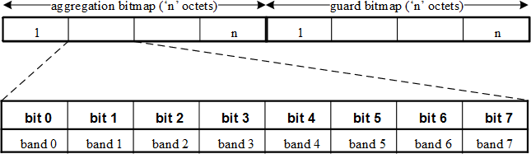

##### Figure 88—Aggregation and guard bitmap per optical source type

For example,

* If band 1 and band 2 need to be aggregated (assuming a blue LED), the aggregation bitmap is indicated as 0110000, and the guard bitmap is indicated as 0000000.
* If band 1 is being used but there is leakage in bands 3, 4, 5 (assuming a white LED, which is realized via a blue LED with yellow phosphor), the aggregation bitmap is indicated as 0100000, and the guard bitmap is indicated as 0001110.

##### 5.3.19.2 WQI information element

The wavelength quality indicator (WQI) is communicated to another device using the WQI information element. The WQI value to be sent in the information element may be an average value across a number of packets, and WQI value sets for a number of band plan identifiers can be reported using the WQI information element as shown in Table 24. The WQI information element is 8 octets in length, and the WQI information is provided for all band plan identifiers. If a band plan identifier is not supported, WQI of 0 shall be reported.

##### Table 24—WQI information element

|  |  |
| --- | --- |
| **Band plan code** | **WQI value** |
| 0x00 | 0x00 to 0xff |
| 0x01 | 0x00 to 0xff |
| 0x02 | 0x00 to 0xff |
| 0x03 | 0x00 to 0xff |
| 0x04 | 0x00 to 0xff |
| 0x05 | 0x00 to 0xff |
| 0x06 | 0x00 to 0xff |
| 0x07 | 0x00 to 0xff |

## MAC sublayer service specification

#### Overview

The MAC sublayer provides an interface between the SSCS, DME, and PHY. The MAC sublayer conceptually includes a management entity called the MLME. This entity provides the service interfaces through which layer management functions may be invoked. The MLME is also responsible for maintaining a database of managed objects pertaining to the MAC sublayer. This database is referred to as the MAC sublayer PIB.

Figure 89 depicts the components and interfaces of the MAC sublayer.

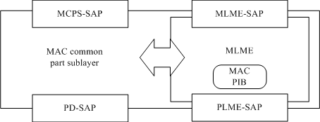

##### Figure 89—MAC sublayer reference model

The MAC sublayer provides the following two services, accessed through two SAPs:

1. The MAC data service, accessed through the MCPS-SAP
2. The MAC management service, accessed through the MLME-SAP

These two services provide the interface between the SSCS and the PHY, via the PD-SAP and PLME-SAP interfaces (see Clause 9). In addition to these external interfaces, an implicit interface also exists between the MLME and the MCPS that allows the MLME to use the MAC data service.

#### MAC data service

The MCPS-SAP supports the transport of SSCS protocol data units (SPDUs) between peer SSCS entities. Table 25 lists the primitives supported by the MCPS-SAP. These primitives are discussed in the subclauses referenced in this table.

##### Table 25—MCPS-SAP primitives

|  |  |  |  |
| --- | --- | --- | --- |
| **MCPS-SAP primitive** | **Request** | **Confirm** | **Indication** |
| MCPS-DATA | 6.2.1 | 6.2.2 | 6.2.3 |
| MCPS-PURGE | 6.2.4 | 6.2.5 | — |

##### MCPS-DATA.request

The MCPS-DATA.request primitive requests the transfer of an SPDU (i.e., MSDU) from a local SSCS entity to a single peer SSCS entity. In the packed mode, multiple MSDU are passed via a local SSCS entity to a single peer SSCS entity.

The semantics of the MCPS-DATA.request primitive are as follows:

MCPS-DATA.request ( SrcAddrMode, DstAddrMode, DstOWPANId,

DstAddr, MsduLength, Msdu, MsduHandle, TxOptions, SecurityLevel, KeyIdMode, KeySource, KeyIndex, DataRate, BurstMode, ColorReceived, ColorNotReceived

)

Table 26 specifies the parameters for the MCPS-DATA.request primitive.

##### Table 26—MCPS-DATA.request parameters

|  |  |  |  |
| --- | --- | --- | --- |
| **Name** | **Type** | **Valid range** | **Description** |
| SrcAddrMode | Integer | 0x00–0x03 | The source addressing mode for this primitive and subsequent MPDU. This value can take one of the following values:  0x00 = No address (addressing fields omitted, as defined in 5.2.1.1.1)  0x01 = Reserved  0x02 = 16-bit short address 0x03 = 64-bit extended address |
| DstAddrMode | Integer | 0x00–0x03 | The destination addressing mode for this primitive and subsequent MPDU. This value can take one of the following values:  0x00 = No address (addressing fields omitted, as defined in 5.2.1.1.1)  0x01 = No address field (broadcast only mode with no address fields present)  0x02 = 16-bit short address 0x03 = 64-bit extended address |
| DstOWPANId | Integer | 0x0000–0xffff | The 16-bit OWPAN identifier of the entity to which the MSDU is being transferred. |
| DstAddr | Device address | As specified by the DstAddrMode parameter | The individual device address of the entity to which the MSDU is being transferred. |

**Table 26—MCPS-DATA.request parameters *(continued)***

|  |  |  |  |
| --- | --- | --- | --- |
| **Name** | **Type** | **Valid range** | **Description** |
| MsduLength | Integer |  *aMaxMACPaylo adSize* | The number of octets contained in the MSDU to be transmitted by the MAC sublayer entity. |
| Msdu | Set of octets | — | The set of octets forming the MSDU to be transmitted by the MAC sublayer entity. |
| MsduHandle | Integer | 0x00–0xff | The handle associated with the MSDU to be transmitted by the MAC sublayer entity. |
| TxOptions | Bitmap | 3-bit field | The 3 bits (b0, b1, b2) indicate the transmission options for this MSDU.  For b0, 1 = acknowledged transmission, 0 = unacknowledged transmission.  For b1, 1 = GTS transmission, 0 = CAP transmission for a beacon-enabled OWPAN.  For b2, 1 = indirect transmission, 0 = direct transmission.  For a nonbeacon-enabled OWPAN, bit b1 should always be set to 0. |
| SecurityLevel | Integer | 0x00–0x07 | The security level to be used (as defined in Table 67 in 7.4.2.1). |
| KeyIdMode | Integer | 0x00–0x03 | The mode used to identify the key to be used (as defined in Table 68 in 7.4.2.2). This parameter is ignored if the SecurityLevel parameter is set to 0x00. |
| KeySource | Set of 0, 4,  or 8 octets | As specified by the KeyIdMode parameter | The originator of the key to be used (see 7.4.4.1). This parameter is ignored if the KeyIdMode parameter is ignored or set to 0x00. |
| KeyIndex | Integer | 0x01–0xff | The index of the key to be used (see 7.4.4.2). This parameter is ignored if the KeyIdMode parameter is ignored or set to 0x00. |
| DataRate | Enumeration | 6-bit field | The data rate of the PHY frame to be transmitted by the PHY entity as shown in Table 90. |
| BurstMode | Boolean | TRUE or FALSE | The BurstMode bit shall be set TRUE if the burst mode is being used (as discussed in 8.6.1); otherwise, the BurstMode bit shall be set FALSE. |
| ColorReceived | Boolean | TRUE or FALSE | ColorReceived shall be set as TRUE, when the acknowledgment frame is sent and the color function for the ACK state indication is used by the CVD frame.  ColorReceived shall be set as FALSE when the acknowledgment frame is sent but the color function for the ACK state indication is not used by the CVD frame. |
| ColorNotReceived | Boolean | TRUE or FALSE | ColorNotReceived shall be set as TRUE, when the acknowledgment frame is not sent but the color function for the non-ACK state indication is used by the CVD frame.  ColorNotReceived shall be set as FALSE when the acknowledgment frame is not sent and the color function for the non-ACK state indication is not used by the CVD frame. |

##### Appropriate usage

The MCPS-DATA.request primitive is generated by a local SSCS entity when an SPDU (i.e., MSDU) is to be transferred to a peer SSCS entity.

##### Effect on receipt

On receipt of the MCPS-DATA.request primitive, the MAC sublayer entity begins the transmission of the supplied MSDU.

The MAC sublayer builds an MPDU to transmit from the supplied arguments. The flags in the SrcAddrMode and DstAddrMode parameters correspond to the addressing subfields in the Frame Control field, as shown in 5.2.1.1, and are used to construct both the frame control and addressing fields of the MHR. If both the SrcAddrMode and the DstAddrMode parameters are set to 0x00 (i.e., addressing fields omitted), the MAC sublayer will issue the MCPS-DATA.confirm primitive with a status of INVALID_ADDRESS.

The TxOptions parameter indicates how the MAC sublayer data service transmits the supplied MSDU. If the TxOptions parameter specifies that an acknowledged transmission is required, the Acknowledgment Request subfield of the Frame Control field will be set to one (see 5.1.7.4).

If the TxOptions parameter specifies that a GTS transmission is required, the MAC sublayer will determine whether it has a valid GTS (for GTS usage rules, as defined in 5.1.8.3). If a valid GTS could not be found, the MAC sublayer will issue the MCPS-DATA.confirm primitive with a status of INVALID_GTS. If a valid GTS was found, the MAC sublayer will defer, if necessary, until the GTS. If the TxOptions parameter specifies that a GTS transmission is not required, the MAC sublayer will transmit the MSDU using either slotted random access in the CAP for a beacon-enabled OWPAN or unslotted random access for a nonbeacon-enabled OWPAN. Specifying a GTS transmission in the TxOptions parameter overrides an indirect transmission request.

If the TxOptions parameter specifies that an indirect transmission is required and this primitive is received by the MAC sublayer of a coordinator, the data frame is sent using indirect transmission, i.e., the data frame is added to the list of pending transactions stored on the coordinator and extracted at the discretion of the device concerned using the method described in 5.1.7.3. Transactions with a broadcast destination address will be transmitted using the mechanism described in d. Transactions with a unicast destination address can then be extracted at the discretion of each device concerned using the method described in 5.1.7.3. If there is no capacity to store the transaction, the MAC sublayer will discard the MSDU and issue the MCPS- DATA.confirm primitive with a status of TRANSACTION_OVERFLOW. If there is capacity to store the transaction, the coordinator will add the information to the list. If the transaction is not handled within *macTransactionPersistenceTime*, the transaction information will be discarded and the MAC sublayer will issue the MCPS-DATA.confirm primitive with a status of TRANSACTION_EXPIRED. The transaction handling procedure is described in 5.1.6. If the TxOptions parameter specifies that an indirect transmission is required and if the device receiving this primitive is not a coordinator, the destination address is not present, or the TxOptions parameter also specifies a GTS transmission, the indirect transmission option will be ignored.

If the TxOptions parameter specifies that an indirect transmission is not required, the MAC sublayer will transmit the MSDU using slotted random access either in the CAP for a beacon-enabled OWPAN or immediately for a nonbeacon-enabled OWPAN. If the TxOptions parameter specifies that a direct transmission is required and the MAC sublayer does not receive an acknowledgment from the recipient after *macMaxFrameRetries* retransmissions (see 5.1.7.4), it will discard the MSDU and issue the MCPS- DATA.confirm primitive with a status of NO_ACK.

If the SecurityLevel parameter is set to a valid value other than 0x00, indicating that security is required for this frame, the MAC sublayer will set the Security Enabled subfield of the Frame Control field to one. The MAC sublayer will perform outgoing processing on the frame based on the DstAddr, SecurityLevel, KeyIdMode, KeySource, and KeyIndex parameters, as described in 7.2.1. If any error occurs during outgoing frame processing, the MAC sublayer will discard the frame and issue the MCPS-DATA.confirm primitive with the error status returned by outgoing frame processing.

If the requested transaction is too large to fit in the CAP or GTS, as appropriate, the MAC sublayer shall discard the frame and issue the MCPS-DATA.confirm primitive with a status of FRAME_TOO_LONG.

If the transmission attempts a random access (either slotted or unslotted) and the random access algorithm failed due to adverse conditions on the channel, and the TxOptions parameter specifies that a direct transmission is required, the MAC sublayer will discard the MSDU and issue the MCPS-DATA.confirm primitive with a status of CHANNEL_ACCESS_FAILURE.

If the MAC sublayer receives the request while transmission is prohibited, it shall delay transmission until transmission is permitted.

If the MPDU was successfully transmitted and, if requested, an acknowledgment was received, the MAC sublayer will issue the MCPS-DATA.confirm primitive with a status of SUCCESS.

If any parameter in the MCPS-DATA.request primitive is not supported or is out of range, the MAC sublayer will issue the MCPS-DATA.confirm primitive with a status of INVALID_PARAMETER.

##### MCPS-DATA.confirm

The MCPS-DATA.confirm primitive reports the results of a request to transfer an SPDU (MSDU) from a local SSCS entity to a single peer SSCS entity.

The semantics of the MCPS-DATA.confirm primitive are as follows:

MCPS-DATA.confirm ( MsduHandle, status, Timestamp

)

Table 27 specifies the parameters for the MCPS-DATA.confirm primitive.

##### Table 27—MCPS-DATA.confirm parameters

|  |  |  |  |
| --- | --- | --- | --- |
| **Name** | **Type** | **Valid range** | **Description** |
| MsduHandle | Integer | 0x00–0xff | The handle associated with the MSDU being confirmed. |
| status | Enumeration | SUCCESS, TRANSACTION_OVERFLOW, TRANSACTION_EXPIRED, CHANNEL_ACCESS_FAILURE, INVALID_ADDRESS, INVALID_GTS, NO_ACK, COUNTER_ERROR, FRAME_TOO_LONG, UNAVAILABLE_KEY, UNSUPPORTED_SECURITY, INVALID_PARAMETER | The status of the last MSDU transmission. |
| Timestamp | Integer | 0x000000–0xffffff | Optional. The time, in optical clocks, at which the data were transmitted (see 5.1.5.1).  The value of this parameter will be considered valid only if the value of the status parameter is SUCCESS; if the status parameter is not equal to SUCCESS, the value of the Timestamp parameter shall not be used for any other purpose. The boundary is described by *macTimeStampOffset* (as defined in Table 62).  The time stamp is a 24-bit value, and the precision of this value shall be a minimum of 20 bits, with the lowest 4 bits being the least significant. |

* + - 1. **When generated**

The MCPS-DATA.confirm primitive is generated by the MAC sublayer entity in response to an MCPS- DATA.request primitive. The MCPS-DATA.confirm primitive returns a status of either SUCCESS, indicating that the request to transmit was successful, or the appropriate error code. The status values are fully described in 6.2.1.2 and subclauses referenced by 6.2.1.2.

##### Appropriate usage

On receipt of the MCPS-DATA.confirm primitive, the SSCS of the initiating device is notified of the result of its request to transmit. If the transmission attempt was successful, the status parameter will be set to SUCCESS. Otherwise, the status parameter will indicate the error.

##### MCPS-DATA.indication

The MCPS-DATA.indication primitive indicates the transfer of an SPDU (i.e., MSDU) from the MAC sublayer to the local SSCS entity. In the packed mode, multiple MSDU are passed via a local SSCS entity to a single peer SSCS entity.

The semantics of the MCPS-DATA.indication primitive are as follows:

MCPS-DATA.indication ( SrcAddrMode, SrcOWPANId,

SrcAddr, DstAddrMode, DstOWPANId,

DstAddr, MsduLength, Msdu, MpduLinkQuality, DSN,

Timestamp, SecurityLevel, KeyIdMode, KeySource, KeyIndex, DataRate, BurstMode, ColorReceived, ColorNotReceived

)

Table 28 specifies the parameters for the MCPS-DATA.indication primitive.

##### Table 28—MCPS-DATA.indication parameters

|  |  |  |  |
| --- | --- | --- | --- |
| **Name** | **Type** | **Valid range** | **Description** |
| SrcAddrMode | Integer | 0x00–0x03 | The source addressing mode for this primitive corresponding to the received MPDU. This value can take one of the following values:  0x00 = no address (addressing fields omitted). 0x01 = reserved.  0x02 = 16-bit short address. 0x03 = 64-bit extended address. |
| SrcOWPANId | Integer | 0x0000–0xffff | The 16-bit OWPAN identifier of the entity from which the MSDU was received. |
| SrcAddr | Device address | As specified by the SrcAddrMode parameter | The individual device address of the entity from which the MSDU was received. |

|  |  |  |  |
| --- | --- | --- | --- |
| **Name** | **Type** | **Valid range** | **Description** |
| DstAddrMode | Integer | 0x00–0x03 | The destination addressing mode for this primitive corresponding to the received MPDU. This value can take one of the following values:  0x00 = no address (addressing fields omitted)  0x01 = no address field (broadcast only mode with no address fields present)  0x02 = 16-bit short device address 0x03 = 64-bit extended device address |
| DstOWPANId | Integer | 0x0000–0xffff | The 16-bit OWPAN identifier of the entity to which the MSDU is being transferred. |
| DstAddr | Device address | As specified by the DstAddrMode parameter | The individual device address of the entity to which the MSDU is being transferred. |
| MsduLength | Integer | *aMaxMacPayloa dSize* | The number of octets contained in the MSDU being indicated by the MAC sublayer entity. |
| Msdu | Set of octets | — | The set of octets forming the MSDU being indicated by the MAC sublayer entity. |
| MpduLinkQuality | Integer | 0x00–0xff | WQI value measured during reception of the MPDU. Lower values represent lower WQI (see 5.3.19.2) |
| DSN | Integer | 0x00–0xff | The DSN of the received data frame. |
| Timestamp | Integer | 0x000000–0xffffff | Optional. The time, in optical clocks, at which the data were received (see 5.1.5.1).  The boundary is described by *macTimeStampOffset* (as defined in Table 62).  The time stamp is a 24-bit value, and the precision of this value shall be a minimum of 20 bits, with the lowest 4 bits being the least significant. |
| SecurityLevel | Integer | 0x00–0x07 | The security level purportedly used by the received data frame (as defined in Table 67 in 7.4.2.1). |
| KeyIdMode | Integer | 0x00–0x03 | The mode used to identify the key purportedly used by the originator of the received frame (as defined in Table 68 in 7.4.2.2). This parameter is invalid if the SecurityLevel parameter is set to 0x00. |
| KeySource | Set of 0, 4,  or 8 octets | As specified by the KeyIdMode parameter | The originator of the key purportedly used by the originator of the received frame (see 7.4.4.1). This parameter is invalid if the KeyIdMode parameter is invalid or set to 0x00. |
| KeyIndex | Integer | 0x01–0xff | The index of the key purportedly used by the originator of the received frame (see 7.4.4.2). This parameter is invalid if the KeyIdMode parameter is invalid or set to 0x00. |
| DataRate | Enumeration | 6-bit field | The data rate of the PHY frame to be transmitted by the PHY entity as shown in Table 90. |

|  |  |  |  |
| --- | --- | --- | --- |
| **Name** | **Type** | **Valid range** | **Description** |
| BurstMode | Boolean | TRUE or FALSE | The BurstMode bit shall be set TRUE if the burst mode is being used (as discussed in 8.6.1); otherwise, the BurstMode bit shall be set FALSE. |
| ColorReceived | Boolean | TRUE or FALSE | ColorReceived shall be set as TRUE, if CVD frame is sent when data frame is successfully received. |
| ColorNotReceived | Boolean | TRUE or FALSE | ColorNotReceived shall be set as TRUE, if CVD frame is sent when data frame is not received. |

* + - 1. **When generated**

The MCPS-DATA.indication primitive is generated by the MAC sublayer and issued to the SSCS on receipt of a data frame at the local MAC sublayer entity that passes the appropriate message filtering operations as described in 5.1.7.2.

##### Appropriate usage

On receipt of the MCPS-DATA.indication primitive, the SSCS is notified of the arrival of data at the device.

##### MCPS-PURGE.request

The MCPS-PURGE.request primitive allows the next higher layer to purge an MSDU from the transaction queue.

This primitive is optional for a device.

The semantics of the MCPS-PURGE.request primitive are as follows:

MCPS-PURGE.request ( MsduHandle

)

Table 29 specifies the parameters for the MCPS-PURGE.request primitive.

##### Table 29—MCPS-PURGE.request parameters

|  |  |  |  |
| --- | --- | --- | --- |
| **Name** | **Type** | **Valid range** | **Description** |
| MsduHandle | Integer | 0x00–0xff | The handle of the MSDU to be purged from the transaction queue. |

* + - 1. **Appropriate usage**

The MCPS-PURGE.request primitive is generated by the next higher layer whenever a MSDU is to be purged from the transaction queue.

##### Effect on receipt

On receipt of the MCPS-PURGE.request primitive, the MAC sublayer attempts to find in its transaction queue the MSDU indicated by the MsduHandle parameter. If an MSDU has left the transaction queue, the handle will not be found, and the MSDU can no longer be purged. If an MSDU matching the given handle is found, the MSDU is discarded from the transaction queue, and the MAC sublayer issues the MCPS- PURGE.confirm primitive with a status of SUCCESS. If an MSDU matching the given handle is not found, the MAC sublayer issues the MCPS-PURGE.confirm primitive with a status of INVALID_HANDLE.

##### MCPS-PURGE.confirm

The MCPS-PURGE.confirm primitive allows the MAC sublayer to notify the next higher layer of the success of its request to purge an MSDU from the transaction queue.

This primitive is optional for a device.

The semantics of the MCPS-PURGE.confirm primitive are as follows:

MCPS-PURGE.confirm ( MsduHandle, status

)

Table 30 specifies the parameters for the MCPS-PURGE.confirm primitive.

##### Table 30—MCPS-PURGE.confirm parameters

|  |  |  |  |
| --- | --- | --- | --- |
| **Name** | **Type** | **Valid range** | **Description** |
| MsduHandle | Integer | 0x00–0xff | The handle of the MSDU requested to be purge from the transaction queue. |
| status | Enumeration | SUCCESS, INVALID_HANDLE | The status of the request to be purged an MSDU from the transaction queue. |

* + - 1. **When generated**

The MCPS-PURGE.confirm primitive is generated by the MAC sublayer entity in response to an MCPS- PURGE.request primitive. The MCPS-PURGE.confirm primitive returns a status of either SUCCESS, indicating that the purge request was successful, or INVALID_HANDLE, indicating an error. The status values are fully described in 6.2.5.2.

##### Appropriate usage

On receipt of the MCPS-PURGE.confirm primitive, the next higher layer is notified of the result of its request to purge an MSDU from the transaction queue. If the purge request was successful, the status parameter will be set to SUCCESS. Otherwise, the status parameter will indicate the error.

##### Data service message sequence chart

Figure 90 illustrates a sequence of messages necessary for a successful data transfer between two devices. Figure 111 and Figure 112 also illustrate this, including the steps taken by the PHY.

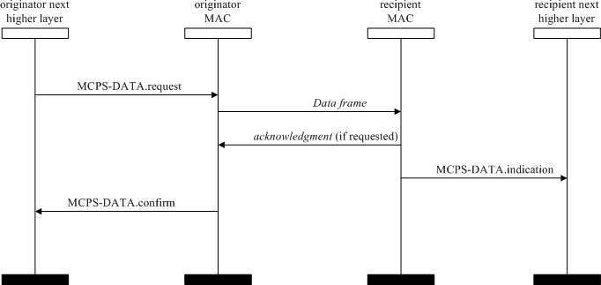

##### Figure 90—Message sequence chart describing the MAC data service

#### MAC management service

The MLME-SAP allows the transport of management commands between the next higher layer and the MLME. Table 31 summarizes the primitives supported by the MLME through the MLME-SAP interface. Primitives marked with a diamond (◻) are optional for an RFD. Primitives marked with an asterisk (*) are optional for both device types (i.e., RFD and FFD). The primitives are discussed in the subclauses referenced in this table.

##### Table 31—Summary of the primitives accessed through the MLME-SAP

|  |  |  |  |  |
| --- | --- | --- | --- | --- |
| **Name** | **Request** | **Indication** | **Response** | **Confirm** |
| MLME-ASSOCIATE | 6.3.1.1 | 6.3.1.2◻ | 6.3.1.3◻ | 6.3.1.4 |
| MLME-DISASSOCIATE | 6.3.2.1 | 6.3.2.2 |  | 6.3.2.3 |
| MLME-BEACON-NOTIFY |  | 6.3.3.1 |  |  |
| MLME-GET | 6.3.4.1 |  |  | 6.3.4.2 |
| MLME-GTS | 6.3.5.1 | 6.3.5.2 |  | 6.3.5.3 |
| MLME-RESET | 6.3.6.1 |  |  | 6.3.6.2 |
| MLME-RX-ENABLE | 6.3.7.1 |  |  | 6.3.7.2 |
| MLME-SCAN | 6.3.8.1 |  |  | 6.3.8.2 |
| MLME-COMM-STATUS |  | 6.3.9.1 |  |  |
| MLME-SET | 6.3.10.1 |  |  | 6.3.10.2 |

**Table 31—Summary of the primitives accessed through the MLME-SAP *(continued)***

|  |  |  |  |  |
| --- | --- | --- | --- | --- |
| **Name** | **Request** | **Indication** | **Response** | **Confirm** |
| MLME-START | 6.3.11.1◻ |  |  | 6.3.11.2◻ |
| MLME-SYNC | 6.3.12.1* |  |  |  |
| MLME-SYNC-LOSS |  | 6.3.13.1 |  |  |
| MLME-POLL | 6.3.14.1 |  |  | 6.3.14.2 |

##### Association primitives

MLME-SAP association primitives define how a device becomes associated with a OWPAN.

All devices shall provide an interface for the request and confirm association primitives. The indication and response association primitives are optional for a device.

##### MLME-ASSOCIATE.request

The MLME-ASSOCIATE.request primitive allows a device to request an association with a coordinator. The semantics of the MLME-ASSOCIATE.request primitive are as follows:

MLME-ASSOCIATE.request ( LogicalChannel, CoordAddrMode, CoordOWPANId, CoordAddress,

CapabilityInformation, SecurityLevel, KeyIdMode, KeySource, KeyIndex, ColorAssoc

)

Table 32 specifies the parameters for the MLME-ASSOCIATE.request primitive.

##### Table 32—MLME-ASSOCIATE.request parameters

|  |  |  |  |
| --- | --- | --- | --- |
| **Name** | **Type** | **Valid range** | **Description** |
| LogicalChannel | Integer | Selected from the available logical channels supported by the PHY (see Table 80) | The logical channel on which to attempt association. |
| CoordAddrMode | Integer | 0x02–0x03 | The coordinator addressing mode for this primitive and subsequent MPDU. This value can take one of the following values:  2 = 16-bit short address  3 = 64-bit extended address |

**Table 32—MLME-ASSOCIATE.request parameters *(continued)***

|  |  |  |  |
| --- | --- | --- | --- |
| **Name** | **Type** | **Valid range** | **Description** |
| CoordOWPANId | Integer | 0x0000–0xffff | The OWPAN identifier of the coordinator as specified in the received beacon frame. |
| CoordAddress | Device address | As specified by the CoordAddrMode parameter | The address of the coordinator with which to associate. |
| CapabilityInforma tion | Bitmap | As defined in 5.3.19.1 | Specifies the operational capabilities of the associating device. |
| SecurityLevel | Integer | 0x00–0x07 | The security level to be used (as defined in Table 67 in 7.4.2.1). |
| KeyIdMode | Integer | 0x00–0x03 | The mode used to identify the key to be used (as defined in Table 68 in 7.4.2.2). This parameter is ignored if the SecurityLevel parameter is set to 0x00. |
| KeySource | Set of 0, 4,  or 8 octets | As specified by the KeyIdMode parameter | The originator of the key to be used (see 7.4.4.1). This parameter is ignored if the KeyIdMode parameter is ignored or set to 0x00. |
| KeyIndex | Integer | 0x01–0xff | The index of the key to be used (see 7.4.4.2). This parameter is  ignored if the KeyIdMode parameter is ignored or set to 0x00. |
| ColorAssoc | Boolean | TRUE or FALSE | ColorAssoc shall be set as TRUE if the color CVD frame is to be transmitted after the association request command is sent. |

##### Appropriate usage

The MLME-ASSOCIATE.request primitive is generated by the next higher layer of an unassociated device and issued to its MLME to request an association with a OWPAN through a coordinator. If the device wishes to associate through a coordinator on a beacon-enabled OWPAN, the MLME may optionally track the beacon of that coordinator prior to issuing this primitive.

##### Effect on receipt

On receipt of the MLME-ASSOCIATE.request primitive, the MLME of an unassociated device first updates the appropriate PHY and MAC PIB attributes and then generates an association request command as shown in 5.3.1, as dictated by the association procedure described in 5.1.4.1.

The SecurityLevel parameter specifies the level of security to be applied to the association request command frame. Typically, the association request command should not be implemented using security. However, if the device requesting association shares a key with the coordinator, then security may be specified.

If the SecurityLevel parameter is set to a valid value other than 0x00, indicating that security is required for this frame, the MLME will set the Security Enabled subfield of the Frame Control field to one. The MAC sublayer will perform outgoing processing on the frame based on the CoordAddress, SecurityLevel, KeyIdMode, KeySource, and KeyIndex parameters, as described in 7.2.1. If any error occurs during

outgoing frame processing, the MLME will discard the frame and issue the MLME-ASSOCIATE.confirm primitive with the error status returned by outgoing frame processing.

If the association request command cannot be sent to the coordinator due to the unslotted random access algorithm indicating a busy channel, the MLME will issue the MLME-ASSOCIATE.confirm primitive with a status of CHANNEL_ACCESS_FAILURE.

If the MLME successfully transmits an association request command, the MLME will expect an acknowledgment in return. If an acknowledgment is not received, the MLME will issue the MLME- ASSOCIATE.confirm primitive with a status of NO_ACK (see 5.1.7.4).

If the MLME of an unassociated device successfully receives an acknowledgment to its association request command, the MLME will wait for a response to the request (see 5.1.4.1). If the MLME of the device does not receive a response, it will issue the MLME-ASSOCIATE.confirm primitive with a status of NO_DATA.

If the MLME of the device extracts an association response command frame from the coordinator, it will then issue the MLME-ASSOCIATE.confirm primitive with a status equal to the contents of the Association Status field in the association response command as shown in 5.3.2.3.

On receipt of the association request command, the MLME of the coordinator issues the MLME- ASSOCIATE.indication primitive.

If any parameter in the MLME-ASSOCIATE.request primitive is either not supported or out of range, the MLME will issue the MLME-ASSOCIATE.confirm primitive with a status of INVALID_PARAMETER.

##### MLME-ASSOCIATE.indication

The MLME-ASSOCIATE.indication primitive is used to indicate the reception of an association request command.

The semantics of the MLME-ASSOCIATE.indication primitive are as follows:

MLME-ASSOCIATE.indication ( DeviceAddress,

CapabilityInformation, SecurityLevel, KeyIdMode, KeySource,

KeyIndex

)

Table 33 specifies the parameters for the MLME-ASSOCIATE.indication primitive.

##### Table 33—MLME-ASSOCIATE.indication parameters

|  |  |  |  |
| --- | --- | --- | --- |
| **Name** | **Type** | **Valid range** | **Description** |
| DeviceAddress | Device address | An extended 64-bit  IEEE address | The address of the device requesting association. |
| CapabilityInforma tion | Bitmap | Refer to 5.3.19.1 | The operational capabilities of the device requesting association. |

**Table 33—MLME-ASSOCIATE.indication parameters *(continued)***

|  |  |  |  |
| --- | --- | --- | --- |
| **Name** | **Type** | **Valid range** | **Description** |
| SecurityLevel | Integer | 0x00–0x07 | The security level purportedly used by the received MAC command frame (as defined in Table 67 in 7.4.2.1). |
| KeyIdMode | Integer | 0x00–0x03 | The mode used to identify the key purportedly used by the originator of the received frame (as defined in Table 68 in 7.4.2.2). This parameter is invalid if the SecurityLevel parameter is set to 0x00. |
| KeySource | Set of 0, 4,  or 8 octets | As specified by the KeyIdMode parameter | The originator of the key purportedly used by the originator of the received frame (see 7.4.4.1). This parameter is invalid if the KeyIdMode parameter is invalid or set to 0x00. |
| KeyIndex | Integer | 0x01–0xff | The index of the key purportedly used by the originator of the received frame (see 7.4.4.2). This parameter is invalid if the KeyIdMode parameter is invalid or set to 0x00. |

* + - * 1. **When generated**

The MLME-ASSOCIATE.indication primitive is generated by the MLME of the coordinator and issued to its next higher layer to indicate the reception of an association request command (as defined in 5.3.1).

##### Appropriate usage

When the next higher layer of a coordinator receives the MLME-ASSOCIATE.indication primitive, the coordinator determines whether to accept or reject the unassociated device using an algorithm outside the scope of this standard. The next higher layer of the coordinator then issues the MLME- ASSOCIATE.response primitive to its MLME.

The association decision and the response should become available at the coordinator within a time of *macResponseWaitTime* (see 5.1.4.1). After this time, the device requesting association attempts to extract the association response command frame from the coordinator, using the method described in 5.1.7.3, in order to determine whether the association was successful.

##### MLME-ASSOCIATE.response

The MLME-ASSOCIATE.response primitive is used to initiate a response to an MLME- ASSOCIATE.indication primitive.

The semantics of the MLME-ASSOCIATE.response primitive are as follows:

MLME-ASSOCIATE.response ( DeviceAddress,

AssocShortAddress, status,

CapabilityNegotiationResponse, SecurityLevel,

KeyIdMode, KeySource, KeyIndex

)

Table 34 specifies the parameters for the MLME-ASSOCIATE.response primitive.

##### Table 34—MLME-ASSOCIATE.response parameters

|  |  |  |  |
| --- | --- | --- | --- |
| **Name** | **Type** | **Valid range** | **Description** |
| DeviceAddress | Device address | An extended 64-bit  IEEE address | The address of the device requesting association. |
| AssocShortAddress | Integer | 0x0000–0xffff | The 16-bit short device address allocated by the coordinator on successful association. This parameter is set to 0xffff if the association was unsuccessful. |
| status | Enumeration | Refer to 5.3.2.3 | The status of the association attempt. |
| CapabilityNegotiati onResponse | Integer | 00–11 | The coordinator indicates who will send color compensation information (same definitions and usage as the color stabilization scheme subfield in Table 22). |
| SecurityLevel | Integer | 0x00–0x07 | The security level to be used (as defined in Table 67 in 7.4.2.1). |
| KeyIdMode | Integer | 0x00–0x03 | The mode used to identify the key to be used (as defined in Table 68 in 7.4.2.2). This parameter is ignored if the SecurityLevel parameter is set to 0x00. |
| KeySource | Set of 0, 4, or  8 octets | As specified by the KeyIdMode parameter | The originator of the key to be used (see 7.4.4.1). This parameter is ignored if the KeyIdMode parameter is ignored or set to 0x00. |
| KeyIndex | Integer | 0x01–0xff | The index of the key to be used (see 7.4.4.2). This parameter is ignored if the KeyIdMode parameter is ignored or set to 0x00. |

* + - * 1. **Appropriate usage**

The MLME-ASSOCIATE.response primitive is generated by the next higher layer of a coordinator and issued to its MLME in order to respond to the MLME-ASSOCIATE.indication primitive.

##### Effect on receipt

When the MLME of a coordinator receives the MLME-ASSOCIATE.response primitive, it generates an association response command as shown in 5.3.2. The command frame is sent to the device requesting association using indirect transmission, i.e., the command frame is added to the list of pending transactions stored on the coordinator and extracted at the discretion of the device concerned using the method described in 5.1.7.3.

If the SecurityLevel parameter is set to a valid value other than 0x00, indicating that security is required for this frame, the MLME will set the Security Enabled subfield of the Frame Control field to one. The MAC sublayer will perform outgoing processing on the frame based on the DeviceAddress, SecurityLevel, KeyIdMode, KeySource, and KeyIndex parameters, as described in 7.2.1. If any error occurs during outgoing frame processing, the MLME will discard the frame and issue the MLME-COMM- STATUS.indication primitive with the error status returned by outgoing frame processing.

Upon receipt of the MLME-ASSOCIATE.response primitive, the coordinator attempts to add the information contained in the primitive to its list of pending transactions. If there is no capacity to store the transaction, the MAC sublayer will discard the frame and issue the MLME-COMM-STATUS.indication

primitive with a status of TRANSACTION_OVERFLOW. If there is capacity to store the transaction, the coordinator will add the information to the list. If the transaction is not handled within *macTransactionPersistenceTime*, the transaction information will be discarded and the MAC sublayer will issue the MLME-COMM-STATUS.indication primitive with a status of TRANSACTION_EXPIRED. The transaction handling procedure is described in 5.1.6.

If the frame was successfully transmitted and an acknowledgment was received, if requested, the MAC sublayer will issue the MLME-COMM-STATUS.indication primitive with a status of SUCCESS.

If any parameter in the MLME-ASSOCIATE.response primitive is not supported or is out of range, the MAC sublayer will issue the MLME-COMM-STATUS.indication primitive with a status of INVALID_PARAMETER.

##### MLME-ASSOCIATE.confirm

The MLME-ASSOCIATE.confirm primitive is used to inform the next higher layer of the initiating device whether its request to associate was successful or unsuccessful.

The semantics of the MLME-ASSOCIATE.confirm primitive are as follows:

MLME-ASSOCIATE.confirm ( AssocShortAddress, status,

CapabilityNegotiationResponse, SecurityLevel,

KeyIdMode, KeySource, KeyIndex

)

Table 35 specifies the parameters for the MLME-ASSOCIATE.confirm primitive.

##### Table 35—MLME-ASSOCIATE.confirm parameters

|  |  |  |  |
| --- | --- | --- | --- |
| **Name** | **Type** | **Valid range** | **Description** |
| AssocShortAddress | Integer | 0x0000–0xffff | The short device address allocated by the coordinator on successful association. This parameter will be equal to 0xffff if the association attempt was unsuccessful. |
| status | Enumeration | The value of the Status field of the association response command  (as defined in 5.3.2.3), SUCCESS,  CHANNEL_ACCESS_FAILURE, NO_ACK, NO_DATA, COUNTER_ERROR, FRAME_TOO_LONG, IMPROPER_KEY_TYPE, IMPROPER_SECURITY_LEVEL, SECURITY_ERROR, UNAVAILABLE_KEY, UNSUPPORTED_LEGACY, UNSUPPORTED_SECURITY, INVALID_PARAMETER | The status of the association attempt. |

|  |  |  |  |
| --- | --- | --- | --- |
| **Name** | **Type** | **Valid range** | **Description** |
| CapabilityNegotiati onResponse | Integer | 00–11 | Coordinator indicates who will send (see Table 22). |
| SecurityLevel | Integer | 0x00–0x07 | If the primitive was generated following failed outgoing processing of an association request command:  The security level to be used (as defined in Table 67 in 7.4.2.1).  If the primitive was generated following receipt of an association response command:  The security level purportedly used by the received frame (as defined in Table 67 in 7.4.2.1). |
| KeyIdMode | Integer | 0x00–0x03 | If the primitive was generated following failed outgoing processing of an association request command:  The mode used to identify the key to be used (as defined in Table 68 in 7.4.2.2). This parameter is ignored if the SecurityLevel parameter is set to 0x00.  If the primitive was generated following receipt of an association response command:  The mode used to identify the key purportedly used by the originator of the received frame (as defined in Table 68 in 7.4.2.2). This parameter is invalid if the SecurityLevel parameter is set to 0x00. |
| KeySource | Set of 0, 4, or  8 octets | As specified by the KeyIdMode parameter | If the primitive was generated following failed outgoing processing of an association request command:  The originator of the key to be used (see 7.4.4.1). This parameter is ignored if the KeyIdMode parameter is ignored or set to 0x00.  If the primitive was generated following receipt of an association response command:  The originator of the key purportedly used by the originator of the received frame (see 7.4.4.1). This parameter is invalid if the KeyIdMode parameter is invalid or set to 0x00. |

|  |  |  |  |
| --- | --- | --- | --- |
| **Name** | **Type** | **Valid range** | **Description** |
| KeyIndex | Integer | 0x01–0xff | If the primitive was generated following failed outgoing processing of an association request command:  The index of the key to be used  (see 7.4.4.2). This parameter is ignored if the KeyIdMode parameter is ignored or set to 0x00.  If the primitive was generated following receipt of an association response command:  The index of the key purportedly used by the originator of the received frame (see 7.4.4.2). This parameter is invalid if the KeyIdMode parameter is invalid or set to 0x00. |

* + - * 1. **When generated**

The MLME-ASSOCIATE.confirm primitive is generated by the initiating MLME and issued to its next higher layer in response to an MLME-ASSOCIATE.request primitive. If the request was successful, the status parameter will indicate a successful association, as contained in the Status field of the association response command. Otherwise, the status parameter indicates either an error code from the received association response command or the appropriate error code from Table 35. The status values are fully described in 6.3.1.1.2 and subclauses referenced by 6.3.1.1.2.

##### Appropriate usage

On receipt of the MLME-ASSOCIATE.confirm primitive, the next higher layer of the initiating device is notified of the result of its request to associate with a coordinator. If the association attempt was successful, the status parameter will indicate a successful association, as contained in the Status field of the association response command, and the device will be provided with a 16-bit short address as specified in Table 2 in

5.1.4.1. If the association attempt was unsuccessful, the address will be equal to 0xffff, and the status parameter will indicate the error.

##### 6.3.1.5 Association-message sequence charts

Figure 91 illustrates a sequence of messages that may be used by a device that is not tracking the beacon of the coordinator, specified in 5.1.7.3, to successfully associate with a OWPAN. Figure 107 and Figure 108, as described in 6.6, illustrate this same scenario, including steps taken by the PHY, for a device associating with a coordinator and for a coordinator allowing association by a device, respectively.

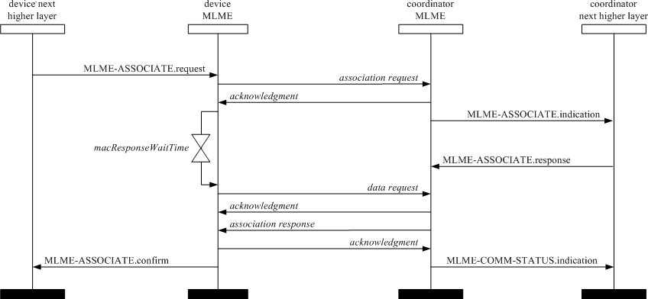

##### Figure 91—Message sequence chart for association

##### Disassociation primitives

The MLME-SAP disassociation primitives define how a device can disassociate from a OWPAN. All devices shall provide an interface for these disassociation primitives.

##### MLME-DISASSOCIATE.request

The MLME-DISASSOCIATE.request primitive is used by an associated device to notify the coordinator of its intent to leave the OWPAN. It is also used by the coordinator to instruct an associated device to leave the OWPAN.

The semantics of the MLME-DISASSOCIATE.request primitive are as follows:

MLME-DISASSOCIATE.request (

DeviceAddrMode, DeviceOWPANId, DeviceAddress, DisassociateReason, TxIndirect, SecurityLevel, KeyIdMode, KeySource, KeyIndex, ColorDisAssoc

)

Table 36 specifies the parameters for the MLME-DISASSOCIATE.request primitive.

##### Table 36—MLME-DISASSOCIATE.request parameters

|  |  |  |  |
| --- | --- | --- | --- |
| **Name** | **Type** | **Valid range** | **Description** |
| DeviceAddrMode | Integer | 0x02–0x03 | The addressing mode of the device to which to send the disassociation notification command. |
| DeviceOWPANId | Integer | 0x0000–0xffff | The OWPAN identifier of the device to which to send the disassociation notification command. |
| DeviceAddress | Device address | As specified by the DeviceAddrMode parameter. | The address of the device to which to send the disassociation notification command. |
| DisassociateReaso n | Integer | 0x00–0xff | The reason for the disassociation (as defined in 5.3.3.2). |
| TxIndirect | Boolean | TRUE or FALSE | TRUE if the disassociation notification command is to be sent indirectly. |
| SecurityLevel | Integer | 0x00–0x07 | The security level to be used (as defined in Table 67 in 7.4.2.1). |
| KeyIdMode | Integer | 0x00–0x03 | The mode used to identify the key to be used (as defined in Table 68 in 7.4.2.2). This parameter is ignored if the SecurityLevel parameter is set to 0x00. |
| KeySource | Set of 0, 4, or  8 octets | As specified by the KeyIdMode parameter | The originator of the key to be used (see 7.4.4.1). This parameter is ignored if the KeyIdMode parameter is ignored or set to 0x00. |
| KeyIndex | Integer | 0x01–0xff | The index of the key to be used (see 7.4.4.2). This parameter is ignored if the KeyIdMode parameter is ignored or set to 0x00. |
| ColorDisAssoc | Boolean | TRUE or FALSE | ColorDisAssoc shall be set as TRUE if the color CVD frame is to be transmitted after the disassociation notification command is sent. |

* + - * 1. **Appropriate usage**

The MLME-DISASSOCIATE.request primitive is generated by the next higher layer of an associated device and issued to its MLME to request disassociation from the OWPAN. It is also generated by the next higher layer of the coordinator and issued to its MLME to instruct an associated device to leave the OWPAN.

##### Effect on receipt

On receipt of the MLME-DISASSOCIATE.request primitive, the MLME compares the DeviceOWPANId parameter with *macOWPANId*. If the DeviceOWPANId parameter is not equal to *macOWPANId*, the MLME issues the MLME-DISASSOCIATE.confirm primitive with a status of INVALID_PARAMETER. If the DeviceOWPANId parameter is equal to *macOWPANId*, the MLME evaluates the primitive address fields.

If the DeviceAddrMode parameter is equal to 0x02 and the DeviceAddress parameter is equal to *macCoordShortAddress* or if the DeviceAddrMode parameter is equal to 0x03 and the DeviceAddress parameter is equal to *macCoordExtendedAddress*, the TxIndirect parameter is ignored, and the MLME sends a disassociation notification command (see 5.3.3) to its coordinator in the CAP for a beacon-enabled OWPAN or immediately for a nonbeacon-enabled OWPAN.

If the DeviceAddrMode parameter is equal to 0x02 and the DeviceAddress parameter is not equal to *macCoordShortAddress* or if the DeviceAddrMode parameter is equal to 0x03 and the DeviceAddress parameter is not equal to *macCoordExtendedAddress*, and if this primitive was received by the MLME of a coordinator with the TxIndirect parameter set to TRUE, the disassociation notification command will be sent using indirect transmission, i.e., the command frame is added to the list of pending transactions stored on the coordinator and extracted at the discretion of the device concerned using the method described in 5.1.7.3.

If the DeviceAddrMode parameter is equal to 0x02 and the DeviceAddress parameter is not equal to *macCoordShortAddress* or if the DeviceAddrMode parameter is equal to 0x03 and the DeviceAddress parameter is not equal to *macCoordExtendedAddress*, and if this primitive was received by the MLME of a coordinator with the TxIndirect parameter set to FALSE, the MLME sends a disassociation notification command to the device in the CAP for a beacon-enabled OWPAN or immediately for a nonbeacon-enabled OWPAN.

Otherwise, the MLME issues the MLME-DISASSOCIATE.confirm primitive with a status of INVALID_PARAMETER and does not generate a disassociation notification command.

If the disassociation notification command is to be sent using indirect transmission and there is no capacity to store the transaction, the MLME will discard the frame and issue the MLME-DISASSOCIATE.confirm primitive with a status of TRANSACTION_OVERFLOW. If there is capacity to store the transaction, the coordinator will add the information to the list. If the transaction is not handled within *macTransaction- PersistenceTime*, the transaction information will be discarded, and the MLME will issue the MLME-DISASSOCIATE.confirm with a status of TRANSACTION_EXPIRED. The transaction handling procedure is described in 5.1.6.

If the disassociation notification command cannot be sent due to an unslotted random access algorithm failure and this primitive was received either by the MLME of a coordinator with the TxIndirect parameter set to FALSE or by the MLME of a device, the MLME will issue the MLME-DISASSOCIATE.confirm primitive with a status of CHANNEL_ACCESS_FAILURE.

If the SecurityLevel parameter is set to a valid value other than 0x00, indicating that security is required for this frame, the MLME will set the Security Enabled subfield of the Frame Control field to one. The MAC sublayer will perform outgoing processing on the frame based on the DeviceAddress, SecurityLevel, KeyIdMode, KeySource, and KeyIndex parameters, as described in 7.2.1. If any error occurs during outgoing frame processing, the MLME will discard the frame and issue the MLME- DISASSOCIATE.confirm primitive with the error status returned by outgoing frame processing.

If the MLME successfully transmits a disassociation notification command, the MLME will expect an acknowledgment in return. If an acknowledgment is not received and this primitive was received either by the MLME of a coordinator with the TxIndirect parameter set to FALSE or by the MLME of a device, the MLME will issue the MLME-DISASSOCIATE.confirm primitive with a status of NO_ACK (see 5.1.7.4).

If the MLME successfully transmits a disassociation notification command and receives an acknowledgment in return, the MLME will issue the MLME-DISASSOCIATE.confirm primitive with a status of SUCCESS.

On receipt of the disassociation notification command, the MLME of the recipient issues the MLME- DISASSOCIATE.indication primitive.

If any parameter in the MLME-DISASSOCIATE.request primitive is not supported or is out of range, the MLME will issue the MLME-DISASSOCIATE.confirm primitive with a status of INVALID_PARAMETER.

##### MLME-DISASSOCIATE.indication

The MLME-DISASSOCIATE.indication primitive is used to indicate the reception of a disassociation notification command.

The semantics of the MLME-DISASSOCIATE.indication primitive are as follows:

MLME-DISASSOCIATE.indication (

DeviceAddress, DisassociateReason, SecurityLevel, KeyIdMode, KeySource, KeyIndex

)

Table 37 specifies the parameters for the MLME-DISASSOCIATE.indication primitive.

##### Table 37—MLME-DISASSOCIATE.indication parameters

|  |  |  |  |
| --- | --- | --- | --- |
| **Name** | **Type** | **Valid range** | **Description** |
| DeviceAddress | Device address | An extended 64-bit  IEEE address | The address of the device requesting disassociation. |
| DisassociateReaso n | Integer | 0x00–0xff | The reason for the disassociation (as defined in 5.3.3.2). |
| SecurityLevel | Integer | 0x00–0x07 | The security level purportedly used by the received MAC command frame (as defined in Table 67 in 7.4.2.1). |
| KeyIdMode | Integer | 0x00–0x03 | The mode used to identify the key purportedly used by the originator of the received frame (as defined in Table 68 in 7.4.2.2). This parameter is invalid if the SecurityLevel parameter is set to 0x00. |
| KeySource | Set of 0, 4,  or 8 octets | As specified by the KeyIdMode parameter | The originator of the key purportedly used by the originator of the received frame (see 7.4.4.1). This parameter is invalid if the KeyIdMode parameter is invalid or set to 0x00. |
| KeyIndex | Integer | 0x01–0xff | The index of the key purportedly used by the originator of the received frame (see 7.4.4.2). This parameter is invalid if the KeyIdMode parameter is invalid or set to 0x00. |

* + - * 1. **When generated**

The MLME-DISASSOCIATE.indication primitive is generated by the MLME and issued to its next higher layer on receipt of a disassociation notification command.

##### Appropriate usage

The next higher layer is notified of the reason for the disassociation.

##### MLME-DISASSOCIATE.confirm

The MLME-DISASSOCIATE.confirm primitive reports the results of an MLME-DISASSOCIATE.request primitive.

The semantics of the MLME-DISASSOCIATE.confirm primitive are as follows:

MLME-DISASSOCIATE.confirm (

status, DeviceAddrMode, DeviceOWPANId, DeviceAddress

)

Table 38 specifies the parameters for the MLME-DISASSOCIATE.confirm primitive.

##### Table 38—MLME-DISASSOCIATE.confirm parameters

|  |  |  |  |
| --- | --- | --- | --- |
| **Name** | **Type** | **Valid range** | **Description** |
| status | Enumeration | SUCCESS, TRANSACTION_OVERFLOW, TRANSACTION_EXPIRED, NO_ACK, CHANNEL_ACCESS_FAILURE, COUNTER_ERROR, FRAME_TOO_LONG, UNAVAILABLE_KEY, UNSUPPORTED_SECURITY, INVALID_PARAMETER | The status of the disassociation attempt. |
| DeviceAddrMode | Integer | 0x02–0x03 | The addressing mode of the device that has either requested disassociation or been instructed to disassociate by its coordinator. |
| DeviceOWPANId | Integer | 0x0000–0xffff | The OWPAN identifier of the device that has either requested disassociation or been instructed to disassociate by its coordinator. |
| DeviceAddress | Device address | As specified by the DeviceAddrMode parameter | The address of the device that has either requested disassociation or been instructed to disassociate by its coordinator. |

* + - * 1. **When generated**

The MLME-DISASSOCIATE.confirm primitive is generated by the initiating MLME and issued to its next higher layer in response to an MLME-DISASSOCIATE.request primitive. This primitive returns a status of either SUCCESS, indicating that the disassociation request was successful, or the appropriate error code. The status values are fully described in 6.3.2.1.2 and subclauses referenced by 6.3.2.1.2.

##### Appropriate usage

On receipt of the MLME-DISASSOCIATE.confirm primitive, the next higher layer of the initiating device is notified of the result of the disassociation attempt. If the disassociation attempt was successful, the status parameter will be set to SUCCESS. Otherwise, the status parameter indicates the error.

##### Disassociation-message sequence charts

The request to disassociate may originate either from a device or from the coordinator through which the device has associated. Figure 92 illustrates the sequence of messages necessary for a device to successfully disassociate itself from the OWPAN.

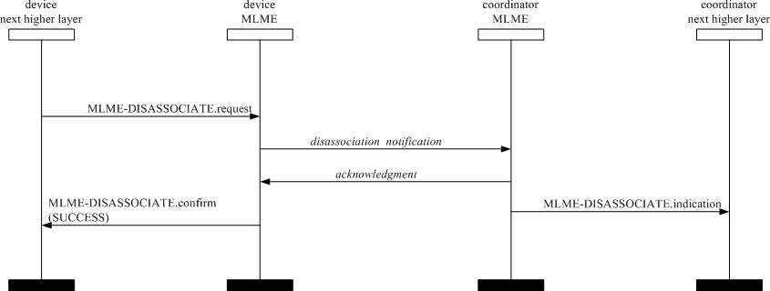

##### Figure 92—Message sequence chart for disassociation initiated by a device

Figure 93 illustrates the sequence necessary for a coordinator in a beacon-enabled OWPAN to successfully disassociate a device from its OWPAN using indirect transmission.

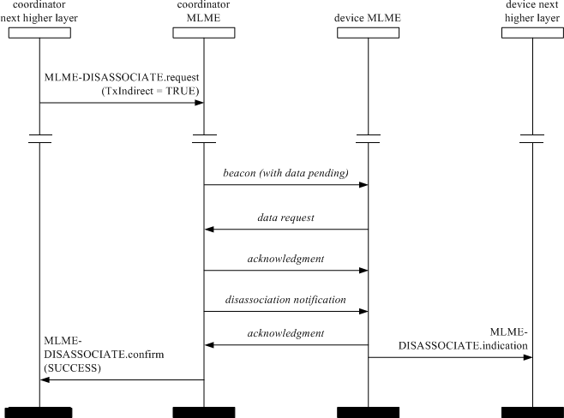

##### Figure 93—Message sequence chart for disassociation initiated by a coordinator, using indirect transmission, in a beacon-enabled OWPAN

##### Beacon notification primitive

The MLME-SAP beacon notification primitive defines how a device may be notified when a beacon is received during normal operating conditions.

All devices shall provide an interface for the beacon notification primitive.

##### MLME-BEACON-NOTIFY.indication

The MLME-BEACON-NOTIFY.indication primitive is used to send parameters contained within a beacon frame received by the MAC sublayer to the next higher layer. The primitive also sends a measure of the WQI and the time the beacon frame was received.

The semantics of the MLME-BEACON-NOTIFY.indication primitive are as follows:

MLME-BEACON-NOTIFY.indication (

BSN,

OWPANDescriptor, PendAddrSpec, AddrList, sduLength,

sdu

)

Table 39 specifies the parameters for the MLME-BEACON-NOTIFY.indication primitive.

##### Table 39—MLME-BEACON-NOTIFY.indication parameters

|  |  |  |  |
| --- | --- | --- | --- |
| **Name** | **Type** | **Valid range** | **Description** |
| BSN | Integer | 0x00–0xff | The beacon sequence number. |
| OWPANDescriptor | OWPANDescri ptor value | Refer to Table 40 | The OWPANDescriptor for the received beacon. |
| PendAddrSpec | Bitmap | Refer to 5.2.2.1.6 | The beacon pending address specification. |
| AddrList | List of device addresses | — | The list of addresses of the devices for which the beacon source has data. |
| sduLength | Integer | 0–*aMaxBeaconPayloadLength* | The number of octets contained in the beacon payload of the beacon frame received by the MAC sublayer. |
| sdu | Set of octets | — | The set of octets comprising the beacon payload to be transferred from the MAC sublayer entity to the next higher layer. |

Table 40 describes the elements of the OWPANDescriptor type.

##### Table 40—Elements of OWPAN descriptor

|  |  |  |  |
| --- | --- | --- | --- |
| **Name** | **Type** | **Valid range** | **Description** |
| CoordAddrMode | Integer | 0x02–0x03 | The coordinator addressing mode corresponding to the received beacon frame. This value can take one of the following values:  2 = 16-bit short address  3 = 64-bit extended address |
| CoordOWPANId | Integer | 0x0000–0xffff | The OWPAN identifier of the coordinator as specified in the received beacon frame. |
| CoordAddress | Device address | As specified by the CoordAddrMode parameter | The address of the coordinator as specified in the received beacon frame. |
| LogicalChannel | Integer | Selected from the available logical channels supported by the PHY (see Table 80). | The current logical channel occupied by the network. |
| SuperframeSpec | Bitmap | Refer to 5.2.2.1.2 | The superframe specification as specified in the received beacon frame. |
| GTSPermit | Boolean | TRUE or FALSE | TRUE if the beacon is from the coordinator that is accepting GTS requests. |
| LinkQuality | Integer | 0x00–0xff | The WQI at which the network beacon was received. Lower values represent lower WQI (see 5.3.19.2). |
| TimeStamp | Integer | 0x000000–0xffffff | The time at which the beacon frame was received, in symbols. This value is equal to the timestamp taken when the beacon frame was received, as described in 5.1.5.1.  This is a 24-bit value, and the precision of this value shall be a minimum of 20 bits, with the lowest 4 bits being the least significant. |
| SecurityFailure | Enumeration | SUCCESS, COUNTER_ERROR, IMPROPER_KEY_TYPE,  IMPROPER_SECURITY_LEVEL, SECURITY_ERROR, UNAVAILABLE_KEY, UNSUPPORTED_LEGACY, UNSUPPORTED_SECURITY | SUCCESS if there was no error in the security processing of the frame. One of the other status codes indicating an error in the security processing otherwise (see 7.2.3). |
| SecurityLevel | Integer | 0x00–0x07 | The security level purportedly used by the received beacon frame (as defined in Table 67 in 7.4.2.1). |
| KeyIdMode | Integer | 0x00–0x03 | The mode used to identify the key purportedly used by the originator of the received frame (as defined in Table 68 in 7.4.2.2). This parameter is invalid if the SecurityLevel parameter is set to 0x00. |

**Table 40—Elements of OWPAN descriptor *(continued)***

|  |  |  |  |
| --- | --- | --- | --- |
| **Name** | **Type** | **Valid range** | **Description** |
| KeySource | Set of 0, 4, or  8 octets | As specified by the KeyIdMode parameter | The originator of the key purportedly used by the originator of the received frame (see 7.4.4.1). This parameter is invalid if the KeyIdMode parameter is invalid or set to 0x00. |
| KeyIndex | Integer | 0x01–0xff | The index of the key purportedly used by the originator of the received frame (see 7.4.4.2). This parameter is invalid if the KeyIdMode parameter is invalid or set to 0x00. |

##### When generated

The MLME-BEACON-NOTIFY.indication primitive is generated by the MLME and issued to its next higher layer upon receipt of a beacon frame either when *macAutoRequest* is set to FALSE or when the beacon frame contains one or more octets of payload.

##### Appropriate usage

On receipt of the MLME-BEACON-NOTIFY.indication primitive, the next higher layer is notified of the arrival of a beacon frame at the MAC sublayer.

##### Primitives for reading PIB attributes

The MLME-SAP get primitives define how to read values from the PIB. All devices shall provide an interface for these get primitives.

##### MLME-GET.request

The MLME-GET.request primitive requests information about a given PIB attribute. The semantics of the MLME-GET.request primitive are as follows:

MLME-GET.request ( PIBAttribute,

PIBAttributeIndex

)

Table 41 specifies the parameters for the MLME-GET.request primitive.

##### Table 41—MLME-GET.request parameters

|  |  |  |  |
| --- | --- | --- | --- |
| **Name** | **Type** | **Valid range** | **Description** |
| PIBAttribute | Integer | Refer to Table 62 | The identifier of the PIB attribute to read. |
| PIBAttributeIndex | Integer | Attribute specific; as defined in Table 62 | The index within the table of the specified PIB attribute to read. This parameter is valid only for MAC PIB attributes that are tables; it is ignored when accessing PHY PIB attributes. |

* + - * 1. **Appropriate usage**

The MLME-GET.request primitive is generated by the next higher layer and issued to its MLME to obtain information from the PIB.

##### Effect on receipt

On receipt of the MLME-GET.request primitive, the MLME checks to see if the PIB attribute is a MAC PIB attribute or PHY PIB attribute. If the requested attribute is a MAC attribute, the MLME attempts to retrieve the requested MAC PIB attribute from its database. If the identifier of the PIB attribute is not found in the database, the MLME will issue the MLME-GET.confirm primitive with a status of UNSUPPORTED_ATTRIBUTE. If the PIBAttributeIndex parameter specifies an index for a table that is out of range, the MLME will issue the MLME-GET.confirm primitive with a status of INVALID_INDEX. If the requested MAC PIB attribute is successfully retrieved, the MLME will issue the MLME-GET.confirm primitive with a status of SUCCESS.

If the requested attribute is a PHY PIB attribute, the request is passed to the PHY by issuing the PLME- GET.request primitive. Once the MLME receives the PLME-GET.confirm primitive, it will translate the received status value because the status values used by the PHY are not the same as those used by the MLME (e.g., the status values for SUCCESS are 0x00 and 0x07 in the MAC and PHY enumeration tables, respectively). Following the translation, the MLME will issue the MLME-GET.confirm primitive to the next higher layer with the status parameter resulting from the translation and the PIBAttribute and PIBAttributeValue parameters equal to those returned by the PLME primitive.

##### MLME-GET.confirm

The MLME-GET.confirm primitive reports the results of an information request from the PIB. The semantics of the MLME-GET.confirm primitive are as follows:

MLME-GET.confirm ( status,

PIBAttribute, PIBAttributeIndex, PIBAttributeValue

)

Table 42 specifies the parameters for the MLME-GET.confirm primitive.

##### Table 42—MLME-GET.confirm parameters

|  |  |  |  |
| --- | --- | --- | --- |
| **Name** | **Type** | **Valid range** | **Description** |
| status | Enumeration | SUCCESS, UNSUPPORTED_ATTRIBUTE, INVALID_INDEX | The result of the request for PIB attribute information. |
| PIBAttribute | Integer | Refer to Table 62 | The identifier of the PIB attribute that was read. |

**Table 42—MLME-GET.confirm parameters *(continued)***

|  |  |  |  |
| --- | --- | --- | --- |
| **Name** | **Type** | **Valid range** | **Description** |
| PIBAttributeIndex | Integer | Attribute specific;  as defined in Table 62 | The index within the table or array of the specified PIB attribute to read.  This parameter is valid only for MAC PIB attributes that are tables or arrays; it is ignored when accessing PHY PIB attributes. |
| PIBAttributeValue | Various | Attribute specific;  as defined in Table 62 | The value of the indicated PIB attribute that was read.  This parameter has zero length when the status parameter is set to UNSUPPORTED_ATTRIBUTE. |

##### When generated

The MLME-GET.confirm primitive is generated by the MLME and issued to its next higher layer in response to an MLME-GET.request primitive. This primitive returns a status of either SUCCESS, indicating that the request to read a PIB attribute was successful, or an error code of UNSUPPORTED_ATTRIBUTE. When an error code of UNSUPPORTED_ATTRIBUTE is returned, the PIBAttribute value parameter will be set to length zero. The status values are fully described in 6.3.4.1.2.

##### Appropriate usage

On receipt of the MLME-GET.confirm primitive, the next higher layer is notified of the results of its request to read a PIB attribute. If the request to read a PIB attribute was successful, the status parameter will be set to SUCCESS. Otherwise, the status parameter indicates the error.

##### GTS management primitives

The MLME-SAP GTS management primitives define how GTSs are requested and maintained. A device wishing to use these primitives and GTSs in general will already be tracking the beacons of its coordinator.

These GTS management primitives are optional.

##### MLME-GTS.request

The MLME-GTS.request primitive allows a device to send a request to the coordinator to allocate a new GTS or to deallocate an existing GTS. This primitive is also used by the coordinator to initiate a GTS deallocation.

The semantics of the MLME-GTS.request primitive are as follows:

MLME-GTS.request ( GTSCharacteristics, SecurityLevel, KeyIdMode, KeySource, KeyIndex

)

Table 43 specifies the parameters for the MLME-GTS.request primitive.

##### Table 43—MLME-GTS.request parameters

|  |  |  |  |
| --- | --- | --- | --- |
| **Name** | **Type** | **Valid range** | **Description** |
| GTSCharacteristics | GTS  characteristics | Refer to 5.3.13.2 | The characteristics of the GTS request, including whether the request is for the allocation of a new GTS or the deallocation of an existing GTS. |
| SecurityLevel | Integer | 0x00–0x07 | The security level to be used (as defined in Table 67 in 7.4.2.1). |
| KeyIdMode | Integer | 0x00–0x03 | The mode used to identify the key to be used (as defined in Table 68 in 7.4.2.2). This parameter is ignored if the SecurityLevel parameter is set to 0x00. |
| KeySource | Set of 0, 4, or  8 octets | As specified by the KeyIdMode parameter | The originator of the key to be used (see 7.4.4.1). This parameter is ignored if the KeyIdMode parameter is ignored or set to 0x00. |
| KeyIndex | Integer | 0x01–0xff | The index of the key to be used (see 7.4.4.2). This parameter is ignored if the KeyIdMode parameter is ignored or set to 0x00. |

* + - * 1. **Appropriate usage**

The MLME-GTS.request primitive is generated by the next higher layer of a device and issued to its MLME to request the allocation of a new GTS or to request the deallocation of an existing GTS. It is also generated by the next higher layer of the coordinator and issued to its MLME to request the deallocation of an existing GTS.

##### Effect on receipt

On receipt of the MLME-GTS.request primitive by a device, the MLME of a device attempts to generate a GTS request command, specified in 5.3.13, with the information contained in this primitive and, if successful, sends it to the coordinator.

If *macShortAddress* is equal to 0xfffe or 0xffff, the device is not permitted to request a GTS. In this case, the MLME issues the MLME-GTS.confirm primitive containing a status of NO_SHORT_ADDRESS.

If the SecurityLevel parameter is set to a valid value other than 0x00, indicating that security is required for this frame, the MLME will set the Security Enabled subfield of the Frame Control field to one. The MAC sublayer will perform outgoing processing on the frame based on *macCoordExtendedAddress* and the SecurityLevel, KeyIdMode, KeySource, and KeyIndex parameters, as described in 7.2.1. If any error occurs during outgoing frame processing, the MLME will discard the frame and issue the MLME-GTS.confirm primitive with the error status returned by outgoing frame processing.

If the GTS request command cannot be sent due to an unslotted random access algorithm failure, the MLME will issue the MLME-GTS.confirm primitive with a status of CHANNEL_ACCESS_FAILURE.

If the MLME successfully transmits a GTS request command, the MLME will expect an acknowledgment in return. If an acknowledgment is not received, the MLME will issue the MLME-GTS.confirm primitive with a status of NO_ACK (see 5.1.7.4).

If a GTS is being allocated (see 5.1.8.2) and the request has been acknowledged, the device will wait for a confirmation via a GTS descriptor specified in a beacon frame from its coordinator. If the MLME of the coordinator can allocate the requested GTS, it will issue the MLME-GTS.indication primitive with the characteristics of the allocated GTS and generate a GTS descriptor with the characteristics of the allocated GTS and the 16-bit short address of the requesting device. If the MLME of the coordinator cannot allocate the requested GTS, it will generate a GTS descriptor with a start slot of zero and the short address of the requesting device.

If the device receives a beacon frame from its coordinator with a GTS descriptor containing a 16-bit short address that matches *macShortAddress*, the device will process the descriptor. If no descriptor for that device is received, the MLME will issue the MLME-GTS.confirm primitive with a status of NO_DATA.

If a descriptor is received that matches the characteristics requested (indicating that the coordinator has approved the GTS allocation request), the MLME of the device will issue the MLME-GTS.confirm primitive with a status of SUCCESS and a GTSCharacteristics parameter with a characteristics type equal to one, indicating a GTS allocation.

If the descriptor is received with a start slot of zero (indicating that the coordinator has denied the GTS allocation request), the device requesting the GTS issues the MLME-GTS.confirm primitive with a status of DENIED, indicating that the GTSCharacteristics parameter is to be ignored.

If a GTS is being deallocated (see 5.1.8.4) at the request of a device and the request has been acknowledged by the coordinator, the device will issue the MLME-GTS.confirm primitive with a status of SUCCESS and a GTSCharacteristics parameter with a characteristics type equal to zero, indicating a GTS deallocation. On receipt of a GTS request command with a request type indicating a GTS deallocation, the coordinator will acknowledge the frame and deallocates the GTS. The MLME of the coordinator will then issue the MLME- GTS.indication primitive with the appropriate GTS characteristics. If the coordinator does not receive the deallocation request, countermeasures can be applied by the coordinator to determine consistency is maintained as discussed in 5.1.8.6.

If the MLME of the coordinator receives an MLME-GTS.request primitive indicating deallocation, the coordinator will deallocate the GTS and issue the MLME-GTS.confirm primitive with a status of SUCCESS and a GTSCharacteristics parameter with a characteristics type equal to zero.

If the device receives a beacon frame from its coordinator with a GTS descriptor containing a short address that matches *macShortAddress* and a start slot equal to zero, the device immediately stops using the GTS. The MLME of the device then notifies the next higher layer of the deallocation by issuing the MLME- GTS.indication primitive with a GTSCharacteristics parameter containing the characteristics of the deallocated GTS.

If any parameter in the MLME-GTS.request primitive is not supported or is out of range, the MLME will issue the MLME-GTS.confirm primitive with a status of INVALID_PARAMETER.

##### MLME-GTS.indication

The MLME-GTS.indication primitive indicates that a GTS has been allocated or that a previously allocated GTS has been deallocated.

The semantics of the MLME-GTS.indication primitive are as follows:

MLME-GTS.indication ( DeviceAddress,

GTSCharacteristics, SecurityLevel, KeyIdMode, KeySource, KeyIndex

)

Table 44 specifies the parameters for the MLME-GTS.indication primitive.

##### Table 44—MLME-GTS.indication parameters

|  |  |  |  |
| --- | --- | --- | --- |
| **Name** | **Type** | **Valid range** | **Description** |
| DeviceAddress | Device address | 0x0000–0xfffd | The 16-bit short address of the device that has been allocated or deallocated a GTS. |
| GTSCharacteristics | GTS  characteristics | Refer to 5.3.13.2 | The characteristics of the GTS. |
| SecurityLevel | Integer | 0x00–0x07 | If the primitive was generated when a GTS deallocation is initiated by the coordinator itself, the security level to be used is set to 0x00.  If the primitive was generated whenever a GTS is allocated or deallocated following the reception of a GTS request command:  The security level purportedly used by the received MAC command frame (as defined in Table 67 in 7.4.2.1). |
| KeyIdMode | Integer | 0x00–0x03 | If the primitive was generated when a GTS deallocation is initiated by the coordinator itself, this parameter is ignored.  If the primitive was generated whenever a GTS is allocated or deallocated following the reception of a GTS request command:  The mode used to identify the key purportedly used by the originator of the received frame (as defined in Table 68 in 7.4.2.2). This parameter is invalid if the SecurityLevel parameter is set to 0x00. |

**Table 44—MLME-GTS.indication parameters *(continued)***

|  |  |  |  |
| --- | --- | --- | --- |
| **Name** | **Type** | **Valid range** | **Description** |
| KeySource | Set of 0, 4, or  8 octets | As specified by the KeyIdMode parameter | If the primitive was generated when a GTS deallocation is initiated by the coordinator itself, this parameter is ignored.  If the primitive was generated whenever a GTS is allocated or deallocated following the reception of a GTS request command:  The originator of the key purportedly used by the originator of the received frame (see 7.4.4.1). This parameter is invalid if the KeyIdMode parameter is invalid or set to 0x00. |
| KeyIndex | Integer | 0x01–0xff | If the primitive was generated when a GTS deallocation is initiated by the coordinator itself, this parameter is ignored.  If the primitive was generated whenever a GTS is allocated or deallocated following the reception of a GTS request command:  The index of the key purportedly used by the originator of the received frame (see 7.4.4.2). This parameter is invalid if the KeyIdMode parameter is invalid or set to 0x00. |

##### When generated

The MLME-GTS.indication primitive is generated by the MLME of the coordinator to its next higher layer whenever a GTS is allocated or deallocated following the reception of a GTS request command by the MLME as discussed in 5.3.13. The MLME of the coordinator also generates this primitive when a GTS deallocation is initiated by the coordinator itself. The Characteristics Type field in the GTSCharacteristics parameter will be equal to one if a GTS has been allocated or zero if a GTS has been deallocated.

This primitive is generated by the MLME of a device and issued to its next higher layer when the coordinator has deallocated one of its GTSs. In this case, the Characteristics Type field of the GTSCharacteristics parameter is equal to zero.

##### Appropriate usage

On receipt of the MLME-GTS.indication primitive the next higher layer is notified of the allocation or de- allocation of a GTS.

##### MLME-GTS.confirm

The MLME-GTS.confirm primitive reports the results of a request to allocate a new GTS or deallocate an existing GTS.

The semantics of the MLME-GTS.confirm primitive are as follows:

MLME-GTS.confirm ( GTSCharacteristics, status

)

Table 45 specifies the parameters for the MLME-GTS.confirm primitive.

##### Table 45—MLME-GTS.confirm parameters

|  |  |  |  |
| --- | --- | --- | --- |
| **Name** | **Type** | **Valid range** | **Description** |
| GTSCharacteristics | GTS  characteristics | Refer to 5.3.13.2 | The characteristics of the GTS. |
| status | Enumeration | SUCCESS, DENIED, NO_SHORT_ADDRESS, CHANNEL_ACCESS_FAILURE, NO_ACK, NO_DATA, COUNTER_ERROR, FRAME_TOO_LONG, UNAVAILABLE_KEY, UNSUPPORTED_SECURITY, INVALID_PARAMETER | The status of the GTS request. |

* + - * 1. **When generated**

The MLME-GTS.confirm primitive is generated by the MLME and issued to its next higher layer in response to a previously issued MLME-GTS.request primitive.

If the request to allocate or deallocate a GTS was successful, this primitive will return a status of SUCCESS and the Characteristics Type field of the GTSCharacteristics parameter will have the value of one or zero, respectively. Otherwise, the status parameter will indicate the appropriate error code. The reasons for these status values are fully described in 6.3.5.1.2 and subclauses referenced by 6.3.5.1.2.

##### Appropriate usage

On receipt of the MLME-GTS.confirm primitive the next higher layer is notified of the result of its request to allocate or deallocate a GTS. If the request was successful, the status parameter will indicate a successful GTS operation. Otherwise, the status parameter will indicate the error.

##### 6.3.5.4 GTS management message sequence charts

Figure 94 and Figure 95 illustrate the sequence of messages necessary for successful GTS management. The first depicts the message flow for the case in which the device initiates the GTS allocation. The second depicts the message flow for the two cases for which a GTS deallocation occurs, first, by a device and, second, by the coordinator.

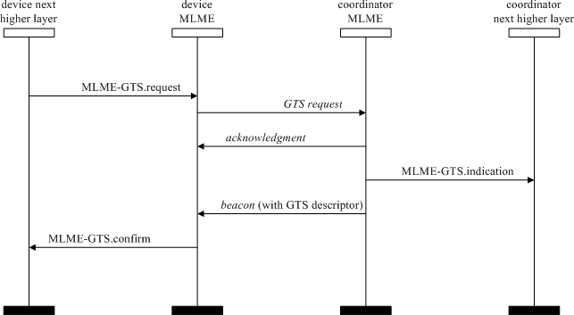

##### Figure 94—Message sequence chart for GTS allocation initiated by a device

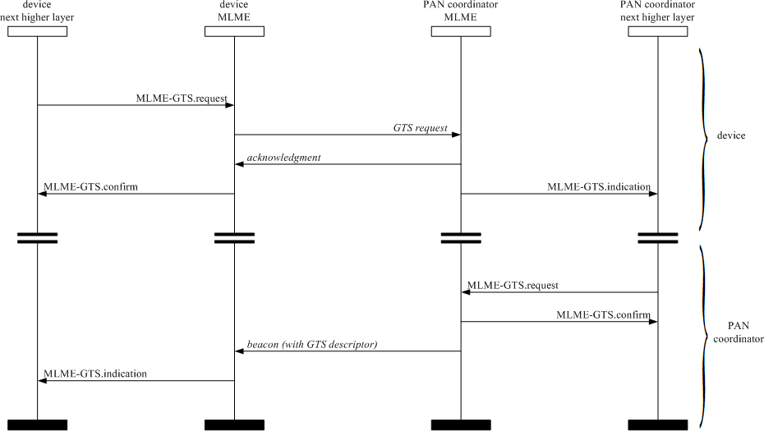

**Figure 95—Message sequence chart for GTS deallocation initiated by a device (a) and the PAN coordinator (b)**

##### Primitives for resetting the MAC sublayer

MLME-SAP reset primitives specify how to reset the MAC sublayer to its default values. All devices shall provide an interface for these reset primitives.

##### MLME-RESET.request

The MLME-RESET.request primitive allows the next higher layer to request that the MLME performs a reset operation.

The semantics of the MLME-RESET.request primitive are as follows:

MLME-RESET.request ( SetDefaultPIB

)

Table 46 specifies the parameter for the MLME-RESET.request primitive.

##### Table 46—MLME-RESET.request parameter

|  |  |  |  |
| --- | --- | --- | --- |
| **Name** | **Type** | **Valid range** | **Description** |
| SetDefaultPIB | Boolean | TRUE or FALSE | If TRUE, the MAC sublayer is reset, and all MAC PIB attributes are set to their default values. If FALSE, the MAC sublayer is reset, but all MAC PIB attributes retain their values prior to the generation of the MLME-RESET.request primitive. |

* + - * 1. **Appropriate usage**

The MLME-RESET.request primitive is generated by the next higher layer and issued to the MLME to request a reset of the MAC sublayer to its initial conditions. The MLME-RESET.request primitive is issued prior to the use of the MLME-START.request or the MLME-ASSOCIATE.request primitives.

##### Effect on receipt

On receipt of the MLME-RESET.request primitive, the MLME issues the PLME-SET-TRX-STATE.request primitive with a state of FORCE_TRX_OFF. On receipt of the PLME-SET-TRX-STATE.confirm primitive, the MAC sublayer is then set to its initial conditions, clearing all internal variables to their default values. If the SetDefaultPIB parameter is set to TRUE, the MAC PIB attributes are set to their default values.

The MLME-RESET.confirm primitive with a status of SUCCESS is issued on completion.

##### MLME-RESET.confirm

The MLME-RESET.confirm primitive reports the results of the reset operation. The semantics of the MLME-RESET.confirm primitive are as follows:

MLME-RESET.confirm ( status

)

Table 47 specifies the parameter for the MLME-RESET.confirm primitive.

##### Table 47—MLME-RESET.confirm parameter

|  |  |  |  |
| --- | --- | --- | --- |
| **Name** | **Type** | **Valid range** | **Description** |
| status | Enumeration | SUCCESS | The result of the reset operation. |

* + - * 1. **When generated**

The MLME-RESET.confirm primitive is generated by the MLME and issued to its next higher layer in response to an MLME-RESET.request primitive and following the receipt of the PLME-SET-TRX- STATE.confirm primitive.

##### Appropriate usage

On receipt of the MLME-RESET.confirm primitive, the next higher layer is notified of its request to reset the MAC sublayer. This primitive returns a status of SUCCESS indicating that the request to reset the MAC sublayer was successful.

##### Primitives for specifying the receiver enable time

MLME-SAP receiver state primitives define how a device can enable or disable the receiver at a given time. These receiver state primitives are optional.

##### MLME-RX-ENABLE.request

The MLME-RX-ENABLE.request primitive allows the next higher layer to request that the receiver is either enabled for a finite period of time or disabled.

The semantics of the MLME-RX-ENABLE.request primitive are as follows:

MLME-RX-ENABLE.request ( DeferPermit, RxOnTime,

RxOnDuration

)

Table 48 specifies the parameters for the MLME-RX-ENABLE.request primitive.

##### Table 48—MLME-RX-ENABLE.request parameters

|  |  |  |  |
| --- | --- | --- | --- |
| **Name** | **Type** | **Valid range** | **Description** |
| DeferPermit | Boolean | TRUE or FALSE | TRUE if the requested operation can be deferred until the next superframe if the requested time has already passed. FALSE if the requested operation is only to be attempted in the current superframe. This parameter is ignored for nonbeacon-enabled OWPANs.  If the issuing device is the OWPAN coordinator, the term *superframe* refers to its own superframe.  Otherwise, the term refers to the superframe of the coordinator through which the issuing device is associated. |

**Table 48—MLME-RX-ENABLE.request parameters *(continued)***

|  |  |  |  |
| --- | --- | --- | --- |
| **Name** | **Type** | **Valid range** | **Description** |
| RxOnTime | Integer | 0x000000–0xffffff | The number of optical clocks measured from the start of the superframe before the receiver is to be enabled or disabled. This is a 24-bit value, and the precision of this value shall be a minimum of 20 bits, with the lowest 4 bits being the least significant. This parameter is ignored for nonbeacon-enabled OWPANs.  If the issuing device is the OWPAN coordinator, the term *superframe* refers to its own superframe.  Otherwise, the term refers to the superframe of the coordinator through which the issuing device is associated. |
| RxOnDuration | Integer | 0x000000–0xffffff | The number of optical clocks for which the receiver is to be enabled.  If this parameter is equal to 0x000000, the receiver is to be disabled. |

##### Appropriate usage

The MLME-RX-ENABLE.request primitive is generated by the next higher layer and issued to the MLME to enable the receiver for a fixed duration, at a time relative to the start of the current or next superframe on a beacon-enabled OWPAN or immediately on a nonbeacon-enabled OWPAN. This primitive may also be generated to cancel a previously generated request to enable the receiver. The receiver is enabled or disabled exactly once per primitive request.

##### Effect on receipt

The MLME will treat the request to enable or disable the receiver as secondary to other responsibilities of the device (e.g., GTSs, coordinator beacon tracking, beacon transmissions). When the primitive is issued to enable the receiver, the device will enable its receiver until either the device has a conflicting responsibility or the time specified by RxOnDuration has expired. In the case of a conflicting responsibility, the device will interrupt the receive operation. After the completion of the interrupting operation, the RxOnDuration will be checked to determine whether the time has expired. If so, the operation is complete. If not, the receiver is re- enabled until either the device has another conflicting responsibility or the time specified by RxOnDuration has expired. When the primitive is issued to disable the receiver, the device will disable its receiver unless the device has a conflicting responsibility.

On a nonbeacon-enabled OWPAN, the MLME ignores the DeferPermit and RxOnTime parameters and requests that the PHY enable or disable the receiver immediately. If the request is to enable the receiver, the receiver will remain enabled until RxOnDuration symbols have elapsed.

Before attempting to enable the receiver on a beacon-enabled OWPAN, the MLME first determines whether (RxOnTime + RxOnDuration) is less than the beacon interval, as defined by *macBeaconOrder*. If (RxOnTime + RxOnDuration) is not less than the beacon interval, the MLME issues the MLME-RX- ENABLE.confirm primitive with a status of ON_TIME_TOO_LONG.

The MLME then determines whether the receiver can be enabled in the current superframe. The OWPAN coordinator issuing this primitive makes the determination based on its own superframe. A device that is not the OWPAN coordinator makes the determination based on the superframe of the coordinator through which it is associated. If the current number of optical clocks measured from the start of the superframe is less than RxOnTime, the MLME attempts to enable the receiver in the current superframe. If the current number of

optical clocks measured from the start of the superframe is greater than or equal to RxOnTime and DeferPermit is equal to TRUE, the MLME defers until the next superframe and attempts to enable the receiver in that superframe. Otherwise, if the MLME cannot enable the receiver in the current superframe and is not permitted to defer the receive operation until the next superframe, the MLME issues the MLME- RX-ENABLE.confirm primitive with a status of PAST_TIME.

If the RxOnDuration parameter is equal to zero, the MLME requests that the PHY disable its receiver.

If any parameter in the MLME-RX-ENABLE.request primitive is not supported or is out of range, the MAC sublayer will issue the MLME-RX-ENABLE.confirm primitive with a status of INVALID_PARAMETER.

If the request to enable or disable the receiver was successful, the MLME issues the MLME-RX- ENABLE.confirm primitive with a status of SUCCESS.

##### MLME-RX-ENABLE.confirm

The MLME-RX-ENABLE.confirm primitive reports the results of the attempt to enable or disable the receiver.

The semantics of the MLME-RX-ENABLE.confirm primitive are as follows:

MLME-RX-ENABLE.confirm ( status

)

Table 49 specifies the parameter for the MLME-RX-ENABLE.confirm primitive.

##### Table 49—MLME-RX-ENABLE.confirm parameter

|  |  |  |  |
| --- | --- | --- | --- |
| **Name** | **Type** | **Valid range** | **Description** |
| status | Enumeration | SUCCESS, PAST_TIME, ON_TIME_TOO_LONG, INVALID_PARAMETER | The result of the request to enable or disable the receiver. |

* + - * 1. **When generated**

The MLME-RX-ENABLE.confirm primitive is generated by the MLME and issued to its next higher layer in response to an MLME-RX-ENABLE.request primitive.

##### Appropriate usage

On receipt of the MLME-RX-ENABLE.confirm primitive, the next higher layer is notified of its request to enable or disable the receiver. This primitive returns a status of either SUCCESS, if the request to enable or disable the receiver was successful, or the appropriate error code. The status values are fully described in 6.3.7.1.2.

##### Message sequence chart for changing the state of the receiver

Figure 96 illustrates the sequence of messages necessary for enabling the receiver for a fixed duration when the device does not have any conflicting responsibilities. Figure 96a) illustrates the case for a beacon- enabled OWPAN where it is assumed both that the MLME-RX-ENABLE.request has been received by the MLME without sufficient time available to enable the receiver in the current superframe and that the DeferPermit parameter is TRUE. Figure 96b) illustrates the case for a nonbeacon-enabled OWPAN where the receiver is enabled immediately.

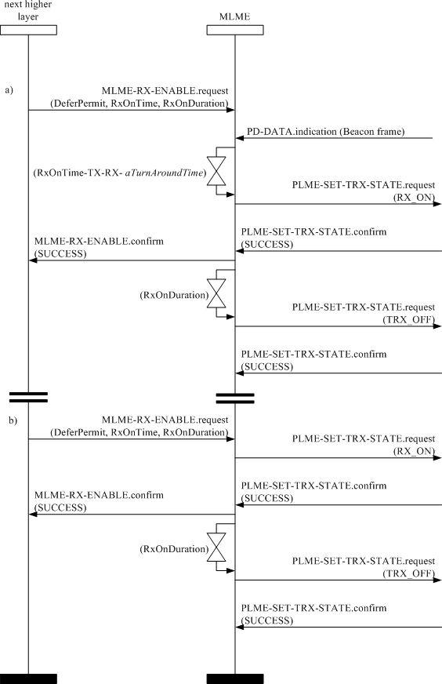

##### Figure 96—Message sequence chart for changing the state of the receiver

##### Primitives for channel scanning

MLME-SAP scan primitives define how a device can determine the energy usage or the presence or absence of OWPANs in a communications channel.

All devices shall provide an interface for these scan primitives.

##### MLME-SCAN.request

The MLME-SCAN.request primitive is used to initiate a channel scan over a given list of channels. A device can use a channel scan to measure the energy on the channel, search for the coordinator with which it associated, or search for all coordinators transmitting beacon frames within the coverage area of the scanning device.

The semantics of the MLME-SCAN.request primitive are as follows:

MLME-SCAN.request ( ScanType,

ScanChannels, ScanDuration, SecurityLevel, KeyIdMode, KeySource, KeyIndex, ColorScan

)

Table 50 specifies the parameters for the MLME-SCAN.request primitive.

##### Table 50—MLME-SCAN.request parameters

|  |  |  |  |
| --- | --- | --- | --- |
| **Name** | **Type** | **Valid range** | **Description** |
| ScanType | Integer | 0x00–0x01 | Indicates the type of scan performed: 0x00 = active scan (optional for a device) 0x01 = passive scan  0x10 = scan-over-backhaul |
| ScanChannels | Bitmap | 8-bit field | The 8 bits (b0, b1,... b7) indicate which channels are to be scanned (1 = scan, 0 = do not scan). |
| ScanDuration | Integer | 0–14 | The time spent scanning each channel is [*aBaseSuperframeDuration*  (2*n* + 1)] optical clocks, where *n* is the value of the ScanDuration parameter. |
| SecurityLevel | Integer | 0x00–0x07 | The security level to be used (as defined in Table 67 in 7.4.2.1). |
| KeyIdMode | Integer | 0x00–0x03 | The mode used to identify the key to be used (as defined in Table 68 in 7.4.2.2). This parameter is ignored if the SecurityLevel parameter is set to 0x00. |
| KeySource | Set of 0, 4,  or 8 octets | As specified by the KeyIdMode parameter | The originator of the key to be used (see 7.4.4.1). This parameter is ignored if the KeyIdMode parameter is ignored or set to 0x00. |

**Table 50—MLME-SCAN.request parameters *(continued)***

|  |  |  |  |
| --- | --- | --- | --- |
| **Name** | **Type** | **Valid range** | **Description** |
| KeyIndex | Integer | 0x01–0xff | The index of the key to be used (see 7.4.4.2). This parameter is ignored if the KeyIdMode parameter is ignored or set to 0x00. |
| ColorScan | Boolean | TRUE or FALSE | ColorScan shall be set as TRUE if the color CVD frame is to be transmitted either during passive scan or after the beacon request command is sent (see 5.1.2.1) for an active scan. |

##### Appropriate usage

The MLME-SCAN.request primitive is generated by the next higher layer and issued to its MLME to initiate a channel scan to search for activity within the coverage area of the device. This primitive can be used to perform an active scan, passive scan, or scan-over-backhaul to locate beacon frames containing any OWPAN identifier. Refer to 5.1.3.1 for a description of each type of scan in detail.

All devices shall be capable of performing passive scans, while active scans are optional for a device. However, a device may support active scanning to participate in a nonbeacon-enabled network.

##### Effect on receipt

If the MLME receives the MLME-SCAN.request primitive while performing a previously initiated scan operation, it issues the MLME-SCAN.confirm primitive with a status of SCAN_IN_PROGRESS. Otherwise, the MLME initiates a scan in all channels specified in the ScanChannels parameter.

The active scan is performed on each channel by the MLME first sending a beacon request command as specified in 5.3.6. The MLME then enables the receiver and records the information contained in each received beacon in a OWPAN descriptor structure as shown in Table 40. The active scan on a particular channel terminates when the number of OWPAN descriptors stored equals an implementation-specified maximum or when [*aBaseSuperframeDuration*  (2*n* + 1)] optical clocks, where *n* is the value of the ScanDuration parameter, have elapsed, whichever comes first. Refer to 5.1.2.1.1 for more detailed information on the active channel scan procedure.

The passive scan is performed on each channel by the MLME enabling its receiver and recording the information contained in each received beacon in a OWPAN descriptor structure as specified in Table 40. The passive scan on a particular channel terminates when the number of OWPAN descriptors stored equals an implementation-specified maximum or when [*aBaseSuperframeDuration*  (2*n* + 1)] optical clocks, where *n* is the value of the ScanDuration parameter, have elapsed, whichever comes first. Refer to 5.1.2.1.2 for more detailed information on the passive channel scan procedure.

The scan-over-backhaul is performed on each channel by the MLME first sending a scan-over-backhaul request command to other coordinators through the backhaul as specified in 6.7.6. The MLME then enables the receiver and records the information contained in each received scan-over-backhaul confirmation command. The scan-over-backhaul on a particular channel terminates when the number of OWPAN descriptors stored equals an implementation-specified maximum or when [*aBaseSuperframeDuration*  (2*n* + 1)] optical clocks, where *n* is the value of the ScanDuration parameter, have elapsed, whichever comes first. Refer to 6.2.2.1.1 for more detailed information on the scan-over-backhaul procedure.

If the SecurityLevel parameter is set to a valid value other than 0x00, indicating that security is required for this frame, the MLME will set the Security Enabled subfield of the Frame Control field to one. The MAC

sublayer will perform outgoing processing on the frame based on *macCoordExtendedAddress*, the SecurityLevel, KeyIdMode, KeySource, and KeyIndex parameters, as described in 7.2.1. If any error occurs during outgoing frame processing, the MLME will discard the frame and issue the MLME-SCAN.confirm primitive with the error status returned by outgoing frame processing.

The results of an active, or passive scan or scan-over-backhaul are reported to the next higher layer through the MLME-SCAN.confirm primitive. If the scan is successful and *macAutoRequest* is set to TRUE, the primitive results will include a set of OWPAN descriptor values. If the scan is successful and *macAutoRequest* is set to FALSE, the primitive results will contain a null set of OWPAN descriptor values; each OWPAN descriptor value will be sent individually to the next higher layer using separate MLME- BEACON-NOTIFY (see 6.3.3.1) primitives. In both cases, the MLME-SCAN.confirm primitive will contain a list of unscanned channels and a status of SUCCESS.

If, during an active scan, the MLME is unable to transmit a beacon request command on a channel specified by the ScanChannels parameter due to a channel access failure, the channel will appear in the list of unscanned channels returned by the MLME-SCAN.confirm primitive. If the MLME was able to send a beacon request command on at least one of the channels but no beacons were found, the MLME- SCAN.confirm primitive will contain a null set of OWPAN descriptor values, regardless of the value of *macAutoRequest*, and a status of NO_BEACON.

If, during an active or passive scan, the implementation-specified maximum is reached thus terminating the scan procedure, the MAC sublayer will issue the MLME-SCAN.confirm primitive with a status of LIMIT_REACHED.

If any parameter in the MLME-SCAN.request primitive is not supported or is out of range, the MAC sublayer will issue the MLME-SCAN.confirm primitive with a status of INVALID_PARAMETER.

##### MLME-SCAN.confirm

The MLME-SCAN.confirm primitive reports the result of the channel scan request. The semantics of the MLME-SCAN.confirm primitive are as follows:

MLME-SCAN.confirm ( status,

ScanType, UnscannedChannels, ResultListSize, OWPANDescriptorList

)

Table 51 specifies the parameters for the MLME-SCAN.confirm primitive.

##### Table 51—MLME-SCAN.confirm parameters

|  |  |  |  |
| --- | --- | --- | --- |
| **Name** | **Type** | **Valid range** | **Description** |
| status | Enumeration | SUCCESS, LIMIT_REACHED, NO_BEACON, SCAN_IN_PROGRESS, COUNTER_ERROR, FRAME_TOO_LONG, UNAVAILABLE_KEY, UNSUPPORTED_SECURITY, INVALID_PARAMETER | The status of the scan request. |

**Table 51—MLME-SCAN.confirm parameters *(continued)***

|  |  |  |  |
| --- | --- | --- | --- |
| **Name** | **Type** | **Valid range** | **Description** |
| ScanType | Integer | 0x00–0x01 | Indicates the type of scan performed: 0x00 = active scan  0x01 = passive scan  0x10 = scan-over-backhaul |
| UnscannedChanne ls | Bitmap | 8-bit field | Indicates which channels given in the request were not scanned (1 = not scanned, 0 = scanned or not requested). |
| ResultListSize | Integer | Implementation specific | The number of elements returned in the appropriate result lists. |
| OWPANDescripto rList | List of OWPAN  descriptor values | Refer to Table 40 | The list of OWPAN descriptors, one for each beacon found during a scan if *macAutoRequest* is set to TRUE. This parameter is null when *macAutoRequest* is set to FALSE during a scan. |

##### When generated

The MLME-SCAN.confirm primitive is generated by the MLME and issued to its next higher layer when the channel scan initiated with the MLME-SCAN.request primitive has completed. If the MLME- SCAN.request primitive requested a scan with *macAutoRequest* set to FALSE, the OWPANDescriptorList parameter will be null.

The MLME-SCAN.confirm primitive returns a status of either SUCCESS, indicating that the requested scan was successful, or the appropriate error code. The status values are fully described in 6.3.8.1.2 and subclauses referenced by 6.3.8.1.2.

##### Appropriate usage

On receipt of the MLME-SCAN.confirm primitive, the next higher layer is notified of the results of the scan procedure. If the requested scan was successful, the status parameter will be set to SUCCESS. Otherwise, the status parameter indicates the error.

##### Channel scan message sequence charts

Figure 109 and Figure 110 (in 6.6) illustrate the sequence of messages necessary to perform a passive scan and an active scan. These figures include steps taken by the PHY.

##### Communication status primitive

The MLME-SAP communication status primitive defines how the MLME communicates to the next higher layer about transmission status, when the transmission was instigated by a response primitive, and about security errors on incoming packets.

All devices shall provide an interface for this communication status primitive.

##### MLME-COMM-STATUS.indication

The MLME-COMM-STATUS.indication primitive allows the MLME to indicate a communications status. The semantics of the MLME-COMM-STATUS.indication primitive are as follows:

MLME-COMM-STATUS.indication (

OWPANId,

SrcAddrMode, SrcAddr, DstAddrMode, DstAddr, status, SecurityLevel, KeyIdMode, KeySource, KeyIndex

)

Table 52 specifies the parameters for the MLME-COMM-STATUS.indication primitive.

##### Table 52—MLME-COMM-STATUS.indication parameters

|  |  |  |  |
| --- | --- | --- | --- |
| **Name** | **Type** | **Valid range** | **Description** |
| OWPANId | Integer | 0x0000–0xffff | The 16-bit OWPAN identifier of the device from which the frame was received or to which the frame was being sent. |
| SrcAddrMode | Integer | 0x00–0x03 | The source addressing mode for this primitive. This value can take one of the following values:  0 = no address (addressing fields omitted)  0x01 = no address field (broadcast only mode with no address fields present)  0x02 = 16-bit short address 0x03 = 64-bit extended address |
| SrcAddr | Device address | As specified by the SrcAddrMode parameter | The individual device address of the entity from which the frame causing the error originated. |
| DstAddrMode | Integer | 0x00–0x03 | The destination addressing mode for this primitive. This value can take one of the following values:  0x00 = no address (addressing fields omitted)  0x01 = reserved  0x02 = 16-bit short address 0x03 = 64-bit extended address |
| DstAddr | Device address | As specified by the DstAddrMode parameter | The individual device address of the device for which the frame was intended. |

|  |  |  |  |
| --- | --- | --- | --- |
| **Name** | **Type** | **Valid range** | **Description** |
| status | Enumeration | SUCCESS, TRANSACTION_OVERFLOW, TRANSACTION_EXPIRED, CHANNEL_ACCESS_FAILURE, NO_ACK, COUNTER_ERROR, FRAME_TOO_LONG, IMPROPER_KEY_TYPE, IMPROPER_SECURITY_LEVEL  , SECURITY_ERROR, UNAVAILABLE_KEY, UNSUPPORTED_LEGACY, UNSUPPORTED_SECURITY, INVALID_PARAMETER | The communications status. |
| SecurityLevel | Integer | 0x00–0x07 | If the primitive was generated following a transmission instigated through a response primitive:  The security level to be used (as defined in Table 67 in 7.4.2.1).  If the primitive was generated on receipt of a frame that generates an error in its security processing:  The security level purportedly used by the received frame (as defined in Table 67 in 7.4.2.1). |
| KeyIdMode | Integer | 0x00–0x03 | If the primitive was generated following a transmission instigated through a response primitive:  The mode used to identify the key to be used (as defined in Table 68 in 7.4.2.2). This parameter is ignored if the SecurityLevel parameter is set to 0x00.  If the primitive was generated on receipt of a frame that generates an error in its security processing:  The mode used to identify the key purportedly used by the originator of the received frame (as defined in Table 68 in 7.4.2.2). This parameter is invalid if the SecurityLevel parameter is set to 0x00. |

|  |  |  |  |
| --- | --- | --- | --- |
| **Name** | **Type** | **Valid range** | **Description** |
| KeySource | Set of 0, 4,  or 8 octets | As specified by the KeyIdMode parameter | If the primitive was generated following a transmission instigated through a response primitive:  The originator of the key to be used (see 7.4.4.1). This parameter is ignored if the KeyIdMode parameter is ignored or set to 0x00.  If the primitive was generated on receipt of a frame that generates an error in its security processing:  The originator of the key purportedly used by the originator of the received frame (see 7.4.4.1). This parameter is invalid if the KeyIdMode parameter is invalid or set to 0x00. |
| KeyIndex | Integer | 0x01–0xff | If the primitive was generated following a transmission instigated through a response primitive:  The index of the key to be used (see 7.4.4.2). This parameter is  ignored if the KeyIdMode parameter is ignored or set to 0x00.  If the primitive was generated on receipt of a frame that generates an error in its security processing:  The index of the key purportedly used by the originator of the received frame (see 7.4.4.2). This parameter is invalid if the KeyIdMode parameter is invalid or set to 0x00. |

* + - * 1. **When generated**

The MLME-COMM-STATUS.indication primitive is generated by the MLME and issued to its next higher layer either following a transmission instigated through a response primitive or on receipt of a frame that generates an error in its security processing (see 7.2.3).

The MLME-COMM-STATUS.indication primitive is generated by the MAC sublayer entity following the MLME-ASSOCIATE.response primitive. This primitive returns a status of either SUCCESS, indicating that the request to transmit was successful, an error code of TRANSACTION_OVERFLOW, TRANSACTION_EXPIRED, CHANNEL_ACCESS_FAILURE, NO_ACK, or INVALID_PARAMETER

(these status values are fully described in 6.3.1.3.2), or an error code resulting from failed security processing (these status values are fully described in 7.2.1 and 7.2.3).

##### Appropriate usage

On receipt of the MLME-COMM-STATUS.indication primitive, the next higher layer is notified of the communication status of a transmission or notified of an error that has occurred during the secure processing of incoming frame.

##### Primitives for writing PIB attributes

MLME-SAP set primitives define how PIB attributes may be written. All devices shall provide an interface for these set primitives.

##### MLME-SET.request

The MLME-SET.request primitive attempts to write the given value to the indicated PIB attribute.

##### Semantics of the primitive

The semantics of the MLME-SET.request primitive are as follows:

MLME-SET.request ( PIBAttribute,

PIBAttributeIndex, PIBAttributeValue

)

Table 53 specifies the parameters for the MLME-SET.request primitive.

##### Table 53—MLME-SET.request parameters

|  |  |  |  |
| --- | --- | --- | --- |
| **Name** | **Type** | **Valid range** | **Description** |
| PIBAttribute | Integer | Refer to Table 62 and Table 69 | The identifier of the PIB attribute to write. |
| PIBAttributeIndex | Integer | Attribute specific; as defined in Table 62 and  Table 69 | The index within the table of the specified PIB attribute to write. This parameter is valid only for MAC PIB attributes that are tables; it is ignored when accessing PHY PIB attributes. |
| PIBAttributeValue | Various | Attribute specific; as defined in Table 62 and  Table 69 | The value to write to the indicated PIB attribute. |

* + - * 1. **Appropriate usage**

The MLME-SET.request primitive is generated by the next higher layer and issued to its MLME to write the indicated PIB attribute.

##### Effect on receipt

On receipt of the MLME-SET.request primitive, the MLME checks to see if the PIB attribute is a MAC PIB attribute or PHY PIB attribute. If the requested attribute is a MAC attribute, the MLME attempts to write the given value to the indicated MAC PIB attribute in its database. If the PIBAttribute parameter specifies an attribute that is a read-only attribute, shown in Table 62, the MLME will issue the MLME-SET.confirm primitive with a status of READ_ONLY. If the PIBAttribute parameter specifies an attribute that is not found in the database, the MLME will issue the MLME-SET.confirm primitive with a status of UNSUPPORTED_ATTRIBUTE. If the PIBAttributeIndex parameter specifies an index for a table that is out of range, the MLME will issue the MLME-SET.confirm primitive with a status of INVALID_INDEX. If the

PIBAttributeValue parameter specifies a value that is out of the valid range for the given attribute, the MLME will issue the MLME-SET.confirm primitive with a status of INVALID_PARAMETER. If the requested MAC PIB attribute is successfully written, the MLME will issue the MLME-SET.confirm primitive with a status of SUCCESS.

If the PIBAttribute parameter indicates that *macBeaconPayloadLength* is to be set and the length of the resulting beacon frame exceeds *aMaxPHYFrameSize* (e.g., due to the additional overhead required for security processing), the MAC sublayer shall not update *macBeaconPayloadLength* and will issue the MLME-GET.confirm primitive with a status of INVALID_PARAMETER.

If the requested attribute is a PHY PIB attribute, the request is passed to the PHY by issuing the PLME- SET.request primitive. Once the MLME receives the PLME-SET.confirm primitive, it will translate the received status value because the status values used by the PHY are not the same as those used by the MLME (e.g., the status values for SUCCESS are 0x00 and 0x07 in the MAC and PHY enumeration tables, respectively). Following the translation, the MLME will issue the MLME-SET.confirm primitive to the next higher layer with the status parameter resulting from the translation and the PIBAttribute parameter equal to that returned by the PLME primitive.

##### MLME-SET.confirm

The MLME-SET.confirm primitive reports the results of an attempt to write a value to a PIB attribute. The semantics of the MLME-SET.confirm primitive are as follows:

MLME-SET.confirm ( status,

PIBAttribute, PIBAttributeIndex

)

Table 54 specifies the parameters for the MLME-SET.confirm primitive.

##### Table 54—MLME-SET.confirm parameters

|  |  |  |  |
| --- | --- | --- | --- |
| **Name** | **Type** | **Valid range** | **Description** |
| status | Enumeration | SUCCESS, READ_ONLY, UNSUPPORTED_ATTRIBUTE, INVALID_INDEX, INVALID_PARAMETER | The result of the request to write the PIB attribute. |
| PIBAttribute | Integer | Refer to Table 62 and Table 69 | The identifier of the PIB attribute that was written. |
| PIBAttributeIndex | Integer | Attribute specific;  as defined in Table 62 and Table 69 | The index within the table of the specified PIB attribute to write. This parameter is valid only for MAC PIB attributes that are tables; it is ignored when accessing PHY PIB attributes. |

* + - * 1. **When generated**

The MLME-SET.confirm primitive is generated by the MLME and issued to its next higher layer in response to an MLME-SET.request primitive. The MLME-SET.confirm primitive returns a status of either

SUCCESS, indicating that the requested value was written to the indicated PIB attribute, or the appropriate error code. The status values are fully described in 6.3.10.1.3.

##### Appropriate usage

On receipt of the MLME-SET.confirm primitive, the next higher layer is notified of the result of its request to set the value of a PIB attribute. If the requested value was written to the indicated PIB attribute, the status parameter will be set to SUCCESS. Otherwise, the status parameter indicates the error.

##### Primitives for updating the superframe configuration

MLME-SAP start primitives define how a coordinator can request to start using a new superframe configuration in order to initiate a OWPAN, begin transmitting beacons on an already existing OWPAN, thus facilitating device discovery, or to stop transmitting beacons.

These start primitives are optional for a device.

##### MLME-START.request

The MLME-START.request primitive allows the OWC coordinator to initiate a new OWPAN or to begin using a new superframe configuration. This primitive may also be used by a device already associated with an existing OWPAN to begin using a new superframe configuration.

The semantics of the MLME-START.request primitive are as follows:

MLME-START.request ( OWPANId,

LogicalChannel, StartTime, BeaconOrder, SuperframeOrder, OWPANCoordinator, CoordRealignment,

CoordRealignSecurityLevel, CoordRealignKeyIdMode, CoordRealignKeySource, CoordRealignKeyIndex, BeaconSecurityLevel, BeaconKeyIdMode, BeaconKeySource, BeaconKeyIndex

)

Table 55 specifies the parameters for the MLME-START.request primitive.

##### Table 55—MLME-START.request parameters

|  |  |  |  |
| --- | --- | --- | --- |
| **Name** | **Type** | **Valid range** | **Description** |
| OWPANId | Integer | 0x0000–0xffff | The OWPAN identifier to be used by the device. |
| LogicalChannel | Integer | Selected from the available logical channels | The logical channel on which to start using the new superframe configuration. |

|  |  |  |  |
| --- | --- | --- | --- |
| **Name** | **Type** | **Valid range** | **Description** |
| StartTime | Integer | 0x000000–0xffffff | The time at which to begin transmitting beacons. If this parameter is equal to 0x000000, beacon transmissions will begin immediately. Otherwise, the specified time is relative to the received beacon of the coordinator with which the device synchronizes.  This parameter is ignored if either the BeaconOrder parameter has a value of 15 or the OWPANCoordinator parameter is TRUE.  The time is specified in optical clocks and is rounded to a backoff slot boundary. This is a 24-bit value, and the precision of this value shall be a minimum of 20 bits, with the lowest 4 bits being the least significant. |
| BeaconOrder | Integer | 0–15 | How often the beacon is to be transmitted. A value of 15 indicates that the coordinator will not transmit periodic beacons.  Refer to 5.1.1.1 for an explanation of the relationship between the beacon order and the beacon interval. |
| SuperframeOrder | Integer | 0–*BO* or 15 | The length of the active portion of the superframe, including the beacon frame. If the BeaconOrder parameter (*BO*) has a value of 15, this parameter is ignored.  Refer to 5.1.1.1 for an explanation of the relationship between the superframe order and the superframe duration. |
| OWPANCoordinat or | Boolean | TRUE or FALSE | If this value is TRUE, the device will become the coordinator of a new OWPAN. If this value is FALSE, the device will begin using a new superframe configuration on the OWPAN with which it is associated. |
| CoordRealignment | Boolean | TRUE or FALSE | TRUE if a coordinator realignment command is to be transmitted prior to changing the superframe configuration or FALSE otherwise. |
| CoordRealignSecu rityLevel | Integer | 0x00–0x07 | The security level to be used for coordinator realignment command frames (as defined in Table 67 in 7.4.2.1). |
| CoordRealignKeyI dMode | Integer | 0x00–0x03 | The mode used to identify the key to be used (as defined in Table 68 in 7.4.2.2). This parameter is ignored if the CoordRealignSecurityLevel parameter is set to 0x00. |
| CoordRealignKey Source | Set of 0, 4, or  8 octets | As specified by the CoordRealignKeyI dMode parameter | The originator of the key to be used (see 7.4.4.1). This parameter is ignored if the CoordRealignKeyIdMode parameter is ignored or set to 0x00. |
| CoordRealignKeyI ndex | Integer | 0x01–0xff | The index of the key to be used (see 7.4.4.2). This parameter is ignored if the CoordRealignKeyIdMode parameter is ignored or set to 0x00. |
| BeaconSecurityLe vel | Integer | 0x00–0x07 | The security level to be used for beacon frames (as defined in Table 67 in 7.4.2.1). |

|  |  |  |  |
| --- | --- | --- | --- |
| **Name** | **Type** | **Valid range** | **Description** |
| BeaconKeyIdMod e | Integer | 0x00–0x03 | The mode used to identify the key to be used (as defined in Table 68 in 7.4.2.2). This parameter is ignored if the BeaconSecurityLevel parameter is set to 0x00. |
| BeaconKeySource | Set of 0, 4, or  8 octets | As specified by the BeaconKeyIdMod e parameter | The originator of the key to be used (see 7.4.4.1). This parameter is ignored if the BeaconKeyIdMode parameter is ignored or set to 0x00. |
| BeaconKeyIndex | Integer | 0x01–0xff | The index of the key to be used (see 7.4.4.2). This parameter is ignored if the BeaconKeyIdMode parameter is ignored or set to 0x00. |

* + - * 1. **Appropriate usage**

The MLME-START.request primitive is generated by the next higher layer and issued to its MLME to request that a device start using a new superframe configuration.

##### Effect on receipt

If the MLME-START.request primitive is received when *macShortAddress* is set to 0xffff, the MLME will issue the MLME-START.confirm primitive with a status of NO_SHORT_ADDRESS.

When the CoordRealignment parameter is set to TRUE, the coordinator attempts to transmit a coordinator realignment command frame as described in 5.1.3.3. If the transmission of the coordinator realignment command fails due to a channel access failure, the MLME will not make any changes to the superframe configuration (i.e., no PIB attributes will be changed) and will issue an MLME-START.confirm with a status of CHANNEL_ACCESS_FAILURE. If the coordinator realignment command is successfully transmitted, the MLME updates the appropriate PIB parameters with the values of the BeaconOrder, SuperframeOrder, OWPANId, and LogicalChannel parameters, as described in 5.1.3.5, and will issue an MLME- START.confirm with a status of SUCCESS.

When the CoordRealignment parameter is set to FALSE, the MLME updates the appropriate PIB parameters with the values of the BeaconOrder, SuperframeOrder, OWPANId, and LogicalChannel parameters, as described in 5.1.3.5.

The address used by the coordinator in its beacon frames is determined by the current value of

*macShortAddress*, which is set by the next higher layer before issuing this primitive.

If the SecurityLevel parameter is set to a valid value other than 0x00, indicating that security is required for this frame, the MLME will set the Security Enabled subfield of the Frame Control field to one. The MAC sublayer will perform outgoing processing on the frame, as described in 7.2.1. If the CoordRealignment parameter is set to TRUE, the CoordRealignSecurityLevel, CoordRealignKeyIdMode, CoordRealignKeySource, and CoordRealignKeyIndex parameters will be used to process the MAC command frame. If the BeaconOrder parameter indicates a beacon-enabled network, the BeaconSecurityLevel, BeaconKeyIdMode, BeaconKeySource, and BeaconKeyIndex parameters will be used to process the beacon frame. If any error occurs during outgoing frame processing, the MLME will discard the frame and issue the MLME-START.confirm primitive with the error status returned by outgoing frame processing.

If the length of the beacon frame exceeds *aMaxPHYFrameSize* (e.g., due to the additional overhead required for security processing), the MAC sublayer shall discard the beacon frame and issue the MLME- START.confirm primitive with a status of FRAME_TOO_LONG.

The MLME shall ignore the StartTime parameter if the BeaconOrder parameter is equal to 15 because this indicates a nonbeacon-enabled OWPAN. If the BeaconOrder parameter is less than 15, the MLME examines the StartTime parameter to determine the time to begin transmitting beacons; the time is defined in optical clocks and is rounded to a backoff slot boundary. If the OWC coordinator parameter is set to TRUE, the MLME ignores the StartTime parameter and begins beacon transmissions immediately. Setting the StartTime parameter to 0x000000 also causes the MLME to begin beacon transmissions immediately. If the OWPANCoordinator parameter is set to FALSE and the StartTime parameter is nonzero, the MLME calculates the beacon transmission time by adding StartTime optical clocks to the time, obtained from the local clock, when the MLME receives the beacon of the coordinator through which it is associated. If the time calculated causes the outgoing superframe to overlap the incoming superframe, the MLME shall not begin beacon transmissions. In this case, the MLME issues the MLME-START.confirm primitive with a status of SUPERFRAME_OVERLAP. Otherwise, the MLME then begins beacon transmissions when the current time, obtained from the local clock, equals the number of calculated optical clocks.

If the StartTime parameter is nonzero and the MLME is not currently tracking the beacon of the coordinator through which it is associated, the MLME will issue the MLME-START.confirm primitive with a status of TRACKING_OFF.

On completion of this procedure, the MLME responds with the MLME-START.confirm primitive. If the attempt to start using a new superframe configuration was successful, the status parameter will be set to SUCCESS. If any parameter is not supported or is out of range, the status parameter will be set to INVALID_PARAMETER.

##### MLME-START.confirm

The MLME-START.confirm primitive reports the results of the attempt to start using a new superframe configuration.

The semantics of the MLME-START.confirm primitive are as follows:

MLME-START.confirm ( status

)

Table 56 specifies the parameters for the MLME-START.confirm primitive.

##### Table 56—MLME-START.confirm parameters

|  |  |  |  |
| --- | --- | --- | --- |
| **Name** | **Type** | **Valid range** | **Description** |
| status | Enumeration | SUCCESS, NO_SHORT_ADDRESS, SUPERFRAME_OVERLAP, TRACKING_OFF, INVALID_PARAMETER, COUNTER_ERROR, FRAME_TOO_LONG, UNAVAILABLE_KEY, UNSUPPORTED_SECURITY, CHANNEL_ACCESS_FAILURE | The result of the attempt to start using an updated superframe configuration. |

* + - * 1. **When generated**

The MLME-START.confirm primitive is generated by the MLME and issued to its next higher layer in response to an MLME-START.request primitive. The MLME-START.confirm primitive returns a status of either SUCCESS, indicating that the MAC sublayer has started using the new superframe configuration, or the appropriate error code. The status values are fully described in 6.3.11.1.2 and subclauses referenced by 6.3.11.1.2.

##### Appropriate usage

On receipt of the MLME-START.confirm primitive, the next higher layer is notified of the result of its request to start using a new superframe configuration. If the MAC sublayer has been successful, the status parameter will be set to SUCCESS. Otherwise, the status parameter indicates the error.

##### Message sequence chart for updating the superframe configuration

Figure 97 illustrates the sequence of messages necessary for initiating beacon transmissions as a coordinator. Figure 106 illustrates the sequence of messages necessary for the OWC coordinator to start beaconing on a new OWPAN; this figure includes steps taken by the PHY.

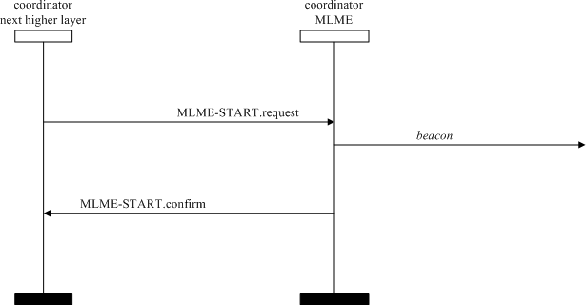

##### Figure 97—Message sequence chart for updating the superframe configuration

##### Primitive for synchronizing with a coordinator

MLME-SAP synchronization primitives define how synchronization with a coordinator may be achieved and how a loss of synchronization is communicated to the next higher layer.

All devices shall provide an interface for the indication primitive. The request primitive is optional.

##### MLME-SYNC.request

The MLME-SYNC.request primitive requests to synchronize with the coordinator by acquiring and, if specified, tracking its beacons.

The semantics of the MLME-SYNC.request primitive are as follows:

MLME-SYNC.request ( LogicalChannel, TrackBeacon

)

Table 57 specifies the parameters for the MLME-SYNC.request primitive.

##### Table 57—MLME-SYNC.request parameters

|  |  |  |  |
| --- | --- | --- | --- |
| **Name** | **Type** | **Valid range** | **Description** |
| LogicalChannel | Integer | Selected from the available logical channels supported by the PHY | The logical channel on which to attempt coordinator synchronization. |
| TrackBeacon | Boolean | TRUE or FALSE | TRUE if the MLME is to synchronize with the next beacon and attempt to track all future beacons. FALSE if the MLME is to synchronize with only the next beacon. |

* + - * 1. **Appropriate usage**

The MLME-SYNC.request primitive is generated by the next higher layer of a device on a beacon-enabled OWPAN and issued to its MLME to synchronize with the coordinator.

##### Effect on receipt

If the MLME-SYNC.request primitive is received by the MLME on a beacon-enabled OWPAN, it will first set *phyCurrentChannel* equal to the values of the LogicalChannel parameters, respectively; both attributes are updated by issuing the PLME-SET.request primitive. If the TrackBeacon parameter is equal to TRUE, the MLME will track the beacon, i.e., enable its receiver just before the expected time of each beacon so that the beacon frame can be processed. If the TrackBeacon parameter is equal to FALSE, the MLME will locate the beacon, but not continue to track it.

If this primitive is received by the MLME while it is currently tracking the beacon, the MLME will not discard the primitive, but rather treat it as a new synchronization request.

If the beacon could not be located either on its initial search or during tracking, the MLME will issue the MLME-SYNC-LOSS.indication primitive with a loss reason of BEACON_LOST.

##### Primitive for synchronization loss with a coordinator

* + - 1. **MLME-SYNC-LOSS.indication**

The MLME-SYNC-LOSS.indication primitive indicates the loss of synchronization with a coordinator. The semantics of the MLME-SYNC-LOSS.indication primitive are as follows:

MLME-SYNC-LOSS.indication (

LossReason, OWPANId,

LogicalChannel, SecurityLevel, KeyIdMode, KeySource, KeyIndex

)

Table 58 specifies the parameters for the MLME-SYNC-LOSS.indication primitive.

##### Table 58—MLME-SYNC-LOSS.indication parameters

|  |  |  |  |
| --- | --- | --- | --- |
| **Name** | **Type** | **Valid range** | **Description** |
| LossReason | Enumeration | OWPAN_ID_CONFLICT, REALIGNMENT, BEACON_LOST | The reason that synchronization was lost. |
| OWPANId | Integer | 0x0000–0xffff | The OWPAN identifier with which the device lost synchronization or to which it was realigned. |
| LogicalChannel | Integer | Selected from the available logical channels supported by the PHY (see Table 80). | The logical channel on which the device lost synchronization or to which it was realigned. |
| SecurityLevel | Integer | 0x00–0x07 | If the primitive was either generated by the device itself following loss of synchronization or generated by the coordinator upon detection of a OWPAN ID conflict, the security level is set to 0x00.  If the primitive was generated following the reception of either a coordinator realignment command or a OWPAN ID conflict notification command:  The security level purportedly used by the received MAC frame (as defined in Table 67 in 7.4.2.1). |

**Table 58—MLME-SYNC-LOSS.indication parameters *(continued)***

|  |  |  |  |
| --- | --- | --- | --- |
| **Name** | **Type** | **Valid range** | **Description** |
| KeyIdMode | Integer | 0x00–0x03 | If the primitive was either generated by the device itself following loss of synchronization or generated by the coordinator upon detection of a OWPAN ID conflict, this parameter is ignored.  If the primitive was generated following the reception of either a coordinator realignment command or a OWPAN ID conflict notification command:  The mode used to identify the key purportedly used by the originator of the received frame (as defined in Table 68 in 7.4.2.2). This parameter is invalid if the SecurityLevel parameter is set to 0x00. |
| KeySource | Set of 0, 4,  or 8 octets | As specified by the KeyIdMode parameter | If the primitive was either generated by the device itself following loss of synchronization or generated by the coordinator upon detection of a OWPAN ID conflict, this parameter is ignored.  If the primitive was generated following the reception of either a coordinator realignment command or a OWPAN ID conflict notification command:  The originator of the key purportedly used by the originator of the received frame  (see 7.4.4.1). This parameter is invalid if the KeyIdMode parameter is invalid or set to 0x00. |
| KeyIndex | Integer | 0x01–0xff | If the primitive was either generated by the device itself following loss of synchronization or generated by the coordinator upon detection of a OWPAN ID conflict, this parameter is ignored.  If the primitive was generated following the reception of either a coordinator realignment command or a OWPAN ID conflict notification command:  The index of the key purportedly used by the originator of the received frame (see 7.4.4.2). This parameter is invalid if the KeyIdMode parameter is invalid or set to 0x00. |

* + - 1. **Message sequence chart for synchronizing with a coordinator**

Figure 98 illustrates the sequence of messages necessary for a device to synchronize with a coordinator. In Figure 98a), a single synchronization request is issued. The MLME then searches for a beacon and, if found, determines whether the coordinator has any data pending for the device. If so, the data are requested as described in 5.1.7.3. In Figure 98b), a track synchronization request is issued. The MLME then searches for

a beacon and, if found, attempts to keep track of it using a timer that expires just before the expected time of the next beacon.

For both examples Figure 98a) and Figure 98b), the received beacon frames do not contain payload, and *macAutoRequest* is set to TRUE. The MLME also checks for any data pending in the coordinator for the device when a beacon frame is received.

device next higher layer

device MLME

coordinator MLME

single synchronization request

a)

MLME-SYNC.request(FALSE)

*beacon frame(with data pending)*

*data request*

track synchronization request

MLME-SYNC.request(TRUE)

*beacon*

*timer to expire before the next*

*beacon*

*beacon*

b)

##### Figure 98—Message sequence chart for synchronizing to a coordinator in a beacon- enabled OWPAN

* + - * 1. **When generated**

The MLME-SYNC-LOSS.indication primitive is generated by the MLME of a device and issued to its next higher layer in the event of a loss of synchronization with the coordinator. It is also generated by the MLME of the OWC coordinator and issued to its next higher layer in the event of a OWPAN ID conflict.

If a device that is associated through the OWC coordinator has detected a OWPAN identifier conflict and communicated it to the OWC coordinator, the MLME will issue this primitive with the LossReason parameter set to OWPAN_ID_CONFLICT. Similarly, if the OWC coordinator receives a OWPAN ID conflict notification command, as specified in 5.3.5, the MLME will issue this primitive with the LossReason parameter set to OWPAN_ID_CONFLICT.

If a device has received the coordinator realignment command, specified in 5.3.7, from the coordinator through which it is associated, the MLME will issue this primitive with the LossReason parameter set to

REALIGNMENT and the OWPANId, LogicalChannel, and security-related parameters set as described in 5.1.3.4.

If a device has not heard the beacon for *aMaxLostBeacons* consecutive superframes following an MLME- SYNC.request primitive, either initially or during tracking, the MLME will issue this primitive with the LossReason parameter set to BEACON_LOST. The OWPANId, LogicalChannel parameters shall be set according to the coordinator with which synchronization was lost. The SecurityLevel parameter shall be set to zero and the KeyIdMode, KeySource, and KeyIndex parameters shall be ignored. If the beacon was being tracked, the MLME will not attempt to track the beacon any further.

##### Appropriate usage

On receipt of the MLME-SYNC-LOSS.indication primitive, the next higher layer is notified of a loss of synchronization.

##### Primitives for requesting data from a coordinator

MLME-SAP polling primitives define how to request data from a coordinator. All devices shall provide an interface for these polling primitives.

##### MLME-POLL.request

The MLME-POLL.request primitive prompts the device to request data from the coordinator. The semantics of the MLME-POLL.request primitive are as follows:

MLME-POLL.request ( CoordAddrMode, CoordOWPANId, CoordAddress, SecurityLevel, KeyIdMode, KeySource, KeyIndex

)

Table 59 specifies the parameter for the MLME-POLL.request primitive.

##### Table 59—MLME-POLL.request parameters

|  |  |  |  |
| --- | --- | --- | --- |
| **Name** | **Type** | **Valid range** | **Description** |
| CoordAddrMode | Integer | 0x02–0x03 | The addressing mode of the coordinator to which the poll is intended. This parameter can take one of the following values:  2 = 16-bit short address  3 = 64-bit extended address |
| CoordOWPANId | Integer | 0x0000–0xfffe | The OWPAN identifier of the coordinator to which the poll is intended. |

**Table 59—MLME-POLL.request parameters *(continued)***

|  |  |  |  |
| --- | --- | --- | --- |
| **Name** | **Type** | **Valid range** | **Description** |
| CoordAddress | Device- Address | As specified by the CoordAddrMode parameter | The address of the coordinator to which the poll is intended. |
| SecurityLevel | Integer | 0x00–0x07 | The security level to be used (as defined in Table 67 in 7.4.2.1). |
| KeyIdMode | Integer | 0x00–0x03 | The mode used to identify the key to be used (as defined in Table 68 in 7.4.2.2). This parameter is ignored if the SecurityLevel parameter is set to 0x00. |
| KeySource | Set of 0, 4, or  8 octets | As specified by the KeyIdMode parameter | The originator of the key to be used (see 7.4.4.1). This parameter is ignored if the KeyIdMode parameter is ignored or set to 0x00. |
| KeyIndex | Integer | 0x01–0xff | The index of the key to be used (see 7.4.4.2). This parameter is ignored if the KeyIdMode parameter is ignored or set to 0x00. |

##### Appropriate usage

The MLME-POLL.request primitive is generated by the next higher layer and issued to its MLME when data are to be requested from a coordinator.

##### Effect on receipt

On receipt of the MLME-POLL.request primitive, the MLME generates and sends a data request command, as specified in 5.3.4. If the poll is directed to the coordinator, the data request command may be generated without any destination address information present. Otherwise, the data request command is always generated with the destination address information in the CoordOWPANId and CoordAddress parameters.

If the SecurityLevel parameter is set to a valid value other than 0x00, indicating that security is required for this frame, the MLME will set the Security Enabled subfield of the Frame Control field to one. The MAC sublayer will perform outgoing processing on the frame based on the CoordAddress, SecurityLevel, KeyIdMode, KeySource, and KeyIndex parameters, as described in 7.2.1. If any error occurs during outgoing frame processing, the MLME will discard the frame and issue the MLME-POLL.confirm primitive with the error status returned by outgoing frame processing.

If the data request command cannot be sent due to an unslotted random access algorithm failure, the MLME will issue the MLME-POLL.confirm primitive with a status of CHANNEL_ACCESS_FAILURE.

If the MLME successfully transmits a data request command, the MLME will expect an acknowledgment in return. If an acknowledgment is not received, the MLME will issue the MLME-POLL.confirm primitive with a status of NO_ACK (see 5.1.7.4).

If an acknowledgment is received, the MLME will request that the PHY enable its receiver if the Frame Pending subfield of the acknowledgment frame is set to one. If the Frame Pending subfield of the acknowledgment frame is set to zero, the MLME will issue the MLME-POLL.confirm primitive with a status of NO_DATA.

If a frame is received from the coordinator with a zero length payload or if the frame is a MAC command frame, the MLME will issue the MLME-POLL.confirm primitive with a status of NO_DATA. If a frame is received from the coordinator with nonzero length payload, the MLME will issue the MLME- POLL.confirm primitive with a status of SUCCESS. In this case, the actual data are indicated to the next higher layer using the MCPS-DATA.indication primitive as specified in 6.2.3.

If a frame is not received within *macMaxFrameTotalWaitTime* CAP optical clocks in a beacon-enabled OWPAN, or optical clocks in a nonbeacon-enabled OWPAN, even though the acknowledgment to the data request command has its Frame Pending subfield set to one, the MLME will issue the MLME- POLL.confirm primitive with a status of NO_DATA.

If any parameter in the MLME-POLL.request primitive is not supported or is out of range, the MLME will issue the MLME-POLL.confirm primitive with a status of INVALID_PARAMETER.

##### MLME-POLL.confirm

The MLME-POLL.confirm primitive reports the results of a request to poll the coordinator for data. The semantics of the MLME-POLL.confirm primitive are as follows:

MLME-POLL.confirm (

status

)

Table 60 specifies the parameters for the MLME-POLL.confirm primitive.

##### Table 60—MLME-POLL.confirm parameters

|  |  |  |  |
| --- | --- | --- | --- |
| **Name** | **Type** | **Valid range** | **Description** |
| status | Integer | SUCCESS, CHANNEL_ACCESS_FAILURE, NO_ACK, NO_DATA, COUNTER_ERROR, FRAME_TOO_LONG, UNAVAILABLE_KEY, UNSUPPORTED_SECURITY, INVALID_PARAMETER | The status of the data request. |

* + - * 1. **When generated**

The MLME-POLL.confirm primitive is generated by the MLME and issued to its next higher layer in response to an MLME-POLL.request primitive. If the request was successful, the status parameter will be equal to SUCCESS, indicating a successful poll for data. Otherwise, the status parameter indicates the appropriate error code. The status values are fully described in 6.3.14.1.2 and the subclauses referenced by 6.3.14.1.2.

##### Appropriate usage

On receipt of the MLME-POLL.confirm primitive, the next higher layer is notified of the status of the procedure to request data from the coordinator.

##### Message sequence chart for requesting data from a coordinator

Figure 99 illustrates the sequence of messages necessary, including the layer behavior of the device and the over-the-air interface, for a device to request data from a coordinator.

In both scenarios Figure 99a) and Figure 99b), a poll request is issued to the MLME, which then sends a data request command to the coordinator. In Figure 99a), the corresponding acknowledgment has the frame pending (FP) subfield set to zero and the MLME issues the poll request confirmation immediately. In Figure 99b), the corresponding acknowledgment has the Frame Pending subfield set to one and the MLME enables the receiver in anticipation of the data frame from the coordinator. On receipt of this data frame, the MLME issues a poll request confirmation followed by a data indication containing the data of the received frame.

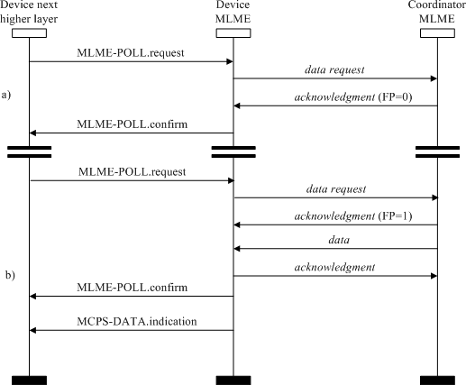

##### Figure 99—Message sequence chart for requesting data from a coordinator

#### MAC constants and PIB attributes

This subclause specifies the constants and attributes required by the MAC sublayer.

##### MAC constants

The constants that define the characteristics of the MAC sublayer are presented in Table 61.

##### Table 61—MAC sublayer constants

|  |  |  |
| --- | --- | --- |
| **Constant** | **Description** | **Value** |
| *aBaseSlotDuration* | The number of optical clocks forming a superframe slot when the superframe order is equal to 0 (see 5.1.1.1). | 60 |
| *aBaseSuperframeDuration* | The number of optical clocks forming a superframe when the superframe order is equal to 0. | *aBaseSlotDuration*   aNumSuperframeSlots |
| *aExtendedAddress* | The 64-bit extended address (EUI-64) assigned to the device. | Device specific |
| *aGTSDescPersistenceTime* | The number of superframes in which a GTS descriptor exists in the beacon frame of the coordinator. | 4 |
| *aMaxBeaconOverhead* | The maximum number of octets added by the MAC sublayer to the MAC Payload of a beacon frame. | 75 |
| *aMaxBeaconPayloadLength* | The maximum size, in octets, of a beacon payload. | *aMaxPHYFrameSize* –  *aMaxBeaconOverhead* |
| *aMaxLostBeacons* | The number of consecutive lost beacons that will cause the MAC sublayer of a receiving device to declare a loss of synchronization. | 4 |
| *aMaxMACPayloadSize* | The maximum number of octets that can be transmitted in the MSDU field. | *aMaxPHYFrameSize* –  *aMinMPDUOverhead* |
| *aMaxMPDUUnsecuredOverhead* | The maximum number of octets added by the MAC sublayer to the PSDU without security. | 25 |
| *aMaxSIFSFrameSize* | The maximum size of an MPDU, in octets, that can be followed by a SIFS period. | 18 |
| *aMinCAPLength* | The minimum number of optical clocks forming the CAP. This determines that MAC commands can still be transferred to devices when GTSs are being used.  An exception to this minimum shall be allowed for the accommodation of the temporary increase in the beacon frame length needed to perform GTS maintenance (as defined in 5.2.2.1.3). | 440 |
| *aMinMPDUOverhead* | The minimum number of octets added by the MAC sublayer to the PSDU. | PHY I, PHY II, and PHY III: 9 PHY IV: 0/2  PHY V and PHY VI: 7/9 |
| *aNumSuperframeSlots* | The number of slots contained in any superframe. | 16 |
| *aUnitBackoffPeriod* | The number of optical clocks forming the basic time period used by the unslotted random access algorithm. | 20 |

##### MAC PIB attributes

The MAC PIB comprises the attributes required to manage the MAC sublayer of a device. The attributes contained in the MAC PIB are presented in Table 62 and Table 69. Attributes marked with a dagger (†) are read-only attributes (i.e., attribute can only be set by the MAC sublayer), which can be read by the next higher layer using the MLME-GET.request primitive. All other attributes can be read or written by the next higher layer using the MLME-GET.request or MLME-SET.request primitives, respectively. Higher layers may impose additional constraints on read/write operations, without making devices non-compliant. Attributes marked with a diamond () are optional for a device (i.e., not operating as a coordinator).

The read-only attribute *macAckWaitDuration* is dependent on a combination of constants and PHY PIB attributes. The formula for relating the constants and attributes is shown in Equation (1).

*AckWaitTime* =*backoff period + aTurnaroundTime-RX-TX + clock period*  *numSymAckFrame* (1)

where numSymAckFrame is the number of bits in the acknowledgment frame and is equal to 103 for PHY I and PHY II and to 111 for PHY III. For B-ACK mode, the AckWaitTime would be larger, depending on the number of acknowledgments in the B-ACK mode as explained in 5.2.2.2. The clock period is obtained via the optical rates specified in Table 76, Table 77, and Table 78.

The attribute *macMaxFrameTotalWaitTime* may be set by the next higher layer and is dependent upon a combination of PHY and MAC PIB attributes and constants. The formula relating the attributes and constants is shown in Equation (2).

*macMaxFrameTotalWaitTime* = (2)

*m* – 1 

  2*macMinBE* + *k* + 2*macMaxBE* – 1  *macMaxCSMABackoffs* – *m*

 

* *aUnitBackoffPeriod* + *phyMaxFrameDuration*

 *k* = 0 

where

*m* is min(*macMaxBE-macMinBE, macMaxCSMABackoffs)*

##### Table 62—MAC PIB attributes

|  |  |  |  |  |  |
| --- | --- | --- | --- | --- | --- |
| **Attribute** | **Identifier** | **Type** | **Range** | **Description** | **Default** |
| *macAckWaitDurati on*† | 0x40 | Integer | Refer to Equation (1) | The maximum number of optical clocks to wait for an acknowledgment frame to arrive following a transmitted data frame.  This value is dependent on the supported PHY, which determines both the selected logical channel. The calculated value is the time to commence transmitting the acknowledgment plus the length of the acknowledgment frame. The commencement time is described in 5.1.7.4.2. | Dependent on currently selected PHY |

|  |  |  |  |  |  |
| --- | --- | --- | --- | --- | --- |
| **Attribute** | **Identifier** | **Type** | **Range** | **Description** | **Default** |
| *macAssociatedOW PANCoord* | 0x41 | Boolean | TRUE or FALSE | Indication of whether the device is associated to the OWPAN through the coordinator. A value of TRUE indicates the device has associated through the coordinator. Otherwise, the value is set to FALSE. | FALSE |
| *macAssociationPer mit* | 0x42 | Boolean | TRUE or FALSE | Indication of whether a coordinator is currently allowing association. A value of TRUE indicates that association is permitted. | FALSE |
| *macAutoRequest* | 0x43 | Boolean | TRUE or FALSE | Indication of whether a device automatically sends a data request command if its address is listed in the beacon frame. A value of TRUE indicates that the data request command is automatically sent. | TRUE |
|  |  |  |  | This attribute also affects the generation of the MLME-BEACON-  NOTIFY.indication primitive (see 6.3.3.1.1). |  |
| *macBeaconPayload*   | 0x44 | Set of octets | — | The contents of the beacon payload. | NULL |
| *macBeaconPayload Length* | 0x45 | Integer | 0 –  *aMaxBeaconPa yloadLength* | The length, in octets, of the beacon payload. | 0 |
| *macBeaconOrder* | 0x46 | Integer | 0–15 | Specification of how often the coordinator transmits its beacon. If beacon order = 15, the coordinator will not transmit a periodic beacon. Refer to 5.1.1.1 for an explanation of the relationship between the beacon order and the beacon interval. | 15 |

|  |  |  |  |  |  |
| --- | --- | --- | --- | --- | --- |
| **Attribute** | **Identifier** | **Type** | **Range** | **Description** | **Default** |
| *macBeaconTxTime*†   | 0x47 | Integer | 0x000000–  0xffffff | The time that the device transmitted its last beacon frame, in symbol periods. The measurement shall be taken at the same symbol boundary within every transmitted beacon frame, the location of which is implementation specific. | 0x000000 |
|  |  |  |  | This is a 24-bit value, and the precision of this value shall be a minimum of  20 bits, with the lowest four bits being the least significant. |  |
| *macBSN* | 0x48 | Integer | 0x00–0xff | The sequence number added to the transmitted beacon frame. | Random value from within the range |
| *macCoordExtended Address* | 0x49 | IEEE address | An extended 64-bit  IEEE address | The 64-bit address of the coordinator through which the device is associated. | — |
| *macCoordShortAdd ress* | 0x4a | Integer | 0x0000–0xffff | The 16-bit short address assigned to the coordinator through which the device is associated. A value of 0xfffe indicates that the coordinator is only using its 64-bit extended address. A value of 0xffff indicates that this value is unknown. | 0xffff |
| *macDSN* | 0x4b | Integer | 0x00–0xff | The sequence number added to the transmitted data or MAC command frame. | Random value from within the range |
| *macGTSPermit* | 0x4c | Boolean | TRUE or FALSE | TRUE if the coordinator is to accept GTS requests.  FALSE otherwise. | TRUE |
| *macMaxBE* | 0x4d | Integer | 3–15 | The maximum value of the backoff exponent in the unslotted random access algorithm. Refer to 5.1.2.2 for a detailed explanation of the backoff exponent. | 5 |
| *macMaxCSMABack* | 0x4e | Integer | 0–5 | The maximum number of | 4 |
| *offs* |  |  |  | backoffs the unslotted |  |
|  |  |  |  | random access algorithm |  |
|  |  |  |  | will attempt before |  |
|  |  |  |  | declaring a channel access |  |
|  |  |  |  | failure. |  |

|  |  |  |  |  |  |
| --- | --- | --- | --- | --- | --- |
| **Attribute** | **Identifier** | **Type** | **Range** | **Description** | **Default** |
| *macMaxFrameTota lWaitTime* | 0x4f | Integer | Refer to Equation (2) | The maximum number of optical clocks in a beacon- enabled OWPAN, or in a nonbeacon-enabled OWPAN, to wait either for a frame intended as a response to a data request frame or for a broadcast frame following a beacon with the Frame Pending subfield set to one. | Dependent on currently selected PHY |
|  |  |  |  | This attribute, which shall only be set by the next higher layer, is dependent upon *macMinBE*, *macMaxBE*, *macMaxCSMABackoffs* and the number of optical clocks per octet. Refer to 6.4.2 for the formula relating the attributes. |  |
| *macMaxFrameRetri es* | 0x50 | Integer | 0–7 | The maximum number of retries allowed after a transmission failure. | 3 |
| *macMinBE* | 0x51 | Integer | 0–*macMaxBE* | The minimum value of the backoff exponent in the unslotted random access algorithm. Refer to 5.1.2.2 for a detailed explanation of the backoff exponent. | 3 |
| *macMinLIFSPeriod*  † | 0x52 | Integer | As defined in Table 81 in  8.3.4 | The minimum number of optical clocks forming a LIFS period. | Dependent on currently selected PHY |
| *macMinSIFSPeriod*  † | 0x53 | Integer | As defined in Table 81 in  8.3.4 | The minimum number of optical clocks forming a SIFS period. | Dependent on currently selected PHY |
| *macOWPANId* | 0x54 | Integer | 0x0000–0xffff | The 16-bit identifier of the OWPAN on which the device is operating. If this value is 0xffff, the device is not associated. | 0xffff |
| *macResponseWaitTi* | 0x55 | Integer | 2–64 | The maximum time, in | 32 |
| *me* |  |  |  | multiples of |  |
|  |  |  |  | *aBaseSuperframeDuration*, |  |
|  |  |  |  | a device shall wait for a |  |
|  |  |  |  | response command frame to |  |
|  |  |  |  | be available following a |  |
|  |  |  |  | request command frame. |  |

|  |  |  |  |  |  |
| --- | --- | --- | --- | --- | --- |
| **Attribute** | **Identifier** | **Type** | **Range** | **Description** | **Default** |
| *macRxOnWhenIdle* | 0x56 | Boolean | TRUE or FALSE | Indication of whether the MAC sublayer is to enable its receiver during idle periods. For a beacon- enabled OWPAN, this attribute is relevant only during the CAP of the incoming superframe. For a nonbeacon-enabled OWPAN, this attribute is relevant at all times. | FALSE |
| *macSecurityEnable d* | 0x57 | Boolean | TRUE or FALSE | Indication of whether the MAC sublayer has security enabled.  A value of TRUE indicates that security is enabled, while a value of FALSE indicates that security is disabled. | TRUE |
| *macShortAddress* | 0x58 | Integer | 0x0000–0xffff | The 16-bit address that the device uses to communicate in the OWPAN. If the device is the coordinator, this value shall be chosen before a OWPAN is started.  Otherwise, the address is allocated by a coordinator during association.  A value of 0xfffe indicates that the device has associated but has not been allocated an address. A value of 0xffff indicates that the device does not have a short address. | 0xffff |
| *macSuperframeOrd er*† | 0x59 | Integer | 0–15 | The length of the active portion of the outgoing superframe, including the beacon frame. If superframe order = 15, the superframe will not be active following the beacon. Refer to 5.1.1.1 for an explanation of the relationship between the superframe order and the superframe duration. | 15 |
| *macTimestampSupp orted*† | 0x5a | Boolean | TRUE or FALSE | Indication of whether the MAC sublayer supports the optional time stamping feature for incoming and outgoing data frames. | Implementa- tion specific |

|  |  |  |  |  |  |
| --- | --- | --- | --- | --- | --- |
| **Attribute** | **Identifier** | **Type** | **Range** | **Description** | **Default** |
| *macTransactionPer sistenceTime* | 0x5b | Integer | 0x0000–0xffff | The maximum time (in unit periods) that a transaction is stored by a coordinator and indicated in its beacon.  The unit period is governed by *macBeaconOrder*, *BO*, as follows: For 0  *BO*  14, the unit period will be *aBaseSuperframeDuration*   * 2*BO*. For *BO = 15*, the unit period will be   *aBaseSuperframeDuration*. | 0x01f4 |
| *macDim* | 0x5c | Integer | 0–1000 | Percentage dimming; 0 is 0% visibility and 1000 is  100% visibility. | 0 |
| *macNumAcks* | 0x5d | Integer | 0–15 | Maximum number of times not receiving  acknowledgments to trigger fast link recovery procedure. | 3 |
| *macLinkTimeOut* | 0x5e | Integer | 0–255 | A timer initiated when the link recovery procedure is triggered. If the timer expires while the device has not received any fast link recovery response signal since the fast link recovery procedure is triggered, the device assumes that the link is broken and cannot be recovered. The range for *macLinkTimeOut* is defined in terms of the number of superframes. | 63 |
| *macDimOverrideRe quest* | 0x5f | Boolean | TRUE or FALSE | Shall be set to 1 after OWC device association and shall be set to 0 after the OWC device disassociation. | 0 |
| *macDimPWMOverr ideRequest* | 0x60 | Boolean | TRUE or FALSE | Shall be set to 1 to inform the dimmer circuit that the OWC device will be responsible for dimming and to disable any PWM circuit present in the dimmer. | 0 |
| *macDimDataFailur eIndication* | 0x61 | Boolean | TRUE or FALSE | Shall be set to 1 when the device is unable to perform data communication under dimming. | 0 |

|  |  |  |  |  |  |
| --- | --- | --- | --- | --- | --- |
| **Attribute** | **Identifier** | **Type** | **Range** | **Description** | **Default** |
| *macDuringASSOC Color* | 0x62 | Unsigned | 0–255 | Use *macDuringASSOCColor* for the color assignment of the CVD frame when the color function for the association MAC state indication between MLME- ASSOCIATE.request and MLME-  ASSOCIATE.confirm is used by the CVD frame. | 0 |
|  |  |  |  | The unsigned integer is the index for the lookup table for the color function table, *phyColorFunction*, as shown in Table 115. |  |
| *macDuringDISASS OCColor* | 0x63 | Unsigned | 0–255 | Use *macDuringDISASSOCColor* for the color assignment of the CVD frame when the color function for the disassociation MAC state indication between MLME- DISASSOCIATE.request and MLME- DISASSOCIATE.confirm is used by the CVD frame. | 0 |
|  |  |  |  | The unsigned integer is the index for the lookup table for the color function table, *phyColorFunction*, as shown in Table 115. |  |
| *macDuringSCANC olor* | 0x64 | Unsigned | 0–255 | Use *macDuringSCANColor* for the color assignment of the CVD frame when the color function for the scan MAC state indication between MLME- SCAN.request and MLME- SCAN.confirm is used by the CVD frame. | 0 |
|  |  |  |  | The unsigned integer is the index for the lookup table for the color function table, *phyColorFunction*, as shown in Table 115. |  |

|  |  |  |  |  |  |
| --- | --- | --- | --- | --- | --- |
| **Attribute** | **Identifier** | **Type** | **Range** | **Description** | **Default** |
| *macColorReceived* | 0x65 | Unsigned | 0–255 | Use *macColorReceived* for the color assignment of the CVD Frame when the acknowledgment frame is sent and the color function for the ACK state indication is used by the CVD frame.  The unsigned integer is the index for the lookup table for the color function table, *phyColorFunction*, as shown in Table 115. | 0 |
| *macColorNotReceiv ed* | 0x66 | Unsigned | 0–255 | Use *macColorNotReceived* for the color assignment of the CVD Frame when the acknowledgment frame is not sent but the color function for the non-ACK state indication is used by the CVD frame.  The unsigned integer is the index for the lookup table for the color function table, *phyColorFunction*, as shown in Table 115. | 0 |
| *macCQIColorLFER* | 0x67 | Unsigned | 0–255 | Use *macCQIColorLFER* for the color assignment of the CVD frame when the color function for the channel quality indication showing the low FER is used by the CVD frame.  The unsigned integer is the index for the lookup table for the color function table, *phyColorFunction*, as shown in Table 115. | 0 |
| *macCQIColorMFE R* | 0x68 | Unsigned | 0–255 | Use *macCQIColorMFER* for the color assignment of the CVD frame when the color function for the channel quality indication showing the medium FER is used by the CVD frame.  The unsigned integer is the index for the lookup table for the color function table, *phyColorFunction*, as shown in Table 115. | 0 |

|  |  |  |  |  |  |
| --- | --- | --- | --- | --- | --- |
| **Attribute** | **Identifier** | **Type** | **Range** | **Description** | **Default** |
| *macCQIColorHFE R* | 0x69 | Unsigned | 0–255 | Use *macCQIColorHFER* for the color assignment of the CVD frame when the color function for the channel quality indication showing the high FER is used by the CVD frame.  The unsigned integer is the index for the lookup table for the color function table, *phyColorFunction*, as shown in Table 115. | 0 |
| *macCFAppColor* | 0x6a | Unsigned | 0–255 | Use *macCFAppColor* for the color assignment of the CVD frame when the color function for the indication of application-dependent information is used by the CVD frame.  The unsigned integer is the index for the lookup table for the color function table, *phyColorFunction*, as shown in Table 115. | 0 |
| *macColorStabilizati on* | 0x6b | Binary integer | 00–11 | The color stabilization action entailed when receiving CVD frames. The information for setting these two bits is found in  Table 22. | 0 |
| *macColorStabilizati onTimer* | 0x6c | Integer | 0x0–0xffffffff | Minimum time between two stabilization measurements (see 8.5.4) that are send back to the corresponding CSK TX. The time is measured in multiples of *aMaxPHYFrameSize* frames for color stabilization. | 0x00400000 |
| *macUseDimmedOO Kmode* | 0x6d | Boolean | TRUE or FALSE | Shall be set to 1 when dimming is to be performed in the dimmed OOK mode in conjunction with OOK. | 0 |
| *macTimeStampOffs et* | 0x6e | Octet | 0x00–0xff | The location of the time stamp after the end of the preamble in optical clocks. | 0 |
| *macUseBlinkingNot ification* | 0x6f | Boolean | TRUE or FALSE | Shall be set to 0 when blinking notification is to be performed. | 1 |

|  |  |  |  |  |  |
| --- | --- | --- | --- | --- | --- |
| **Attribute** | **Identifier** | **Type** | **Range** | **Description** | **Default** |
| *macBlinkingNotific ationFrequency* | 0x70 | Integer | 0–10 | The frequency of blinking notification  0: 0.25 Hz  1: 0.5 Hz  2: 0.75 Hz  3: 1 Hz  4: 1.25 Hz  5: 1.5 Hz  6: 1.75 Hz  7: 2 Hz  8: 2.25 Hz  9: 2.5 Hz  10: 2.75 Hz | 0 |
| *macLedIdAmbiguity Resolution* | 0x71 | Unsigned | 0**–**255 | This attribute resolves the ambiguity of a short LED identifier by appending it to a Service Set Identifier (SSID) as shown in  Table 63. | 0 |
| *macFrameControl* | 0x72 | Unsigned | 2 octets | This attribute specifies MAC Frame Control field configuration. See 5.2.1.1 for details. | 0 |
| *macSequenceNumb er* | 0x73 | Unsigned | 1 octets | This attribute specifies MAC Sequence Number field configuration. See  5.2.1.2 for details. | 0 |
| *macDestinationOW PANIdentifer* | 0x74 | Unsigned | 2 octets | This attribute specifies MAC Destination OWPAN ID field configuration. See  5.2.1.3 for details. | 0 |
| *macDestinationAdd ress* | 0x75 | Unsigned | 2 or 8 octets | This attribute specifies MAC Destination Address field configuration. See  5.2.1.4 for details. | 0 |
| *macSourceOWPANI dentifier* | 0x76 | Unsigned | 2 octets | This attribute specifies MAC Source OWPAN ID field configuration. See  5.2.1.5 for details. | 0 |
| *macSourceAddress* | 0x77 | Unsigned | 2 or 8 octets | This attribute specifies MAC Source Address field configuration. See 5.2.1.6 for details. | 0 |
| *macAcknowledgeFi eld* | 0x78 | Unsigned | variable length | This attribute specifies MAC acknowledge field configuration. See 5.2.1.7 for details. | 0 |
| *macFramePayload* | 0x79 | Unsigned | variable length | This attribute specifies MAC Frame Payload field configuration. See 5.2.1.8 for details. | 0 |

|  |  |  |  |  |  |
| --- | --- | --- | --- | --- | --- |
| **Attribute** | **Identifier** | **Type** | **Range** | **Description** | **Default** |
| *macFCS* | 0x7a | Unsigned | 2 octets | This attribute specifies MAC FCS field configuration. See 5.2.1.9 for details. | 0 |
| *macMsduLength* | 0x7b | Integer | 0**–**65535 | This attribute specifies the length of MSDU. | 0 |
| *macOffsetVPWMD ataUsage* | 0x7c | Unsigned | 0**–**255 | This attribute indicates the type of data transmitted using flash light transmitter. 0: LED identifier without IP address  1: LED identifier with IP address  3: Authentication data | 0 |
| *mac2DCODETxDat aType* | 0x7c | Unsigned | 0**–**255 | This attribute indicates the type of data to be transmitted.  0: Normal data (media content, information content based on the application its used)  1: LED identifier data 2: Authentication data | 0 |

**Table 63—Ambiguity resolution method**

|  |  |  |
| --- | --- | --- |
| **PIB attribute value** | **Method name** | **Method** |
| 0 | Identifier without payload | Pre-append identifier to SSID |
| 1 | Identifier and SSID hash | Pre-append identifier to hash resolved SSID |
| 2 | W/ or w/o identifier and IP address | Pre-append identifier to provided IP address |

#### Optical clock-rate selection

The standard supports multiple optical clock rates in order to accommodate a wide variety of optical sources and receivers. The standard also supports the use of asymmetric clock rates between transmitter and receiver since they constitute independent chains and may support different clock-rate ranges. The multiple clocks associated with each PHY type are respectively shown in Table 76, Table 77, and Table 78.

Support for the minimum clock rate for a given PHY type shall be mandatory for all TX and RX devices. All specified clock rates less than the maximum supported clock rate in a given device shall also be supported in that device. If a clock rate is supported, all data rates associated with that clock rate shall be supported. The preamble, headers, and payload in the PHY shall have the same clock rate. The header shall be sent at lowest data rate for the chosen clock rate. The payload can choose any data rate belonging to the chosen clock rate.

The clock-rate negotiation can be supported with or without explicit clock-rate negotiation, as indicated in the capabilities information field in Table 18. Explicit clock-rate negotiation implies that the devices shall transmit a clock rate change notification command as in 5.3.14 before a new clock rate is used. If explicit clock-rate negotiation is not used, the device shall have the capability to perform synchronization at all supported optical clock rates without any prior knowledge of the clock rate chosen at the transmitter for communication.

##### Optical-clock-rate selection for peer-to-peer topology

Let us assume that Device 1 supports clock rates at the transmitter (*C*1*, C*2*, … Ct*1), where *Ct*1 is the maximum clock rate supported at the transmitter at of the coordinator. Also, *C*1 *< C*2 *< ... < Ct*1. Within a PHY type, the clock rates are integral multiples of each other to make the clock generation and selection simple at the transmitter (i.e., *Ci+*1*/Ci = m*, which is an integer). The receiver may support more or less clock rates than the transmitter since the receiver optronics is physically independent of the transmitter clock. Let the clocks supported by the receiver of device 1 be *C*1*, C*2*, … Cr*1, where *Cr*1 is the maximum clock rate supported at the receiver of device 1. Similarly, let *Ct*2 and *Cr*2 be the maximum clock rates supported by the device 2. Support for the lowest clock rate *C*1 is mandatory at both the transmitter and receiver for all devices i.e., *t*1*, t*2*, r*1*, r*2  1. For every clock rate, there is an associated set of data rates at the physical layer. This data rate is dependent on the modulation, run-length limited (RLL) coding, and FEC used at the physical layer for a given clock rate. Let the data rate be represented by rate{*Ci,p*}, where *Ci* is the chosen clock rate and 1  *p*  *N*(*Ci*), where *N*(*Ci*) is the number of physical layer data rates associated with clock rate *Ci*.

##### Explicit notification

In Figure 100, a device sends the association request at the lowest clock *C*1 at a physical layer data rate of rate{*C*1*,k*}. The data rate index *k* is typically chosen to be the lowest data rate to guarantee maximum range and reliability for the given clock rate. In this association request, the device also informs the coordinator of the maximum clock rate supported by its transmitter and receiver (*Ct*2, *Cr*2). The maximum-clock-rate information is provided by the Capabilities information element (as shown in Table 18), which shall also be transmitted during this association request. The coordinator receives the association request and compares the received information about the supported clocks at the device and compares it with its supported clocks. In order for it to communicate, it shall select a clock rate *C_SEL*1 that is equal to or lower than *MAX_C_SEL*1, which is the minimum of its maximum transmitter clock and the maximum receiver clock supported by the coordinator. The decision to use clock rates lower than *MAX_C_SEL*1 and *MAX_C_SEL*2 at the coordinator and the device for, respectively, the transmission depends on the performance and throughput needs of the coordinator and the devices. The coordinator also sends an association grant back to the device at the same lowest clock rate *C*1 supported by all devices. The devices then exchange the selected clock frequencies by using the clock-rate-change notification command for future communication before they switch to the selected clock frequencies. The devices may also decide to change the clock rate anytime in future communication, as long as it is below *MAX_C_SEL*1 and *MAX_C_SEL*2 for transmission at the coordinator and device, respectively.

coordinator (supports clocks TX: *C*1*,C*2*,...Ct*1

RX: *C*1*,C*2*,...Cr*1)

device (supports clocks TX: *C*1*,C*2*,...Ct*2

RX: *C*1*,C*2*,...Cr*2)

*association request* (clock *C*1, rate{*C*1,*k*}) inform max clock of device (*Ct*2*,Cr*2)

*association grant* (clock *C*1, rate{*C*1,*j*}) inform max clock of coordinator(*Ct*1*,Cr*1)

inform selected clock *C_SEL*1 (clock *C*1) inform selected clock *C_SEL*2 (clock *C*1) device to coordinator(clock *C_SEL*2) coordinator to device(clock *C_SEL*1)

*MAX_C_SEL*2 = min (*Cr*1*, Ct*2) *C_SEL*2 ≤ *MAX_C_SEL*2

*MAX_C_SEL*1 = min (*Cr*2*, Ct*1) *C_SEL*1 ≤ *MAX_C_SEL*1

There is a data rate table rate{*Ci,j*} associated with each clock rate

Dev1 to Dev2 (clock Csel1)

*Ci* where *j* is the data rate index associated with clock rate *Ci*

##### Figure 100—Clock-rate selection for peer-to-peer topology (explicit notification)

* + - 1. **Without explicit notification**

It is also possible for the coordinator to send the association grant at the new clock rate *C_SEL*2 and not have to explicitly exchange notification information, as shown in Figure 101, if the coordinator has the capability to detect all clock rates less than its maximum receive clock rate. In this case, communication can occur without overhead for explicit notification.

coordinator (supports clocks TX: *C*1*,C*2*,...Ct*1

RX: *C*1*,C*2*,...Cr*1)

device (supports clocks TX: *C*1*,C*2*,...Ct*2

RX: *C*1*,C*2*,...Cr*2)

*association request* (clock *C*1, rate{*C*1*,k*}) inform max clock of device (*Ct*2*,Cr*2)

*MAX_C_SEL*1 = min (*Cr*2*, Ct*1) *C_SEL*1 ≤ *MAX_C_SEL*1

*association grant*(clock *C_SEL*1, rate{*C_SEL*2,*j*}) inform max clock of coordinator (*Ct*1*,Cr*1)

*MAX_C_SEL*2 = min (*Cr*1*, Ct*2) *C_SEL*2 ≤ *MAX_C_SEL*2

device to coordinator(clock *C_SEL*2)

coordinator to device(clock *C_SEL*1)

There is a data rate table rate{*Ci,j*} associated with each clock rate

*Ci* where *j* is the data rate index associated with clock rate *Ci*

##### Figure 101—Clock-rate selection for peer-to-peer topology (without explicit notification)

##### Optical-clock-rate selection for star topology

* + - 1. **Explicit notification**

Figure 102 shows the optical clock-rate selection for a star topology. In this case, let us assume device 1 to be a coordinator. The coordinator will send a broadcast message via a beacon to all nodes, such as devices 2 and 3, and inform them of its supported clock rates. The CAP always uses the lowest clock rate *C*1 for uplink contention. The coordinator and the devices communicate the selected clock frequencies during the CFP using clock rate *C*1 before switching to the selected clock frequencies. The information about the coordinator capabilities is broadcast using the Capabilities information element. The current clock in use, and any change of clock, is communicated via the clock rate change notification.

coordinator (supports clocks TX: *C*1*,C*2*,...Ct*1

RX: *C*1*,C*2*,...Cr*1)

device 2 (supports clocks TX: *C*1*,C*2*,...Ct*2

RX: *C1,C*2*,...Cr*2)

device 3 (supports clocks TX: *C*1*,C*2*,...Ct*3

RX: *C*1*,C*2*,...Cr*3)

inform max clock of coordinator(*Ct*1*,Cr*1)

contentionaccess period (clock *C*1,rate{*C*1*,j*} ) inform max clock of device 2 (*Ct*2*,Cr*2)

contentionaccess period (clock *C*1,rate{*C*1*,m*}) inform max clock of device 3 (*Ct*3*,Cr*3)

*C_SEL*3 ≤ min (*Cr*1*, Ct*3)

*C_SEL*2 ≤ min (*Cr*1*, Ct*2)

*C_SEL*12 ≤ min (*Cr*2*, Ct*1) *C_SEL*13 ≤ min (*Cr*3*, Ct*1)

beacon (clock *C*1,rate{*C*1*,k*})

CFP: inform clock *C_SEL*12 (clock *C*1) CFP: inform clock *C_SEL*2 (clock *C*1)

CFP: inform clock *C_SEL*13 (clock *C*1) CFP: inform clock *C_SEL*3 (clock *C*1)

CFP: device 2 to coordinator (clock *C_SEL*2)

CFP: coordinator to device 2 (clock *C_SEL*12) CFP: device 3 to coordinator (clock *C_SEL*3)

CFP: coordinator to device 3 (clock *C_SEL*13)

##### Figure 102—Clock-rate selection for star topology (explicit notification)

* + - 1. **Without explicit notification**

Similar to the peer-to-peer topology, the clock-rate selection for the star topology can also occur without explicit notification, as shown in Figure 103.

coordinator (supports clocks TX: *C*1*,C*2*,...Ct*1

RX: *C*1*,C*2*,...Cr*1)

device 2 (supports clocks TX: *C*1*,C*2*,...Ct*2

RX: *C*1*,C*2*,...Cr*2)

device 3 (supports clocks TX: *C*1*,C*2*,...Ct*3

RX: *C*1*,C*2*,...Cr*3)

inform max clock of coordinator(*Ct*1*,Cr*1)

contentionaccess period (clock *C*1,rate{*C*1*,j*})

inform max clock of device 3 (*Ct*3*,Cr*3)

CFP: device 2 to coordinator(clock *C_SEL*2)

CFP: coordinator todevice 2 (clock *C_SEL*12) CFP: device 3 to coordinator(clock *C_SEL*3)

CFP: coordinator to device3 (clock *C_SEL*13)

*C_SEL*12 ≤ min (*Cr*2*, Ct*1) *C_SEL*13 ≤ min (*Cr*3*, Ct*1)

inform max clock of device 2 (*Ct*2*,Cr*2)

contentionaccess period(clock *C*1,rate{*C*1*,m*})

*C_SEL*3 ≤ min (*Cr*1*, Ct*3)

*C_SEL*2 ≤ min (*Cr*1*, Ct*2)

beacon (clock *C*1,rate{*C*1*,k*})

##### Figure 103—Clock-rate selection for star topology (without explicit notification)

##### Clock-rate selection for multicast topology

* + - 1. **Explicit notification**

Figure 104 shows the clock-rate selection for multicast topologies assuming bidirectional communication and with explicit notification.

coordinator (supports clocks TX: *C*1*,C*2*,...Ct*1

RX: *C*1*,C*2*,...Cr*1)

device 2 (supports clocks TX: *C*1*,C*2*,...Ct*2

RX: *C*1*,C*2*,...Cr*2)

device 3 (supports clocks TX: *C*1*,C*2*,...Ct*3

RX: *C*1*,C2,...Cr*3)

beacon (clock *C*1, rate{*C*1*,j*}) inform max clock of coordinator (*Ct*1*,Cr*1)

contention access period(clock *C*1, rate{*C*1*,j*}) inform max clock of device 2 (*Ct*2*,Cr*2)

contention access period(clock *C*1, rate{*C*1*,m*}) inform max clock of device 3 (*Ct*3*,Cr*3)

CFP: inform clock change to *C_SEL*1 (clock *C_SEL*12)

multicast message (clock *C_SEL*1)

CFP: inf

*C_SEL*1 ≤ min (*Cr*2*, Cr*3*, Ct*1) *C_SEL*12 ≤ min (*Cr*2*, Ct*1) *C_SEL*13 ≤ min (*Cr*3*, Ct*1)

orm clock change to *C_SEL*1 (clock *C_SEL*13)

*C_SEL*3 ≤ min (*Cr*1*, Ct*3)

*C_SEL*2 ≤ min (*Cr*1*, Ct*2)

##### Figure 104—Clock-rate selection for multicast (assuming bidirectional communication)

* + - 1. **Without explicit notification**

Figure 105 shows the clock-rate selection for multicast topologies assuming bidirectional communication but with no explicit notification.

coordinator (supports clocks TX: *C*1*,C*2*,...Ct*1

RX: *C*1*,C*2*,...Cr*1)

device 2 (supports clocks TX: *C*1*,C*2*,...Ct*2

RX: *C*1*,C*2*,...Cr*2)

device 3 (supports clocks TX: *C*1*,C*2*,...Ct*3

RX: *C*1*,C*2*,...Cr*3)

beacon (clock *C*1, rate{*C*1*,j*}) inform max clock of coordinator (*Ct*1*,Cr*1)

contention access period(clock *C*1, rate{*C*1*,j*}) inform max clock of device 2 (*Ct*2*,Cr*2)

contention access period(clock *C*1, rate{*C*1*,m*}) inform max clock of device 3 (*Ct*3*,Cr*3)

multicast message (clock *C_SEL*1)

*C_SEL*1 ≤ min (*Cr*2*, Cr*3*, Ct*1)

*C_SEL*3 ≤ min (*Cr*1*, Ct*3)

*C_SEL*2 ≤ min (*Cr*1*, Ct*2)

##### Figure 105—Clock-rate selection for multicast (bidirectional communication and no explicit notification)

#### 6.6 Message sequence charts illustrating MAC-PHY interaction

This subclause illustrates the main tasks specified in this standard. Each task is described by use of a message sequence chart to illustrate the chronological order, rather than the exact timing, of the primitives required for each task.

The primitives necessary for the coordinator to start a new OWPAN are shown in Figure 106. The first action the next higher layer takes after resetting the MAC sublayer is to initiate a scan to search for other OWPANs in the area. An active scan is required. The steps for performing an active scan are shown in Figure 110.

Once a new OWPAN is established, the coordinator is ready to accept requests from other devices to join the OWPAN. Figure 107 shows the primitives issued by a device requesting association, while Figure 108 illustrates the steps taken by a coordinator allowing association. In the process of joining a OWPAN, the device requesting association will perform either a passive or an active scan to determine which OWPANs in the area are allowing association; Figure 109 and Figure 110 detail the primitives necessary to complete a passive scan and an active scan, respectively.

The primitives necessary for transmitting and receiving a single data frame are shown next. The actions taken by the originator of the frame are shown in Figure 111, while the actions taken by the recipient are shown in Figure 112.

.

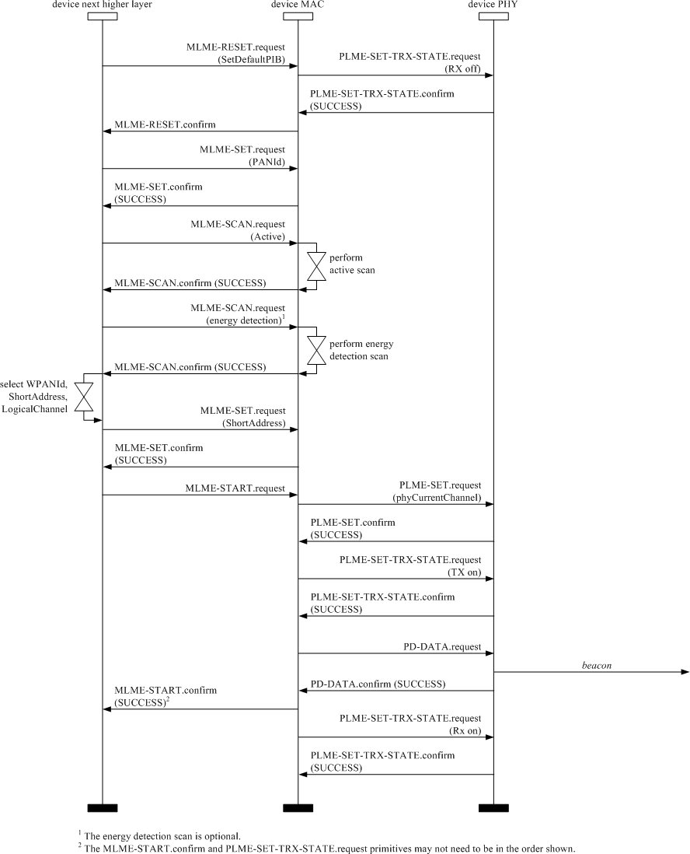

##### Figure 106—OWPAN start message sequence chart—coordinator

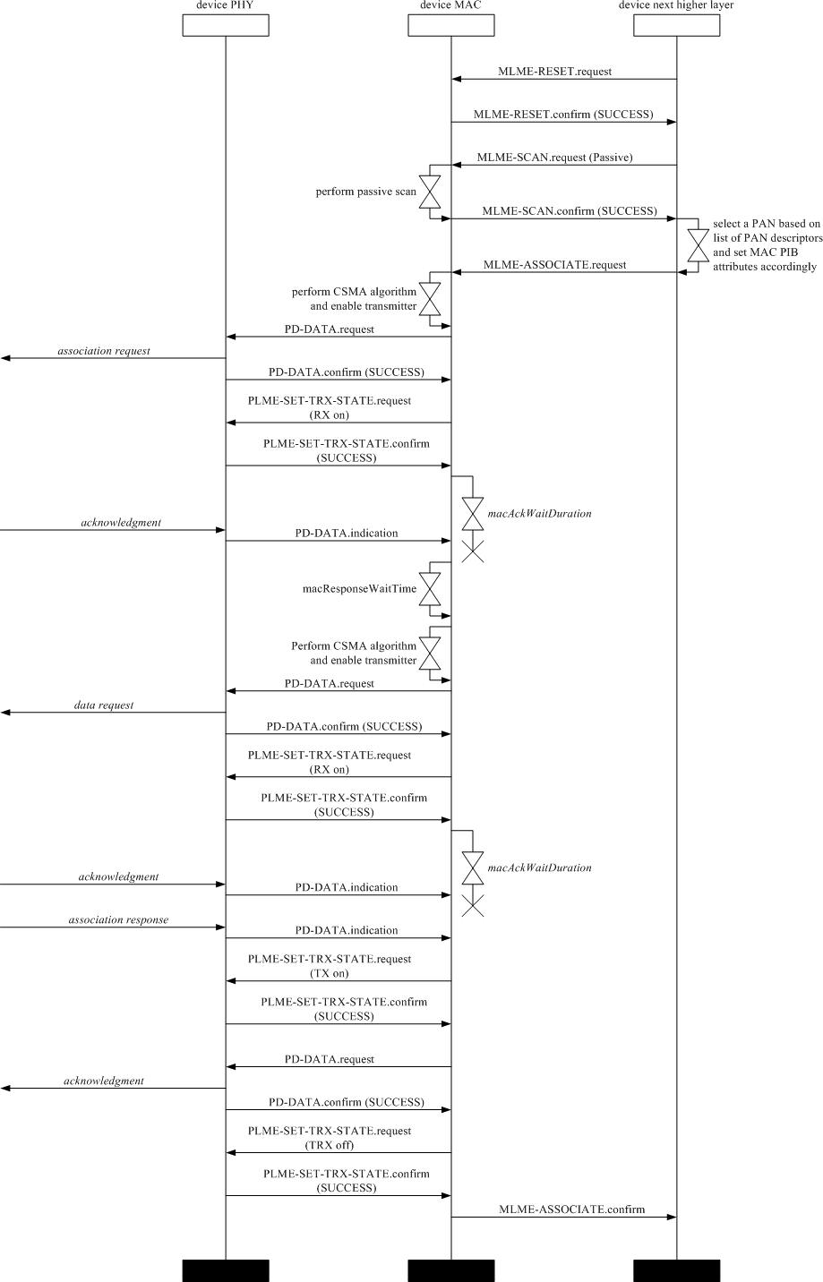

**Figure 107—Association message sequence chart—device**

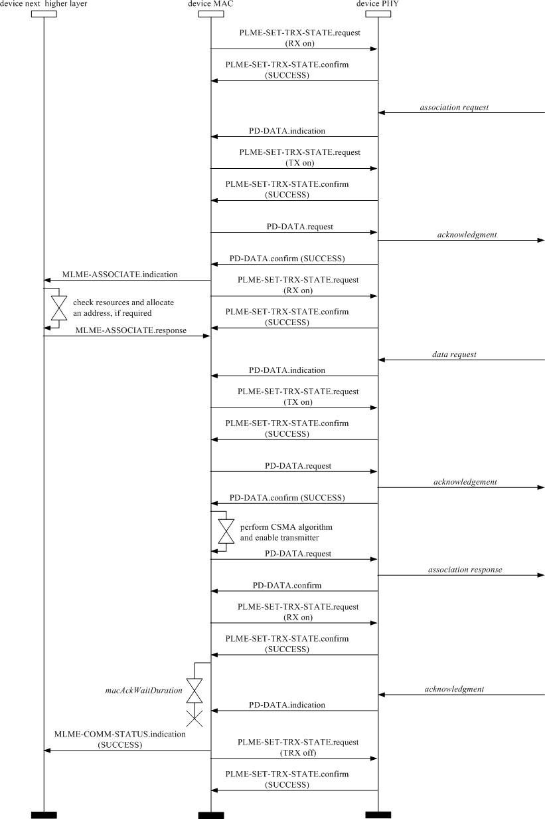

**Figure 108—Association message sequence chart—coordinator**

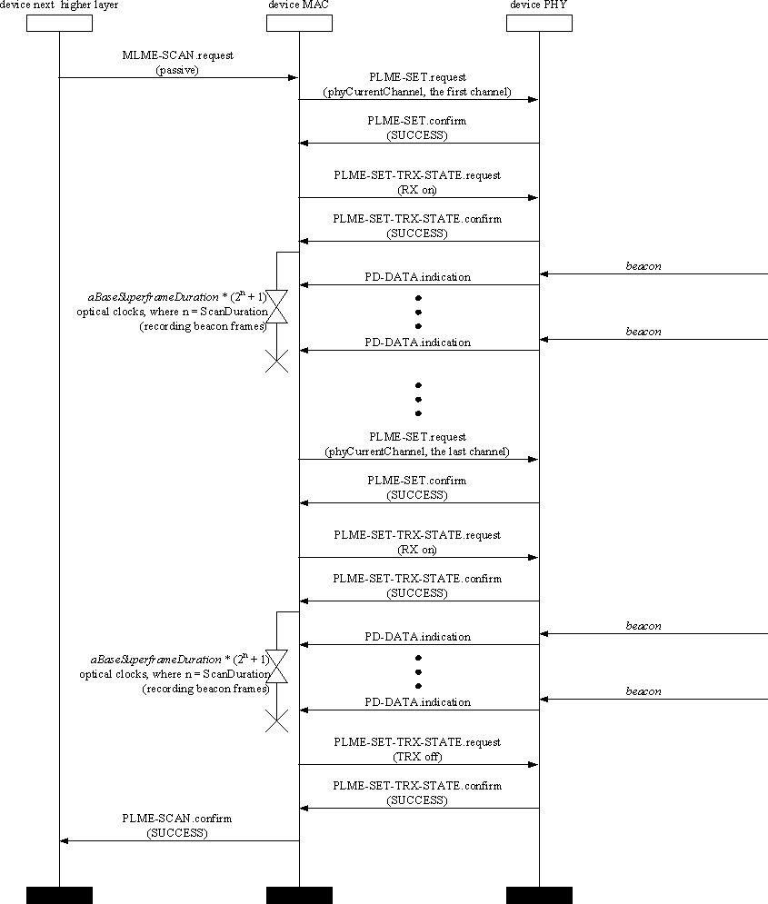

**Figure 109—Passive scan message sequence chart**

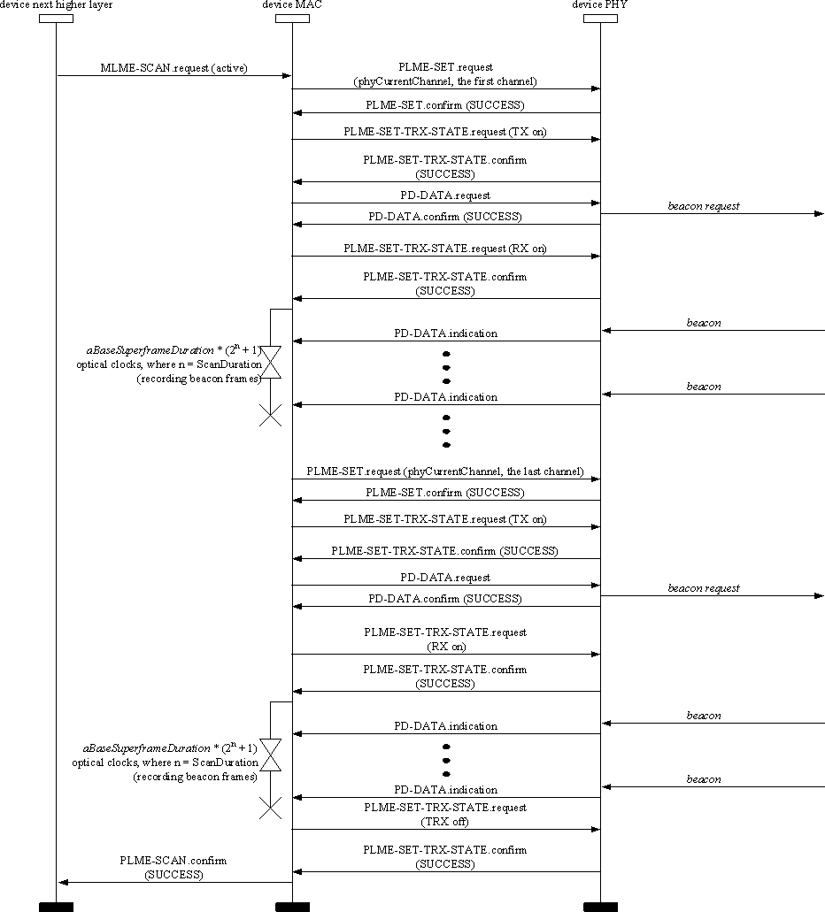

**Figure 110—Active scan message sequence chart**

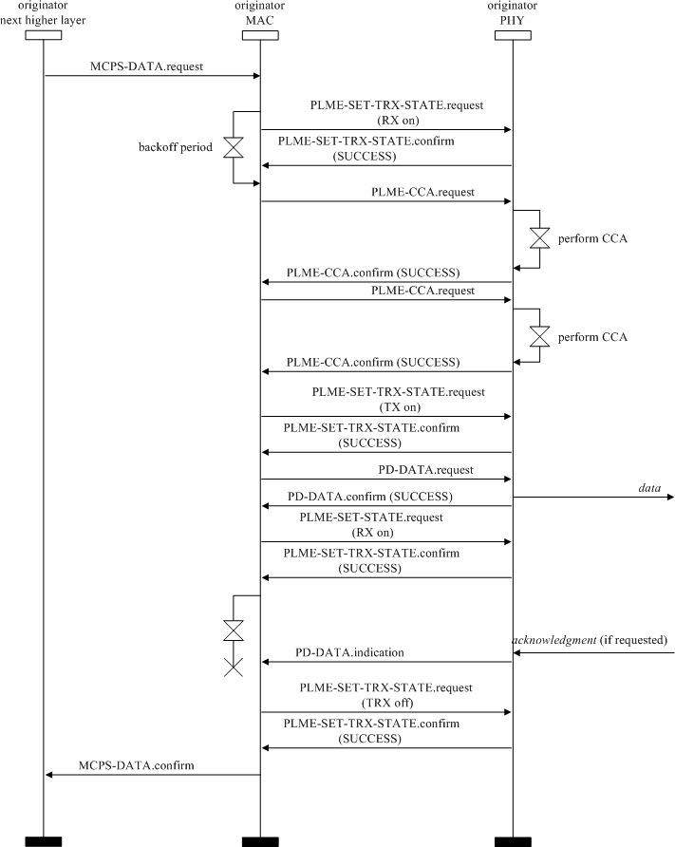

**Figure 111—Data-transmission message sequence chart—originator**

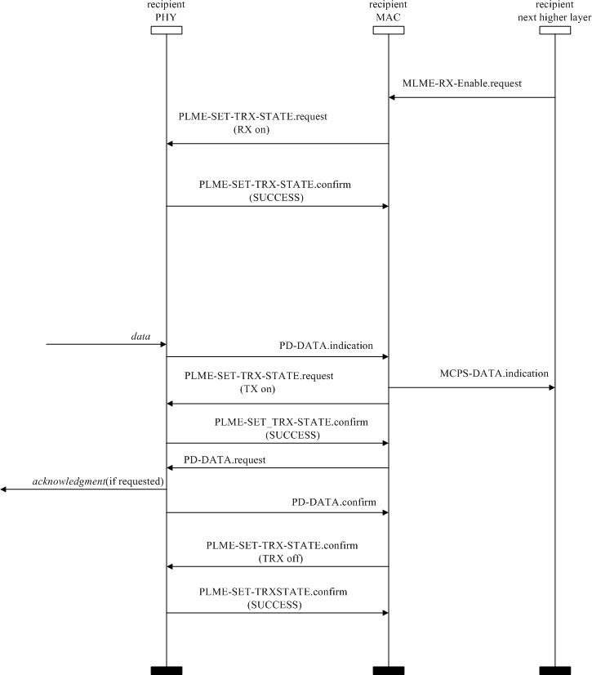

**Figure 112—Data-transmission message sequence chart—recipient**

## Security suite specifications

#### Overview

The MAC sublayer is responsible for providing security services on specified incoming and outgoing frames when requested to do so by the higher layers. This standard supports the following security services (as defined in 4.6 for definitions):

* + - Data confidentiality
    - Data authenticity
    - Replay protection

The information determining how to provide the security is found in the security-related PIB (as defined in Table 69 in 7.5.1).

#### Functional description

A device may optionally implement security. A device that does not implement security shall not provide a mechanism for the MAC sublayer to perform any cryptographic transformation on incoming and outgoing frames nor require any PIB attributes associated with security. A device that implements security shall provide a mechanism for the MAC sublayer to provide cryptographic transformations on incoming and outgoing frames using information in the PIB attributes associated with security when the *macSecurityEnabled* attribute is set to TRUE.

If the MAC sublayer is required to transmit a frame or receives an incoming frame, the MAC sublayer shall process the frame as specified in 7.2.1 and 7.2.3, respectively.

##### Outgoing frame security procedure

The inputs to this procedure are the frame to be secured and the SecurityLevel, KeyIdMode, KeySource, and KeyIndex parameters from the originating primitive or automatic request PIB attributes. The outputs from this procedure are the status of the procedure and, if this status is SUCCESS, the secured frame. If outgoing frame security procedure is not successful, the frame is discarded

The outgoing frame security procedure involves the following steps as applicable:

* + - 1. If the Security Enabled subfield of the Frame Control field of the frame to be secured is set to zero, the procedure shall set the security level to zero.
      2. If the Security Enabled subfield of the Frame Control field of the frame to be secured is set to one, the procedure shall set the security level to the SecurityLevel parameter. If the resulting security level is zero, the procedure shall return with a status of UNSUPPORTED_SECURITY.
      3. If the *macSecurityEnabled* attribute is set to FALSE and the security level is not equal to zero, the procedure shall return with a status of UNSUPPORTED_SECURITY.
      4. The procedure shall determine whether the frame to be secured satisfies the constraint on the maximum length of MAC frames, as follows:
         1. The procedure shall set the length *M*, in octets, of the Authentication field to zero if the security level is equal to zero and shall determine this value from the security level and Table 67 otherwise.
         2. The procedure shall determine the length AuxLen, in octets, of the auxiliary security header (see 7.4) using KeyIdMode and the security level.
         3. The procedure shall determine the data expansion as AuxLen + *M*.
         4. The procedure shall check whether the length of the frame to be secured, including data expansion and FCS, is less than or equal to *aMaxPHYFrameSize*. If this check fails, the procedure shall return with a status of FRAME_TOO_LONG.
      5. If the security level is zero, the procedure shall set the secured frame to be the frame to be secured and return with the secured frame and a status of SUCCESS.
      6. The procedure shall set the frame counter to the *macFrameCounter* attribute. If the frame counter has the value 0xffffffff, the procedure shall return with a status of COUNTER_ERROR and all keys associated with the device shall be reinitialized and updated as discussed in 7.5.5.
      7. The procedure shall obtain the key using the outgoing frame key retrieval procedure as described in

7.2.2. If that procedure fails, the procedure shall return with a status of UNAVAILABLE_KEY.

* + - 1. The procedure shall insert the auxiliary security header into the frame, with fields set as follows:
         1. The Security Level subfield of the Security Control field shall be set to the security level.
         2. The Key Identifier Mode subfield of the Security Control field shall be set to the KeyIdMode parameter.
         3. The Frame Counter field shall be set to the frame counter.
         4. If the KeyIdMode parameter is set to a value not equal to zero, the Key Source and Key Index subfields of the Key Identifier field shall be set to the KeySource and KeyIndex parameters, respectively.
      2. The procedure shall then use *aExtendedAddress*, the frame counter, the security level, and the key to produce the secured frame according to the transformation process known as CCM* [or the extension of CCM, which is the combined counter with CBC-MAC (i.e., cipher block chaining message authentication code) mode of operation] that is described in the security operations (see 7.3.4).
         1. If the SecurityLevel parameter specifies the use of encryption (as defined in Table 67 in 7.4.2.1), the encryption operation shall be applied only to the actual payload field within the MSDU, i.e., the Beacon Payload field (see 5.2.2.1.8), Command Payload field (see 5.2.2.4.3), or Data Payload field (see 5.2.2.2.2), depending on the frame type. The corresponding payload field is passed to the CCM* transformation process described in 7.3.4 as the unsecured payload (as defined in Table 64 in 7.3.4.2). The resulting encrypted payload shall substitute the original payload.
         2. The remaining fields in the MSDU part of the frame shall be passed to the CCM* transformation process described in 7.3.4 as the nonpayload fields (see Table 64).
         3. The ordering and exact manner of performing the encryption and integrity operations and the placement of the resulting encrypted data or integrity code within the MSDU field shall be as defined in 7.3.4.
      3. The procedure shall increment the frame counter by one and set the *macFrameCounter* attribute to the resulting value.
      4. The procedure shall return with the secured frame and a status of SUCCESS.

##### Outgoing frame key retrieval procedure

The inputs to this procedure are the frame to be secured and the KeyIdMode, KeySource, and KeyIndex parameters from the originating primitive. The outputs from this procedure are a passed or failed status and, if passed, a key.

The outgoing frame key retrieval procedure involves the following steps as applicable:

* + - 1. If the KeyIdMode parameter is set to 0x00 (implicit key identification), the procedure shall determine the key lookup data and key lookup size as follows:
         1. If the Destination Addressing Mode subfield of the Frame Control field of the frame is set to 0x00 and the *macOWPANCoordShortAddress* attribute is set to a value in the range 0x0000– 0xfffd (i.e., the short address is used), the key lookup data shall be set to the 2-octet Source

OWPAN Identifier field of the frame right-concatenated (see B.2.1. of IEEE Std 802.15.4- 2015)7 with the 2-octet *macOWPANCoordShortAddress* attribute right-concatenated with the single octet 0x00. The key lookup size shall be set to five.

7 Information about references can be found in Clause 2.

* + - * 1. If the Destination Addressing Mode subfield of the Frame Control field of the frame is set to 0x00 and the *macOWPANCoordShortAddress* attribute is set to 0xfffe (i.e., the extended address is used), the key lookup data shall be set to the 8-octet *macOWPANCoordExtendedAddress* attribute right-concatenated (see B.2.1 of IEEE Std 802.15.4-2015) with the single octet 0x00. The key lookup size shall be set to nine.
        2. If the Destination Addressing Mode subfield of the Frame Control field of the frame is set to 0x02, the key lookup data shall be set to the 2-octet Destination OWPAN Identifier field of the frame right-concatenated (see B.2.1 of IEEE Std 802.15.4-2015) with the 2-octet Destination Address field of the frame right-concatenated with the single octet 0x00. The key lookup size shall be set to five.
        3. If the Destination Addressing Mode subfield of the Frame Control field of the frame is set to 0x03, the key lookup data shall be set to the 8-octet Destination Address field of the frame right-concatenated (see B.2.1 of IEEE Std 802.15.4-2015) with the single octet 0x00. The key lookup size shall be set to nine.
      1. If the KeyIdMode parameter is set to a value not equal to 0x00 (explicit key identification), the procedure shall determine the key lookup data and key lookup size as follows:
         1. If the KeyIdMode parameter is set to 0x01, the key lookup data shall be set to the 8-octet *macDefaultKeySource* attribute right-concatenated (see B.2.1 of IEEE Std 802.15.4-2015) with the single octet KeyIndex parameter. The key lookup size shall be set to nine.
         2. If the KeyIdMode parameter is set to 0x02, the key lookup data shall be set to the 4-octet KeySource parameter right-concatenated (see B.2.1 of IEEE Std 802.15.4-2015) with the single octet KeyIndex parameter. The key lookup size shall be set to five.
         3. If the KeyIdMode parameter is set to 0x03, the key lookup data shall be set to the 8-octet KeySource parameter right-concatenated (see B.2.1 of IEEE Std 802.15.4-2015) with the single octet KeyIndex parameter. The key lookup size shall be set to nine.
      2. The procedure shall obtain the KeyDescriptor by passing the key lookup data and the key lookup size to the KeyDescriptor lookup procedure as described in 7.2.5. If that procedure returns with a failed status, this procedure shall also return with a failed status.
      3. The MAC sublayer shall set the key to the Key element of the KeyDescriptor.
      4. The procedure shall return with a passed status, having obtained the key identifier and the key.

NOTE—For broadcast frames, the outgoing frame key retrieval procedure will result in a failed status if implicit key identification is used. Hence, explicit key identification should be used for broadcast frames.8

##### Incoming frame security procedure

The input to this procedure is the frame to be unsecured. The outputs from this procedure are the unsecured frame, the security level, the key identifier mode, the key source, the key index, and the status of the procedure. All outputs of this procedure are assumed to be invalid unless and until explicitly set in this procedure. It is assumed that the PIB attributes associating KeyDescriptors in *macKeyTable* with a single, unique device or a number of devices will have been established by the next higher layer. The incoming frame security procedure involves the following steps:

* + - 1. If the Security Enabled field of the Frame Control field of the frame to be unsecured is set to zero, the procedure shall set the security level to zero.
      2. If the Security Enabled field of the Frame Control field of the frame to be unsecured is set to one, the procedure shall set the unsecured frame to be the frame to be unsecured and return with a status of UNSUPPORTED_LEGACY.
      3. If the Security Enabled field of the Frame Control field of the frame to be unsecured is set to one, the procedure shall set the security level and the key identifier mode to the corresponding fields of the Security Control field of the auxiliary security header of the frame to be unsecured, and the key

8 Notes in text, tables, and figures of a standard are given for information only and do not contain requirements needed to implement the standard.

source and key index to the corresponding fields of the Key Identifier field of the auxiliary security header of the frame to be unsecured, if present. If the resulting security level is zero, the procedure shall set the unsecured frame to be the frame to be unsecured and return with a status of UNSUPPORTED_SECURITY.

* + - 1. If the *macSecurityEnabled* attribute is set to FALSE, the procedure shall set the unsecured frame to be the frame to be unsecured and return with a status of SUCCESS if the security level is equal to zero and with a status of UNSUPPORTED_SECURITY otherwise.
      2. The procedure shall determine whether the frame to be unsecured meets the minimum security level by passing the security level, the frame type, and, depending on whether the frame is a MAC command frame, the first octet of the MSDU (i.e., command frame identifier for a MAC command frame) to the incoming security level checking procedure as described in 7.2.8. If that procedure fails, the procedure shall set the unsecured frame to be the frame to be unsecured and return with a status of IMPROPER_SECURITY_LEVEL.
      3. If the security level is set to zero, the procedure shall set the unsecured frame to be the frame to be unsecured and return with a status of SUCCESS.
      4. The procedure shall obtain the KeyDescriptor, DeviceDescriptor, and KeyDeviceDescriptor using the incoming frame security material retrieval procedure described in 7.2.4. If that procedure fails, the procedure shall set the unsecured frame to be the frame to be unsecured and return with a status of UNAVAILABLE_KEY.
      5. The procedure shall determine whether the frame to be unsecured conforms to the key usage policy by passing the KeyDescriptor, the frame type, and, depending on whether the frame is a MAC command frame, the first octet of the MSDU (i.e., command frame identifier for a MAC command frame) to the incoming key usage policy checking procedure as described in 7.2.9. If that procedure fails, the procedure shall set the unsecured frame to be the frame to be unsecured and return with a status of IMPROPER_KEY_TYPE.
      6. If the Exempt element of the DeviceDescriptor is set to FALSE and if the incoming security level checking procedure of step e) above had as output the “conditionally passed” status, the procedure shall set the unsecured frame to be the frame to be unsecured and return with a status of IMPROPER_SECURITY_LEVEL.
      7. The procedure shall set the frame counter to the Frame Counter field of the auxiliary security header of the frame to be unsecured. If the frame counter has the value 0xffffffff, the procedure shall set the unsecured frame to be the frame to be unsecured and return with a status of COUNTER_ERROR.
      8. The procedure shall determine whether the frame counter is greater than or equal to the FrameCounter element of the DeviceDescriptor. If this check fails, the procedure shall set the unsecured frame to be the frame to be unsecured and return with a status of COUNTER_ERROR.
      9. The procedure shall then use the ExtAddress element of the DeviceDescriptor, the frame counter, the security level, and the Key element of the KeyDescriptor to produce the unsecured frame according to the CCM* inverse transformation process described in the security operations (see 7.3.5).
         1. If the security level specifies the use of encryption (as defined in Table 67 in 7.4.2.1), the decryption operation shall be applied only to the actual payload field within the MSDU, i.e., the Beacon Payload field (see 5.2.2.1.8), Command Payload field (see 5.2.2.4.3), or Data Payload field (see 5.2.2.2.2), depending on the frame type. The corresponding payload field shall be passed to the CCM* inverse transformation process described in 7.3.5 as the secure payload.
         2. The remaining fields in the MSDU part of the frame shall be passed to the CCM* inverse transformation process described in 7.3.5 as the nonpayload fields.
      10. If the CCM* inverse transformation process fails, the procedure shall set the unsecured frame to be the frame to be unsecured and return with a status of SECURITY_ERROR.
      11. The procedure shall increment the frame counter by one and set the FrameCounter element of the DeviceDescriptor to the resulting value.
      12. If the FrameCounter element is equal to 0xffffffff, the procedure shall set the Blacklisted element of the KeyDeviceDescriptor.
      13. The procedure shall return with the unsecured frame and a status of SUCCESS.

##### Incoming frame security material retrieval procedure

The input to this procedure is the frame to be unsecured. The outputs from this procedure are a passed or failed status and, if passed, a KeyDescriptor, a DeviceDescriptor, and a KeyDeviceDescriptor.

The incoming frame security material retrieval procedure involves the following steps as applicable:

* + - 1. If the Key Identifier Mode subfield of the Security Control field of the auxiliary security header of the frame is set to 0x00 (implicit key identification), the procedure shall determine the key lookup data and the key lookup size as follows:
         1. If the source address mode of the Frame Control field of the frame is set to 0x00 and the *macOWPANCoordShortAddress* attribute is set to a value in the range 0x0000–0xfffd (i.e., the short address is used), the key lookup data shall be set to the 2-octet Destination OWPAN Identifier field of the frame right-concatenated (see B.2.1 of IEEE Std 802.15.4-2015) with the 2-octet *macOWPANCoordShortAddress* attribute right-concatenated with the single octet 0x00. The key lookup size shall be set to five.
         2. If the source address mode of the Frame Control field of the frame is set to 0x00 and the *macOWPANCoordShortAddress* attribute is set to 0xfffe (i.e., the extended address is used), the key lookup data shall be set to the 8-octet *macOWPANCoordExtendedAddress* attribute right- concatenated (see B.2.1 of IEEE Std 802.15.4-2015) with the single octet 0x00. The key lookup size shall be set to nine.
         3. If the source address mode of the Frame Control field of the frame is set to 0x02, the key lookup data shall be set to the 2-octet Source OWPAN Identifier field of the frame, right- concatenated (see B.2.1 of IEEE Std 802.15.4-2015) with the 2-octet Source Address field of the frame right-concatenated with the single octet 0x00. The key lookup size shall be set to five.
         4. If the source address mode of the Frame Control field of the frame is set to 0x03, the key lookup data shall be set to the 8-octet Source Address field of the frame right-concatenated (see

B.2.1 of IEEE Std 802.15.4-2015) with the single octet 0x00. The key lookup size shall be set to nine.

* + - 1. If the Key Identifier Mode subfield of the Security Control field of the auxiliary security header of the frame is set to a value not equal to 0x00 (explicit key identification), the procedure shall determine the key lookup data and key lookup size as follows:
         1. If the key identifier mode is set to 0x01, the key lookup data shall be set to the 8-octet *macDefaultKeySource* attribute right-concatenated (see B.2.1 of IEEE Std 802.15.4-2015) with the 1-octet Key Index subfield of the Key Identifier field of the auxiliary security header. The key lookup size shall be set to nine.
         2. If the key identifier mode is set to 0x02, the key lookup data shall be set to the right- concatenation (see B.2.1 of IEEE Std 802.15.4-2015) of the 4-octet Key Source subfield and the 1-octet Key Index subfield of the Key Identifier field of the auxiliary security header. The key lookup size shall be set to five.
         3. If the key identifier mode is set to 0x03, the key lookup data shall be set to the right- concatenation (see B.2.1 of IEEE Std 802.15.4-2015) of the 8-octet Key Source subfield and the 1-octet Key Index subfield of the Key Identifier field of the auxiliary security header. The key lookup size shall be set to nine.
      2. The procedure shall obtain the KeyDescriptor by passing the key lookup data and the key lookup size to the KeyDescriptor lookup procedure as described in 7.2.5. If that procedure returns with a failed status, the procedure shall also return with a failed status.
      3. The procedure shall determine the device lookup data and the device lookup size as follows:
         1. If the source address mode of the Frame Control field of the frame is set to 0x00 and the *macOWPANCoordShortAddress* attribute is set to a value in the range 0x0000–0xfffd (i.e., the short address is used), the device lookup data shall be set to the 2-octet Destination OWPAN

Identifier field of the frame right-concatenated (see B.2.1 of IEEE Std 802.15.4-2015) with the 2-octet *macOWPANCoordShortAddress* attribute. The device lookup size shall be set to four.

* + - * 1. If the source address mode of the Frame Control field of the frame is set to 0x00 and the *macOWPANCoordShortAddress* attribute is set to 0xfffe (i.e., the extended address is used), the device lookup data shall be set to the 8-octet *macOWPANCoordExtendedAddress* attribute. The device lookup size shall be set to eight.
        2. If the source address mode of the Frame Control field of the frame is set to 0x02, the device lookup data shall be set to the 2-octet Source OWPAN Identifier field of the frame, right- concatenated (see B.2.1 of IEEE Std 802.15.4-2015) with the 2-octet Source Address field of the frame. The device lookup size shall be set to four.
        3. If the source address mode of the Frame Control field of the frame is set to 0x03, the device lookup data shall be set to the 8-octet Source Address field of the frame. The device lookup size shall be set to eight.
      1. The procedure shall obtain the DeviceDescriptor and the KeyDeviceDescriptor by passing the KeyDescriptor, the device lookup data, and the device lookup size to the blacklist checking procedure as described in 7.2.6. If that procedure returns with a failed status, the procedure shall also return with a failed status.
      2. The procedure shall return with a passed status having obtained the KeyDescriptor, the DeviceDescriptor, and the KeyDeviceDescriptor.

##### Key descriptor lookup procedure

The inputs to this procedure are the key lookup data and the key lookup size. The outputs from this procedure are a passed or failed status and, if passed, a KeyDescriptor.

The KeyDescriptor lookup procedure involves the following steps as applicable:

* + - 1. For each KeyDescriptor in the *macKeyTable* attribute and for each KeyIdLookupDescriptor in the KeyIdLookupList of the KeyDescriptor, the procedure shall check whether the LookupDataSize element of the KeyIdLookupDescriptor indicates the same integer value, shown in Table 75, as the key lookup size and whether the LookupData element of the KeyIdLookupDescriptor is equal to the key lookup data. If both checks pass (i.e., there is a match), the procedure shall return with this (matching) KeyDescriptor and a passed status.
      2. The procedure shall return with a failed status.

##### Blacklist checking procedure

The inputs to this procedure are the KeyDescriptor, the device lookup data, and the device lookup size. The outputs from this procedure are a passed or failed status and, if passed, a DeviceDescriptor and a KeyDeviceDescriptor.

The blacklist checking procedure involves the following steps as applicable:

* + - 1. For each KeyDeviceDescriptor in the KeyDeviceList of the KeyDescriptor:
         1. The procedure shall obtain the DeviceDescriptor using the DeviceDescriptorHandle element of the KeyDeviceDescriptor.
         2. If the UniqueDevice element of the KeyDeviceDescriptor is set to TRUE, the procedure shall return with the DeviceDescriptor, the KeyDeviceDescriptor, and a passed status if the BlackListed element of the KeyDeviceDescriptor is set to FALSE, or the procedure shall return with a failed status if this Blacklisted element is set to TRUE.
         3. If the UniqueDevice element of the KeyDeviceDescriptor is set to FALSE, the procedure shall execute the DeviceDescriptor lookup procedure as described in 7.2.7, with the device lookup data and the device lookup size as inputs. If the corresponding output of that procedure is a passed status, the procedure shall return with the DeviceDescriptor, the KeyDevice-Descriptor,

and a passed status if the Blacklisted element of the KeyDeviceDescriptor is set to FALSE, or the procedure shall return with a failed status if this Blacklisted element is set to TRUE.

* + - 1. The procedure shall return with a failed status.

##### Device descriptor lookup procedure

The inputs to this procedure are the DeviceDescriptor, the device lookup data, and the device lookup size. The output from this procedure is a passed or failed status.

The DeviceDescriptor lookup procedure involves the following steps as applicable:

* + - 1. If the device lookup size is four and the device lookup data is equal to the OWPAN ID element of the DeviceDescriptor right-concatenated (see B.2.1 of IEEE Std 802.15.4-2015) with the ShortAddress element of the Device-Descriptor, this procedure shall return with a passed status.
      2. If the device lookup size is eight and the device lookup data is equal to the ExtAddress element of the DeviceDescriptor, this procedure shall return with a passed status.
      3. The procedure shall return with a failed status.

##### Incoming security level checking procedure

The inputs to this procedure are the incoming security level, the frame type and the command frame identifier. The output from this procedure is a passed, failed, or “conditionally passed” status.

The incoming security level checking procedure involves the following steps as applicable:

* + - 1. It is recommended to use message integrity code (MIC) for all secure messages as defined in Table 67. For each SecurityLevelDescriptor in the *macSecurityLevelTable* attribute:
         1. If the frame type is not equal to 0x03 and the frame type is equal to the FrameType element of the SecurityLevelDescriptor, the procedure shall compare the incoming security level (as SEC1) with the SecurityMinimum element of the SecurityLevelDescriptor (as SEC2) according to the algorithm described in 7.4.2.1. If this comparison fails (i.e., evaluates to FALSE), the procedure shall return with a “conditionally passed” status if the DeviceOverrideSecurityMinimum element of the SecurityLevelDescriptor is set to TRUE and the security level is set to zero and with a failed status otherwise.
         2. If the frame type is equal to 0x03, the frame type is equal to the FrameType element of the SecurityLevelDescriptor, and the command frame identifier is equal to the CommandFrameIdentifier element of the SecurityLevelDescriptor, the procedure shall compare the incoming security level (as SEC1) with the SecurityMinimum element of the SecurityLevelDescriptor (as SEC2) according to the algorithm described in 7.4.2.1. If this comparison fails (i.e., evaluates to FALSE), the procedure shall return with a “conditionally passed” status if the DeviceOverrideSecurityMinimum element of the SecurityLevelDescriptor is set to TRUE and the security level is set to zero and with a failed status otherwise.
      2. The procedure shall return with a passed status.

##### Incoming key usage policy checking procedure

The inputs to this procedure are the KeyDescriptor, the frame type, and the command frame identifier. The output from this procedure is a passed or failed status.

The incoming key usage policy checking procedure involves the following steps as applicable:

* + - 1. For each KeyUsageDescriptor in the KeyUsageList of the KeyDescriptor:
         1. If the frame type is not equal to 0x03 and the frame type is equal to the FrameType element of the KeyUsageDescriptor, the procedure shall return with a passed status.
         2. If the frame type is equal to 0x03, the frame type is equal to the FrameType element of the KeyUsageDescriptor, and the command frame identifier is equal to the CommandFrameIdentifier element of the KeyUsageDescriptor, the procedure shall return with a passed status.
      2. The procedure shall return with a failed status.

#### Security operations

This subclause describes the parameters for the CCM* security operations, as specified in Annex A of IEEE Std 802.15.4-2015.

##### Integer and octet representation

The integer and octet representation conventions specified in Annex A of IEEE Std 802.15.4-2015 are used throughout 7.3.

##### CCM* nonce

The CCM* nonce is a 13-octet string and is used for the advanced encryption standard (AES)-CCM* mode of operation (see B.2.2 of IEEE Std 802.15.4-2015). The nonce shall be formatted as shown in Figure 113, with the leftmost field in the figure defining the first (and leftmost) octets and the rightmost field defining the last (and rightmost) octet of the nonce.

Octets: 8 4 1

|  |  |  |
| --- | --- | --- |
| Source Address | Frame Counter | Security Level |

##### Figure 113—CCM* nonce

The source address shall be set to the extended address *aExtendedAddress* of the device originating the frame, the frame counter to the value of the respective field in the auxiliary security header (see 7.4), and the security level to the security level identifier corresponding to the Security Level subfield of the Security Control field of the auxiliary security header as defined in Table 67.

The source address, frame counter, and security level shall be represented as specified in 7.3.1.

##### CCM* prerequisites

Securing a frame involves the use of the CCM* mode encryption and authentication transformation, as described in B.4.1. of IEEE Std 802.15.4-2015. Unsecuring a frame involves the use of the CCM* decryption and authentication checking process, as described in B.4.2 of IEEE Std 802.15.4-2015. The prerequisites for the CCM* forward and inverse transformations are as follows:

* + - * The underlying block cipher shall be the AES encryption algorithm as specified in B.3.1 of IEEE Std 802.15.4-2015.
      * The bit ordering shall be as defined in 7.3.1.
      * The length in octets of the Length field *L* shall be 2 octets.
      * The length of the Authentication field *M* shall be 0 octets, 4 octets, 8 octets, or 16 octets, as required.

The length of the Authentication field *M* for the CCM* forward transformation and the CCM* inverse transformation is determined from Table 67, using the Security Level subfield of the Security Control field of the auxiliary security header of the frame.

##### CCM* transformation data representation

This subclause describes how the inputs and output of the CCM* forward transformation, as described in

* + 1. of IEEE Std 802.15.4-2015, are formed.

The inputs are as follows:

* + - * Key
      * Nonce
      * *a* data
      * *m* data

The output is *c* data.

##### Key and nonce data inputs

The Key data for the CCM* forward transformation is passed by the outgoing frame security procedure described in 7.2.1. The nonce data for the CCM* transformation is constructed as described in 7.3.2.

* + - 1. ***a* data and *m* data**

In the CCM* transformation process, the data fields shall be applied as in Table 64.

##### Table 64—*a* data and *m* data for all security levels

|  |  |  |
| --- | --- | --- |
| **Security level identifier** | ***a* data** | ***m* data** |
| 0x00 | None | None |
| 0x01 | MHR || Auxiliary security header || Nonpayload fields || Unsecured payload fields | None |
| 0x02 | MHR || Auxiliary security header || Nonpayload fields || Unsecured payload fields | None |
| 0x03 | MHR || Auxiliary security header || Nonpayload fields || Unsecured payload fields | None |
| 0x04 | None | Unsecured payload fields |
| 0x05 | MHR || Auxiliary security header || Nonpayload fields | Unsecured payload fields |
| 0x06 | MHR || Auxiliary security header || Nonpayload fields | Unsecured payload fields |
| 0x07 | MHR || Auxiliary security header || Nonpayload fields | Unsecured payload fields |

* + - 1. ***c* data output**

In the CCM* transformation process, the data fields that are applied, or right-concatenated and applied, represent octet strings.

The secured payload fields right-concatenated with the authentication tag shall substitute the unsecured payload field in the original unsecured frame to form the secured frame (see Table 65).

##### Table 65—*c* data for all security levels

|  |  |
| --- | --- |
| **Security level identifier** | ***c* data** |
| 0x00 | None |
| 0x01 | MIC-32 |
| 0x02 | MIC-64 |
| 0x03 | MIC-128 |
| 0x04 | Secured payload fields |
| 0x05 | Secured payload fields || MIC-32 |
| 0x06 | Secured payload fields || MIC-64 |
| 0x07 | Secured payload fields || MIC-128 |

##### CCM* inverse transformation data representation

This subclause describes how the inputs and output of the CCM* inverse transformation, as described in

* + 1. of IEEE Std 802.15.4-2015, are formed.

The inputs are as follows:

* + - * Key
      * Nonce
      * *c* data
      * *a* data

The output is *m* data.

##### Key and nonce data inputs

The key data for the CCM* inverse transformation is passed by the incoming frame security procedure described in 7.2.3. The nonce data for the CCM* transformation is constructed as described in 7.3.2.

* + - 1. ***c* data and *a* data**

In the CCM* inverse transformation process, the data fields shall be applied as in Table 66.

##### Table 66—*c* data and *a* data for all security levels

|  |  |  |
| --- | --- | --- |
| **Security level identifier** | ***c* data** | ***a* data** |
| 0x00 | None | None |
| 0x01 | MIC-32 | MHR || Auxiliary security header || Nonpayload fields ||Secured payload fields |
| 0x02 | MIC-64 | MHR || Auxiliary security header || Nonpayload fields || Secured payload fields |

**Table 66—*c* data and *a* data for all security levels *(continued)***

|  |  |  |
| --- | --- | --- |
| **Security level identifier** | ***c* data** | ***a* data** |
| 0x03 | MIC-128 | MHR || Auxiliary security header || Nonpayload fields || Secured payload fields |
| 0x04 | Secured payload fields | MHR || Auxiliary security header || Nonpayload fields |
| 0x05 | Secured payload fields || MIC-32 | MHR || Auxiliary security header || Nonpayload fields |
| 0x06 | Secured payload fields || MIC-64 | MHR || Auxiliary security header || Nonpayload fields |
| 0x07 | Secured payload fields || MIC-128 | MHR || Auxiliary security header || Nonpayload fields |

##### *m* data output

The *m* data shall then substitute secured payload fields and authentication tag in the original secured frame to form the unsecured frame.

#### Auxiliary Security header

The Auxiliary Security Header field has a variable length and contains information required for security processing, including a Security Control field, a Frame Counter field, and a Key Identifier field. The Auxiliary Security Header field shall be present only if the Security Enabled subfield of the Frame Control field is set to one. The Auxiliary Security Header field shall be formatted as illustrated in Figure 114.

Octets: 1 4 0/1/5/9

|  |  |  |
| --- | --- | --- |
| Security Control | Frame Counter | Key Identifier |

##### Figure 114—Format of the auxiliary security header

##### Integer and octet representation

The auxiliary security header is a MAC frame field (see 5.2.1.7) and, therefore, uses the representation conventions specified in 5.2.

##### Security Control field

The Security Control field is 1 octet in length and is used to provide information about what protection is applied to the frame. The Security Control field shall be formatted as shown in Figure 115.

Bit: 0–2 3–4 5–7

|  |  |  |
| --- | --- | --- |
| Security Level | Key Identifier Mode | Reserved |

##### Figure 115—Security Control field format

* + - 1. **Security Level subfield**

The Security Level subfield indicates the actual frame protection that is provided. This value can be adapted on a frame-by-frame basis and allows for varying levels of data authenticity (to allow minimization of security overhead in transmitted frames where required) and for optional data confidentiality. The cryptographic protection offered by the various security levels is shown in Table 67. When nontrivial protection is required, replay protection is always provided.

##### Table 67—Security levels available to the MAC sublayer

|  |  |  |  |  |
| --- | --- | --- | --- | --- |
| **Securitylevel identifier** | **Security Control field**  **(Figure 115)** **b2 b1 b0** | **Security attributes** | **Data confidentiality** | **Data authenticity (including length *M* of authentication tag,**  **in octets)** |
| 0x00 | '000' | None | OFF | NO (*M* = 0) |
| 0x01 | '001' | MIC-32 | OFF | YES (*M* = 4) |
| 0x02 | '010' | MIC-64 | OFF | YES (*M* = 8) |
| 0x03 | '011' | MIC-128 | OFF | YES (*M* = 16) |
| 0x04 | '100' | ENC | ON | NO (*M* = 0) |
| 0x05 | '101' | ENC-MIC-32 | ON | YES (*M* = 4) |
| 0x06 | '110' | ENC-MIC-64 | ON | YES (*M* = 8) |
| 0x07 | '111' | ENC-MIC-128 | ON | YES (*M* = 16) |

**ENC** = encryption mode.

Security levels can be ordered according to the corresponding cryptographic protection offered. Here, a first security level SEC1 is greater than or equal to a second security level SEC2 if and only if SEC1 offers at least the protection offered by SEC2, both with respect to data confidentiality and with respect to data authenticity. The statement “SEC1 is greater than or equal to SEC2” shall be evaluated as TRUE if both of the following conditions apply:

* + - * 1. Bit position b2 in SEC1 is greater than or equal to bit position b2 in SEC2 (where Encryption OFF < Encryption ON).
        2. The integer value of bit positions b1 b0 in SEC1 is greater than or equal to the integer value of bit positions b1 b0 in SEC2 [where increasing integer values indicate increasing levels of data authenticity provided, i.e., message integrity code (MIC)-0 < MIC-32 < MIC-64 < MIC-128].

Otherwise, the statement shall be evaluated as FALSE.

For example, ENC-MIC-64  MIC-64 is TRUE because ENC-MIC-64 offers the same data authenticity protection as MIC-64, plus confidentiality. On the other hand, MIC-128  ENC-MIC-64 is FALSE because even though MIC-128 offers stronger data authenticity than ENC-MIC-64, it offers no confidentiality.

##### Key Identifier Mode subfield

The Key Identifier Mode subfield indicates whether the key that is used to protect the frame can be derived implicitly or explicitly; furthermore, it is used to indicate the particular representations of the Key Identifier field (see 7.4.4) if derived explicitly. The Key Identifier Mode subfield shall be set to one of the values listed

in Table 68. The Key Identifier field of the auxiliary security header (see 7.4.4) shall be present only if this subfield has a value that is not equal to 0x00.

##### Table 68—Values of the key identifier mode

|  |  |  |  |
| --- | --- | --- | --- |
| **Key identifier mode** | **Key Identifier Mode subfield b1 b0** | **Description** | **Key Identifier field length (octets)** |
| 0x00 | '00' | Key is determined implicitly from the originator and recipient(s) of the frame, as indicated in the frame header. | 0 |
| 0x01 | '01' | Key is determined from the 1-octet Key Index subfield of the Key Identifier field of the auxiliary security header in conjunction with *macDefaultKeySource.* | 1 |
| 0x02 | '10' | Key is determined explicitly from the 4-octet Key Source subfield and the 1-octet Key Index subfield of the Key Identifier field of the auxiliary security header. | 5 |
| 0x03 | '11' | Key is determined explicitly from the 8-octet Key Source subfield and the 1-octet Key Index subfield of the Key Identifier field of the auxiliary security header. | 9 |

##### Frame Counter field

The Frame Counter field is 4 octets in length and represents the *macFrameCounter* attribute of the originator of a protected frame. It is used to provide semantic security of the cryptographic mechanism used to protect a frame and to offer replay protection.

##### Key Identifier field

The Key Identifier field has a variable length and identifies the key that is used for cryptographic protection of outgoing frames, either explicitly or in conjunction with implicitly defined side information. The Key Identifier field shall be present only if the Key Identifier Mode subfield of the Security Control field of the auxiliary security header (see 7.4.2.2) is set to a value different from 0x00. The Key Identifier field shall be formatted as illustrated in Figure 116.

Octets: 0/4/8 1

|  |  |
| --- | --- |
| Key Source | Key Index |

##### Figure 116—Format for the Key Identifier field, if present

* + - 1. **Key Source subfield**

The Key Source subfield, when present, is either 4 octets or 8 octets in length, according to the value specified by the Key Identifier Mode subfield of the Security Control field (see 7.4.2.2), and indicates the originator of a group key.

##### Key Index subfield

The Key Index subfield is 1 octet in length and allows unique identification of different keys with the same originator.

It is the responsibility of each key originator to make sure that actively used keys that it issues have distinct key indices and that the key indices are all different from 0x00.

#### Security-related MAC PIB attributes

The security-related MAC PIB attributes contain the following:

* + - Key table (*macKeyTable*, *macKeyTableEntries*)
    - Device table (*macDeviceTable*, *macDeviceTableEntries*)
    - Minimum security level table (*macSecurityLevelTable*, *macSecurityLevelTableEntries*)
    - Frame counter (*macFrameCounter*)
    - Automatic request attributes (*macAutoRequestSecurityLevel*, *macAutoRequestKeyIdMode*, *macAutoRequestKeySource*, *macAutoRequestKeyIndex*)
    - Default key source (*macDefaultKeySource*)
    - Coordinator address (*macOWPANCoordExtendedAddress, macOWPANCoordShortAddress*)

##### PIB security material

The PIB security-related attributes are presented in Table 69, Table 70, Table 71, Table 72, Table 73, Table 74, and Table 75.

##### Table 69—Security-related MAC PIB attributes

|  |  |  |  |  |  |
| --- | --- | --- | --- | --- | --- |
| **Attribute** | **Identifier** | **Type** | **Range** | **Description** | **Default** |
| *macKeyTable* | 0x71 | List of KeyDescriptor entries (see Table 70) | — | A table of KeyDescriptor entries, each containing keys and related information required for secured communications. | (empty) |
| *macKeyTableEntri es* | 0x72 | Integer | Implementa- tion specific | The number of entries in  *macKeyTable*. | 0 |
| *macDeviceTable* | 0x73 | List of DeviceDescripto r entries (see Table 74) | — | A table of DeviceDescriptor entries, each indicating a remote device with which this device securely communicates. | (empty) |
| *macDeviceTableEn tries* | 0x74 | Integer | Implementa- tion specific | The number of entries in  *macDeviceTable*. | 0 |
| *macSecurityLevelT able* | 0x75 | Table of SecurityLevelDe scriptor entries (see Table 73) | — | A table of SecurityLevelDescriptor entries, each with information about the minimum security level expected depending on incoming frame type and subtype. | (empty) |

**Table 69—Security-related MAC PIB attributes *(continued)***

|  |  |  |  |  |  |
| --- | --- | --- | --- | --- | --- |
| **Attribute** | **Identifier** | **Type** | **Range** | **Description** | **Default** |
| *macSecurityLevelT ableEntries* | 0x76 | Integer | Implementa- tion specific | The number of entries in  *macSecurityLevelTable*. | 0 |
| *macFrameCounter* | 0x77 | Integer | 0x00000000–  0xffffffff | The outgoing frame counter for this device. | 0x00000000 |
| *macAutoRequestSe curityLevel* | 0x78 | Integer | 0x00–0x07 | The security level used for automatic data requests. | 0x06 |
| *macAutoRequestKe yIdMode* | 0x79 | Integer | 0x00–0x03 | The key identifier mode used for automatic data requests. This attribute is invalid if the *macAutoRequestSecurityLe vel* attribute is set to 0x00. | 0x00 |
| *macAutoRequestKe ySource* | 0x7a | As specified by the *macAutoRequest KeyIdMode* parameter | — | The originator of the key used for automatic data requests. This attribute is invalid if the *macAutoRequestKeyIdMod e* element is invalid or set to 0x00. | All octets 0xff |
| *macAutoRequestKe yIndex* | 0x7b | Integer | 0x01–0xff | The index of the key used for automatic data requests.  This attribute is invalid if the  *macAutoRequestKeyIdMod e* attribute is invalid or set to 0x00. | All octets 0xff |
| *macDefaultKeySou rce* | 0x7c | Set of 8 octets | — | The originator of the default key used for key identifier mode 0x01. | All octets 0xff |
| *macOWPANCoord ExtendedAddress* | 0x7d | IEEE address | An extended 64-bit  IEEE address | The 64-bit address of the coordinator. | — |
| *macOWPANCoord ShortAddress* | 0x7e | Integer | 0x0000–0xffff | The 16-bit short address assigned to the coordinator. A value of 0xfffe indicates that the coordinator is only using its 64-bit extended address. A value of 0xffff indicates that this value is unknown. | 0x0000 |

**Table 70—Elements of KeyDescriptor**

|  |  |  |  |
| --- | --- | --- | --- |
| **Name** | **Type** | **Range** | **Description** |
| KeyIdLookupList | List of KeyIdLookupDescriptor entries (see Table 75) | — | A list of KeyIdLookupDescriptor entries used to identify this KeyDescriptor. |
| KeyIdLookupListE ntries | Integer | Implementation specific | The number of entries in KeyIdLookupList. |
| KeyDeviceList | List of KeyDeviceDescriptor entries (see Table 72) | — | A list of KeyDeviceDescriptor entries indicating which devices are currently using this key, including their blacklist status. |
| KeyDeviceListEntr ies | Integer | Implementation specific | The number of entries in KeyDeviceList. |
| KeyUsageList | List of KeyUsageDescriptor entries (see Table 71) | — | A list of KeyUsageDescriptor entries indicating the frame types with which this key may be used. |
| KeyUsageListEntri es | Integer |  | The number of entries in KeyUsageList. |
| Key | Set of 16 octets | — | The actual value of the key. |

**Table 71—Elements of KeyUsageDescriptor**

|  |  |  |  |
| --- | --- | --- | --- |
| **Name** | **Type** | **Range** | **Description** |
| FrameType | Integer | 0x00–0x03 | As defined in 5.2.1.1.1. |
| CommandFrameId entifier | Integer | 0x00–0x09 | As defined in Table 12. |

**Table 72—Elements of KeyDeviceDescriptor**

|  |  |  |  |
| --- | --- | --- | --- |
| **Name** | **Type** | **Range** | **Description** |
| DeviceDescriptor Handle | Integer | Implementation specific | Handle to the DeviceDescriptor corresponding to the device (see Table 74). |
| UniqueDevice | Boolean | TRUE or FALSE | Indication of whether the device indicated by DeviceDescriptorHandle is uniquely associated with the KeyDescriptor, i.e., it is a link key as opposed to a group key. |
| Blacklisted | Boolean | TRUE or FALSE | Indication of whether the device indicated by DeviceDescriptorHandle previously communicated with this key prior to the exhaustion of the frame counter. If TRUE, this indicates that the device shall not use this key further because it exhausted its use of the frame counter used with this key. |

**Table 73—Elements of SecurityLevelDescriptor**

|  |  |  |  |
| --- | --- | --- | --- |
| **Name** | **Type** | **Range** | **Description** |
| FrameType | Integer | 0x00–0x03 | As defined in 5.2.1.1.1. |
| CommandFrameId entifier | Integer | 0x00–0x09 | As defined in Table 12. |
| SecurityMinimum | Integer | 0x00–0x07 | The minimal required/expected security level for incoming MAC frames with the indicated frame type and, if present, command frame type (as defined in Table 67 in 7.4.2.1). |
| DeviceOverrideSe curityMinimum | Boolean | TRUE or FALSE | Indication of whether originating devices for which the Exempt flag is set may override the minimum security level indicated by the SecurityMinimum element. If TRUE, this indicates that for originating devices with Exempt status, the incoming security level zero is acceptable, in addition to the incoming security levels meeting the minimum expected security level indicated by the SecurityMinimum element. |

**Table 74—Elements of DeviceDescriptor**

|  |  |  |  |
| --- | --- | --- | --- |
| **Name** | **Type** | **Range** | **Description** |
| OWPANId | Device OWPAN ID | 0x0000–0xffff | The 16-bit OWPAN identifier of the device in this DeviceDescriptor. |
| ShortAddress | Device short address | 0x0000–0xffff | The 16-bit short address of the device in this DeviceDescriptor. A value of 0xfffe indicates that this device is using only its extended address. A value of 0xffff indicates that this value is unknown. |
| ExtAddress | IEEE  address | Any valid 64-bit device address | The 64-bit IEEE extended address of the device in this DeviceDescriptor. This element is also used in unsecuring operations on incoming frames. |
| FrameCounter | Integer | 0x00000000–  0xffffffff | The incoming frame counter of the device in this DeviceDescriptor. This value is used to provide sequential freshness of frames. |
| Exempt | Boolean | TRUE or FALSE | Indication of whether the device may override the minimum security level settings defined in Table 73. |

**Table 75—Elements of KeyIdLookupDescriptor**

|  |  |  |  |
| --- | --- | --- | --- |
| **Name** | **Type** | **Range** | **Description** |
| LookupData | Set of 5 or 9 octets | — | Data used to identify the key. |
| LookupDataSize | Integer | 0x00–0x01 | A value of 0x00 indicates a set of 5 octets; a value of 0x01 indicates a set of 9 octets. |

##### Key table

The key table holds key descriptors (keys with related key-specific information) that are required for security processing of outgoing and incoming frames. Key-specific information in the key table is identified

based on information explicitly contained in the requesting primitive or in the received frame, as described in the outgoing frame key retrieval procedure (see 7.2.2) and the incoming frame security material retrieval procedure (see 7.2.4), as well as in the KeyDescriptor lookup procedure (see 7.2.5).

##### Device table

The device table holds device descriptors (device-specific addressing information and security-related information) that, when combined with key-specific information from the key table, provide all the keying material needed to secure outgoing (see 7.2.1) and unsecure incoming frames (see 7.2.3). Device-specific information in the device table is identified based on the originator of the frame, as described in the DeviceDescriptor lookup procedure (see 7.2.7), and on key-specific information, as described in the blacklist checking procedure (see 7.2.6).

##### Minimum security level table

The minimum security level table holds information regarding the minimum security level the device expects to have been applied by the originator of a frame, depending on frame type and, if it concerns a MAC command frame, the command frame identifier. Security processing of an incoming frame will fail if the frame is not adequately protected, as described in the incoming frame security procedure (see 7.2.3) and in the incoming security level checking procedure (see 7.2.8).

##### Frame counter

The 4-octet frame counter is used to provide replay protection and semantic security of the cryptographic building block used for securing outgoing frames. The frame counter is included in each secured frame and is one of the elements required for the unsecuring operation at the recipient(s). The frame counter is incremented each time an outgoing frame is secured, as described in the outgoing frame security procedure (see 7.2.1). When the frame counter reaches its maximum value of 0xffffffff, the associated keying material can no longer be used, thus requiring all keys associated with the device to be updated. This provides a mechanism for ensuring that the keying material for every frame is unique and, thereby, provides for sequential freshness.

##### Automatic request attributes

Automatic request attributes hold all the information needed to secure outgoing frames generated automatically and not as a result of a higher layer primitive, as is the case with automatic data requests.

##### Default key source

The default key source is information commonly shared between originator and recipient(s) of a secured frame, which, when combined with additional information explicitly contained in the requesting primitive or in the received frame, allows an originator or a recipient to determine the key required for securing or unsecuring this frame, respectively. This provides a mechanism for significantly reducing the overhead of security information contained in secured frames in particular use cases as shown in 7.2.2 and 7.2.4.

##### Coordinator address

The address of the coordinator is information commonly shared between all devices in a OWPAN, which, when combined with additional information explicitly contained in the requesting primitive or in the received frame, allows an originator of a frame directed to the coordinator or a recipient of a frame originating from the coordinator to determine the key and security-related information required for securing or unsecuring, respectively, this frame as shown in 7.2.2 and 7.2.4.

## PHY specification

#### Overview

This clause specifies six PHY options for this standard. The PHY is responsible for the following tasks:

* + - Activation and deactivation of the OWC transceiver
    - WQI for received frames
    - Channel selection
    - Data transmission and reception
    - Error correction
    - Synchronization

Constants and attributes that are specified and maintained by the PHY are written in the text of this clause in italics. Constants have a general prefix of “*a*”, e.g., *aMaxPHYFrameSize*, and are listed in Table 114 (in 9.5.1). Attributes have a general prefix of “*phy*”, e.g., *phyCurrentChannel*, and are listed in Table 115 (in 9.5.2).

This clause specifies requirements that are common to all of the PHYs defined in this standard.

#### Operating modes

A compliant PHY shall implement at least one of the PHY I to PHY VI modes (as defined in Clause 10, Clause 11, Clause 12, Clause 13, Clause 14, and Clause 15) given in Table 76 to Table 79. A device implementing the PHY III mode in Table 78 shall also implement PHY II mode for coexistence as summarized in 4.4.1.2. The PHY modulation modes may operate in the presence of dimming. Modulation using OOK under dimming provides constant range and variable data rate by inserting compensation time as defined in 4.4.3.2, while modulation using VPPM under dimming provides constant data rate and variable range by adjusting the pulse width as summarized in 4.4.3.2.

As shown in Table 76 through Table 79, the standard provides channel coding support for error correction. PHY I supports concatenated coding with Reed-Solomon (RS) and convolutional coding (CC) since it has been designed for outdoor use with short frames. PHY II and PHY III support only RS coding. PHY I and PHY II also support an RLL code to provide DC balance, clock recovery, and flicker mitigation.

In addition to modulation and coding, multiple optical rates are provided for all PHY types in order to support a broad class of optical transmitters (LEDs) for various applications. The choice of optical rate used for communication is decided by the MAC during device discovery. The MAC shall select the optical clock rate for communication during the optical clock-rate selection process as defined in 6.5. The preamble shall be sent at clock rate chosen by the TX and supported by the RX. The preamble is a time domain sequence and does not have any modulation, channel coding, or line coding. The PHY header shall be sent at the lowest data rate for the chosen clock rate. The clock rate does not change through the frame between the preamble, header, and payload.

##### Table 76—PHY I operating modes

|  |  |  |  |  |  |
| --- | --- | --- | --- | --- | --- |
| **Modulation** | **RLL code** | **Optical clock rate (kHz)** | **FEC** | | **Data rate (kbps)** |
| **Outer code (RS)** | **Inner code (CC)** |
| OOK | Manchester | 200 | (15,7) | 1/4 | 11.67 |
| (15,11) | 1/3 | 24.44 |
| (15,11) | 2/3 | 48.89 |
| (15,11) | none | 73.3 |
| none | none | 100 |
| VPPM | 4B6B | 400 | (15,2) | none | 35.56 |
| (15,4) | none | 71.11 |
| (15,7) | none | 124.4 |
| none | none | 266.6 |

**Table 77—PHY II operating modes**

|  |  |  |  |  |
| --- | --- | --- | --- | --- |
| **Modulation** | **RLL code** | **Optical clock rate (MHz)** | **FEC** | **Data rate (Mbps)** |
| VPPM | 4B6B | 3.75 | RS(64,32) | 1.25 |
| RS(160,128) | 2 |
| 7.5 | RS(64,32) | 2.5 |
| RS(160,128) | 4 |
| None | 5 |
| OOK | 8B10B | 15 | RS(64,32) | 6 |
| RS(160,128) | 9.6 |
| 30 | RS(64,32) | 12 |
| RS(160,128) | 19.2 |
| 60 | RS(64,32) | 24 |
| RS(160,128) | 38.4 |
| 120 | RS(64,32) | 48 |
| RS(160,128) | 76.8 |
| None | 96 |

**Table 78—PHY III operating modes**

|  |  |  |  |
| --- | --- | --- | --- |
| **Modulation** | **Optical clock rate (MHz)** | **FEC** | **Data rate (Mbps)** |
| 4-CSK | 12 | RS(64,32) | 12 |
| 8-CSK | RS(64,32) | 18 |
| 4-CSK | 24 | RS(64,32) | 24 |
| 8-CSK | RS(64,32) | 36 |
| 16-CSK | RS(64,32) | 48 |
| 8-CSK | None | 72 |
| 16-CSK | None | 96 |

**Table 79—PHY IV, PHY V, and PHY VI operating modes**

|  |  |  |  |  |  |
| --- | --- | --- | --- | --- | --- |
| **OCC MCS ID** | **Modulation** | **RLL** | **Optical clock rate** | **FEC** | **Data rate** |
| **PHY IV operating modes** | | | | | |
| 0 | UFSOOK | NA | Multiple of frame rate | MIMO path dependent | 10 bps (60 fps camera with 1/3 rate FEC) |
| 1 | Twinkle VPPM | NA | 4x bit rate | RS(15,11) | 4 kbps |
| 2 | S2-PSK | Half-rate code | 10 Hz | Temporal error correction | 5 bps |
| 3 | HS-PSK | Half-rate code for S2-PSK | 10 kHz | RS(15,7) | 22 kbps |
| 4 | Offset-VPWM | None | 25 Hz | RS(15,2)/RS(15,4)/  None | 18 bps |
| **PHY V operating modes** | | | | | |
| 5 | RS-FSK | None | 30 Hz | XOR FEC | 120 bps (16-FSK  without FEC) |
| 6 | C-OOK | Manchester/ 4B6B | 2.2 kHz/  4.4 kHz | Inner Hamming code, Optional outer RS(15,11) | 400 bps (4.4kHz, 4B6B,  no FEC) |
| 7 | CM-FSK | None | 10 Hz | Optional outer RS(15,11) | 60 bps (64-FSK,  no FEC) |
| 8 | MPM | None | 12.5 kHz | Temporal error correction | 5.71 kHz |

**Table 79—PHY IV, PHY V, and PHY VI operating modes *(continued)***

|  |  |  |  |  |  |
| --- | --- | --- | --- | --- | --- |
| **OCC MCS ID** | **Modulation** | **RLL** | **Optical clock rate** | **FEC** | **Data rate** |
| **PHY VI operating modes** | | | | | |
| 9 | A-QL | None | 10 Hz | Outer RS(15,11),  Inner CC(1/4) | 5.54 kbps (32x32 cells TX, CC(1/4) RS(15,11)) |
| 10 | HA-QL | Half-rate code | 10 Hz | Outer RS(15,7),  Inner CC(1/4) | 140 bps |
| 11 | VTASC | None | 30 Hz | RS(64,32)/ RS(160,128)/None | 512 kbps (FEC None) |
| 12 | SS2DC | None | 30 Hz | RS(64,32)/ RS(160,128)/None | 368 kbps (FEC None) |
| 13 | IDE-MPFSK-  Blend | None | 30 Hz | RS(64,32)/ RS(160,128)/None | 32 kbps (FEC None) |
| 14 | IDE-Watermark | None | 30 Hz | RS(64,32)/ RS(160,128)/None | 256 kbps (FEC None) |

**A-QL** = asynchronous quick link; **CM-FSK** = camera m-ary frequency shift keying; **C-OOK** = camera ON-OFF keying; **HA-QL** = hidden asynchronous quick link; **HS-PSK** = hybrid spatial phase shift keying; **IDE** = invisible data embedding; **MPFSK** = m-ary phase-frequency shift keying; **MIMO** = multiple-input, multiple-output; **MPM** = mirror pulse modulation; **Offset-VPWM** = offset variable pulse width modulation; **RS-FSK** = rolling shutter frequency shift keying; **S2-PSK** = spatial two-phase shift keying; **SS2DC** = sequential scalable two- dimensional color; **Twinkle VPPM** = Twinkle variable pulse position modulation; **UFSOOK** = undersampled frequency shift ON-OFF keying; **VTASC** = variable transparent amplitude-shape-color.

#### General requirements

##### Wavelength band plan

A compliant device shall operate with peak radiated energy within the optical light spectrum defined as being from 10,000 nm to 190 nm (long-wavelength infrared to far ultraviolet). A compliant device shall operate in one or several optical light frequency bands as summarized in Table 80.

The codes in Table 80 are used to indicate the wavelengths containing the spectral peak for the transmitted frame and are indicated in the PHY header. This information may be used by the receiver for optimizing its performance. The standard also supports use of wide bandwidth optical transmitters (such as white LEDs) that can transmit on multiple bands or have leakage in other bands using the concepts of channel aggregation and guard channels, as discussed in 5.1.2.5.

##### Optical mapping

A high switching level from the PHY, applied to the light source, shall result in a high radiated intensity. A low switching level from the PHY, applied to the light source, shall result in a reduced radiated intensity. The extinction ratio, defined as the ratio of the high radiated intensity to the low radiated intensity, is at the discretion of the implementer.

##### Table 80—Optical light wavelength band plan

|  |  |  |  |  |  |  |
| --- | --- | --- | --- | --- | --- | --- |
| **Frequency band** | | | | **Bandwidth** | | **Code** |
| **(nm)** | | **(THz)** | | **(nm)** | **(THz)** |
| 190 | 380 | 789 | 1579 | 190 | 790 | 000 |
| 380 | 529 | 567 | 789 | 149 | 222 | 001 |
| 529 | 598 | 502 | 567 | 69 | 65 | 010 |
| 598 | 649 | 462 | 502 | 51 | 40 | 011 |
| 649 | 694 | 432 | 462 | 45 | 30 | 100 |
| 694 | 737 | 407 | 432 | 43 | 25 | 101 |
| 737 | 780 | 385 | 407 | 43 | 22 | 110 |
| 780 | 10 000 | 30 | 385 | 9220 | 350 | 111 |

##### Maximum error tolerance for multiple optical sources

If multiple optical sources are used for communication, it is recommended the optical sources have similar frequency responses in order to assist communication. The digital input to all the optical sources from the PHY shall be synchronized. Figure 117 shows the allowable spread at the output of the optical sources, assuming a synchronized digital input. The maximum spread at the average signal intensity level during the rise and fall time at the output of the optical sources shall not vary by more than 12.5% of the clock period.

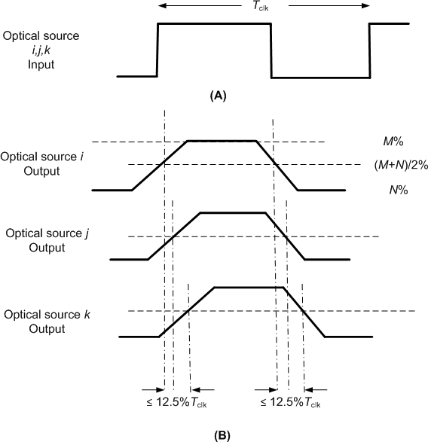

##### Figure 117—Maximum allowable spread at the output of optical sources

##### Minimum LIFS, SIFS, and RIFS periods

An interframe space (IFS) is used to provide spacing between adjacent frames. The minimum spacing between frames is dependent on the MAC mode of operation. The standard provides three types of interframe space: long (LIFS), short (SIFS), and reduced (RIFS). For peer-to-peer and star topologies, the SIFS, LIFS, and RIFS period is based on the currently negotiated optical clock rate by the MAC before starting data communication. Once the optical clock rate is selected, the SIFS, LIFS, and RIFS period is fixed to the values shown in Table 81. The clock-rate negotiation for a peer-to-peer and star topology is provided in 6.5. For a star topology, the beacon period and CAP are defined at the lowest optical clock rate to provide fair access to the medium. For a broadcast topology, the IFS is defined based on the optical clock rate chosen for broadcasting data to other devices. The minimum LIFS, SIFS, and RIFS periods for each of the PHYs are shown in Table 81. A detailed description, use, and illustration of LIFS, SIFS, and RIFS is shown in Figure 20. Note that for PHY IV, PHY V and PHY VI, the variables *macMinLIFSPeriod*, *macMinSIFSPeriod*, and *macMinRIFSPeriod* are 0.

##### Table 81—Minimum LIFS, SIFS, and RIFS periods

|  |  |  |  |  |
| --- | --- | --- | --- | --- |
| **PHY** | ***macMinLIFSPeriod*** | ***macMinSIFSPeriod*** | ***macMinRIFSPeriod*** | **Units** |
| PHY I | 400 | 120 | 40 | Optical clocks |
| PHY II | 400 | 120 | 40 | Optical clocks |
| PHY III | 400 | 120 | 40 | Optical clocks |
| PHY IV | 0 | 0 | 0 | Optical clocks |
| PHY V | 0 | 0 | 0 | Optical clocks |
| PHY VI | 0 | 0 | 0 | Optical clocks |

##### TX-to-RX turnaround time

The TX-to-RX turnaround time shall be as shown in Table 114 and shall be measured at the air interface from the trailing edge of the last clock of the last transmission until the receiver is ready to begin the reception of the next PHY frame.

##### RX-to-TX turnaround time

The RX-to-TX turnaround time shall be as shown in Table 114 and shall be measured at the air interface from the trailing edge of the last clock of the received frame until the transmitter is ready to begin transmission of the resulting acknowledgment. Actual transmission start times are specified by the MAC sublayer.

##### Transmit data clock frequency tolerance

The transmitted data clock frequency tolerance shall be ± 20 ppm maximum except for the MPM transmit data clock frequency tolerance, which shall be ± 500 ppm maximum.

##### Wavelength quality indicator (WQI)

* + - 1. **OOK and VPPM WQI support**

The WQI measurement is a characterization of the strength and/or quality of a received frame. The measurement may be implemented using receiver energy detection, a signal-to-noise ratio estimation, or a combination of these methods. The use of the WQI result by the network or application layers is not specified in this standard. The WQI measurement shall be performed for each received frame, and the result shall be reported to the MAC sublayer using the PD-DATA.indication, specified in 9.3.3, as an integer ranging from 0x00 to 0xff. The minimum and maximum WQI values (0x00 and 0xff) should be associated with the lowest and highest quality standard compliant signals detectable by the receiver, and WQI values in between should be uniformly distributed between these two limits. At least seven unique values of WQI shall be used. WQI value shall indicate the band plan identifier, as given by the value in the PHY header of the received frame. A single WQI value set consists of band plan identifier and corresponding WQI value as defined in Table 24.

##### CSK WQI support

A device shall be capable of estimating the link quality of the received color channel, where the color quality shall be defined as an estimate of the SNR available after the clock and data recovery and will include all implementation losses associated with that particular receiver architecture (e.g., quantization noise, channel estimation errors). All estimated values, when measured under static channel conditions, shall be monotonically increasing with signal strength over the entire reporting range. Note that the estimates may exhibit saturation behavior at values higher than that required for highest data rate operation. Finally, the link quality estimates shall be made on a frame-by-frame basis. No bounds on absolute accuracy with respect to an external reference plane are intended or implied by this specification.

##### Clear channel assessment (CCA)

The PHY may provide the capability to perform CCA according to at least one of the following three methods:

* + - 1. CCA Mode 1: Energy above threshold. CCA may report a busy medium upon detecting any energy above the energy detect threshold.
      2. CCA Mode 2: Carrier sense only. CCA may report a busy medium only upon the detection of a signal with the modulation characteristics with this standard. This signal may be above or below the energy detect threshold.
      3. CCA Mode 3: Carrier sense with energy above threshold. CCA may report a busy medium only upon the detection of a signal with the modulation characteristics compliant with this standard, with energy above the energy detect threshold. See 4.3 for conceptual guidance.

For any of the CCA modes, if the PLME-CCA.request primitive, specified in 9.2.1, is received by the PHY during reception of a PPDU, CCA may report a busy medium. PPDU reception is considered to be in progress following detection of the preamble, and it remains in progress until the number of octets specified by the decoded PHR has been received.

A busy channel may be indicated by the PLME-CCA.confirm primitive with a status of BUSY as specified in 9.2.2.

A clear channel may be indicated by the PLME-CCA.confirm primitive with a status of IDLE as specified in 9.2.2.

The PHY PIB attribute *phyCCAMode* may indicate the appropriate operation mode as specified in Table 115.

#### Data modes

The PHY shall support the following normal data transmission modes as shown in Figure 118:

* + 1. Single mode
    2. Packed mode
    3. Burst mode

In addition, there is a fourth mode for data transfer called “dimmed OOK” mode, which is used for data transfer while dimming in conjunction with OOK.

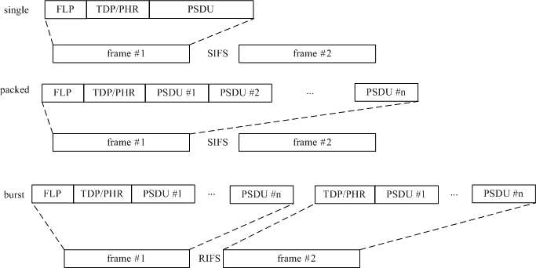

##### Figure 118—Data modes supported by the MAC (single, packed, burst)

The single mode transfers one PPDU per frame. This may be used for very short data communication such as acknowledgments, association, beaconing, or for information broadcast mode, for example.

The packed mode contains multiple PPDUs per frame and is used to send multiple consecutive PPDUs to the same destination within the frame for high throughput. Thus, the overhead of sending multiple MAC and PHY headers to the same destination is eliminated in this mode, providing higher MAC efficiency. This can be used in most modes as the preferred means of data communication.

The burst data mode uses a reduced length PHY preamble, as defined in 8.6.1, after the first frame in the burst. In addition, the RIFS is used between frames instead of the SIFS. The shorter preamble increases the efficiency and throughput in this mode.

The dimmed OOK mode is used to support data transfer under dimming requirements, as summarized in 4.4.3.2.

#### Dimming and flicker mitigation

A compliant device shall honor all dimming requests from the upper layer. The dimming request from the upper layers to the PHY shall be indicated using the PHY PIB attribute *phyDim* as shown in Table 115. The PHY shall support dimming using at least one of the techniques specified in either 8.5.1 or 8.5.2, when the PHY PIB attribute *phyDim* is set.

##### Dimming during idle time

The dimming during idle time is supported to avoid flicker and is achieved by the methods described in 4.4.3.2.1.

##### Idle pattern and compensation time dimming

An in-band or out-of-band idle pattern whose duty cycle variation results in brightness variation may be optionally inserted between the data frames for light dimming. Note that the concept of out-of-band includes the option of using an un-modulated DC bias to maintain properly dimmed visibility. The compensation time (i.e., the ON or OFF time of a light source but containing no modulated data) can be also inserted into either the idle pattern or into the data frame (if using the dimmed OOK mode) to reduce or increase the average brightness of a light source.

##### Visibility pattern dimming

The visibility pattern is an in-band idle pattern and is sent as part of the payload of the CVD frame as defined in 5.2.2.5. A set of 11 base low resolution patterns with 10% step size shall be used for dimming using visibility patterns. Any set of 11 base low resolution visibility patterns of any length can be used as long as there is no conflict between the visibility pattern and a valid RLL code. A set of 11 patterns are provided in Table 82 as an example for 8B10B code. The low resolution patterns shall be used to develop high resolution visibility patterns by averaging them across time to generate the required high resolution pattern. For example, if visibility patterns are available at 10% resolution, then a 25% visibility pattern can be attained for example, by alternately sending a 20% visibility pattern followed by a 30% visibility pattern. This method guarantees all visibility patterns will retain the same properties as the base low resolution visibility patterns. The high resolution visibility pattern shall be provided by using the low resolution patterns using the algorithm specified in Figure 119. The visibility patterns are repeated to satisfy the frame length as mentioned in the PHY header.

##### Table 82—Example of visibility patterns for 8B10B code

|  |  |
| --- | --- |
| **Visibility pattern** | **Percentage visibility (%)** |
| 11111 11111 | 100 |
| 11110 11111 | 90 |
| 11110 11110 | 80 |
| 11101 11100 | 70 |
| 11001 11100 | 60 |
| 10001 11100 | 50 |
| 00001 11100 | 40 |
| 00001 11000 | 30 |
| 00001 10000 | 20 |
| 00001 00000 | 10 |
| 00000 00000 | 0 |

Let the following values be defined as follows:

* Visibility patterns: V0, V1, … , V*K*
* Desired visibility = *dv* (expressed as a percentage value) e.g., for a 25.3% visibility, *dv* = 25.3

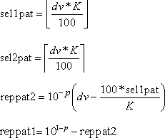Desired precision = *p*, *p* ≤ 0, *p* is an integer (expressed as a logarithm value) e.g., for 0.01%, precision, *p* = –2

Then, to achieve visibility *dv*:

* + repeat Vsel1pat reppat1 times, and
  + repeat Vsel2pat reppat2 times.

##### Figure 119—Algorithm for achieving 0.1% dimming resolution with visibility patterns

##### Dimming during data transmission time

The dimming technologies on data transmission time depend on the PHY modulation schemes and are designed to avoid flicker. As stated in 8.5, all devices shall honor dimming requests but a device shall not be required to support communication for any dimming request. In this case a device may issue a disassociation notification command (see 5.3.3) with the reason given in Table 15. Due to non-linear human eye response to light, dimming levels as low as 0.1% shall be supported for PHY I, PHY II, and PHY III (square law phenomenon).

The PHY modes utilize compensation symbol insertion dimming (4.4.3.2.1), pulse width dimming (4.4.3.2.2), amplitude dimming (4.4.3.2.3), and/or out-of-band dimming (4.4.3.2.4). Table 83 shows a summary of available dimming methods for each PHY operating modes.

##### Table 83—Choice of dimming methods for PHY operating modes

|  |  |  |  |  |
| --- | --- | --- | --- | --- |
| **Mode** | **Compensation symbol insertion dimming** | **Pulse width dimming** | **Amplitude dimming** | **Out-of-band dimming** |
| **PHY I, PHY II, and PHY III operating modes** | | | | |
| OOK | x |  | x | x |
| VPPM |  | x | x | x |
| CSK |  |  | x | x |

**Table 83—Choice of dimming methods for PHY operating modes *(continued)***

|  |  |  |  |  |
| --- | --- | --- | --- | --- |
| **Mode** | **Compensation symbol insertion dimming** | **Pulse width dimming** | **Amplitude dimming** | **Out-of-band dimming** |
| **PHY IV operating modes** | | | | |
| UFSOOK |  | x | x | x |
| S2-PSK |  |  | x | x |
| Twinkle VPPM |  | x | x | x |
| HS-PSK |  | x | x | x |
| Offset-VPWM |  | x |  |  |
| **PHY V operating modes** | | | | |
| RS-FSK |  | x | x | x |
| CM-FSK |  | x | x | x |
| C-OOK |  |  | x | x |
| MPM | x | x | x | x |
| **PHY VI operating modes** | | | | |
| A-QL, HA-QL, VTASC, SS2DC, IDE | |  | x |  |

* + - 1. **CSK-mode dimming**

Dimming is described in 4.4.3.2. In CSK, total average power of multiple light sources is constant. For dimming control, the instantaneous power per light source is changed in order to adjust the average intensity to the required level. CSK keeps the center color of the color constellation with required intensity. A color stabilization scheme for illuminators is also provided in 8.5.4.

##### OOK-mode dimming

Dimming is described in 4.4.3.2. The OOK-mode dimming is supported by using the dimmed OOK bit field set in the PHY header as explained in Table 89 in 8.6.2. An arbitrary dimming level accuracy can be achieved by the combined use of the compensation length (described in 8.6.4.1.2), and optical mapping and extinction ratio (described in 8.3.2). If any requested dimming results in unsatisfactory performance (e.g., flicker generation or color shifting) while trying to maintain compliance to this standard, then the device shall disassociate from the network. The dimming method used by an unassociated device is out of the scope of this standard.

##### VPPM-mode dimming

Dimming is described in 4.4.3.2. VPPM, as implemented here (see 10.6), supports a dimming-level resolution of 10%. To support a dimming resolution of 0.1%, as prescribed in 5.3.10, the VPPM PHY shall use the algorithm provided below.

The algorithm relies on the following symbols: VS0, VS1, VS2, … VS10. VS0 corresponds to the light source being turned off (*macDim* = 0) and VS10 corresponds to the light source fully being turned on (*macDim* = 1000). VS1 to VS9 are the VPPM symbols for *d* = 0.1 to 0.9 (see 10.6).

* + - * 1. Choose the dimming level *macDim* (see Table 62).
        2. First, determine the type of the corresponding symbols, viz.

*k*1  *macDim* /100

and

*k*2  *macDim* /100 , where

• stands for rounding to the next lower integer and

•

for

rounding to the next higher integer.

* + - * 1. Next, calculate the number of how often each symbol is to be sent: rep_2 =

*macDim* – 100  *k*1

and rep_1 = 100 – rep_2 .

* + - * 1. Then, to achieve the desired dimming level *macDim*:

Sequentially assign VS*k*1 rep_1 times, and then,

Assign VS*k*2 rep_2 times.

If the number of VPPM data symbols, to be sent, is not modulo 100, then add VPPM idle- pattern symbols so that the number of VPPM symbols to be sent becomes multiples of 100. The configurations of VPPM data and idle-pattern symbols are shown in Figure 120.

data transmission none data

|  |  |  |  |
| --- | --- | --- | --- |
| VPPM  data  VS*k*  1 | VPPM  data  VS*k*  2 | VPPM  data  VS*k*  1 | VPPM  data  VS*k*  2 |

|  |  |  |
| --- | --- | --- |
| VPPM  data  VS*k*  1 | VPPM  idle pattern  VS*k*  1 | VPPM  idle pattern  VS*k*  2 |

fractionally dimmed fractionally dimmed fractionally dimmed

data transmission

none data

|  |  |  |  |
| --- | --- | --- | --- |
| VPPM  data  VS*k*  1 | VPPM  data  VS*k*  2 | VPPM  data  VS*k*  1 | VPPM  data  VS*k*  2 |

|  |  |  |
| --- | --- | --- |
| VPPM  data  VS*k*  1 | VPPM  data  VS*k*  2 | VPPM  idle pattern  VS*k*  2 |

fractionally dimmed

fractionally dimmed

fractionally dimmed

##### Figure 120—Sequential proportional cycling between two duty symbols to achieve fractional dimming with 0.1% accuracy in VPPM mode

The upper panel shows padding with VS*k*1 and then VS*k*2 idle patterns. The lower panel shows padding with VS*k*2 idle-patterns.

Note that during data transmission time, only VPPM symbols between VS1 and VS9 can carry data information, as shown in Table 119. This is because VS0 (light full off) and VS10 (light full on) cannot carry data information because there are no transitions during these two symbols. Therefore, when a *macDim* value less than 100 is required, data information is carried only by VS1 symbols. Similarly, data information is carried only by VS9 symbols when a *macDim* value greater than 900 is required. All dimming requests must be honored even if data transmission is not possible. It is recommended that the receiver changes its matched filter in step with the change in the transmitter-symbol shape in order to enable optimum detection.

By default, a 50% duty cycle shall be used for VPPM. If dimming is supported using VPPM, a dimming notification command shall be sent by the MAC. Both the TX and RX shall use the above algorithm for VPPM dimming. The transmitter shall honor all dimming requests from the upper layer. It is recommended that the transmitter uses the receiver’s capability information as provided in 5.3.19.1.1 for VPPM dimming support. This information is obtained during the device discovery process described in 5.1.2.4.

##### PHY IV dimming

* + - * 1. **UFSOOK dimming**

UFSOOK accomplishes dimming by changing the duty cycle of the mark and space OOK frequency. Normally the duty cycle is 50%. Decreasing the duty cycle makes the light appear dimmer. Increasing the duty cycle makes the light appear brighter. One of the harmful effects of varying the duty cycle is a decrease in energy per bit (Eb), which manifests itself as the increasingly difficult task of finding the proper sampling phase. The proposed solution is multiphase sampling and repeat coding with voting to mitigate the narrower pulse shape as shown in Figure 121.

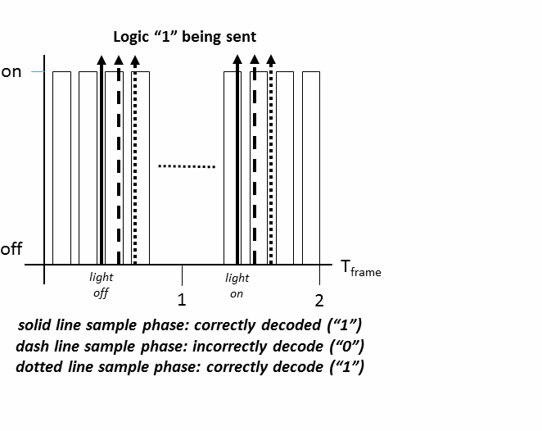

**Figure 121—UFSOOK multiphase dimming**

##### Twinkle VPPM dimming

Twinkle VPPM utilizes amplitude dimming.

##### Offset-VPWM dimming

Offset-VPWM causes flicker, and dimming is supported by pulse width dimming.

##### S2-PSK dimming

S2-PSK dimming is achieved by amplitude modulation as described in 4.4.3.2.3. The configuration of dimming level for S2-PSK shall be implemented over the PHY PIB attribute *phyDim*.

##### HS-PSK dimming

HS-PSK may implement PWM dimming and/or AM dimming as a hybrid dimming method. The dimmable spatial eight-phase shift keying (DS8-PSK) implements dimming over PWM because the DS8-PSK waveform consists of multiple VPPM waveforms. However, two dimming levels (a low dimming level and a high dimming level) shall be applied to the DS8-PSK to generate the AM envelop of the HS-PSK output waveform.

The configuration of two dimming levels is implemented via the two PHY PIB attributes *phyHSpskLowDim*

and *phyHSpskHighDim*.

The configuration of either the PHY PIB attribute *phyHSpskLowDim* or the PHY PIB attribute

*phyHSpskHighDim* or both changes the OFF and ON ratio of the AM envelope of the HS-PSK waveform.

##### PHY V dimming

* + - * 1. **RS-FSK dimming**

RS-FSK dimming is achieved by controlling the pulse width as described in 4.4.3.2.2. The configuration of RS-FSK dimming level shall be implemented via the PHY PIB attribute *phyDim*.

##### CM-FSK dimming

CM-FSK dimming is achieved in the same manner as RS-FSK.

##### C-OOK dimming

The preamble symbol and data symbols are all symmetric symbols, and the average brightness of those is constant at 50%. The optical clock rate is also constant at a considerable low frequency, 2.2 kHz or 4.4 kHz.

C-OOK PHY modes achieve dimming by controlling the amplitude of ones or zeros in OOK signal. The configuration of ones’ amplitude generates the average brightness output at the dimmed level (< 50%). Meanwhile, the configuration of zeros’ amplitude achieves the average brightness output at the bright level (> 50%). The achieved dimming level is the average brightness of one and zero.

##### MPM dimming

MPM utilizes dimming by compensation symbol insertion, amplitude dimming, and out-of-band dimming. Additionally, mirror pulse position modulation (MPPM) utilizes pulse width dimming.

##### 8.5.2.6 PHY VI dimming

PHY VI modes operate with flicker, and dimming is supported by analog dimming but not during data transmission.

##### Flicker mitigation

Flicker mitigation can be divided into intraframe mitigation and interframe flicker mitigation as described in 4.4.3.1.

Intraframe flicker mitigation refers to mitigation flicker within the transmission of a data frame. Intraframe flicker in OOK is avoided by the use of the dimmed OOK mode as described in 8.5.2.2**,** and RLL coding as described in 8.2. VPPM inherently does not cause any interframe flicker and also uses an RLL code. Interframe flicker is avoided in CSK by ensuring constant average power across multiple light sources along with scrambling and the high optical clock rates (MHz) at which this modulation is used.

Interframe flicker mitigation applies to both data transmission (RX mode) and idle periods. While idling, visibility patterns or idle patterns as described in 8.5.1 may be used to provide light emission by the OWC transmitters have the same average brightness over adjacent MFTPs as during data transmission. These patterns can be modulated in-band or out-of-band as in 8.5.1.1.

When the dimmer setting is changed above the MAC sublayer, the MAC sublayer and PHY adjust the data transmission and idle time transmission to adjust to the new dimmer settings. A summary of the different mitigation techniques for interframe and intraframe flicker is provided in Table 84.

##### Table 84—Flicker mitigation for various modulation modes

|  |  |  |
| --- | --- | --- |
| **Flicker mitigation** | **Data transmission (intraframe flicker)** | **Idle or RX periods (interframe flicker)** |
| OOK modulation | Dimmed OOK mode, RLL code | Idle/visibility patterns |
| VPPM | VPPM guarantees no intraframe flicker, RLL code |
| CSK modulation | Constant average power across multiple light sources, scrambler, high optical clock rates (MHz) |

##### CSK color stabilization at the transmitter

This mode is optional and is used for PHY III devices. The control-loop model for the color stabilization scheme is shown in Figure 122. The goal of this control mechanism is to stabilize the center of gravity of the CSK constellation diagram as described in 12.4. Visibility patterns, as described in 8.5.1.2, are sent from the tri-band TX of PHY III to a tri-band RX. An optional back link is used to relay these signals back to the tri- band TX, where they are used to correct the LED driving currents in such a way that the center of gravity of the constellation diagram is moved back to its initial position.

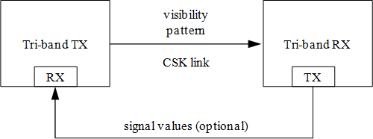

##### Figure 122—Control loop for a color-stabilized CSK link

Figure 123 shows the details of the color stabilization mechanism. Upon transmission of visibility patterns, the received signals after the digital-to-analog converters (D/As) are relayed back to the CSK transmitter. In a color stabilization module, which is out of the scope of this standard, compensation factors *c* for each band are calculated.9 Thereafter, all signal values outputted by the *xy*-to-(*i*,*j*,*k*) converter are multiplied by the respective compensation factors.

In the color stabilization mode, the visibility patterns to be used are in-band idle patterns with 100% visibility (as described in 8.5.1.2). The *xy* values of the emitted light coincides with the color chosen for the visibility pattern phase. The length of the visibility pattern in the CVD frame, as described in 4.4.3.2, is

9 The calculation of the compensation factors is outside the scope of this standard. Examples for such calculations can be found elsewhere in the literature (Walewski [B14]).

chosen so that thermal equilibrium in all band emitters is reached before sending the next CVD frame. The received signal (see Figure 123) is only acquired for the last sent bit of the last visibility pattern or an average over a suitable number of last bits.

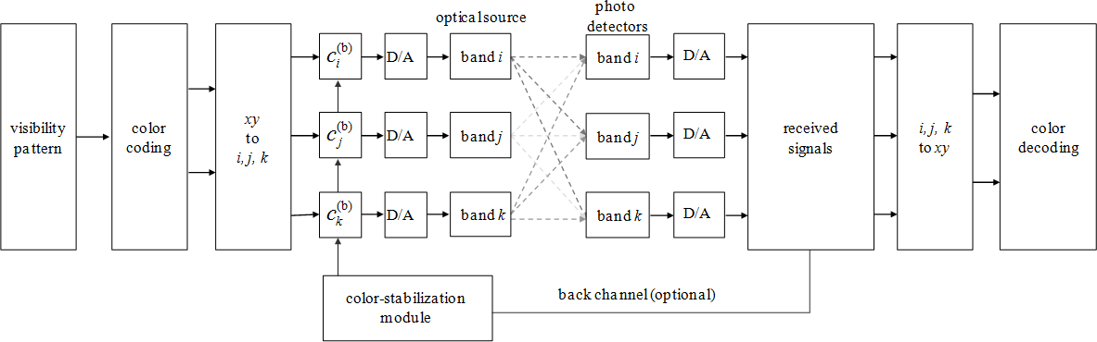

##### Figure 123—Color stabilization link implementation

#### PPDU format

For convenience, the PPDU frame structure is presented so that the leftmost field as written in this standard shall be transmitted or received first. All multiple octet fields shall be transmitted or received least significant octet first and each octet shall be transmitted or received LSB first. The same transmission order should apply to data fields transferred between the PHY and the MAC sublayer. The PPDU frame structure shall be formatted as illustrated in Figure 124.

|  |  |  |  |  |
| --- | --- | --- | --- | --- |
| Preamble (see 8.6.1) | PHY Header (see 8.6.2) | HCS (see 8.6.3) | Optional fields (see 8.6.4) | PSDU (see 8.6.5) |
| SHR | PHR | | | PHY payload |

##### Figure 124—Format of the PPDU

Use of over-the-air PHY frame configuration shall not be done for PHY IV, PHY V, and PHY VI, which shall accomplish PHY frame configuration via the PHY PIB. There shall be no “base default” transmission mode for PHY IV, PHY V, and PHY VI. The PHY PIB shall not be transmitted; rather, it shall be written by the DME and shall be read by the PHY.

##### Preamble field

* + - 1. **PHY I, PHY II, and PHY III**

The Preamble field is used by the transceiver to obtain optical clock synchronization with an incoming message. The standard defines one fast locking pattern (FLP) followed by a choice of four topology- dependent patterns (TDPs) to distinguish different PHY topologies. The MAC shall select the optical clock rate for communication during the clock-rate selection process as defined in 6.5. The preamble shall be sent at a clock rate chosen by the TX and supported by the RX. The preamble is a time domain sequence and does not have any channel coding or line coding.

The preamble first starts with a FLP of at least 64 alternate ones and zeros; that is, the FLP starts as a “1010…” pattern and ends with a ‘0’. The FLP length shall not exceed the maximum as shown in Figure 125. After the FLP, four repetitions of one of four TDPs (defined in Figure 126) shall be sent. The TDP shall be 15 bits in length and the TDP shall be inverted every other repetition to provide DC balance.

64 to 16,384 bits 60 bits

|  |  |  |  |  |
| --- | --- | --- | --- | --- |
| FLP (101010 …) | TDP | ~TDP | TDP | ~TDP |

##### Figure 125—Preamble transmission

P1 : 1 1 1 1 0 1 0 1 1 0 0 1 0 0 0

P2 : 0 0 1 0 1 1 1 0 1 1 1 1 1 1 0

P3 : 1 0 0 1 1 0 0 0 0 0 1 0 0 1 1

P4 : 0 1 0 0 0 0 1 1 0 1 0 0 1 0 1

**Figure 126—TDPs for various topologies**

The preambles shall be transmitted using an OOK modulation. The Preamble field for single data mode and packed data mode shall be formatted as illustrated in Figure 125. For PHY III, all the three light sources shall transmit the same preamble pattern simultaneously in the supported frequency bands within the error tolerance specified in 8.3.3.

For the burst mode transmission, the FLP shall be included only for the first frame. Subsequent frames shall not include the FLP in the burst mode since the receiver is already synchronized to the transmitter. This reduces the preamble length by at least half and provides higher throughput at the MAC sublayer. The Preamble field for burst data mode shall be formatted as illustrated in Figure 127.



##### Figure 127—Burst preamble transmission

The TDP used for a specific a topology is defined in Table 85. The topologies are given in 4.2.

##### Table 85—TDP assignments for various topologies

|  |  |
| --- | --- |
| **TDP** | **Topology** |
| P1 | Topology independent (visibility) |
| P2 | Peer-to-peer |
| P3 | Star |
| P4 | Broadcast |

The same preamble sequences shall be used for all PHY types. The number of repetitions of the FLP can be extended by the MAC during idle time or for different operating modes for better synchronization or to provide visibility or image array receiver-based device discovery.

##### PHY IV

* + - * 1. **UFSOOK Preamble field**

The UFSOOK preamble is a start frame delimiter (SFD) consisting of two consecutive video frames of high- frequency OOK followed by two consecutive video frames of UFSOOK logic one frequency (defined in 13.1.2). See Figure 128.

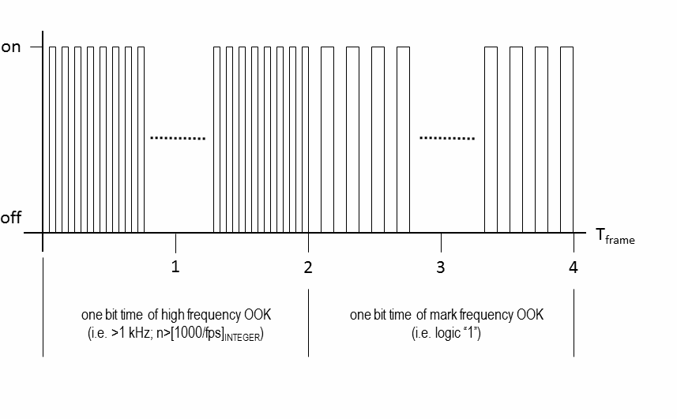

**Figure 128—UFSOOK SFD**

##### Twinkle VPPM Preamble field

The Twinkle VPPM Preamble is actually an SFD as shown in Figure 129.

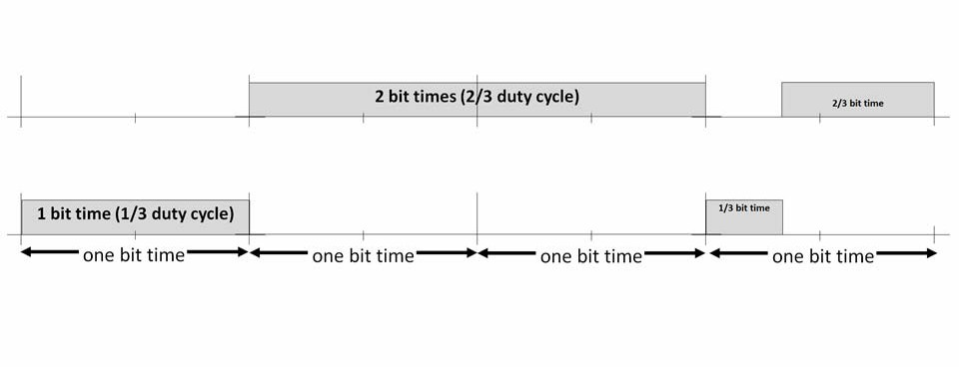

**Figure 129—Twinkle VPPM SFD**

The SFD for 2/3 duty cycle is 4 symbol times long and consists of 1 symbol of light OFF, followed by 2 symbols of light ON, followed by a 2/3 duty cycle VPPM logic 1.

The SFD for 1/3 duty cycle is 4 symbol times long and consists of 1 symbol of light ON, followed by 2 symbols of light OFF, followed by a 1/3 duty cycle VPPM logic 0.

##### Offset-VPWM Preamble field

The Preamble field is used by the transceiver to obtain optical clock synchronization with an incoming data.

The preamble first starts with an FLP. The FLP is fixed as a pattern "11010010". The timing information for preamble is shown in Figure 130.

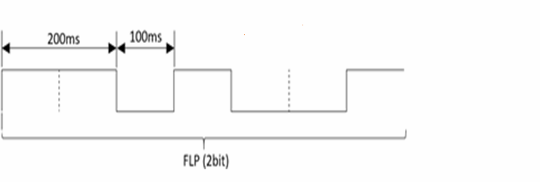

##### Figure 130—Preamble timing diagram

Offset-VPWM uses OOK modulation for the preamble transmission.

##### S2-PSK Preamble field

The Preamble field for S2-PSK has four binary states and is equivalent to two data bit durations long as shown in Figure 131. Each binary among the binary sequence "1 1 1 1" shall be mapped into waveforms to drive LEDs as described in 13.3.

|  |  |
| --- | --- |
| **Preamble duration** | **Two bit times** |
| S2-PSK preamble | 1 1 1 1 |

##### Figure 131—S2-PSK Preamble field

* + - * 1. **HS-PSK Preamble field**

The Preamble field for HS-PSK is two S2-PSK data bit durations long (see Table 86). In other words, the binary sequence "1111" shall be transmitted by two S2-PSK bit durations via the S2-PSK modulation, while the DS8-PSK modulation transmits no data (i.e., idle pattern).

##### Table 86—HS-PSK Preamble field

|  |  |
| --- | --- |
| **Preamble duration** | **Two S2-PSK bit times** |
| S2-PSK bit sequence | 1 1 1 1 |
| DS8-PSK bit sequence | No data (idle patterns) |

* + - 1. **PHY V**
         1. **RS-FSK Preamble field**

The Preamble field is used by the receiver to obtain optical clock synchronization with an incoming message. This will be the frequency baseline, which is denoted as *aPreambleFrequency* (see 5.1). The frequency used is 2.232 kHz, as specified in 9.5.1. The duration of the Preamble field is set to be one symbol duration, or 1/30 s (see 9.5.2).

##### CM-FSK Preamble field

The Preamble field for CM-FSK is two symbol durations and specifies two different frequencies (see Table 87).

##### Table 87—CM-FSK preamble

|  |  |  |
| --- | --- | --- |
| **Duration** | **First symbol time** | **Second symbol time** |
| Preamble | *fSF* | *f’SF* |

The second preamble (*f’SF*) is variable frequency calculated by

*f’SF* = *fSF* + 33 Δ*F*

where the first preamble (*fSF*) and the frequency separation (Δ*F*) are configurable by *phyCmfskPreamble* and

*phyCmfskFrequencySeparation*, respectively.

##### C-OOK Preamble field

The Preamble field for C-OOK is an OOK signal that operates at an out-of-band frequency.

##### MPM Preamble field

Not used.

##### PHY VI

* + - * 1. **IDE Preamble field**

The SHR is used with one FLP followed by a choice of four TDPs to distinguish different PHY topologies as shown in Table 85.

##### A-QL Preamble field

The Preamble field for A-QL is within a data-block duration. The preamble sequence (1010..10) shall have a 64-bit length. The remainder of a block carrying the preamble is for PHR subfields and the training sequence (see 15.1).

##### Hidden A-QL Preamble field

The Preamble field for HA-QL is one data block in duration (equivalent to two optical clock durations), consisting of two blocks.

The preamble sequence (1010…10) along with four states of reference cells have a 64-bit length and fill up the entire block of HA-QL code (8x8 HA-QL block for example) as described in 15.5.

When the HA-QL code has more than 64 cells, zeros are padded at the end of the preamble sequence to fill up the entire block of HA-QL code. A block of the preamble sequence and padded zeros shall be half-rate line coding mapped to be transmitted by a pair of HA-QL blocks, as described in 15.5.2.2.

##### SS2DC Preamble field

The Preamble field for SS2DC follows the IDE Preamble field mode. See 8.6.1.4.1 for more details.

##### VTASC Preamble field

The Preamble field for VTASC follows the IDE Preamble field mode. See 8.6.1.4.1 for more details.

##### 8.6.2 PHY Header field

**8.6.2.1 PHY I, PHY II, and PHY III**

The PHY header, as shown in Table 88, shall be transmitted with an OOK modulation. For PHY III, all light sources shall transmit the same header contents simultaneously within the error tolerance specified in 8.3.3 and the Band Plan ID field shall be set to be the band plan identifier of the lowest wavelength. The MAC shall select the optical clock rate for communication during the clock-rate selection process, as defined in

6.5. The PHY header shall be sent at the lowest data rate for the chosen optical clock rate. The clock rate does not change throughout the frame between the preamble, header, and payload. If the dimmed OOK extension bit is set in the PHY header for dimming support, additional fields are transmitted after the PHY header as shown in Table 89.

##### Table 88—PHY Header field

|  |  |  |
| --- | --- | --- |
| **PHY Header subfields** | **Bit width** | **Explanation on usage** |
| Burst Mode | 1 | Reduce preamble and IFS |
| Channel Number | 3 | Band plan identifier |
| MCS ID | 6 | Provide information about PHY type and data rate |
| PSDU Length | 16 | Length up to *aMaxPHYFrameSize* |
| Dimmed OOK Extension | 1 | Information on compensation time, resync, and length of subframe |
| Reserved subfields | 5 | Future use |

**Table 89—Dimmed OOK Extension subfield**

|  |  |  |
| --- | --- | --- |
| **Extension fields** | **Bit width** | **Explanation on usage** |
| Compensation Length | 10 | Compensation length in optical clocks |
| Resync Length | 4 | Number of resync optical clocks |
| Subframe Length | 10 | Length of subframe in optical clocks |
| OFCS | 8 | Optional field check sequence |

* + - * 1. **Burst Mode subfield**

The burst mode bit indicates that the next frame following the current frame is part of the burst mode. Refer to 5.2.2.2 for more detailed information.

##### Channel Number subfield

The channel number indicates the code used from Table 80. The channel number field for PHY III shall be the band plan identifier of the lowest wavelength. Refer to 8.3.1 for more detailed information.

##### MCS ID subfield

The PHY I, PHY II, and PHY III MCS IDs shall be indicated in the PHY header based on Table 90, which is not applicable to PHYs IV, PHY V, and PHY VI since these PHYs do not transmit a PHY header.

##### Table 90—MCS ID

|  |  |  |  |  |
| --- | --- | --- | --- | --- |
|  | **MCS indication** | **PHY** | **Data rate** | **Unit** |
| 0 | 000000 | I | 11.67 | kbps |
| 1 | 000001 | 24.44 |
| 2 | 000010 | 48.89 |
| 3 | 000011 | 73.3 |
| 4 | 000100 | 100 |
| 5 | 000101 | 35.56 |
| 6 | 000110 | 71.11 |
| 7 | 000111 | 124.4 |
| 8 | 001000 | 266.6 |
| 16 | 010000 | II | 1.25 | Mbps |
| 17 | 010001 | 2 |
| 18 | 010010 | 2.5 |
| 19 | 010011 | 4 |
| 20 | 010100 | 5 |
| 21 | 010101 | 6 |
| 22 | 010110 | 9.6 |
| 23 | 010111 | 12 |
| 24 | 011000 | 19.2 |
| 25 | 011001 | 24 |
| 26 | 011010 | 38.4 |
| 27 | 011011 | 48 |
| 28 | 011100 | 76.8 |
| 29 | 011101 | 96 |

**Table 90—MCS ID *(continued)***

|  |  |  |  |  |
| --- | --- | --- | --- | --- |
|  | **MCS indication** | **PHY** | **Data rate** | **Unit** |
| 32 | 100000 | III | 12 | Mbps |
| 33 | 100001 | 18 |
| 34 | 100010 | 24 |
| 35 | 100011 | 36 |
| 36 | 100100 | 48 |
| 37 | 100101 | 72 |
| 38 | 100110 | 96 |
| Others | | Reserved | | |

##### PSDU Length subfield

The PSDU Length subfield specifies the total number of octets contained in the PSDU. It is a value between 0 and *aMaxPHYFrameSize* as shown in 9.5.1.

##### Dimmed OOK Extension subfield

The dimmed OOK bit shall be set to one when supporting dimming while using OOK modulation. The dimmed OOK bit shall be set when the MAC PIB attribute, *macUseDimmedOOKmode*, as defined in Table 62, indicates the dimmed OOK mode usage. The dimmed OOK extension bit indicates that more optional fields are present at the end of the header. These fields are described in 8.6.4.1.2, 8.6.4.1.3, 8.6.4.1.4, and 8.6.4.1.5.

##### PHY IV

* + - * 1. **UFSOOK PHY Header field**

Not used.

##### Twinkle VPPM PHY Header field

The Twinkle VPPM PHY header consists of a 15-octet address, used for identifying the transmitting unit.

##### Offset-VPWM Preamble field

Not used.

##### S2-PSK PHY Header field

Not used.

##### HS-PSK PHY Header field

The HS-PSK PHY Header subfields shall be mandatory and configured by PHY PIB attributes. Both PHY PIB attributes and the PHY Header subfields (shown in Table 91) shall be used for HS-PSK.

##### Table 91—HS-PSK PHY Header subfields

|  |  |  |
| --- | --- | --- |
| **PHY Header subfields** | **Bit width** | **Explanation on usage** |
| PSDU length | 16 | PSDU length in byte |
| HCS | 16 | Header check sequence |

* + - 1. **PHY V**
         1. **RS-FSK PHY Header field**

Not used.

##### CM-PSK PHY Header field

Not used.

##### C-OOK PHY Header field

Not used.

##### MPM PHY Header field

Not used.

##### PHY VI

* + - * 1. **IDE PHY Header field**

The IDE PHY Header field is described in Table 92.

##### Table 92—IDE PHY Header field

|  |  |  |
| --- | --- | --- |
| **PHY Header subfields** | **Bit width** | **Explanation on usage** |
| PSDU Length | 16 | Length up to *aMaxPHYFrameSize* |
| Reserved fields | 6 | Future use |

The PSDU Length subfield specifies the total number of octets contained in the PSDU.

##### A-QL PHY Header field

The A-QL PHY Header field is same as the HS-PSK PHY Header mode. Refer to 8.6.2.2.5 for more details.

##### HA-QL PHY Header field

Not used.

##### SS2DC PHY Header field

The SS2DC PHY Header field follows the IDE PHY Header mode. Refer to 8.6.2.4.1 for more details.

##### VTASC PHY Header field

The VTASC PHY Header field follows the IDE PHY Header mode. Refer to 8.6.2.4.1 for more details.

##### HCS field

* + - 1. **PHY I, PHY II, and PHY III**

The PHY header shall be protected with a 2-octet CRC-16 header check sequence (HCS). A schematic of the CRC processing used for HCS calculation is shown in Annex . The HCS bits shall be processed in the transmit order. The registers shall be initialized to all ones.

##### PHY IV

**8.6.3.2.1 HS-PSK HCS**

CRC-16 shall be used as HCS. The generation of CRC-16 (with polynomial generator 0x1021) is described in Annex C.

##### PHY V

Not used.

##### PHY VI

* + - * 1. **A-QL HCS**

CRC-16 shall be used as HCS. The generation of CRC-16 (with polynomial generator 0x1021) is described in Annex C.

##### Hidden A-QL HCS

Not used.

##### Optional fields

The structure of the PPDU optional fields is shown in Figure 132.

Tail Bits (see 8.6.4.1.1)

|  |  |  |  |  |  |
| --- | --- | --- | --- | --- | --- |
| Compensation Length  (see 8.6.4.1.2) | Resync Length  (see 8.6.4.1.3) | Subframe Length  (see 8.6.4.1.4) | OFCS (see 8.6.4.1.5) |  | Channel Estimation Sequence  (see 8.6.4.1.6) |

* + - 1. (b) (c)

##### Figure 132—PPDU optional fields

* + - 1. **PHY I, PHY II, and PHY III**

The optional fields shall be formatted as shown in Figure 132. The optional fields in Figure 132 (a) shall be transmitted only when PHY I is used with an optical clock of 200 kHz based on the MCS ID chosen in the PHR. The optional fields in Figure 132 (b) shall be transmitted after the tail bits only if the dimmed OOK bit is set in the PHR. The optional field in Figure 132 (c) shall be transmitted only if PHY III is selected based on the MCS ID chosen in the PHR. The dimmed OOK mode shall not be used with PHY III; i.e., the optional fields (b) and (c) shall never be used simultaneously. Optional fields (a) and (c) shall also never be transmitted simultaneously since they correspond to different PHY types.

##### Tail bits

Six tail bits of zeros shall be added after the HCS when PHY I is used with an optical clock rate of 200 kHz.

##### Compensation length

The compensation length has a 10-bit value, which indicates the number of compensation symbols at the optical clock rate. The values of these compensation symbols are user defined. When used, this field shall be set to a value between 0 to 1023.

##### Resync length

The resync length has a 4-bit value, which indicates the number of resync symbols at the optical clock rate. The resync pattern used is the same as the FLP. When used, this field shall be set to a value from 0 to 15, with a default value of 15.

##### Subframe length and generation

The subframe length has a 10-bit value, which indicates the number of uncoded data bits in the subframe. When used, this field shall be set to a value of 0 to 1023. The subframes shall be generated at the transmitter after the FCS has be determined and the FEC has been applied. The FEC and FCS shall not include the compensation symbols and the resync symbols. All subframes shall have the same length except for the last subframe, which may be truncated to meet the frame length.

##### Optional field check sequence generation

The PPDU optional field check sequence (OFCS) value is calculated across the compensation length, resync length and subframe length fields (as shown in Figure 132 (a) and inserted into the OFCS field.

The OFCS field shall be an 8-bit sequence (ITU-T I.432.1). It shall be the remainder of the division (modulo 2) by the generator polynomial *x*8 + *x*2 + *x* + 1 of the product *x*8 multiplied by the content of the header excluding the OFCS field.

The initial content of the register of the device computing the remainder of the division is preset to all ones and is then modified by division of the header, excluding the OFCS field, by the generator polynomial. The resulting remainder is the 8-bit OFCS.

##### Channel estimation sequence

The channel estimation sequences are three optional 8-bit sequences and are used only for PHY III operation. The information about PHY III is obtained after decoding the PHY header. The channel estimation sequence details are discussed in 12.9.

##### PHY IV

Not used.

##### PHY V

* + - * 1. **RS-FSK optional fields**

The value of the optional field should be a specific ratio of the preamble frequency; therefore, the frequency used in the PSDU cannot overlap with the one used in the optional field. If the optional field is assigned, then the data in the PSDU will be the only parameter of the field of interest; no data payload can be assigned at the same time. The optional fields shall be formatted as shown in Figure 133.

The optional Frequency Labeling field shall be transmitted only when the transmitter informs the receiver about the frequencies used in the data packets. The optional PIB Attribute field shall be transmitted when one tries to configure the PIB values (see Clause 5 for more details). The optional Frequency Labeling and PIB Attribute fields shall never be used simultaneously since they correspond to different attributes.

Gap

Frequency

Labeling

PIB Attribute

**(b) (c)**

##### Figure 133—PPDU optional fields

1. **Gap field.** Gap field is a blank field, which is used to indicate the start of the optional field. The frequency used by the gap field is defined as 20 times of the preamble frequency, i.e., 44.62 kHz. The duration of the field is one symbol duration.
2. **Frequency Labeling field.** Frequency Labeling field is a value defined precisely at one and a half of the preamble frequency, i.e., 3.3 kHz. This is transmitted for one symbol duration. When this field is transmitted, it indicates the PSDU contains the data frequency that will be used in subsequent transmitted data frames (see 6.2), and the PSDU will operate without symbol delimiter as shown in Figure 133.
3. **Frequency labeling under RS-FSK-C8.** When transmitting frequency labels, PSDU encapsulates only one frequency *fbase*=*f*1. The rest of the frequencies, i.e., {*fi* | *i=*2…8}, are determined by the ratio of them to *fbase* (see Table 93).

##### Table 93—Frequency ratios for RS-FSK-C8

|  |  |  |
| --- | --- | --- |
| **Level** | **Frequency ratio** | **Bit pattern** |
| 1 | *fbase* | 000 |
| 2 | (18/17) *fbase* | 001 |
| 3 | (18/16) *fbase* | 010 |
| 4 | (18/15) *fbase* | 011 |
| 5 | (18/14) *fbase* | 100 |
| 6 | (18/13) *fbase* | 101 |
| 7 | (18/12) *fbase* | 110 |
| 8 | (18/11) *fbase* | 111 |

The PIB attribute *phyRsfskNumFrequency* in Table 115 is used to indicate RS-FSK-C8.

1. **Frequency labeling under RS-FSK-C16.** When transmitting frequency labels, PSDU encapsulates only one frequency *fbase*=*f*1. The rest of the frequencies, i.e., {*fi* | *i=*2…16}, are determined by the ratio of them to *fbase* (see Table 94).

##### Table 94—Frequency ratios for RS-FSK-C16

|  |  |  |
| --- | --- | --- |
| **Level** | **Frequency ratio** | **Bit pattern** |
| 1 | *fbase* | 000 |
| 2 | (36/35) *fbase* | 001 |
| 3 | (36/34) *fbase* | 010 |
| 4 | (36/33) *fbase* | 011 |
| 5 | (36/32) *fbase* | 100 |
| 6 | (36/31) *fbase* | 101 |
| 7 | (36/30) *fbase* | 110 |
| 8 | (36/29) *fbase* | 111 |
| 9 | (36/28) *fbase* | 000 |
| 10 | (36/27) *fbase* | 001 |
| 11 | (36/26) *fbase* | 010 |
| 12 | (36/25) *fbase* | 011 |
| 13 | (36/24) *fbase* | 100 |
| 14 | (36/23) *fbase* | 101 |
| 15 | (18/22) *fbase* | 110 |
| 16 | (18/21) *fbase* | 111 |

The PIB attribute *phyRsfskNumFrequency* in Table 115 is used to indicate RS-FSK-C16.

##### 8.6.4.4 PHY VI

**8.6.4.4.1 A-QL optional field**

A channel estimation sequence is added as an extended subfield after the PHR subfields to support a receiver dealing with multi-color imbalance or multi-color interference. The channel estimation sequence details are discussed in 15.1.4.

##### PSDU field

* + - 1. **PHY I, PHY II, and PHY III**

The PSDU field has a variable length and carries the data of the PHY frame. The FCS is appended if the PSDU has a non-zero byte payload. Six tail bits of zeros are attached to end of the PSDU, if PHY I is used with data rates of 11.67 kbps, 24.44 kbps, or 48.89 kbps. The structure of the PSDU field is as shown in Figure 134.

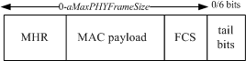

##### Figure 134—PSDU field structure

The complete PPDU format for the PHY is shown in Figure 135.

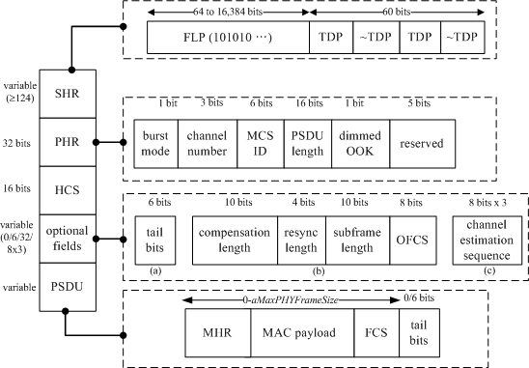

##### Figure 135—PPDU structure

* + - 1. **PHY IV**
         1. **UFSOOK PSDU field**

The UFSOOK PSDU field can contain an arbitrary number of payload bits. The end of the PSDU field is indicated by the presence of another SFD.

##### Twinkle VPPM PSDU field

The Twinkle VPPM PSDU field can contain an arbitrary number of payload bits. The end of the PSDU field is indicated by the presence of another SFD.

##### Offset-VPWM PSDU field

The Offset-VPWM PSDU field has a variable length and carries the arbitrary number of payload bits. The end of the PSDU field is indicated by the presence of another SFD, i.e., the preamble frame.

##### S2-PSK PSDU field

The number of payload bits in the S2-PSK PSDU field is variable, counted from the preamble of the PPDU frame to the preamble of the next PPDU frame.

##### HS-PSK PSDU field

The HS-PSK PSDU field consists of multiple S2-PSK cycle times; each cycle is a subframe that has a low dimming period and a high dimming period so that each period also consists of multiple DS8-PSK data symbols. Each symbol carries 3 bits of data (see Table 95).

The number of DS8-PSK symbols (*N*) that either the low dimming period or the high dimming period of S2-PSK carries is equal to the optical clock rates ratio between the DS8-PSK and the S2-PSK.

##### Table 95—HS-PSK PSDU subframe format

|  |  |  |  |  |  |  |  |
| --- | --- | --- | --- | --- | --- | --- | --- |
| **S2-PSK low dimming period** | | | | **S2-PSK high dimming period** | | | |
| DS8-PSK  symbol 1 | DS8-PSK  symbol 2 | ... | DS8-PSK  symbol *N* | DS8-PSK  symbol 1 | DS8-PSK  symbol 2 | ... | DS8-PSK  symbol *N* |

The end of the PSDU of HS-PSK is indicated by the presence of another HS-PSK preamble. The configuration of the PSDU length is implemented via the PHY PIB attribute *phyPsduLength* and is announced by sending the updated PSDU length via the PHY header subfield.

##### PHY V

* + - * 1. **MPM PSDU field**

The MPM PPDU consists of the PSDU field only. The PSDU field contains an MPDU that is converted by MPM physical layer conversion protocol (PLCP).

##### RS-FSK PSDU field

The RS-FSK PSDU field has a variable length and carries the data of the PHY frame. The symbol delimiter (SD) is introduced at the head and tail of each carried data symbol (DS), as shown in Figure 136. The head and tail SD are still appended if the PSDU has no payload as shown in Figure 137.

|  |  |  |  |  |  |  |  |  |
| --- | --- | --- | --- | --- | --- | --- | --- | --- |
| SD | DS 1 | SD | DS 2 | SD | ... | SD | DS *N* | SD |

##### Figure 136—Format of the RS-FSK PSDU

SD

SD

**Figure 137—Format of the RS-FSK PSDU without data payload**

The SD is not necessary if the transceiver and the receiver are completely time-synchronized; i.e., the camera frame rate and the symbol rate are the same, and the start of the frame and the start of the symbol transmission are aligned. This feature can be disabled through the optional field (4.2.3). In that case, the PSDU field has the format in Figure 138.

|  |  |  |  |
| --- | --- | --- | --- |
| DS 1 | DS 2 | … | DS N |

##### Figure 138—Format of the PSDU without SD

Intuitively, when there is no payload, then the PSDU will cease to exist when SD is disabled.

The end symbol field is needed to mark the end of the PPDU so the receiver can acknowledge the end of this package. The end symbol frequency is defined as 0.75 times the preamble frequency, i.e., 1.673 kHz, and lasts for one symbol duration.

All the packets in the data frame are labeled with a sequence number (SEQ) of the finite field *FphyGapCount* in ascending order. If *phyGroupCount* is S, then the packets in the data frame start from SEQ #0 until SEQ #(S-1), and back to #1 again. An example is shown in Figure 139. A packet with sequence number of *s* uses the frequency set *Fs* (starting from *F*0), given by

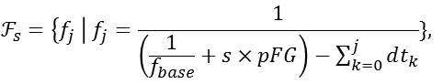

where the *fj* represents the frequency that corresponds to the *j*th largest bit pattern out of all possible bit patterns.

Using this method, each PHY packet can form a packet sequence with increasing sequence numbers, each represented by a different frequency set, determined by *phyFrequencyGap*. One can identify the PHY sequence via the received frequency and recover the corresponding packets, if any.

The data subframe is composed of multiple data packets, which is determined by *phyFEC*. The structure of the data subframe is shown in Figure 139. If *phyFEC* is *N*, then packets until the (*N–*1)th packets are the data packet (DP), while the *N*th packet is the FEC packet (FP). The FEC ratio is defined by the number of FEC packets divided by the number of total packets, 1/*N* in this case.

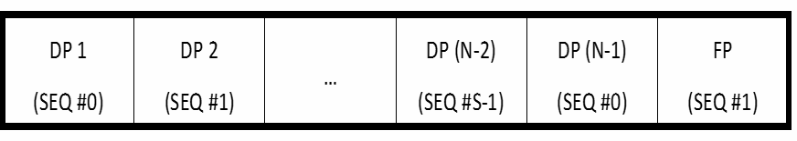

##### Figure 139—An example of data subframe structure

The FEC packets carry the result of the calculation of bit-wise XOR-ing all previous DPs. The FEC packet can be utilized to overcome any single symbol loss out of *N* packets (*N*–1 data packets and 1 FEC packet). The lost packet, if any, can be recovered by XOR-ing the other *N*–1 correctly received packets.

##### CM-FSK PSDU field

The CM-FSK PSDU field consists of multiple data frequency symbols, and each symbol carries multiple bits of data. The amount of bits carried by a frequency symbol depends on the number of frequencies used in modulation. By using 32 frequencies for modulation, 4 data bits along with an asynchronous bit (Ab) are transmitted by a frequency symbol each time. Likewise by using 64 frequencies for modulation, 5 data bits along with an asynchronous bit (Ab) are transmitted by a frequency symbol each time (see Table 96).

##### Table 96—PSDU payloads

|  |  |  |  |  |
| --- | --- | --- | --- | --- |
| **Mode** | **PSDU payloads** | | | |
| **frequency symbol 1** | **frequency symbol 2** | **...** | **frequency symbol *N*** |
| 32-FSK | (1 Ab + 4 data bits) | (1 Ab + 4 data bits) |  | (1 Ab + 4 data bits) |
| 64-FSK | (1 Ab + 5 data bits) | (1 Ab + 5 data bits) |  | (1 Ab + 5 data bits) |
| 64-FSK/2-PSK | (1 Ab + 6 data bits) | (1 Ab + 6 data bits) |  | (1 Ab + 6 data bits) |

During transmission, the symbol rate of transmission must be less than the minimum frame rate of camera to guarantee that every symbol is sampled at least once.

##### C-OOK PSDU field

The C-OOK PSDU field consists of multiple data sub-packets as seen in Figure 140. Each data sub-packet consists of its own preamble and its data sub-packet payload carrying asynchronous bits (Start Data Ab and End Data Ab) and data bits (see Figure 141).

The configuration of PSDU length is implemented via the PHY PIB attribute *phyPsduLength*.

|  |  |  |  |
| --- | --- | --- | --- |
| PSDU | | | |
| Sub-packet 1 | Sub-packet 2 | ... | Sub-packet *N* |

##### Figure 140—PSDU types for C-OOK

|  |  |  |  |
| --- | --- | --- | --- |
| Preamble | Data sub-packet payload | | |
| Ab (start) | data bits | Ab (end) |

**Figure 141—Sub-packet**

* + - 1. **PHY VI**
         1. **IDE PSDU field**

The IDE PSDU field has a variable length and carries the arbitrary number of payload bits based on the block selection. The structure of the PSDU field is as shown in Figure 142.

|  |  |  |  |  |  |
| --- | --- | --- | --- | --- | --- |
|  | Block 1 | Block 2 | ... | Block *N*–1 | Block *N* |
| Data bits | Symbol 1 | Symbol 2 | ... | Symbol *N*–1 | Symbol *N* |

##### Figure 142—IDE PSDU field structure

* + - * 1. **A-QL PSDU field**

The A-QL PSDU field consists of multiple payload blocks. The count of the payload blocks in the PSDU (noted as *N*) is calculated from the PSDU length that is read from the PHY header.

##### Table 97—A-QL PSDU frame format

|  |  |  |  |
| --- | --- | --- | --- |
| PSDU | | | |
| Data block 1 | Data block 2 | ... | Data block *N* |

The configuration of PSDU length is implemented via the PHY PIB attribute *phyPsduLength*.

##### Hidden A-QL PSDU field

The HA-QL PSDU field consists of multiple payload blocks. The number of data blocks (noted as *N*) is counted from a preamble to the next preamble.

##### Table 98—HA-QL PSDU frame format

|  |  |  |  |
| --- | --- | --- | --- |
| PSDU | | | |
| Data block 1 | Data block 2 | ... | Data block *N* |

The configuration of PSDU length shall be implemented via the PHY PIB attribute *phyPsduLength*.

##### SS2DC PSDU field

The SS2DC PSDU field follows the IDE PSDU field structure. See 8.6.5.4.1 for more details.

##### VTASC PSDU field

The VTASC PSDU field follows the IDE PSDU field structure. See 8.6.5.4.1 for more details.

## PHY service specifications

#### Overview

The PHY provides an interface between the MAC sublayer and the physical optical channel. The PHY conceptually includes a management entity called the PLME. This entity provides the layer management service interfaces through which layer management functions may be invoked. The PLME is also responsible for maintaining a database of managed objects pertaining to the PHY. This database is referred to as the PHY PAN information base (PHY PIB).

Figure 143 depicts the components and interfaces of the PHY.

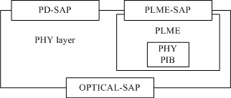

##### Figure 143—PHY SAPs

The PHY provides two services, accessed through two SAPs: the PHY data service, accessed through the PHY data SAP (PD-SAP), and the PHY management service, accessed through the PLME’s SAP (PLME-SAP). The optical SAP provides an interface between the PHY and the optical channel and is not specified in this standard. Any required light source drivers are considered to be part of the optical channel.

#### PHY management service

The PLME-SAP allows the transport of management commands between the MLME or the DME and the PLME. Table 99 lists the primitives supported by the PLME-SAP. These primitives are discussed in the subclauses referenced in Table 99.

##### Table 99—PLME-SAP primitives

|  |  |  |
| --- | --- | --- |
| **PLME-SAP primitive** | **Request** | **Confirm** |
| PLME-CCA | 9.2.1 | 9.2.2 |
| PLME-GET | 9.2.3 | 9.2.4 |
| PLME-SET | 9.2.5 | 9.2.6 |
| PLME-SET-TRX-STATE | 9.2.7 | 9.2.8 |
| PLME-SWITCH | 9.2.9 | 9.2.10 |

##### PLME-CCA.request

The PLME-CCA.request primitive requests that the PLME perform a CCA as defined in 8.3.9. The semantics of the PLME-CCA.request primitive are as follows:

PLME-CCA.request ()

There are no parameters associated with the PLME-CCA.request primitive.

##### When generated

The PLME-CCA.request primitive is generated by the MLME and issued to its PLME whenever the access algorithm requires an assessment of the channel.

##### Effect on receipt

If the receiver is enabled on receipt of the PLME-CCA.request primitive, the PLME will cause the PHY to perform a CCA.

##### PLME-CCA.confirm

The PLME-CCA.confirm primitive reports the results of a CCA. The semantics of the PLME-CCA.confirm primitive are as follows:

PLME-CCA.confirm ( status

)

Table 100 specifies the parameters for the PLME-CCA.confirm primitive.

##### Table 100—PLME-CCA.confirm parameters

|  |  |  |  |
| --- | --- | --- | --- |
| **Name** | **Type** | **Valid range** | **Description** |
| status | Enumeration | TRX_OFF, TX_ON, BUSY, IDLE | The result of the request to perform a CCA. |

* + - 1. **When generated**

The PLME-CCA.confirm primitive is generated by the PLME and issued to its MLME in response to a PLME-CCA.request primitive. When the PHY has completed the CCA, the PLME will issue the PLME- CCA.confirm primitive with a status of either BUSY or IDLE, depending on the result of the CCA.

If the PLME-CCA.request primitive is received while the transceiver is disabled (TRX_OFF state) or if the transmitter is enabled (TX_ON state), the PLME will issue the PLME-CCA.confirm primitive with a status of TRX_OFF or TX_ON, respectively.

##### Effect on receipt

On receipt of the PLME-CCA.confirm primitive, the MLME is notified of the results of the CCA. If the CCA attempt was successful, the status parameter is set to either BUSY or IDLE. Otherwise, the status parameter will indicate the error.

##### PLME-GET.request

The PLME-GET.request primitive requests information about a given PHY PIB attribute. The semantics of the PLME-GET.request primitive are as follows:

PLME-GET.request ( PIBAttribute

)

Table 101 specifies the parameters for the PLME-GET.request primitive.

##### Table 101—PLME-GET.request parameters

|  |  |  |  |
| --- | --- | --- | --- |
| **Name** | **Type** | **Valid range** | **Description** |
| PIBAttribute | Enumeration | As defined in Table 115 | The identifier of the PHY PIB attribute to get. |

* + - 1. **Appropriate usage**

The PLME-GET.request primitive is generated by the MLME and issued to its PLME to obtain information from the PHY PIB.

##### Effect on receipt

On receipt of the PLME-GET.request primitive, the PLME will attempt to retrieve the requested PHY PIB attribute from its database.

##### PLME-GET.confirm

The PLME-GET.confirm primitive reports the results of an information request from the PHY PIB. The semantics of the PLME-GET.confirm primitive are as follows:

PLME-GET.confirm ( status,

PIBAttribute, PIBAttributeValue

)

Table 102 specifies the parameters for the PLME-GET.confirm primitive.

##### Table 102—PLME-GET.confirm parameters

|  |  |  |  |
| --- | --- | --- | --- |
| **Name** | **Type** | **Valid range** | **Description** |
| Status | Enumeration | SUCCESS, UNSUPPORTED_ATTRIBUTE | The result of the request for PHY PIB attribute information. |
| PIBAttribute | Enumeration | As defined in Table 115 | The identifier of the PHY PIB attribute to get. |
| PIBAttributeValue | Various | Attribute specific | The value of the indicated PHY PIB attribute to get. |

* + - 1. **When generated**

The PLME-GET.confirm primitive is generated by the PLME and issued to its MLME in response to a PLME-GET.request primitive. If the identifier of the PIB attribute is not found in the database, the PLME will issue the PLME-GET.confirm primitive with a status of UNSUPPORTED_ATTRIBUTE.

If the requested PHY PIB attribute is successfully retrieved, the PLME will issue the PLME-GET.confirm primitive with a status of SUCCESS.

##### Effect on receipt

On receipt of the PLME-GET.confirm primitive, the MLME is notified of the results of its request to read a PHY PIB attribute. If the request to read a PHY PIB attribute was successful, the status parameter is set to SUCCESS. Otherwise, the status parameter will indicate the error.

##### PLME-SET.request

The PLME-SET.request primitive attempts to set the indicated PHY PIB attribute to the given value. The semantics of the PLME-SET.request primitive are as follows:

PLME-SET.request ( PIBAttribute,

PIBAttributeValue

)

Table 103 specifies the parameters for the PLME-SET.request primitive.

##### Table 103—PLME-SET.request parameters

|  |  |  |  |
| --- | --- | --- | --- |
| **Name** | **Type** | **Valid range** | **Description** |
| PIBAttribute | Enumeration | As defined in Table 115 | The identifier of the PIB attribute to set. |
| PIBAttributeValue | Various | Attribute specific, as defined in Table 115 | The value of the indicated PIB attribute to set. |

* + - 1. **When generated**

The PLME-SET.request primitive is generated by the MLME and issued to its PLME to write the indicated PHY PIB attribute.

##### Effect on receipt

On receipt of the PLME-SET.request primitive, the PLME will attempt to write the given value to the indicated PHY PIB attribute in its database.

##### PLME-SET.confirm

The PLME-SET.confirm primitive reports the results of the attempt to set a PIB attribute. The semantics of the PLME-SET.confirm primitive are as follows:

PLME-SET.confirm ( status,

PIBAttribute

)

Table 104 specifies the parameters for the PLME-SET.confirm primitive.

##### Table 104—PLME-SET.confirm parameters

|  |  |  |  |
| --- | --- | --- | --- |
| **Name** | **Type** | **Valid range** | **Description** |
| status | Enumeration | SUCCESS, UNSUPPORTED_ATTRIBUTE, INVALID_PARAMETER | The status of the attempt to set the requested PIB attribute. |
| PIBAttribute | Enumeration | As defined in Table 115 | The identifier of the PIB attribute being confirmed. |

* + - 1. **When generated**

The PLME-SET.confirm primitive is generated by the PLME and issued to its MLME in response to a PLME-SET.request primitive.

If the PIBAttribute parameter specifies an attribute that is not found in the database, as shown in Table 115, the PLME will issue the PLME-SET.confirm primitive with a status of UNSUPPORTED_ATTRIBUTE. If the PIBAttibuteValue parameter specifies a value that is out of the valid range for the given attribute, the PLME will issue the PLME-SET.confirm primitive with a status of INVALID_PARAMETER.

If the requested PHY PIB attribute is successfully written, the PLME will issue the PLME-SET.confirm primitive with a status of SUCCESS.

##### Effect on receipt

On receipt of the PLME-SET.confirm primitive, the MLME is notified of the result of its request to set the value of a PHY PIB attribute. If the requested value was written to the indicated PHY PIB attribute, the status parameter is set to SUCCESS. Otherwise, the status parameter will indicate the error.

##### PLME-SET-TRX-STATE.request

The PLME-SET-TRX-STATE.request primitive requests that the PHY entity change the internal operating state of the transceiver. The transceiver will have three main states as follows:

1. Transceiver disabled (TRX_OFF)
2. Transmitter enabled (TX_ON)
3. Receiver enabled (RX_ON)

The semantics of the PLME-SET-TRX-STATE.request primitive are as follows:

PLME-SET-TRX-STATE.request (

state

)

Table 105 specifies the parameters for the PLME-SET-TRX-STATE.request primitive.

##### Table 105—PLME-SET-TRX-STATE.request parameters

|  |  |  |  |
| --- | --- | --- | --- |
| **Name** | **Type** | **Valid range** | **Description** |
| state | Enumeration | RX_ON, TRX_OFF, FORCE_TRX_OFF, TX_ON | The new state in which to configure the transceiver. |

* + - 1. **When generated**

The PLME-SET-TRX-STATE.request primitive is generated by the MLME and issued to its PLME when the current operational state of the receiver needs to be changed.

##### Effect on receipt

On receipt of the PLME-SET-TRX-STATE.request primitive, the PLME will cause the PHY to attempt to change to the requested state.

##### PLME-SET-TRX-STATE.confirm

The PLME-SET-TRX-STATE.confirm primitive reports the result of a request to change the internal operating state of the transceiver.

The semantics of the PLME-SET-TRX-STATE.confirm primitive are as follows:

PLME-SET-TRX-STATE.confirm (

status

)

Table 106 specifies the parameters for the PLME-SET-TRX-STATE.confirm primitive.

##### Table 106—PLME-SET-TRX-STATE.confirm parameters

|  |  |  |  |
| --- | --- | --- | --- |
| **Name** | **Type** | **Valid range** | **Description** |
| status | Enumeration | SUCCESS, RX_ON, TRX_OFF, TX_ON, BUSY_RX, BUSY_TX | The result of the request to change the state of the transceiver. |

* + - 1. **When generated**

The PLME-SET-TRX-STATE.confirm primitive is generated by the PLME and issued to its MLME after attempting to change the internal operating state of the transceiver.

##### Effect on receipt

On receipt of the PLME-SET-TRX-STATE.confirm primitive, the MLME is notified of the result of its request to change the internal operating state of the transceiver.

If the state change is accepted, the PHY will issue the PLME-SET-TRX-STATE.confirm primitive with a status of SUCCESS. If this primitive requests a state that the transceiver is already configured, the PHY will issue the PLME-SET-TRX-STATE.confirm primitive with a status indicating the current state, i.e., RX_ON, TRX_OFF, or TX_ON. If this primitive is issued with RX_ON or TRX_OFF argument and the PHY is busy transmitting a PPDU, the PHY will issue the PLME-SET-TRXSTATE.confirm primitive with a status BUSY_TX and defer the state change until the end of transmission. If this primitive is issued with TX_ON or TRX_OFF argument and the PHY is in RX_ON state and has already received a valid preamble, the PHY will issue the PLME-SET-TRX-STATE.confirm primitive with a status BUSY_RX and defer the state change until the end of reception of the PPDU. If this primitive is issued with FORCE_TRX_OFF, the PHY will cause the PHY to go the TRX_OFF state irrespective of the state the PHY is in.

##### PLME-SWITCH.request

The PLME-SWITCH.request primitive request is used by the DME to request that the PHY entity select the switch to enable the appropriate cells in the SW-BIT-MAP. The semantics of the PLME-SWITCH.request primitive are as follows:

PLME-SWITCH.request (

SW-BIT-MAP, DIR

)

Table 107 specifies the parameters for the PLME-SET-TRX-STATE.request primitive.

##### Table 107—PLME-SWITCH.request parameters

|  |  |  |  |
| --- | --- | --- | --- |
| **Name** | **Type** | **Valid range** | **Description** |
| SW-BIT-MAP | Vector of  *n*  *m* entries | Boolean | One bit for each optical source or photodetector and is dependent on the direction. Setting the *k*th bit to a 1 brings the corresponding optical source or photodetector into the cell group. *n* is the number of  cells, and *m* is the number of distinct data streams from the PHY. The value of *m* is three for PHY III. |
| DIR |  | Boolean | 0 is for TX, and 1 is for RX. |

* + - 1. **When generated**

The PLME-SWITCH.request primitive is generated by the DME and issued to its PLME when the current cell selection needs to be changed.

##### Effect on receipt

On receipt of the PLME-SWITCH.request primitive, the PLME will cause the PHY to attempt to change to the cell.

##### PLME-SWITCH.confirm

The PLME-SWITCH.confirm primitive reports the result of a request to change the currently operating cell. The semantics of the PLME-SWITCH.confirm primitive are as follows:

PLME-SWITCH.confirm ( status

)

Table 108 specifies the parameters for the PLME-SWITCH.confirm primitive.

##### Table 108—PLME-SWITCH.confirm parameters

|  |  |  |  |
| --- | --- | --- | --- |
| **Name** | **Type** | **Valid range** | **Description** |
| status | Enumeration | SUCCESS | The result of the request to change the cell. |

* + - 1. **When generated**

The PLME-SWITCH.confirm primitive is generated by the PLME and issued to its DME after attempting to change the cell.

##### Effect on receipt

On receipt of the PLME-SWITCH.confirm primitive, the DME is notified of the result of its request to change the currently operating cell.

If the PHY switch is able to select the new cell, the PHY will issue the PLME-SWITCH.confirm primitive with a status of SUCCESS.

#### PHY data service

The PD-SAP supports the transport of MPDUs between a local MAC sublayer and a local PHY entity. Table 109 lists the primitives supported by the PD-SAP.

##### Table 109—PD-SAP primitives

|  |  |  |  |
| --- | --- | --- | --- |
| **PD-SAP primitive** | **Request** | **Confirm** | **Indication** |
| PD-DATA | 9.3.1 | 9.3.2 | 9.3.3 |

##### PD-DATA.request

The PD-DATA.request primitive requests the transfer of data from the MAC sublayer to form a PSDU at the local PHY entity.

The semantics of the PD-DATA.request primitive are as follows:

PD-DATA.request (

psduLength, psdu, bandplanID

)

Table 110 specifies the parameters for the PD-DATA.request primitive.

##### Table 110—PD-DATA.request parameters

|  |  |  |  |
| --- | --- | --- | --- |
| **Name** | **Type** | **Valid range** | **Description** |
| psduLength | Unsigned integer | 0–  *aMaxPHYFrameS ize* | The number of octets in the PSDU to be transmitted by the PHY entity. |
| psdu | Set of octets | — | The set of octets forming the PSDU to be transmitted by the PHY entity. |
| bandplanID | Unsigned integer | 0–6 | Color band channel of PSDU. |

* + - 1. **When generated**

The PD-DATA.request primitive is generated by a local MAC sublayer entity and issued to its PHY entity to request the transmission of an PPDU.

##### Effect on receipt

The receipt of the PD-DATA.request primitive by the PHY entity will cause the transmission of the supplied PPDU.

##### PD-DATA.confirm

The PD-DATA.confirm primitive confirms the end of the transmission of data from a local MAC sublayer entity.

The semantics of the PD-DATA.confirm primitive are as follows:

PD-DATA.confirm (

status

)

Table 111 specifies the parameters for the PD-DATA.confirm primitive.

##### Table 111—PD-DATA.confirm parameters

|  |  |  |  |
| --- | --- | --- | --- |
| **Name** | **Type** | **Valid range** | **Description** |
| status | Enumeration | SUCCESS, RX_ON, TRX_OFF | The result of the request to transmit a frame. |

* + - 1. **When generated**

The PD-DATA.confirm primitive is generated by the PHY entity and issued to its MAC sublayer entity in response to a PD-DATA.request primitive. Provided the transmitter is enabled (TX_ON state), the PHY will first construct a PPDU containing the supplied PSDU, and then transmit the PPDU. When the PHY entity has completed the transmission, it will issue the PD-DATA.confirm primitive with a status of SUCCESS.

If the PD-DATA.request primitive is received while the receiver is enabled (RX_ON state) or if the transceiver is disabled (TRX_OFF state), the PHY entity will issue the PD-DATA.confirm primitive with a status of RX_ON or TRX_OFF, respectively.

##### Effect on receipt

On receipt of the PD-DATA.confirm primitive, the MAC sublayer entity is notified of the result of its request to transmit. If the transmission attempt was successful, the status parameter is set to SUCCESS. Otherwise, the status parameter will indicate the error.

##### PD-DATA.indication

The PD-DATA.indication primitive indicates the transfer of data from the PHY to the local MAC sublayer entity.

The semantics of the PD-DATA.indication primitive are as follows:

PD-DATA.indication ( psduLength, psdu,

ppduLinkQuality

)

Table 112 specifies the parameters for the PD-DATA.indication primitive.

##### Table 112—PD-DATA.indication parameters

|  |  |  |  |
| --- | --- | --- | --- |
| **Name** | **Type** | **Valid** | **Description** |
| psduLength | Unsigned integer | 0–  *aMaxPHYFrameS ize* | The number of octets contained in the PSDU received by the PHY entity. |
| psdu | Set of octets | — | The set of octets forming the PSDU received by the PHY entity. |
| ppduLinkQuality | Unsigned integer | 0x00–0xff | WQI value measured during reception of the PPDU as defined in 5.3.19.2. |

* + - 1. **When generated**

The PD-DATA.indication primitive is generated by the PHY entity and issued to its MAC sublayer entity to transfer a received PSDU. This primitive will not be generated if the received psduLength field is zero or greater than *aMaxPHYFrameSize*.

##### Effect on receipt

On receipt of the PD-DATA.indication primitive, the MAC sublayer is notified of the arrival of data across the PHY data service.

#### PHY enumeration description

Table 113 shows a description of the PHY enumeration values defined in the PHY specification.

##### Table 113—PHY enumeration description

|  |  |  |
| --- | --- | --- |
| **Enumeration** | **Value** | **Description** |
| BUSY | 0x00 | The CCA attempt has detected a busy channel. |
| BUSY_RX | 0x01 | The transceiver is asked to change its state while receiving. |
| BUSY_TX | 0x02 | The transceiver is asked to change its state while transmitting. |
| FORCE_TRX_OFF | 0x03 | The transceiver is to be switched off. |
| IDLE | 0x04 | The CCA attempt has detected an idle channel. |
| INVALID_PARAMETER | 0x05 | A SET/GET request was issued with a parameter in the primitive that is out of the valid range. |
| RX_ON | 0x06 | The transceiver is in, or is to be configured into, the receiver enabled state. |
| SUCCESS | 0x07 | The request completed successfully. |
| TRX_OFF | 0x08 | The transceiver is in, or is to be configured into, the transceiver disabled state. |
| TX_ON | 0x09 | The transceiver is in, or is to be configured into, the transmitter enabled state. |
| UNSUPPORTED_ATTRIBUTE | 0x0a | A SET/GET request was issued with the identifier of an attribute that is not supported. |

#### PHY constants and PIB attributes

This subclause specifies the constants and attributes required by the PHY.

##### PHY constants

The constants that define the characteristics of the PHY are presented in Table 114. These constants are hardware dependent and shall not be changed during operation.

##### Table 114—PHY constants

|  |  |  |
| --- | --- | --- |
| **Constant** | **Description** | **Value** |
| *aMaxPHYFrameSize* | The maximum PSDU size (in octets) the PHY shall be able to receive. | 1023 for PHY I,  65535 for PHY II and PHY III |
| *aTurnaroundTime-TX-RX* | TX-to-RX maximum turnaround time (as defined in 8.3.5) | Zero optical clock cycles |
| *aTurnaroundTime-RX-TX* | RX-to-TX maximum turnaround time (as defined in 8.3.6) | PHY I: ≤ 240 optical clock cycles, PHY II and PHY III:  ≤ 5120 optical clock cycles |
| *aPreambleFrequency (aPF)* | The Preamble field frequency. This should be universal across different hardware. | 2232 Hz = 16 MHz/(1024 × 7) |
| *aFrequencyLabelingRatio (aFLR)* | This indicates the frequency ratio of the frequency configuring field (*aPF* × *aFLR*). | 1.5 |

##### PHY PIB attributes

The PHY PIB comprises the attributes required to manage the PHY of a device. Each of these attributes can be read or written using the PLME-GET.request and PLME-SET.request primitives, respectively. The attributes contained in the PHY PIB are presented in Table 115.

##### Table 115—PHY PIB attributes

|  |  |  |  |  |
| --- | --- | --- | --- | --- |
| **Attribute** | **Identifier** | **Type** | **Range** | **Description** |
| **Part A : PHY I, PHY II, and PHY III PHY PIB attributes** | | | | |
| *phyCurrentChanne l* | 0x00 | Integer | 0–7 | The wavelength used for all following transmissions and receptions (as defined in 8.3.1). |
| *phyCCAMode* | 0x01 | Octet | Enumerated | b0=CCA mode 1  b1=CCA mode 2  b2=CCA mode 3 b3–b7=reserved  The CCA modes are defined in 8.3.9. |
| *phyDim* | 0x02 | Integer | 0–1000 | 0 is 0% or no visibility and 1000 is 100% visibility (full brightness). |
| *phyUseExtendedM ode* | 0x03 | Integer | 0–1 | This attribute is set to a one to indicate that an extended preamble or visibility pattern is to be used. Otherwise, it is set to zero. |
| *phyColorFunction* | 0x04 | 25  6 by 3 matrix of integer | The row index ranges from 0 to 255 and the elements range from 0 to 255. | A table with three columns per row. The first row is the index, the second and the third columns define the color. |

|  |  |  |  |  |
| --- | --- | --- | --- | --- |
| **Attribute** | **Identifier** | **Type** | **Range** | **Description** |
| *phyBlinkingNotific ationFrequency* | 0x05 | Integer | 0–10 | The frequency of blinking notification: 0: 0.25 Hz  1: 0.5 Hz  2: 0.75 Hz  3: 1 Hz  4: 1.25 Hz  5: 1.5 Hz  6: 1.75 Hz  7: 2 Hz  8: 2.25 Hz  9: 2.5 Hz  10: 2.75 Hz |
| *phyOccEnable* | 0x06 | Boolean | 0/1 | This attribute enables the PHY modes for OCC.  0: PHY I, PHY II, and PHY III  1: PHY IV, PHY V, and PHY VI |
| *phyOccMcsID* | 0x07 | Integer | 0**–**15 | This attribute identifies the OCC modulation when *phyOccEnable* = 1. The proper values for the modulation and coding identification of OCC modes are described in Table 79. |
| *phyPSDULength* | 0x08 | Integer | 0x0**–**0xffff | This is to specify the length PSDU in bit. |
| **Part B: PHY PIB attributes for S2-PSK mode** | | | | |
| *phyS2pskOpticalCl ockRate* | 0x09 | Integer | 0**–**15 | The optical clock rate (or symbol rate) applied for S2-PSK.  0: 5 Hz  1: 10 Hz  2: 15 Hz  Others: Reserved |
| *phyS2pskLineCode* | 0x0a | Integer | 0**–**7 | This specifies the line coding for S2-PSK. 0: None  1: Half rate line coding Others: Reserved |
| *phyS2pskFec* | 0x0b | Integer | 0**–**7 | This attribute specifies FEC for S2-PSK. 0: None  1: RS(15,7)  Other values: Reserved |
| *phyS2pskNumLight Sources* | 0x0c | Integer | 0**–**3 | The number of light sources used to modulate S2-PSK signal.  0: Two light sources 1**–**3: Reserved |
| *phyS2pskModulati onRate* | 0x0d | Integer | 0**–**7 | This attribute specifies the modulation frequency used for S2-PSK.  0: 200 Hz  1: 1000 Hz  2**–**7: Reserved |

|  |  |  |  |  |
| --- | --- | --- | --- | --- |
| **Attribute** | **Identifier** | **Type** | **Range** | **Description** |
| **Part C: PHY PIB attributes for HS-PSK mode** | | | | |
| *phyHspskOpticalC lockRate* | 0x0e | Integer | 0**–**15 | The optical clock rate (or symbol rate) applied for HS-PSK.  0: 10 kHz  1: 50 kHz  Others: Reserved |
| *phyHspskLineCode* | 0x0f | Integer | 0**–**7 | This specifies the line coding for HS-PSK. 0: None  1: Half-rate code for S2-PSK and none for DS8-PSK  Other values: Reserved |
| *phyHspskFec* | 0x10 | Integer | 0**–**7 | This attribute specifies FEC for HS-PSK modulation.  0: None for both S2-PSK and DS8-PSK 1: None for S2-PSK and RS (15,11) for DS8-PSK  2: RS (15,11) for S2-PSK and RS (15,7) for DS8-PSK  Other values: Reserved |
| *phyHSpskNumLigh tSources* | 0x011 | Integer | 0**–**7 | The number of light sources used to modulate HS-PSK signal.  0: Two light sources, each consists of 8 LEDs.  1**–**7: Reserved |
| *phyHSpskHighStre amMode* | 0x012 | Integer | 0**–**7 | The modulation of high data stream. 0: DS8-PSK mode  1**–**7: Reserved |
| *phyHSpskModulati onRate* | 0x013 | Integer | 0**–**7 | This attribute specifies the modulation frequency used for S2-PSK and DSM-PSK of HS-PSK.  0: 200Hz for S2-PSK and 80 kHz for DS8-PSK  1: 1 kHz for S2-PSK and 400 kHz for DS8-PSK  2**–**7: Reserved |
| *phyHSpskLowDim* | 0x014 | Integer | 0**–**500 | This attribute specifies the low dimming level of DS8-PSK. |
| *phyHSpskHighDim* | 0x15 | Integer | 500**–**1000 | This attribute specifies the high dimming level of DS8-PSK. |
| **Part D: PHY PIB attributes for Offset-VPWM mode** | | | | |
| *phyOffsetVPWMO pticalClockRate* | 0x16 | Integer | 0**–**30 | This attribute specifies the optical clock rate for Offset-VPWM. |
| *phyOffsetVPWMSt dPERIOD* | 0x17 | Integer | 0**–**65535 | This attribute specifies the standard PWM period used to transmit the data (in microseconds). |
| *phyOffsetVPWMOf fsetPERIOD* | 0x18 | Integer | 0**–**65535 | This attribute specifies the variable offset PWM period used to transmit the data (in microseconds). |

|  |  |  |  |  |
| --- | --- | --- | --- | --- |
| **Attribute** | **Identifier** | **Type** | **Range** | **Description** |
| **Part E: PHY PIB attributes for RS-FSK mode** | | | | |
| *phyRsfskFrequenc yGap (pFGB)* | 0x19 | Float | 0**–**2 | Indicates the numerator of the ratio between the frequency sets. |
| *phyRsfskFEC* | 0x1a | Float | 0**–**2 | Indicates the number of data symbols protected by one XOR FEC symbol. |
| *phyRsfskUseSplitte rDelimiter* | 0x1b | Float | 0**–**2 | Indicates the the PSDU carries the flag to toggle whether the device is going to use SDs. |
| *phyRsfskSplitterFr equency* | 0x1c | Float | 0**–**2 | Indicates the PSDU carries the splitter frequency. If the SD is already in use, it will use the original *phyRsfskSplitterFrequency* until next cycle. |
| *phyRsfskSplitterDu ration* | 0x1d | Float | 0**–**2 | Indicates the PSDU carries the duration of the SD. This is represented as a ratio of symbol duration to splitter duration in integer. |
| *phyRsfskSymbolDu ration* | 0x1e | Float | 0**–**2 | Indicates the PSDU carries the duration of a data symbol in the PSDU. This is represented as a ratio of the symbol duration to 1/30 s in the base 2 log scale. For example, if the symbol duration is 1/120 s, then the PSDU would contain an integer –2. If the symbol duration is 1/15 s, then the PSDU would contain an integer 2. Note that this does not affect the duration of the Preamble field and the optional field. |
| *phyRsfskUseExten dedMode* | 0x1f | Integer | 0–1 | This attribute is set to a one to indicate that an extended preamble or visibility pattern is to be used. Otherwise, it is set to zero. |
| *phyRsfskOpticalCl ockRate* | 0x20 | Integer | 0**–**15 | The optical clock rate (or symbol rate) applied for RS-FSK. |
| *phyRsfskFec* | 0x21 | Integer | 0**–**7 | This attribute specifies FEC for RS-FSK modulation.  0: XOR FEC  Other values: Reserved |
| *phyRsfskNumFreq uency* | 0x22 | Integer | 0**–**3 | This attribute specifies the number of frequencies used to modulate data in RS-FSK.  0: RS-FSK-C8  1: RS-FSK-C16  2**–**3: Reserved |
| *phyRsfskInvFreque ncyGap* | 0x23 | Integer | 0**–**3 | Indicates the frequency differences between the frequency sets. This is represented by the inverse of frequency gap, i.e., the time difference in seconds. 0: 3.75e-4  1: Use the value specified in *phyRsfskOpticalClockRate* 2**–**3: Reserved |

|  |  |  |  |  |
| --- | --- | --- | --- | --- |
| **Attribute** | **Identifier** | **Type** | **Range** | **Description** |
| *phyRsfskCustomIn vFrequencyGap* | 0x24 | Float | 0**–**3 | Custom inverse frequency gap, used when  *phyRsfskInvFrequencyGap* = 3. |
| *phyRsfskGroupCo unt* | 0x25 | Integer | 0**–**7 | Indicates the maximum sequence number and is decided based upon how many frequency sets exist, i.e., *N*: *n*+1 frequency set. |
| *phyRsfskFEC* | 0x26 | Integer | 0**–**7 | Indicates the number of data symbols protected by one XOR FEC symbol. *N*: *n*+1 symbols |
| *phyRsfskSplitterSy mbolEnable* | 0x27 | Boolean | T/F | Indicates whether the device uses SSs. |
| *phyRsfskSplitterFr equency* | 0x28 | Integer | 0**–**3 | Indicates the splitter frequency. This is represented as a ratio of the splitter frequency to the preamble frequency. If the SS is already in use, it will use the original *phyRsfskSplitterFrequency* until next cycle. 0: 1.4  1**–**2: Reserved  3: Custom |
| *phyRsfskCustomSp litterFrequency* | 0x29 | Float |  | Custom splitter frequency, used when  *phyRsfskSplitterFrequency* = 3. |
| *phyRsfskSplitterDu ration* | 0x2a | Integer | 0**–**7 | Indicates the duration of the SS. This is represented as a ratio of symbol duration to splitter duration in integer.  0: 15  1: 30  2: 60  3: 120  4**–**7: Reserved |
| *phyRsfskSymbolDu rationExp* | 0x2b | Integer | 0**–**7 | Indicates the duration of a data symbol in the PSDU. This is represented as a ratio of the symbol duration to 1/30 s in the base 2 exponentiation. For example, if the symbol duration is 1/120 s, then the exponent would be –2. Note that this does not affect the duration of the Preamble field and the optional field.  0: 0  1: 1  2: 2  3: **–**1  4: **–**2  5**–**6: Reserved  7: Custom |
| *phyRsfskEndSymb olEnable* | 0x2c | Boolean | T/F | Indicates whether the device uses end symbol. |

|  |  |  |  |  |
| --- | --- | --- | --- | --- |
| **Attribute** | **Identifier** | **Type** | **Range** | **Description** |
| **Part F: PHY PIB attributes for CM-FSK mode** | | | | |
| *phyCmfskOpticalC lockRate* | 0x2d | Integer | 0**–**15 | The optical clock rate (or symbol rate) applied for CM-FSK  0: 5 Hz  1: 10 Hz  2: 15 Hz  Others: Reserved |
| *phyCmfskFec* | 0x2e | Integer | 0**–**7 | This attribute specifies FEC for CM-FSK modulation.  0: None  1: RS(15,11) as an outer FEC. Other values: Reserved |
| *phyCmfskAb* | 0x2f | Integer | 0**–**1 | This attribute specifies the number of asynchronous bits (Ab) used to insert to the pack of data bits in prior to mapping a frequency in CM-FSK.  0: 1 Ab is used to support the asynchronous communication  1: 2 Ab(s) is used to support the detection of missing symbols during reception. |
| *phyCmfskNumFreq uency* | 0x30 | Integer | 0**–**3 | This attribute specifies the number of frequencies used to modulate data in CM-FSK.  0: 32-FSK  1: 64-FSK  2**–**3: Reserved |
| *phyCmfskFrequenc ySeparation* | 0x31 | Integer | 0**–**7 | This attribute specifies the frequency separation in CM-FSK.  0: 50 Hz  1: 100 Hz  2**–**7: Reserved |
| *phyCmfskNumPha se* | 0x32 | Integer | 0**–**3 | This attribute specifies the number of phases used to modulate data in CM-FSK. 0: None  1: 2-PSK  2**–**3: Reserved |
| *phyCmfskPreambl e* | 0x33 | Integer | 0**–**7 | This attribute specifies the frequency value of the first preamble (fSF) in CM-FSK.  0: 200 Hz  1**–**7: Reserved |
| *phyCmfskSplitterE nable* | 0x34 | Boolean | T/F | This attribute enables whether the splitter usage in between frequency symbols in CM-FSK. If the splitter is used between two frequency symbols, the duration of the splitter symbol is equal to the duration of data frequency symbol.  FALSE: Disable (default) TRUE: Enable |

|  |  |  |  |  |
| --- | --- | --- | --- | --- |
| **Attribute** | **Identifier** | **Type** | **Range** | **Description** |
| **Part G: PHY PIB attributes for C-OOK mode** | | | | |
| *phyCookOpticalCl ockRate* | 0x35 | Integer | 0**–**15 | The optical clock rate (or symbol rate) applied for C-OOK.  0: 2.2 kHz  1: 4.4 kHz  Others: Reserved |
| *phyCookRLLCode* | 0x36 | Integer | 0**–**7 | This specifies the RLL coding for C-OOK modulation.  0: Manchester  1: 4B6B coding  Other values: Reserved |
| *phyCookFec* | 0x37 | Integer | 0**–**7 | This attribute specifies FEC for C-OOK modulation.  0: None  1: Inner FEC: Hamming (8/4) 2: Inner FEC: Hamming (15/11) 3: Inner FEC: Hamming (8/4), outer FEC: RS(15,11)  4: Inner FEC: Hamming (15/11), outer FEC: RS(15,11)  Other values: Reserved |
| *phyCookSubPacket Rate* | 0x38 | Integer | 0**–**7 | This attribute specifies the data sub-packet rate (denoted as data sub-packet rate) of  C-OOK.  0: 60 sub-packet/s  1: 100 sub-packet/s  2**–**7: Reserved |
| *phyCookPacketRat e* | 0x39 | Integer | 0**–**7 | This attribute specifies the data packet rate of C-OOK.  0: 5 packet/s  1: 10 packet/s  2: 15 packet/s  3**–**7: Reserved |
| *phyCookPreamble Symbol* | 0x3a | Integer | 0**–**7 | This attribute specifies the preamble symbol of PSDU of C-OOK.  0: 6B symbol (preamble = 011100)  1: 10B symbol (preamble = 0011111000)  2**–**3: Reserved |
| *phyCookAb* | 0x3b | Integer | 0**–**3 | This attribute specifies the amount of Asynchronous bit (Ab) per data subframe of C-OOK.  0: 1 bit  1: 2 bit  2**–**3: Reserved |
| **Part H: PHY PIB attributes for MPM mode** | | | | |
| *phyMpmMode* | 0x3c | Integer | 0**–**1 | Indicates the MPM PHY mode. 0: MPWM mode  1: MPPM mode |
| *phyMpmSequence NumberLength* | 0x3d | Integer | 0x0**–**0xf | Indicates the bit length of the Sequence Number subfield. |

|  |  |  |  |  |
| --- | --- | --- | --- | --- |
| **Attribute** | **Identifier** | **Type** | **Range** | **Description** |
| *phyMpmDynamicS equenceNumberLe ngth* | 0x3e | Integer | 0**–**1 | Indicates the bit length of the Sequence Number subfield.  0: Constant length  1: Variable length |
| *phyMpmPlcpHead erSymbol* | 0x3f | Integer | 0x00**–**0xff | Indicates the base symbol value of the PLCP Header subfield. It is referred as *a*. |
| *phyMpmPlcpCente rSymbol* | 0x40 | Integer | 0x00**–**0xff | Indicates the base symbol value of the PLCP Center subfield. It is referred as *b*. |
| *phyMpmPlcpFoote rSymbol* | 0x41 | Integer | 0x00**–**0xff | Indicates the base symbol value of the PLCP Footer subfield. It is referred as *c*. |
| *phyMpmSymbolSiz e* | 0x42 | Integer | 0x00**–**0xff | Indicates the number of symbols of the Payload subfield. 0x0 indicates variable. It is referred as *N*. |
| *phyMpmOddSymb olBit* | 0x43 | Integer | 0x0**–**0xf | Indicates the bit length that is contained in each odd-numbered symbol of the Payload subfield. It is referred as *M*odd. |
| *phyMpmEvenSymb olBit* | 0x44 | Integer | 0x0**–**0xf | Indicates the bit length that is contained in each even-numbered symbol of the Payload subfield. It is referred as *M*even. |
| *phyMpmSymbolOff set* | 0x45 | Integer | 0x00**–**0xff | Indicates the offset value of symbols of the Payload subfield. It is referred as *W*1. |
| *phyMpmSymbolUn it* | 0x46 | Integer | 0x00**–**0xff | Indicates the unit value of symbols of the Payload subfield. It is referred as *W*2. |
| **Part I: PHY PIB attributes for A-QL** | | | | |
| *phyAqlOpticalCloc kRate* | 0x47 | Integer | 0**–**15 | The optical clock rate (or symbol rate) applied for A-QL mode.  0: 5 Hz  1: 10 Hz  2: 15 Hz  Others: Reserved |
| *phyAqlFec* | 0x48 | Integer | 0**–**7 | This attribute specifies FEC for A-QL modulation.  0: None  1: CC(1/4) as inner FEC 2: CC(1/3) as inner FEC; RS(15,11) as outer FEC 3: CC(1/4) as inner FEC; RS(15,7) as outer FEC Other values: Reserved |
| *phyAqlNumCells* | 0x49 | Integer | 0**–**7 | The number of individual cells on TX in A-QL mode.  0: 16x16 cells  1: 32x32 cells  2**–**7: Reserved |
| *phyAqlCellSize* | 0x4a | Integer | 0**–**1000 | This attribute specifies the size of cells (in pixels) to generate the A-QL code. |

|  |  |  |  |  |
| --- | --- | --- | --- | --- |
| **Attribute** | **Identifier** | **Type** | **Range** | **Description** |
| *phyAqlBolderSize* | 0x4b | Float | 0**–**2 | This attributes specifies the ratio between the size of the bolder and the size of the cell. |
| *phyAqlNumCellRef erence* | 0x4c | Integer | 0**–**3 | The number of cells per each of four reference corners in A-QL mode.  0: 1 cell reference 1: 2x2 cell reference 2**–**3: Reserved |
| *phyAqlColorSelect ion* | 0x4d | Integer | 0**–**15 | The selection of color bands used in A-QL mode.  0: Grey mapping  1**–**9: valid combination of colors available in Table 122 |
| **Part J: PHY PIB attributes for HA-QL** | | | | |
| *phyHAqlOpticalCl ockRate* | 0x4e | Integer | 0**–**15 | The optical clock rate (or symbol rate) applied for HA-QL.  0: 5 Hz  1: 10 Hz  2: 15 Hz  Others: Reserved |
| *phyHAqlLineCode* | 0x4f | Integer | 0**–**7 | For HA-QL modulation, this attribute specifies the RLL coding.  0: None  1: Half-rate code Others: Reserved |
| *phyHAqlFec* | 0x50 | Integer | 0**–**7 | This attribute specifies FEC for HA-QL modulation.  0: None  1: CC(1/3) as inner FEC; RS(15,11) as outer FEC 2: CC(1/4) as inner FEC; RS(15,7) as outer FEC Other values: Reserved |
| *phyHAqlNumCells* | 0x51 | Integer | 0**–**7 | The number of individual cells on TX in HA-QL mode.  0: 8x8 cells  1: 16x16 cells  2**–**7: Reserved |
| *phyHAqlNumCellR eference* | 0x52 | Integer | 0**–**3 | The number of cells per each of four reference corners in HA-QL mode. 0: 1 cell reference  1: 2x2 cell reference 2**–**3: Reserved |
| *phyHAqlAb* | 0x53 | Integer | 0**–**7 | This attributes specifies the number of Ab bits embedded into a block of data to be carried by a HA-QL code. |
| *phyHAqlIntensity* | 0x54 | Float | 0**–**1 | This specifies the intensity level of the modulated intensity.  0: Intensity of original image does not change  1: Intensity of original image is inverted |

|  |  |  |  |  |
| --- | --- | --- | --- | --- |
| **Attribute** | **Identifier** | **Type** | **Range** | **Description** |
| **Part K: PHY PIB attributes for VTASC mode** | | | | |
| *phyVTASCTxMode* | 0x55 | Unsigned | 0**–**255 | This attribute indicates the VTASC PHY transmission modes.  0: VTASC mode  1: SS VTASC mode |
| *phyVTASCTxCame raEnable* | 0x56 | Unsigned | 0**–**255 | This attribute indicates whether the transmitter is enabled with a camera for interactive receiver distance-specific data transfer control.  0: Camera not connected 1: Camera connected |
| *phyVTASCRxDista nce* | 0x57 | Unsigned | 0**–**255 | This attribute specifies the receiver distance from transmitter. |
| *phyVTASCFreq* | 0x58 | Unsigned | 0~255 | This attribute specifies the frame rate of VTASC sequence transmission. |
| *phyVTASCCodeAr ea* | 0x59 | Unsigned | 0~255 | This attribute specifies the coded area of the VTASC.  0: Full display mode 1: Partial display mode 2: LED bulb mode 3~255: Reserved |
| *phyVTASCCodeLo cation* | 0x5a | Unsigned | 0~255 | This attribute specifies the coded location of the VTASC.  0: Center  1: Bottom right  2: Bottom left  3: Top right  4: Top left 5~255: Reserved |
| *phyVTASCTLevel* | 0x5b | Unsigned | 0~255 | This attribute specifies the transparency level of the VTASC.  0: One level (100% transparency)  1: Two level (100% & 50% transparency) 2~255: Reserved |
| *phyVTASCALevel* | 0x5c | Unsigned | 0~255 | This attribute specifies the block size of the VTASC.  0: One level  1: Two level  2: Four level 3~255: Reserved |
| *phyVTASCSLevel* | 0x5d | Unsigned | 0~255 | This attribute specifies the number of shapes used in the VTASC.  0: One shape  1: Two shapes  2: Four shapes 3~255: Reserved |

|  |  |  |  |  |
| --- | --- | --- | --- | --- |
| **Attribute** | **Identifier** | **Type** | **Range** | **Description** |
| *phyVTASCCLevel* | 0x5e | Unsigned | 0~255 | This attribute specifies the number of colors used in the VTASC.  0: One color  1: Two colors  2: Four colors  3: Eight colors 4~255: Reserved |
| *phyVTASCAHSize* | 0x5f | Unsigned | 0~255 | This attribute specifies the number of horizontal blocks in the VTASC. |
| *phyVTASCAVSize* | 0x60 | Unsigned | 0~255 | This attribute specifies the number of vertical blocks in the VTASC. |
| *phyVTASCScalRat eCtrl* | 0x61 | Unsigned | 0~255 | This attribute specifies the scalable rate control mode.  0: No scalable bitrate control 1: Multirate scalable controller  2: Distance-adaptive scalable controller 3: Distance-adaptive with multirate scalable controller |
| *phyVTASCScalReg ion1OpticalClockR ate* | 0x62 | Unsigned | 0~255 | This attribute specifies the scalable optical clock rate of VTASC region 1. |
| *phyVTASCScalReg ion2OpticalClockR ate* | 0x63 | Unsigned | 0~255 | This attribute specifies the scalable optical clock rate of VTASC region 2. |
| *phyVTASCScalReg ion3OpticalClockR ate* | 0x64 | Unsigned | 0~255 | This attribute specifies the scalable optical clock rate of VTASC region 3. |
| *phyVTASCScalReg ion4OpticalClockR ate* | 0x65 | Unsigned | 0~255 | This attribute specifies the scalable optical clock rate of VTASC region 4. |
| *phyVTASCScalReg ion1DistanceRang e* | 0x66 | Unsigned | 0~255 | This attribute specifies the distance adapted on VTASC region 1. |
| *phyVTASCScalReg ion2DistanceRang e* | 0x67 | Unsigned | 0~255 | This attribute specifies the distance adapted on VTASC region 2. |
| *phyVTASCScalReg ion3DistanceRang e* | 0x68 | Unsigned | 0~255 | This attribute specifies the distance adapted on VTASC region 3. |
| *phyVTASCScalReg ion4DistanceRang e* | 0x69 | Unsigned | 0~255 | This attribute specifies the distance adapted on VTASC region 4. |
| *phySSCode1Len* | 0x6a | Unsigned | 0~255 | This attribute specifies the spreading code length for SS Code 1. |
| *phySSCode2Len* | 0x6b | Unsigned | 0~255 | This attribute specifies the spreading code length for SS Code 2. |
| *phySSCode3Len* | 0x6c | Unsigned | 0~255 | This attribute specifies the spreading code length for SS Code 3. |

|  |  |  |  |  |
| --- | --- | --- | --- | --- |
| **Attribute** | **Identifier** | **Type** | **Range** | **Description** |
| *phySSCode4Len* | 0x6d | Unsigned | 0~255 | This attribute specifies the spreading code length for SS Code 4. |
| *phySSCode1FP00* | 0x6e | Integer | 0~65535 | This attribute specifies the SS Code 1 pair code 0. |
| *phySSCode1FP01* | 0x6f | Integer | 0~65535 | This attribute specifies the SS Code 1 pair code 1. |
| *phySSCode2FP00* | 0x70 | Integer | 0~65535 | This attribute specifies the SS Code 2 pair code 0. |
| *phySSCode2FP01* | 0x71 | Integer | 0~65535 | This attribute specifies the SS Code 2 pair code 1. |
| *phySSCode3FP00* | 0x72 | Integer | 0~65535 | This attribute specifies the SS Code 3 pair code 0. |
| *phySSCode3FP01* | 0x73 | Integer | 0~65535 | This attribute specifies the SS Code 3 pair code 1. |
| *phySSCode4FP00* | 0x74 | Integer | 0~65535 | This attribute specifies the SS Code 4 pair code 0. |
| *phySSCode4FP01* | 0x75 | Integer | 0~65535 | This attribute specifies the SS Code 4 pair code 1. |
| **Part L: PHY PIB attributes for SS2DC mode** | | | | |
| *phySS2DCTxMode* | 0x76 | Unsigned | 0**–**255 | This attribute indicates the sequential scalable 2D color code PHY transmission modes.  0: SS2DC mode  1: SS SS2DC mode |
| *phySS2DCTxCame raEnable* | 0x77 | Unsigned | 0**–**255 | This attribute indicates whether the transmitter is enabled with a camera for interactive receiver distance-specific data transfer control.  0: Camera not connected 1: Camera connected |
| *phySS2DCRxDista nce* | 0x78 | Unsigned | 0**–**255 | This attribute specifies the receiver distance from the transmitter. |
| *phySS2DCCodeAr ea* | 0x79 | Unsigned | 0~255 | This attribute specifies the coded area of the SS2DC.  0: Full display mode 1: Partial display mode 2: LED bulb mode 3~255: Reserved |
| *phySS2DCCodeLo cation* | 0x7a | Unsigned | 0~255 | This attribute specifies the coded location of the SS2DC.  0: Center  1: Bottom right  2: Bottom left  3: Top right  4: Top left 5~255: Reserved |

|  |  |  |  |  |
| --- | --- | --- | --- | --- |
| **Attribute** | **Identifier** | **Type** | **Range** | **Description** |
| *phySS2DCHSize* | 0x7b | Unsigned | 0~255 | This attribute specifies the number of horizontal blocks in the SS2DC. |
| *phySS2DCVSize* | 0x7c | Unsigned | 0~255 | This attribute specifies the number of vertical blocks in the SS2DC. |
| *phySS2DCCODEH SIZW* | 0x7d | Unsigned | 0**–**255 | This attribute specifies the horizontal size of the 2D code in the SS2DC. |
| *phySS2DCCODEV SIZE* | 0x7e | Unsigned | 0**–**255 | This attribute specifies the vertical size of the 2D code in the SS2DC. |
| *phySS2DCTFreque ncy* | 0x7f | Unsigned | 0~255 | This attribute specifies the frame rate of SS2DC sequence transmission. |
| *phyVTASCTxHSize* | 0x80 | Integer | 0**–**65535 | This attribute specifies the number of horizontal pixels in the 2D display transmitter. |
| *phyVTASCTxVSize* | 0x81 | Integer | 0**–**65535 | This attribute specifies the number of vertical pixels in the 2D display transmitter. |
| **Part M: PHY PIB attributes for IDE mode** | | | | |
| *phyIDETxMode* | 0x82 | Unsigned | 0**–**255 | This attribute indicates the IDE transmission modes.  0: IDE-Blending  1: IDE-Watermark  2: SS IDE-Blend  3: SS IDE-Watermark |
| *phyIDETxCamerE nable* | 0x83 | Unsigned | 0**–**255 | This attribute indicates whether the transmitter is enabled with a camera for interactive receiver distance-specific data transfer control.  0: Camera not connected 1: Camera connected |
| *phyIDERxDistance* | 0x84 | Unsigned | 0**–**255 | This attribute specifies the receiver distance from the transmitter. |
| *phyIDEModulation* | 0x85 | Unsigned | 0~255 | This attribute specifies the modulation. 0: Hybrid-MPFSK  1: 2D binary code 2~255: Reserved |
| *phyIDENoFrequen cy* | 0x86 | Unsigned | 0~255 | This attribute specifies the number of frequency used in M-FSK and Hybrid- MPFSK. |
| *phyIDENoPhase* | 0x87 | Unsigned | 0~255 | This attribute specifies the number of phase used in Hybrid-MPFSK. |
| *phyIDEFreqBase* | 0x88 | Unsigned | 0~255 | This attribute specifies the base frequency used in M-FSK and Hybrid-MPFSK. |
| *phyIDEFreqSepar ation* | 0x89 | Unsigned | 0~255 | This attribute specifies the frequency difference used in M-FSK and Hybrid- MPFSK. |
| *phyIDEPhaseBase* | 0x8a | Unsigned | 0~255 | This attribute specifies the base phase used in Hybrid-MPFSK. |

|  |  |  |  |  |
| --- | --- | --- | --- | --- |
| **Attribute** | **Identifier** | **Type** | **Range** | **Description** |
| *phyIDEPhaseSepa ration* | 0x8b | Unsigned | 0~255 | This attribute specifies the phase difference used in Hybrid-MPFSK. |
| *phyIDECodedArea* | 0x8c | Unsigned | 0~255 | This attribute specifies the coded area of the IDE.  0: Full screen  1: Partial screen 2~255: Reserved |
| *phyIDECodedLoca tion* | 0x8d | Unsigned | 0~255 | This attribute specifies the coded location of the IDE.  0: Center  1: Bottom right  2: Bottom left  3: Top right  4: Top left 5~255: Reserved |
| *phyIDEHSize* | 0x8e | Integer | 0**–**65535 | This attribute specifies the number of horizontal pixels in the display. |
| *phyIDEVSize* | 0x8f | Integer | 0**–**65535 | This attribute specifies the number of vertical pixels in the display. |
| *phyIDEENCHozAr eaSize* | 0x90 | Integer | 0**–**65535 | This attribute specifies the number of horizontal pixel areas to encode. |
| *phyIDEENCVerAr eaSize* | 0x91 | Integer | 0**–**65535 | This attribute specifies the number of horizontal pixel areas to encode. |
| *phyIDEMxNBlock Size* | 0x92 | Unsigned | 0~255 | This attribute specifies the number of horizontal pixels in blocks in the IDE. 0: 16x16 pixels  1: 32x32 pixels  2: 64x64 pixels 3~255: Reserved |
| *phyIDEFrequency* | 0x93 | Unsigned | 0~255 | This attribute specifies the frame rate of IDE sequence transmission. |
| *phyIDETxHSize* | 0x94 | Integer | 0**–**65535 | This attribute specifies the number of horizontal pixels in the 2D display transmitter. |
| *phyIDETxVSize* | 0x95 | Integer | 0**–**65535 | This attribute specifies the number of vertical pixels in the 2D display transmitter. |

**Hybrid-MPFSK** = hybrid m-ary phase-frequency shift keying; **M-FSK** = m-ary frequency shift keying;

**MPPM** = mirror pulse position modulation; **MPWM** = mirror pulse width modulation; **SS** = spread spectrum.

## PHY I specifications

PHY I is targeted towards applications requiring low data rates as shown in Table 76. For PHY I, the PHY header shall be sent at 11.67 kbps if the 200 kHz optical clock rate is selected or at 35.56 kbps if the 400 kHz optical clock rate is selected. Support for 11.67 kbps at 200 kHz optical clock is mandatory.

#### Reference modulator diagram

A reference implementation of the modulator is shown in Figure 144.

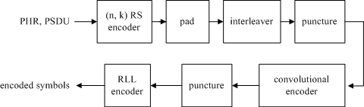

##### Figure 144—Reference modulator diagram for PHY I

For PHY I, concatenated coding is used with a combination of convolutional outer code and a RS inner code. The RS encoder output is padded with zeros to form an interleaver boundary. The padded zeros are then punctured (discarded) and the result is sent to the inner convolutional encoder. The PHR and PSDU parts of the frame are subject to the FEC for error protection. The PHR is coded using parameters corresponding to the lowest data rate for the currently negotiated clock rate.

#### Outer FEC encoder

Systematic RS codes are used for the PHY I outer FEC with 16 elements in the Galois field [GF(16)], generated by the polynomial *x*4*+x+*1. The generators for the RS(*n*,*k*) codes for PHY I (see Table 76) are given in Table 116, where  is a primitive element in GF(16).

##### Table 116—Generator polynomials

|  |  |
| --- | --- |
| **(*n*,*k*)** | **g(x)** |
| (15,11) | x4+α13x3+α6x2+α3x+α10 |
| (15,7) | x8+α14x7+α2x6+α4x5+α2x4+α13x3+α5x2+α11x1+α6 |
| (15,4) | x11+α9x10+α8x9+α4x8+α9x7+α13x6+α4x5+α12x4+α4x3+α5x2+α3x+α6 |
| (15,2) | x13+α3x12+α8x11+α9x10+α2x9+α4x8+α14x7+α6x6+α10x5+ α7x4+ α13x3+ α11x2+ α5x+α |

The Reed-Solomon code may be shortened for the last block if it does not meet the block size requirements. No zero padding is required for the RS code. A shortened RS code is used for frame sizes not matching code word boundaries via the following operation to minimize padding overhead.

Starting with a RS(*n*,*k*) code, one can get an RS(*n*-*s*,*k*-*s*) shortened code as follows:

1. Pad the *k-s* RS symbols with *s* zero RS symbols.
2. Encode using RS(*n*,*k*) encoder.
3. Delete the padded zeros (do not transmit them).
4. At the decoder, add the zeros, then decode.

#### Interleaving and puncturing block

A block interleaver is used as an interleaver between the inner convolutional code and the outer RS code as shown in Figure 145. The interleaver is of a fixed height *n* but has a flexible depth *D*, dependent on the frame size. The flexible depth of the interleaver and the puncturing block after the interleaver is used to minimize padding overhead.

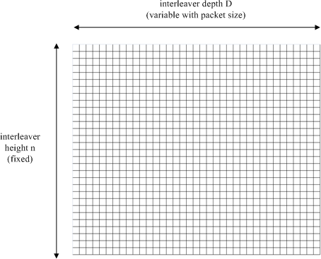

##### Figure 145—Interleaver for PHY I

The following parameters are used to describe the interleaver:

*n* is the RS codeword length

*k* is the number of information data symbols in a RS codeword

*q* is the number of elements in the Galois field: GF(q)

*Lframe* is the input frame size in bytes

*Sframe* is the number of symbols at the input of the RS encoder

*S* is the number of symbols from the output of the shortened RS encoder

*Sblock* is the size of the interleaver used

*D* is the interleaving depth

*i* is the ordered indices take the values 0, 1, …, *Sblock*–1 *l*(*i*) is the interleaved indices

*p* is the number of zero RS symbols

*t* is the ordered indices take the values 0, 1, …, *p*

*z*(*t*) is the locations of the bits to be punctured at the output of the interleaver before transmission

The interleaver and the locations to be punctured are described by the equations shown in Equation (3).

*S*   *L frame* *8 





*frame*

 log2 *(q)* 

*S = n* *  *S frame* *-**k -* *S* mod *k* 

 

 *k* 

*D*   *S* 

 *n* 

*frame*

(3)

*Sblock*

 *n*D*

*p*  *n- (S*

mod *n)*

*l(i) = (i*

mod *D)* * *n +*  *i*  ; for

 *D* 

 

i  0,1, .., (Sblock  1)

*z(t) = (n*  *p*  1 *)*D*  *t*D*  1*;* for t  0,1, .., p -1

The length of the frame is communicated to the receiver in the header so that the receiver can adaptively adjust the interleaver based on the frame sizes. When the data rates corresponding to transmissions using the concatenated codes are used, the header shall also be interleaved according to procedure shown in Equation (3). Since the length of the header is fixed, the receiver can deinterleave the header without explicit transmission of the header length.

#### Inner FEC encoder

The inner code is a based on a rate-1/3 mother convolutional code of constraint length seven (K=7) with generator polynomial g0 = 1338; g1 = 1718; g2 = 1658, as shown in Figure 146.

g0

t

t

t

t

t

t

A0

g1

B0 C0

X0

t

t

t

t

t

t

+

+

+

PHR, PSDU

encoded symbols

g2

##### Figure 146—Rate-1/3 mother convolutional code with constraint length 7

Six tail bits of zeros shall be added at the end of the encoding in order to terminate the convolutional encoder to an all zeros state. The tail bit of zeros shall be applied to both the header and the payload when the inner convolutional code is used.

##### Rate-1/4 code

The rate-1/4 code is obtained by puncturing the rate-1/3 mother code to a rate-1/2 code, as shown in Figure 147, and then using a simple repetition code as shown in Figure 148.

Source Bits

X1

X0

|  |  |
| --- | --- |
| A0 | A1 |
| B0 | B1 |
| C0 | C1 |

Encoded Bits

Transmitted Bits

Punctured bit

##### Figure 147—Puncturing pattern to obtain rate-1/2 code

|  |  |  |  |
| --- | --- | --- | --- |
| A0 | B0 | A1 | B1 |

|  |  |  |  |
| --- | --- | --- | --- |
| A0 | B0 | A1 | B1 |

|  |  |  |  |  |  |  |  |
| --- | --- | --- | --- | --- | --- | --- | --- |
| A0 | A0 | B0 | B0 | A1 | A1 | B1 | B1 |

**Figure 148—Repetition pattern used to obtain the effective rate-1/4 code**

##### Rate-1/3 code

The rate-1/3 code is obtained by using the outputs of the rate-1/3 mother code shown in Figure 146.

##### Rate-2/3 code

The rate-2/3 code is obtained by puncturing the rate-1/3 mother code, as shown in Figure 149.

Source Bits

X1

X0

|  |  |
| --- | --- |
| A0 | A1 |
| B0 | B1 |
| C0 | C1 |

Encoded BIts

Transmitted Bits

Punctured bit

##### Figure 149—Puncturing pattern to obtain rate-2/3 code

|  |  |  |
| --- | --- | --- |
| A0 | B0 | B1 |

#### RLL encoder

##### 4B6B encoding for VPPM modes

All VPPM PHY I modes shall use 4B6B encoding. The 4B6B expands 4-bit to 6-bit coded symbols with DC balance. The counts of 1 and 0 in every VPPM-coded symbol is always equal to 3. Table 117 defines the 4B6B code.

##### Table 117—Mapping input 4B to output 6B

|  |  |  |
| --- | --- | --- |
| **4B (input)** | **6B (output)** | **Hex** |
| 0000 | 001110 | 0 |
| 0001 | 001101 | 1 |
| 0010 | 010011 | 2 |
| 0011 | 010110 | 3 |
| 0100 | 010101 | 4 |
| 0101 | 100011 | 5 |
| 0110 | 100110 | 6 |
| 0111 | 100101 | 7 |
| 1000 | 011001 | 8 |
| 1001 | 011010 | 9 |
| 1010 | 011100 | A |
| 1011 | 110001 | B |
| 1100 | 110010 | C |
| 1101 | 101001 | D |
| 1110 | 101010 | E |
| 1111 | 101100 | F |

The features of the 4B6B code are as follows:

* + - 1. Always 50% duty cycle during one coded symbol
      2. DC balanced RLL code
      3. Error detection capability
      4. Run length limited to four
      5. Allows reasonable clock recovery

Figure 150 compares noncoded symbols to 4B6B-coded symbols.

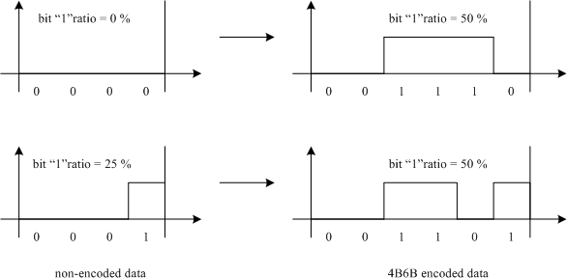

##### Figure 150—Illustrative comparison between noncoded and 4B6B-coded symbols

##### Manchester encoding for OOK mode

All OOK PHY I modes shall use Manchester DC balancing encoding. The Manchester code expands each bit into a coded 2-bit symbol as shown in Table 118.

##### Table 118—Manchester encoding

|  |  |
| --- | --- |
| **bit** | **Manchester symbol** |
| 0 | 01 |
| 1 | 10 |

#### 10.6 Data mapping for VPPM

The data mapping for VPPM shall be defined as in Table 119. The physical value mapped from the logical data ‘0’ has a transition from ‘high’ to ‘low’, and the physical value mapped from the logical data ‘1’ has a transition from ‘low’ to ‘high’, as shown in Table 119. ‘Low’ and ‘high’ values are defined in 8.3.2. The variable *d* in Table 119 is the VPPM duty cycle, and it is assigned by the VPPM-mode dimming mechanism described in 8.5.2.3. It can be varied in steps of 0.1.

##### Table 119—Definition of data mapping for VPPM mode

|  |  |  |
| --- | --- | --- |
| **Logical value** | **Physical value**  *d* is the VPPM duty cycle (0.1  *d*  0.9) | |
| 0 | High | 0  *t* < *dT* |
| Low | *dT*  *t < T* |
| 1 | Low | 0  *t* < (1 – *d*)*T* |
| High | (1 – *d*)*T*  *t* < *T* |

## PHY II specifications

PHY II is targeted towards applications requiring high data rates, as shown in Table 77. For PHY II, the PHY header shall be sent at one of the following data rates: 1.25 Mbps, 2.5 Mbps, 6 Mbps, 12 Mbps, 24 Mbps, or 48 Mbps, depending on the selected optical clock rate. Support for 1.25 Mbps at an optical clock of 3.75 MHz is mandatory.

#### Reference modulator diagram

A reference implementation is in Figure 151. The PHR and PSDU parts of the frame are subject to the FEC for error protection. The PHR is coded using parameters corresponding to the lowest data rate for the currently negotiated clock rate.



##### Figure 151—Reference modulator diagram for PHY II

#### FEC encoder

A systematic Reed-Solomon code operating on GF(256) shall be used for PHY II to correct errors and increase the system reliability. The Reed-Solomon code may be shortened for the last block if it does not meet the block size requirements, as specified for PHY I in 10.2. No zero padding is required for the RS code.

The Reed-Solomon code is defined over GF(256) with a primitive polynomial *x*8*+x*4*+x*3*+x*2+1. The generator for the RS(160,128) code and the RS(64,32) code is given by

g(x) = *x32+α11x31+α8x30+α109x29+α194x28+α254x27+α173x26+α11x25+α75x24+α218x23+α148x23+α149 x21+α44x20+α0x19+α137x18+α104x17+α43x16+α137x15+α203x14+α99x13+α176x12+a59x11+α91x1 0+α194x9+α84x8+α53x7+α248x6+α107x5+α80x4+α28x3+α215x2+α251x+α18* (4)

where α is a primitive element in GF(256).

For the VPPM modes using 4B6B encoding, the RS code word (d1,..., d8) from the GF(256) RS code is broken into 2 nibbles (d1,.., d4) and (d5,.., d8). These nibbles are sent LSB first to the 4B6B encoder as shown in Figure 152.

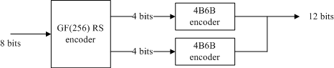

##### Figure 152—GF(256) RS encoder usage with 4B6B encoder

#### RLL encoder

All PHY II VPPM modes shall use 4B6B encoding as defined in 10.5.1. All OOK PHY II modes shall use 8B10B encoding as specified in ANSI/INCITS 373.

#### Data mapping for VPPM

All PHY II VPPM modes shall use data mapping as defined in 10.6.

## PHY III specifications

The data rates supported by PHY III are shown in Table 78. For PHY III, the PHY header shall be sent at 12 Mbps if the 12 MHz optical clock rate is selected or at 24 Mbps if the 24 MHz optical clock rate is selected. Support for 12 Mbps at 12 MHz is mandatory. PHY III devices shall utilize PHY II devices for device discovery. After all devices in the network are discovered and if all of them support PHY III, the coordinator can decide to switch to PHY III mode of operation. In addition, PHY III devices shall exchange their supported bands for CSK operation with the coordinator and the coordinator shall verify that the frequency bands supported in all PHY III devices in the network support reliable CSK communication. This is to determine that transmission on two optical frequency bands of the transmitting device does not fall within one optical filter band of the receiving device for CSK operation, leading to communication errors during CSK operation.

#### Reference modulator diagram

Figure 153 shows the CSK system configuration for PHY III with light sources of three colors (bands *i*, *j*, and *k*). After scrambling and channel coding, data is transformed into *xy* values, according to the mapping rule on the *xy* color coordinates by the color coding block. The PHR and PSDU parts of the frame are subject to the FEC block for error protection. The PHR is coded using parameters corresponding to the lowest data rate for the currently negotiated clock rate. The channel estimation sequence is transmitted after the PHR as shown in Figure 132 (b).

optical source

data



*Pi*

*x*

*y*

*Pk*

channel estimation sequence

*Pj*

*xy*

to

P*i*,P*j*,P*k*

band*k*

D/A

band*j*

D/A

band*i*

D/A

color coding

channel encoder

scrambler

D/A = digital-to-analog converter

##### Figure 153—CSK system diagram for PHY III

#### Scrambler

A scrambler shall be used to provide pseudo-random data for the PHY III. The scrambler shall be applied to the entire PSDU. In addition, the scrambler shall be initialized to a seed value dependent on the TDP at the beginning of the PSDU. The polynomial generator, *g*(*D*), for the pseudo-random binary sequence (PRBS) generator shall be: *g*(*D*) *=* 1 *+ D*14 *+ D*15, where *D* is a single bit delay element. Using this generator polynomial, the corresponding PRBS, *x*[*n*], is generated as in Equation (5).

*x*[*n*] = *x*[*n* − 14] *x*[*n* − 15], *n* = 0, 1, 2, … (5)

where ” denotes modulo-2 addition. The following sequence defines the initialization vector, x*init*, which is specified by the parameter “seed value” in Table 120:

*xinit* = [*xi*[−1] *xi*[-2] … *xi*[−14]*xi*[−15]], …

where *xi*[−*k*] represents the binary initial value at the output of the *kth* delay element. The scrambled data bits, *vm*, are defined in Figure 154 and shall be calculated as follows:

*v*[*m*] = *s*[*m*] *x*[*m*], *m* = 0, 1, 2, …

where *s*[*m*] represents the non-scrambled data bits. The side-stream de-scrambler at the receiver shall be initialized with the same initialization vector, x*init*, used in the transmitter scrambler. The initialization vector is determined from the TDP.

unscrambled data *s*[*n*]



scrambled data *v*[*n*]

*x*[*n*] *x*[*n*-1]

*D*

*x*[*n*-2]

*D*

*x*[*n*-13]

*x*[*n*-14]

*D*

*x*[*n*-15]

*D*

##### Figure 154—Scrambler block diagram

The 15-bit initialization vector or seed value shall correspond to the seed identifier as defined in Table 120, corresponding to the TDP pattern. The seed values shall be incremented in a roll-over fashion for each frame sent by the PHY. For example, if the seed value used is the seed corresponding to P3 in the first frame, the seed value corresponding to P4 is used in the second frame, seed value corresponding to P1 is used in the third frame and so on. All consecutive frames, including retransmissions, shall be sent with a different initial seed value.

##### Table 120—Scrambler seed selection

|  |  |  |
| --- | --- | --- |
| **TDP** | **Seed value**  ***xinit* = *xi*[-1] *xi*[-2]… *xi*[-15]** | **PRBS output First 16 bits**  ***x*[0] *x*[1] … *x*[15]** |
| P1 | 0011 1111 1111 111 | 0000 0000 0000 1000 |
| P2 | 0111 1111 1111 111 | 0000 0000 0000 0100 |
| P3 | 1011 1111 1111 111 | 0000 0000 0000 1110 |
| P4 | 1111 1111 1111 111 | 0000 0000 0000 0010 |

#### Channel encoder

When used, the channel encoding for PHY III is obtained using the 1/2 RS(64,32) code as defined in 11.2.

#### CSK constellation overview

The CSK signal is generated by using three color light sources out of the seven color bands that are defined in 8.3.1. The three vertices of the CSK constellation triangle are decided by the center wave length of the three color bands on *xy* color coordinates. It is possible that some of the optical sources would have a spectral peak at a different frequency than the center of the bandplan. It is also possible that the spectrum of the optical source would be distributed among over multiple frequency bands. Implementers of CSK systems can select the color band based on the center wave length of the actual optical source. Table 121 shows the *xy* color coordinates values assuming the optical source is chosen with the spectral peak occurring at the center of each of the seven color bands. The color calibration function in 12.9 can compensate color coordinate errors caused by the drifting of the optical source characteristics and cancel any interference between the three colors.

##### Table 121—*xy* color coordinates

|  |  |  |  |
| --- | --- | --- | --- |
| **Band (nm)** | **Code** | **Center (nm)** | **(*x*, *y*)** |
| 380–478 | 000 | 429 | (0.169, 0.007) |
| 478–540 | 001 | 509 | (0.011, 0.733) |
| 540–588 | 010 | 564 | (0.402, 0.597) |
| 588–633 | 011 | 611 | (0.669, 0.331) |
| 633–679 | 100 | 656 | (0.729, 0.271) |
| 679–726 | 101 | 703 | (0.734, 0.265) |
| 726–780 | 110 | 753 | (0.734, 0.265) |

Figure 155 shows the center of color bands of Table 121 on *xy* color coordinates.

001

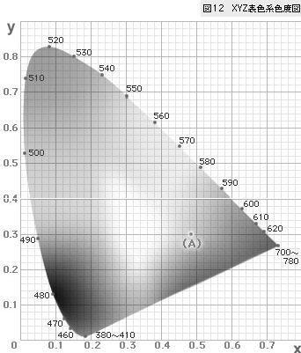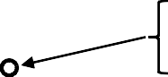

*y*

010

011

000

*x*

100

101

110

##### Figure 155—Center of color bands on *xy* color coordinates

#### CSK constellation design rules

##### Design rule for 4-CSK

4-CSK symbol points are defined by the design rule in Figure 156. Points I, J, and K show the center of the three color bands on *xy* color coordinates in Table 121. In Figure 156, *x*-axis and *y*-axis are the relative value. S0 to S3 are four symbol points of 4-CSK. S1, S2, and S3 are three vertices of the triangle IJK. S0 is the centroid of the triangle IJK. The absolute values for 4-CSK for multiple combinations of the optical sources assuming the spectral peak of the optical source is at the center of the bandplan can be obtained in Yokoi et al. [B17].

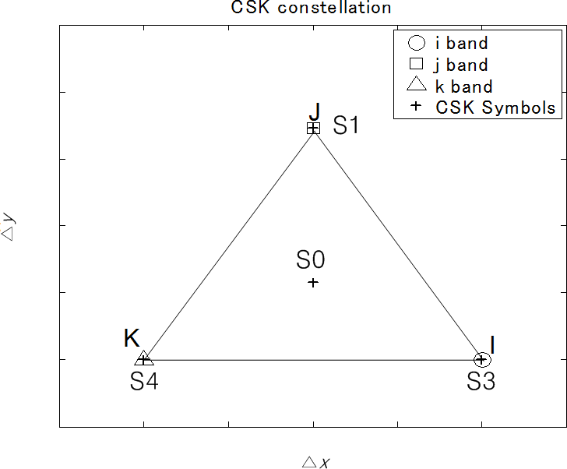

##### Figure 156—Constellation design rule for 4-CSK

##### Design rule for 8-CSK

8-CSK symbol points are defined by the design rule in Figure 157. Points I, J, and K show the center of the three color bands on *xy* color coordinates in Table 121. S0 to S7 are 8 symbol points of 8-CSK. S0, S4, and S7 are three vertices of the triangle IJK. S1 and S2 are points that divide side JK and side JI in the ratio 1:2. Point B and C are midpoints of the line JI and line JK. S6 is a midpoint of the line KI. Point A is the centroid of the triangle B-S6-I. Point D is the centroid of the triangle C-K-S6. S3 is a point that divides line AB in the ratio 1:2. S5 is a point that divides line DC in the ratio 1:2.

The absolute values for 8-CSK for multiple combinations of the optical sources assuming the spectral peak of the optical source is at the center of the bandplan can be obtained in Yokoi et al. [B17].

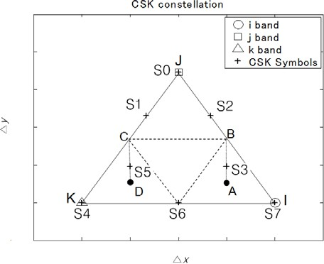

##### Figure 157—Constellation design rule for 8-CSK

##### Design rule for 16-CSK

16-CSK symbol points are defined by the design rule in Figure 158. Points I, J, and K show the center of the three color bands on *xy* color coordinates in Table 121. S0 to S15 are 16 symbol points of 16-CSK. S5, S10, and S15 are three vertices of the triangle IJK. S2 and S8 are points that divide side JK in one third. S3 and S12 are points that divide side JI in one third. S11 and S14 are points that divide side KI in one third. S0 is the centroid of the triangle IJK. S1, S4, S6, S7, S9, and S13 are the centroids of each of the smaller triangles. The absolute values for 16-CSK for multiple combinations of the optical sources assuming the spectral peak of the optical source is at the center of the bandplan can be obtained in Yokoi et al. [B17].

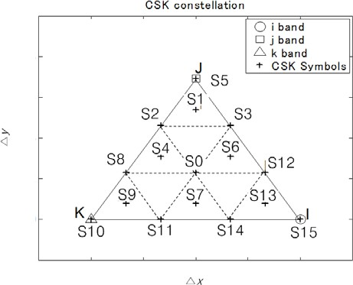

##### Figure 158—Constellation design rule for 16-CSK

#### Data mapping for CSK

4-CSK data mapping is shown in Figure 159. Two bits are assigned per symbol.

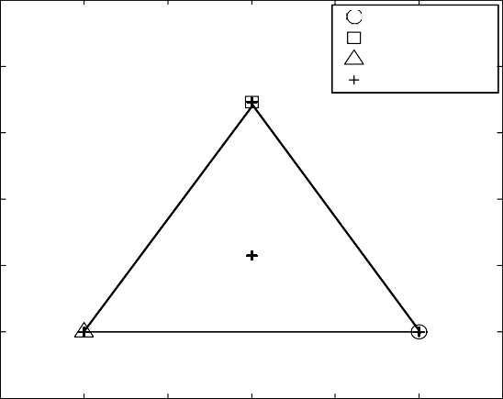**CSK constellation**

[0 0]

[0 1]

y

△y

*i* band *j* band *k* band

CSK Symbols

[1 0] [1 1]

△x

x

##### Figure 159—Data mapping for 4-CSK

8-CSK data mapping is shown in Figure 160. Three bits are assigned per symbol.

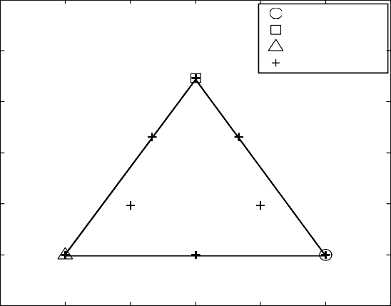**CSK constellation**

[1 0 0]

*i* band *j* band *k* band

CSK Symbols

[0 0 0]

y

△y

[0 0 1]

[1 1 0]

[0 1 0]

[1 0 1]

[0 1 1]

[1 1 1]

△x

x

##### Figure 160—Data mapping for 8-CSK

16-CSK data mapping is shown in Figure 161. Four bits are assigned per symbol.

CSK constellation



[0 0 0 0]

*i* band *j* band *k* band

CSK Symbols

[0 0 0 1]

[0 0 1 1]

[0 1 0 1]

[0 0 1 0]

[1 0 1 0]

[0 1 1 1]

[0 1 1 0] [0 1 0 0]

[1 0 1 1]

[1 1 1 0]

[1 1 0 1]

[1 0 0 1]

[1 1 1 1] [1 1 0 0]

[1 0 0 0]

y

△y

△xx

##### Figure 161—Data mapping for 16-CSK

#### Valid color band combinations

The CSK constellation is decided by the combination of the three color bands. Certain combinations that cannot make a triangle on the *xy* color coordinates are excluded, such as (110-101-100) or (100-011-010). Table 122 shows valid color band combinations that can make triangles for CSK constellations.

##### Table 122—Valid color band combinations for CSK

|  |  |  |  |
| --- | --- | --- | --- |
|  | **Band *i*** | **Band *j*** | **Band *k*** |
| 1 | 110 | 010 | 000 |
| 2 | 110 | 001 | 000 |
| 3 | 101 | 010 | 000 |
| 4 | 101 | 001 | 000 |
| 5 | 100 | 010 | 000 |
| 6 | 100 | 001 | 000 |
| 7 | 011 | 010 | 000 |
| 8 | 011 | 001 | 000 |
| 9 | 010 | 001 | 000 |

Figure 162 shows an example of the CSK constellation triangle when color codes (110, 010, 000) are used.

*y*

Band i

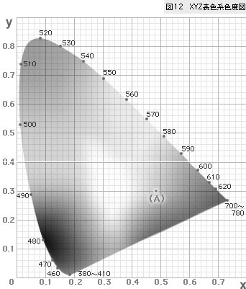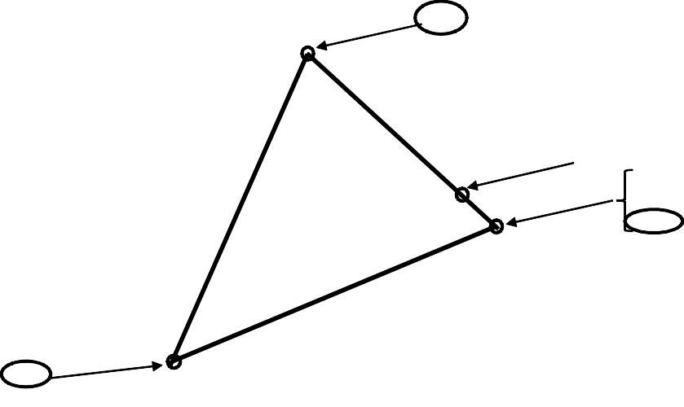

001

Band j

010

011

100

101

110

Band k

000

*x*

##### Figure 162—Valid CSK constellation example for codes (110, 010, 000)

Table 123 shows color band combination and the *xy* coordinate values when color codes (110, 010, 000) are used. Figure 163 shows the CSK constellation points when color codes (110, 010, 000) are used.

##### Table 123—Color band combination example for (110, 010, 000)

|  |  |  |  |
| --- | --- | --- | --- |
| **Center of band (*x*,*y*)** | ***xy* coordinate values of symbols** | | |
| **4-CSK**  **[data] – (*xp*,*yp*)** | **8-CSK**  **[data] – (*xp*,*yp*)** | **16-CSK**  **[data] – (*xp*,*yp*)** |
| (0.734 0.265)  (0.402 0.597)  (0.169 0.007) | [0 0] – (0.402 0.597)  [0 1] – (0.435 0.290)  [1 0] – (0.169 0.007)  [1 1] – (0.734 0.265) | [0 0 0] – (0.324 0.400)  [0 0 1] – (0.297 0.200)  [0 1 0] – (0.579 0.329)  [0 1 1] – (0.452 0.136)  [1 0 0] – (0.402 0.597)  [1 0 1] – (0.169 0.007)  [1 1 0] – (0.513 0.486)  [1 1 1] – (0.734 0.265) | [0 0 0 0] – (0.402 0.597)  [0 0 0 1] – (0.413 0.495)  [0 0 1 0] – (0.335 0.298)  [0 0 1 1] – (0.324 0.400)  [0 1 0 0] – (0.623 0.376)  [0 1 0 1] – (0.513 0.486)  [0 1 1 0] – (0.435 0.290)  [0 1 1 1] – (0.524 0.384)  [1 0 0 0] – (0.734 0.265)  [1 0 0 1] – (0.169 0.007)  [1 0 1 0] – (0.247 0.204)  [1 0 1 1] – (0.258 0.101)  [1 1 0 0] – (0.546 0.179)  [1 1 0 1] – (0.634 0.273)  [1 1 1 0] – (0.546 0.179)  [1 1 1 1] – (0.357 0.093) |

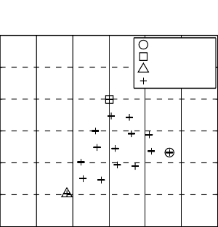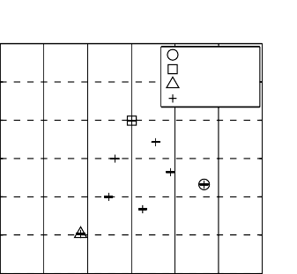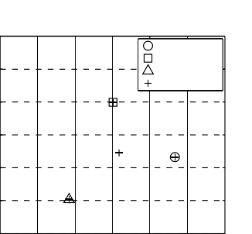CSK constellation CSK constellation CSK constellation

CSK constellation

CSK constellation

CSK constellation

0.8

0.6

0.4

y

*y*

i band j band k band

CSK Symbols

0.8

0.6

0.4

y

*y*

i band j band k band

CSK Symbols

0.8

0.6

0.4

y

*y*

i band j band k band

CSK Symbols

0.2

0

-0.2

-0.2

0 0.2 0.4 0.6 0.8 1

*x*

x

0.2

0

-0.2

-0.2 0 0.2 0.4 0.6 0.8 1

x

*x*

0.2

0

-0.2

-0.2 0 0.2 0.4 0.6 0.8 1

x

*x*

4 CSK 8 CSK 16 CSK

##### Figure 163—CSK constellation made by color band combinations

#### CSK color mapping

Figure 164 shows the Commission international de l’Eclairage (CIE) 1931 *xy* color coordinates (CIE [B2]) with the color mapping for 4-point CSK (4CSK). In this case, four color points are defined.

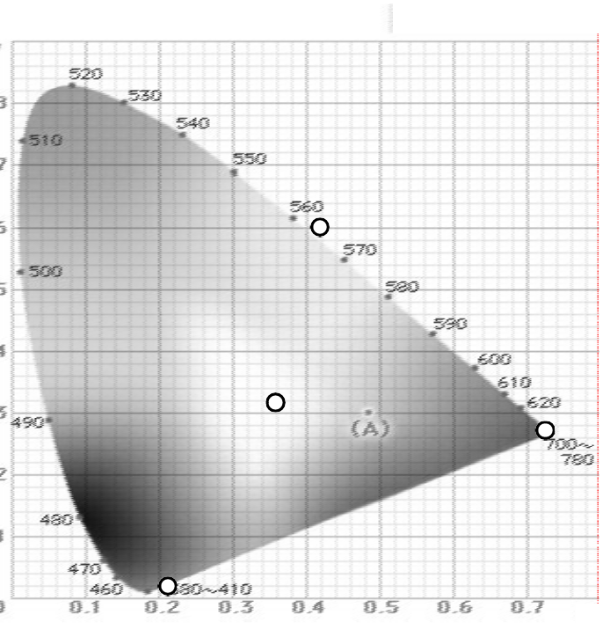**y**

## G(xj,yj)

**00**

**01**

**(xp,yp)**

**11 R(xi,yi)**

**10**

**B(xk,yk) x**

##### Figure 164—CIE 1931 *xy* color coordinates

The points (*xi,yi*), (*xj,yj*), (*xk,yk*) shows the *xy* coordinates of three light sources. The point (*xp,yp*) shows the one of the allocated color points in 4-CSK. The color point (*xp,yp*) is generated by the intensity of the three light sources *Pi*, *Pj*, and *Pk* in Figure 165. These *xy* values are transformed into intensity *Pi*, *Pj*, and *Pk*. The relation between the coordinates and the intensity is shown in Equation (6). In the receiver side, *xy* values are calculated from the received light powers of three colors, and *xy* values are decoded into the received data.

*x p*  *Pi*  *xi*  *Pj*  *x j*  *Pk*  *xk*

*y p*  *Pi*  *y i*  *Pj*  *y j*  *Pk*  *yk*

(6)

*Pi*  *Pj*  *Pk*  1

#### CSK calibration at the receiver

The OWC system could have some degradation, for example, multi-color imbalance, multi-color interference, or other error on *xy* color coordinates caused by ambient light or the light device characteristics; therefore, a CSK compensation method at the receiver is provided in the standard using color calibration for performance improvement. Figure 165 shows the CSK system with color calibration.

data

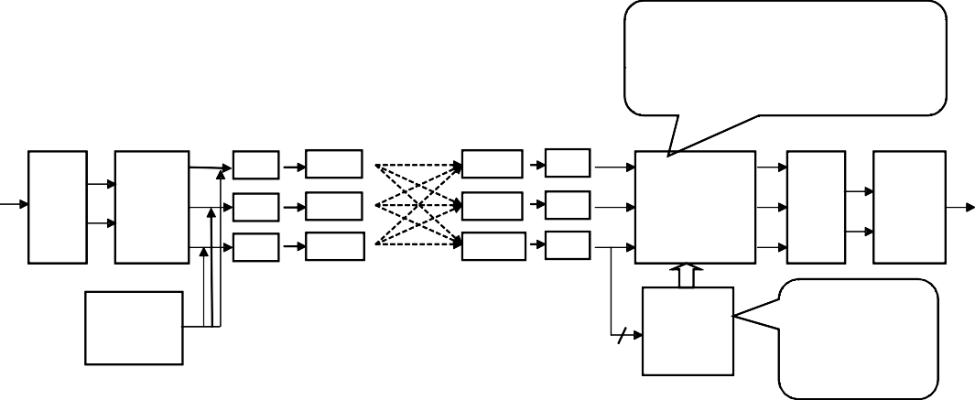

*Pi*  *hii hij hik*   *Pi* 

1

 

*Pj*   *hji hjj hjk*   *Pj* 



 



*Pk*





*h h h*



*ki kj kk*



 

*Pk*

○

opticalsources

photo detectors

*Pi*

*x*

D/A

band*i*

band*i*’

A/D

*Pi*’

*Pi*

color coding *y*

*xy*

to P*i*,P*j* ,P*k*

*Pj*

D/A

band*j*

band*j*’

A/D

RGB

*Pj*’ compensation

*Pj*

RGB

to

*xy*

*x*

*y*

color decoding

*Pk*

D/A

band*k*

band*k*’

A/D

*Pk*’

*Pk*

channel estimation sequence

⬆*hii hij hik* 

channel estimation

⬇

⬇*hji hjj hjk* 

*hki hkj hkk* ✗



⬇



data

A/D = analog-to-digital converter D/A = digital-to-analog converter RGB = red, green, blue

##### Figure 165—CSK system with color calibration

Before data communication, the system estimates the channel propagation matrix using orthogonal sequences included in the channel estimation sequence. The channel propagation matrix is a 3x3 square matrix as shown in Equation (7).

⬆ *hii*

⬇

*hij*

*hik* 

### 



⬇ *h ji*

*h jj*

*h jk* 

(7)

### ⬇

*h*

 *ki*

*hkj*

*h kk* ✗

The propagation deviation can be compensated by multiplying the received signal with the inverted channel matrix as shown in Equation (8).

*Pi* 

*h h h*

1 *Pi* 

*ii*



###  

*ij ik*   

*Pj*   *hji hjj hjk* 

*Pj* 

(8)

*Pk* 

 

*ki kj kk*

*h h h*

*Pk* 

###  

Walsh codes shall be used for channel estimation as shown in Figure 166. During the transmission of the channel estimation sequence, the light sources are modulated with OOK according to the Walsh codes.

Three Walsh code sequences of length 4 are provided for the three bands used for CSK. W(1,4) = {1,–1,1,– 1}, W(2,4) = {1,1,–1,–1}, W(3,4) = {1,–1,–1,1} are the three Walsh codes that shall be used for channel estimation. W(1,4), W(2,4) and W(3,4) shall be used for band *i*, *j*, *k*, respectively. Each bit of the Walsh code shall be transmitted twice. Accurate channel estimation can be obtained by averaging the two bits.

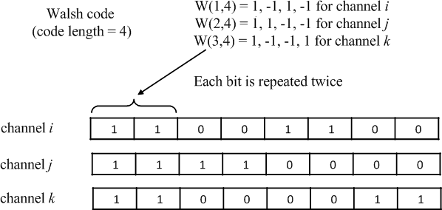

##### Figure 166—Walsh codes for color calibration

## PHY IV specifications

#### UFSOOK

All PHY PPDU formats are described in 8.6. The subclauses pertinent to UFSOOK are 8.6.1.2.1 and 8.6.5.2.1.

##### Reference modulator diagram

A reference implementation of the modulator is shown in Figure 167.

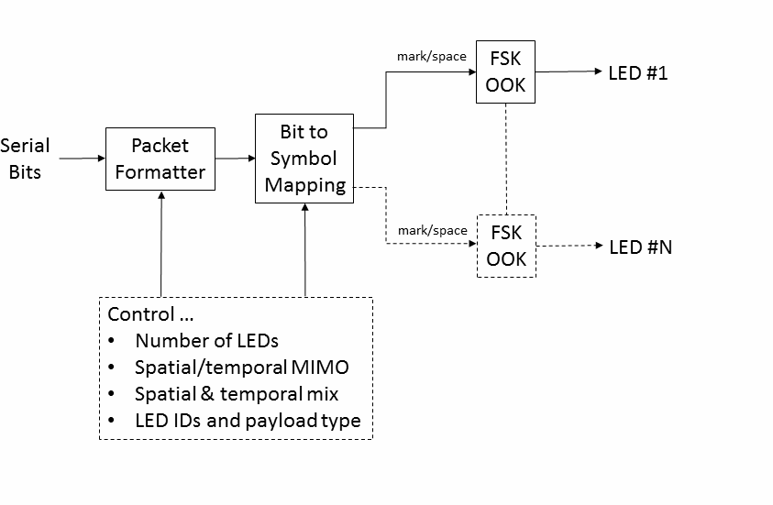

**Figure 167—UFSOOK block diagram**

##### UFSOOK encoder

The UFSOOK encoder encodes bits as OOK frequencies (ON-OFF blinking LED) as follows:

* + - 1. Logic zero: represented by a OOK frequency that is an integer multiple of the camera frame rate.
      2. Logic one: represented by an OOK frequency that is an integer multiple + 1/2 of the camera frame rate.

For example, if the frame rate is 30 fps, then one possible set of related OOK frequencies would be 120 Hz and 105 Hz, respectively.

##### UFSOOK spatial FEC

Spatial redundancy FEC may be applied for UFSOOK by repeating each data frame over multiple LEDs, each with a slight time delay. The amount of time delay is dependent upon the clock phase slippage (i.e., the RX clock is not synchronized to the TX clock), but only needs to be enough to prevent a bit boundary slip over the duration of the data frame for a majority of data frames. While the actual amount of delay is implementation dependent, a time delay greater than a quarter bit duration is generally adequate. See Figure 168.

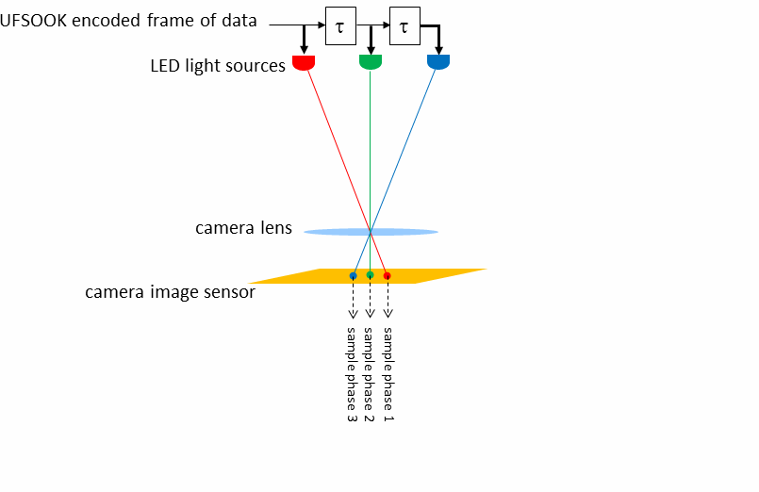

**Figure 168—UFSOOK spatial FEC**

##### UFSOOK temporal FEC

Temporal redundancy FEC may be applied for UFSOOK by serially repeating each data frame over a single LED, each repetition with a slight time delay. The amount of time delay is dependent upon the clock phase slippage (i.e., the RX clock is not synchronized to the TX clock), but only needs to be enough to prevent a bit boundary slip over the duration of the data frame for a majority of data frames. While the actual amount of delay is implementation dependent, a time delay greater than a quarter bit duration is generally adequate. See Figure 169.

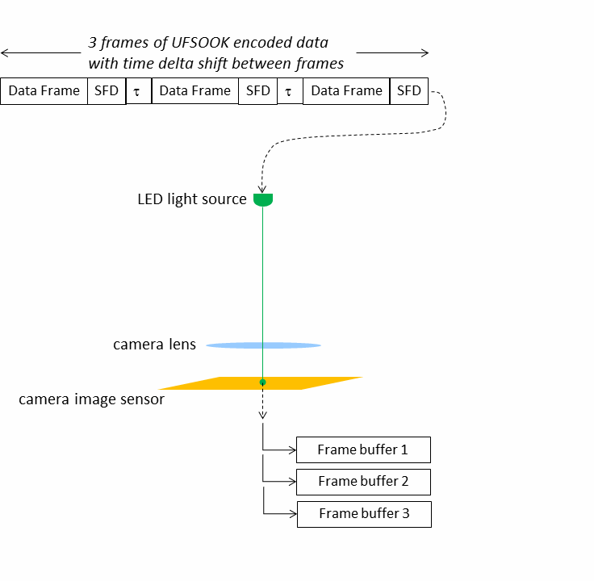

**Figure 169—UFSOOK temporal FEC**

##### UFSOOK MIMO protocol

UFSOOK may utilize a MIMO protocol so the receiver can determine which LED lights, among multiple LED lights, are transmitting data. The protocol supports spatial redundancy, spatial multiplexing, independent data streams, and multiphase FEC. A flowchart showing how the data delimiters are utilized to decode this protocol is shown in Annex M.

##### Additional delimiter definitions

In addition to the previously defined start frame delimiter (8.6.1.2.1), a data delimiter is also defined in this clause. The data delimiter is six video frames long. The first two video frames consist of high-frequency OOK followed by four video frames of OOK transmitted at a frequency that is (*N ±* 0.25) times the video frame rate. For example, given a 30 fps camera (*N*=4), a legitimate frequency would be 112.5 Hz. This frequency would alias to a frequency that is 1/4 the video frame rate. These two delimiters can be used to construct a MIMO frame that supports multiple MIMO modes as shown in Figure 170, in reference to the space-time code frame, by introducing Optional ID and Payload fields.

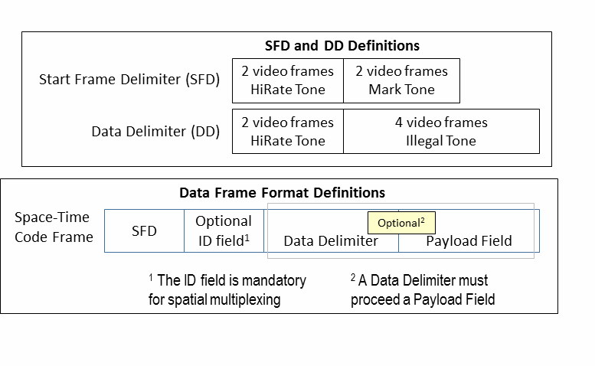

**Figure 170—Additional MIMO delimiter definitions**

##### Independent data streams protocol flowchart

The independent data streams flowchart is shown in Figure 171. When sending independent data streams, each LED in the MIMO group shall asynchronously transmit the SFD. Next, if an identifier is being sent, then all LEDs shall send a unique identifier number. Next, if a payload is being sent, then each LED shall send a data delimiter followed by a unique payload.

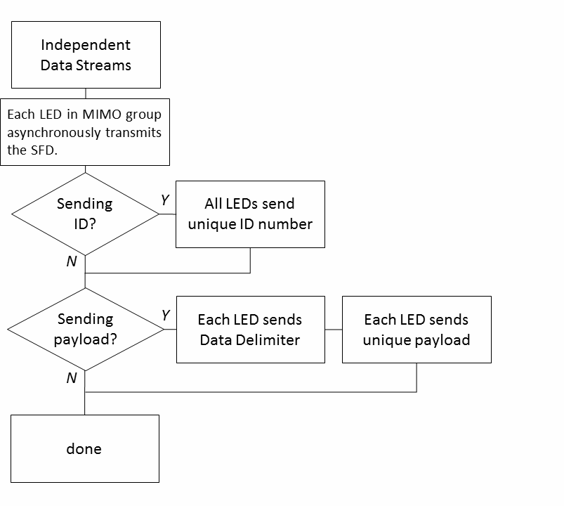

##### Figure 171—UFSOOK independent data streams

* + - 1. **Spatial redundancy protocol flowchart**

The spatial redundancy protocol flowchart is shown in Figure 172. When doing spatial redundancy, each LED in the MIMO group shall synchronously transmit the SFC. Next, if an identifier is being sent, then all LEDs shall send the same identifier number. Next, if a payload is being sent, then each LED shall send the data delimiter followed by the same redundant payload.

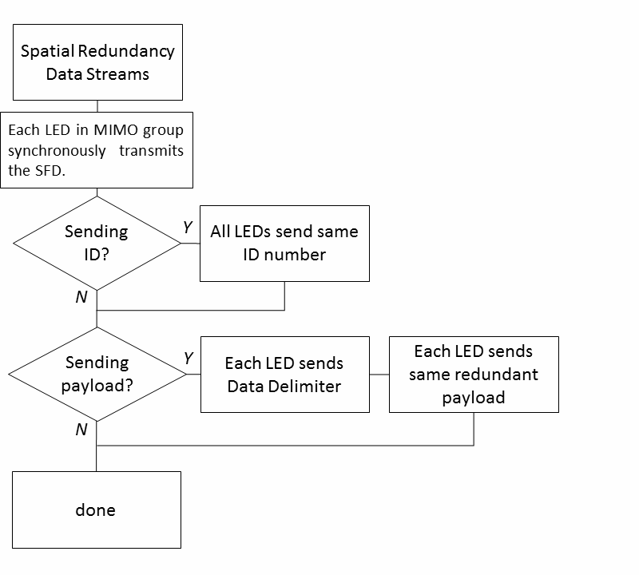

##### Figure 172—UFSOOK spatial redundancy

* + - 1. **Spatial multiphase protocol flowchart**

The spatial multiplexing flowchart is shown in Figure 173. The MIMO group must consist of 2*N* LEDs. First the payload is broken into 2*N* sub-payloads, each corresponding to a related binary index. Each of the LEDs in the MIMO group shall synchronously transmit the SFD. Next each LED shall send a unique identifier binary index. Next, if a payload is being sent, each LED shall send a data delimiter followed by the sub- payload associated with its binary index identifier.

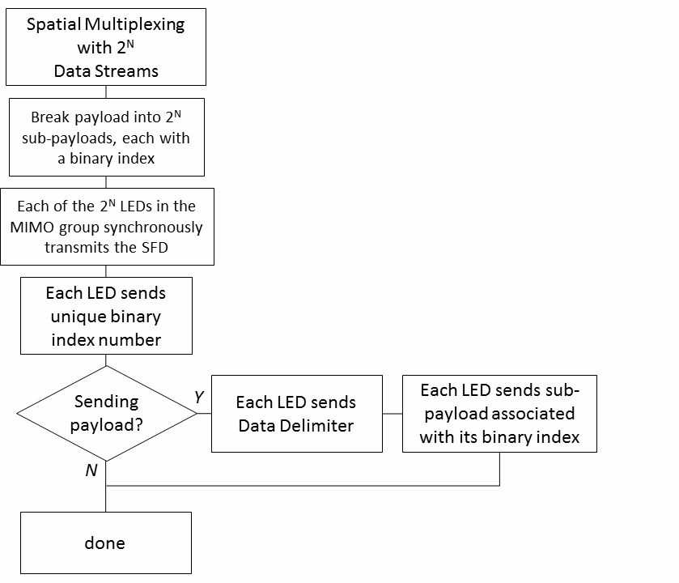

##### Figure 173—UFSOOK spatial multiplexing

* + - 1. **Multiphase FEC protocol flowchart**

The spatial multiphase FEC flowchart is shown in Figure 174. When doing spatial multiphase FEC, each LED in the MIMO group shall asynchronously transmit the SFD. Next, all LEDs shall send the same identifier number. Next, if a payload is being sent, then each LED shall send a data delimiter followed by the redundant payload.

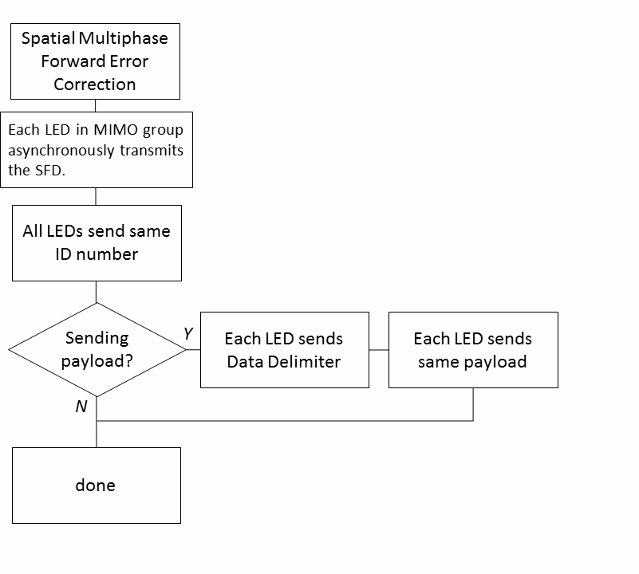

**Figure 174—UFSOOK multiphase FEC**

#### Twinkle VPPM

All PHY PPDU formats are described in 8.6. The clauses pertinent to Twinkle VPPM are 8.6.1.2.2, 8.6.5.2.1, and 8.6.5.2.2.

##### Reference modulator diagram

A reference implementation of the modulator is shown in Figure 175.

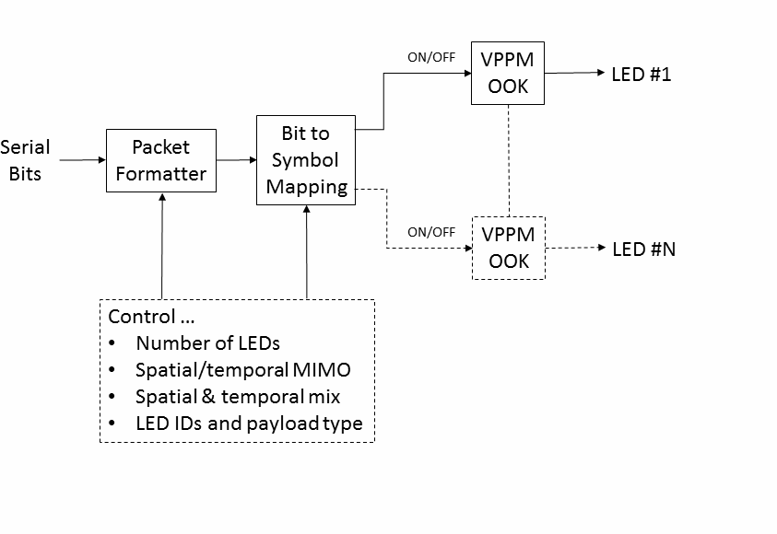

**Figure 175—VPPM block diagram**

##### VPPM encoder

Bits are coded using VPPM with one of two duty cycles. The duty cycles are either 1/3 of a symbol time or 2/3 of a symbol time. The twinkle is generated by alternating between the two duty cycles. See Figure 176.

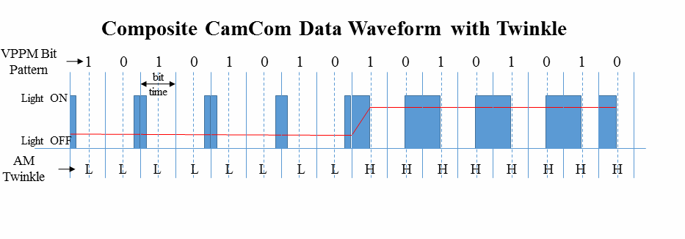

**Figure 176—Composite waveform with twinkle**

The VPPM bit encoding is shown in Figure 177, where the reddish upper half shows the 2/3 duty cycle waveform, and the bluish lower half shows the 1/3 duty cycle waveform.

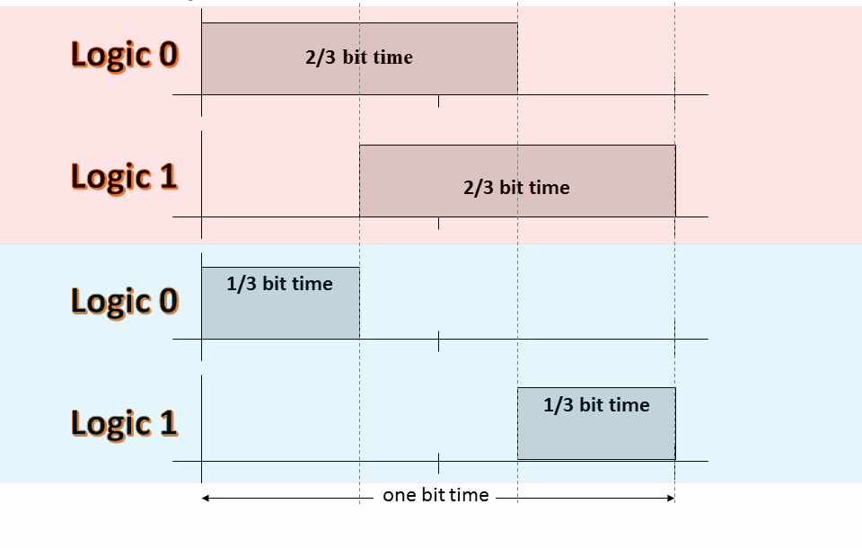

##### Figure 177—Composite waveform VPPM bit definition

A logic zero shall be coded by locating the pulse on the left side of the symbol period, and a logic one shall be coded by locating the pulse on the right side of the symbol period.

##### Twinkle generation

The desired “aliased twinkle frequency” is 1/4 the camera frame rate. For a 30 fps camera this would be

7.5 Hz. In this way Twinkle VPPM is guaranteed to generate the twinkle frequency even if every other sample falls on a transition boundary. The possible AM envelope frequencies are

*F* = *n*  1--  *Ffps*

 4

where *n* is an integer.

For example, given a 24 fps camera and *n* = 4, one possible amplitude modulation frequency would be 4.25 × 24 = 102 Hz.

Using the VPPM bit definitions, alternately transmit 2/3 duty cycle bits for half an amplitude modulation envelope cycle followed by 1/3 duty cycle bits for the second half amplitude modulation envelope cycle. Round to an integer number of transmitted bits per half cycle.

For the above example, alternate between duty cycles every 1/204 s.

#### S2-PSK

##### Reference architecture

A reference architecture to implement S2-PSK is shown in Figure 178. The data may be protected by FEC coding, and then the output is fed into the 1/2-rate line encoder. The bit sequence is mapped into pairs of waveforms to drive a pair of LEDs (LED-1 and LED-2).

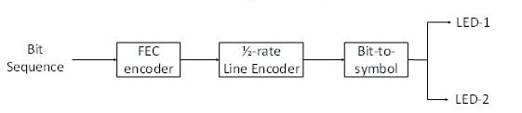

##### Figure 178—S2-PSK block diagram

##### S2-PSK bit-to-symbol mapping

The signal to each LED shall have a square shape, to which ON and OFF amplitudes are configurable to achieve the required dimming level. Two waveforms to drive a pair of LEDs have the same phase or inverse phases depending on a single bit input (see Figure 179).

The optical clock rate (equivalent to bit rate) is configured via the PHY PIB attribute *phyS2pskOpticalClockRate* that is chosen to be no greater than the camera frame rate so that every bit is sampled at least twice.

The configuration of modulation rate is performed over the PHY PIB attribute *phyS2pskModulationRate*

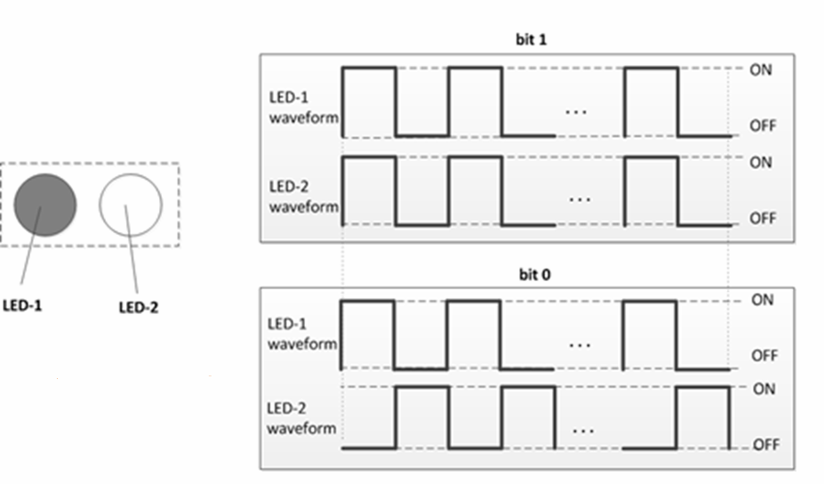that provides non-flicker.

##### Figure 179—S2-PSK bit-to-symbol mapping

##### S2-PSK 1/2-rate line coding

Unlike typical RLL code that is used to provide DC balance, the waveform output of S2-PSK is always DC-balanced regardless of whether the mapping bit is zero or one. Thus, a new line coding at the 1/2-code rate shall be implemented serving two different purposes:

* + - * To support RX decoding under the dismissal of one LED among a pair of LEDs seen by RX.
      * To protect the signal from the error caused by the camera rotation and the error caused by the time deviation between a pair of light sources on the rolling image.

The configuration of 1/2-rate coder is implemented over the PHY PIB attribute *phyS2pskLineCode*. Once the 1/2-rate coding is applied, the PPDU shall map a single bit into a pair of bits as shown in Table 124.

##### Table 124—1/2-rate line coding for S2-PSK

|  |  |
| --- | --- |
| **Data bit input** | **Bits output** |
| 0 | 0 0 |
| 1 | 0 1 |

##### S2-PSK FEC encoder

Error correction may be implemented for S2-PSK that is configurable via the PHY PIB attribute

*phyS2pskFec*.

#### HS-PSK

##### Reference architecture

A reference architecture to implement HS-PSK is illustrated in Figure 180. At first, two data streams are modulated individually in which a low-rate data stream is modulated by S2-PSK and a high rate data stream is modulated by DS8-PSK. Then, the outputs of the S2-PSK modulator are to control the dimming levels of the outputs of DS8-PSK; therefore, the output waveforms are a hybrid modulation of S2-PSK and DS8-PSK.

The operation of the S2-PSK modulator is described in 13.3, and the operation of the DS8-PSK modulator is described in 13.4.2.

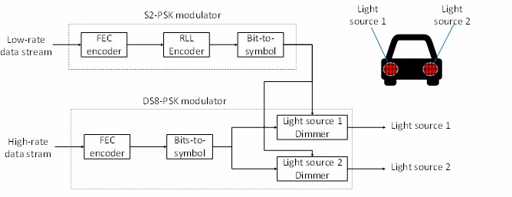

##### Figure 180—HS-PSK block diagram

##### DS8-PSK modulator

* + - 1. **DS8-PSK bits-to-symbol mapping**

This subclause describes the mapping from each of the three bits to a pair of two sets of waveforms to drive a pair of light sources. Here, the number of time slots available on a duty cycle of DS8-PSK waveform is eight (a constant value). In order to divide a DS8-PSK duty cycle into eight time slots, each light source shall consist of a configurable number of LEDs that is at a minimum eight. The configuration of the number of LEDs per light source shall be implemented via the PHY PIB attribute *phyHSpskNumLightSources*.

Waveforms to drive LEDs shall have a rectangular shape at the same modulation rate but with different phases. In a group of waveforms to drive LEDs within a light source, the (*i*+1)th waveform is delayed 1/8 duty cycle compared to the (*i*)th waveform as shown in Figure 181. The modulation rate of waveform signals (=1/ duty cycle) is configurable by the PHY PIB attribute *phyHSpskModulationRate*.

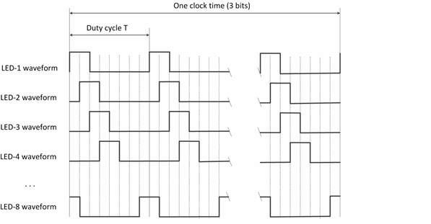

##### Figure 181—Waveforms to drive a group of eight LEDs within a light source (example of 25% dimming)

By using a pair of two light sources with each light source having eight LEDs, three bits are transmitted per optical clock by controlling the shifting value (called *S_Phase_Shift*) of the phases of waveforms driving two light sources. This is implemented by maintaining all the phases of the waveforms of the first group (at 0; T/8; 2T/8; 3T/8; …; 7T/8, respectively) while shifting all the phases of the waveforms of the second group a (*S_Phase_Shift* = *i* × T/8) as compared to that of the first group, where *i* is an integer depending upon 3-bits input.

The mapping from 3 bits to the value of *S_Phase_Shift* (represented by the value of *i*) is shown in Table 125.

The optical clock rate (i.e., the frequency at which a block of 3 bits is clocked out) shall be configured via the PHY PIB attribute *phyHspskOpticalClockRate*.

**Table 125—Mapping table from bits to *S_Phase_Shift***

|  |  |
| --- | --- |
| **3-bit input** | ***S-Phase_Shift* / (T/8) output** |
| 000 | 0 |
| 001 | 1 |
| 010 | 2 |
| 011 | 3 |
| 100 | 4 |
| 101 | 5 |
| 110 | 6 |
| 111 | 7 |

##### DS8-PSK FEC encoder

The configuration of error correction for DS8-PSK shall be implemented over the PHY PIB attribute

*phyHSpskFec*. When the use of FEC is enable, RS (15, 11) shall be used for DS8-PSK error correction.

##### HS-PSK encoder

The DS8-PSK modulator shall map 3 bits into a pair of two sets of waveforms driving a pair of light sources at a high optical clock rate (such as 10 kHz) as described in 13.4.2.1. Meanwhile, it periodically changes the dimming level from a selected low dimming level to a selected high dimming level. The change of dimming level during DS8-PSK encoding that generates an AM signal at a low frequency (configurable in PHY PIB attribute *phyS2pskModulationRate*) shall be controlled by the S2-PSK modulator. As a result, the S2-PSK clock interval is multiple times the DS8-PSK clock interval.

Figure 182 illustrates the output waveform of HS-PSK.

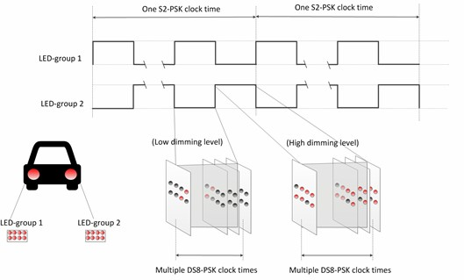

##### Figure 182—HS-PSK waveform to modulate vehicular light sources

##### HS-PSK FEC encoder

The configuration of error correction for HS-PSK, including FEC for S2-PSK and FEC for DS8-PSK, shall be implemented via the PHY PIB attribute *phyHSpskFec*.

#### Offset-VPWM

The Offset-VPWM supported data rates and operating conditions are shown in PHY IV operating modes (see Table 79).

##### Reference architecture

A reference implementation of the Offset-VPWM modulator is shown in Figure 183.

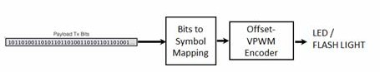

##### Figure 183—Offset-VPWM block diagram

##### Offset-VPWM PHY encoder

The Offset-VPWM encoder is built-in with line coding and coded with the sum (P + nV) of the unit to be added to the minimum pulse (P), which is a reference pulse width (V) as a symbol (P > V, V > time error (jitter). Offset-VPWM specifies a 2-bit data symbol and a 4-bit data symbol according to the number of added pulses.

The data symbol map for the 2-bit symbol with pulse width and respective symbol blinking waveform are shown in Table 126 and Figure 184, respectively.

##### Table 126—Two-bit symbol mapping truth table

|  |  |
| --- | --- |
| **Data bits** | **Pulse width** |
| 00 | P+0V |
| 01 | P+1V |
| 10 | P+2V |
| 11 | P+3V |

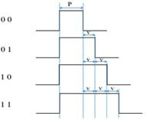

**Figure 184—Two-bit symbol data diagram**

In Offset-VPWM, the data is expressed with offset pulse width, and 4 bits of data (for example) were mapped into 16 Offset-VPWM symbols. The 4-bit symbol mapping truth table is shown in Table 127.

##### Table 127—Four-bit symbol mapping truth table

|  |  |
| --- | --- |
| **Data bits** | **Pulse width** |
| 0000 | P+0V |
| 0001 | P+1V |
| 0010 | P+2V |
| 0011 | P+3V |
| 0100 | P+4V |
| 0101 | P+5V |
| 0110 | P+6V |
| 0111 | P+7V |
| 1000 | P+8V |
| 1001 | P+9V |
| 1010 | P+10V |
| 1011 | P+11V |

**Table 127—Four-bit symbol mapping truth table *(continued)***

|  |  |
| --- | --- |
| **Data bits** | **Pulse width** |
| 1100 | P+12V |
| 1101 | P+13V |
| 1110 | P+14V |
| 1111 | P+15V |

The symbol arrays mapping is described in waveform pattern as shown in Figure 185.

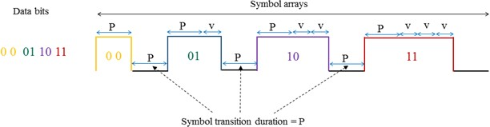

##### Figure 185—Symbol array mapping timing diagram

The optimum value of P is 40 ms and V varies from 10~50% of P. The default V is 50% of P. The P and V are configurable over PHY attributes *phyOffsetVPWMStdPERIOD* and *phyOffsetVPWMOffsetPERIOD,* respectively.

## PHY V specifications

#### RS-FSK

##### Transmitted signal frequency

With the exception of the frequency used by the preamble, which is used to detect the start of a PPDU by the receiver, the actual set of frequencies used for data transmission is specified by the optional fields of the PPDU.

RS-FSK specifies the preamble frequency shall be 2.2 kHz.

For the set of frequencies used by the data symbols, it is recommended to use frequencies between 500 Hz and 1.4 kHz. The former corresponds to a strip width of 66 pixels to 100 pixels, while the latter corresponds to a stripe width of 23 pixels to 36 pixels.

##### Symbol duration

RS-FSK uses a symbol duration that equals to the receiving camera's frame duration. Since most of the cameras use a frame rate of 30 fps when capturing video, the default symbol duration is set to be 1/30 s. Note that the symbol can be configured by using the RS-FSK mode optional field through the PIB attributes in PPDU (see 9.5.2).

#### CM-FSK modulation

##### Reference architecture

The CM-FSK modulation scheme is applied to a system as shown in Figure 186. Ab bit(s) shall be inserted into a block of data bits before mapping from bits into frequency (and bi-phase, if used). Finally, the inverse fast Fourier transform (IFFT) converts the frequency value into the waveform to drive LED.

A camera that has the sampling rate satisfying the Nyquist sampling is used to receive the modulated light.

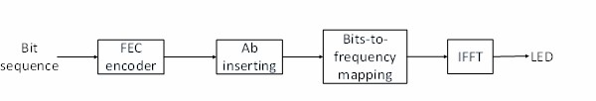

##### Figure 186—Reference architecture for CM-FSK system

##### Asynchronous bit(s) insertion

Before being fed into the bits-to-frequency mapper, a number of clock information bits (Ab) shall be inserted at the beginning of a data symbol. The number of Ab to insert can be one to support the time-variant frame rate RX decoding (see Annex I) or greater than one to support the detection of missing symbols during reception time in the receiver side (see I.4.1). The configuration of Ab is implemented via the PHY PIB attribute *phyCmfskAb*.

##### CM-FSK encoder

After inserting Ab, the packet of bits (including data bits and Ab) is fed into the CM-FSK encoder to map from bits into a frequency. Table 128 shows the packet of bits with Ab bits inserted at the beginning of the packet. The bit length of this packet (equals to *n*+1) depends on how many bits a frequency can carry.

##### Table 128—Packet structure

|  |  |
| --- | --- |
| **b0** | **b1–bn** |
| Ab | Data bits |

* + - 1. **Encoder configuration**

The number of frequencies used to map data shall be configured over the PHY PIB attribute *phyCmfskNumFrequency*. For selected devices, using 32 or 64 frequencies is suggested. Also, the number of frequencies is extendable with reserved values of *phyCmfskNumFrequency*.

The frequency separation is fixed during a selected mode, but configurable via the PHY PIB attribute

*phyCmfskFrequencySeparation*.

In addition to the frequency modulation, the phase of the waveform can also be modulated in which the number of phases is configurable via the PHY PIB attribute *phyCmfskNumPhase*. If *phyCmfskNumPhase*=1, 2-PSK shall be additionally used in conjunction with the frequency modulator, which can help to increase the bandwidth efficiency and coverage extension.

Finally, the optical clock rate that controls the rate frequency at which symbols are clocked out is configured via the PHY PIB attribute *phyCmfskOpticalClockRate*. Cameras with a frame rate higher than twice of the optical clock rate can decode data.

##### 32-FSK bits-to-frequency mapping

One specific case of CM-FSK encoder is 32-FSK. It shall map a packet of bits, including one Ab and four data bits, into a frequency among 32 frequencies *f* 1–*f*32. The bits-to-symbol mapping table is shown in Table 129.

##### Table 129—32-FSK encoding table

|  |  |
| --- | --- |
| **Packet of bits input** | **Frequency output** |
| Preamble 1 | *f*0 |
| 00000 | *f*1 |
| 00001 | *f*2 |
| ... | ... |
| 11110 | *f*31 |
| 11111 | *f*32 |
| Preamble 2 | *f*33 |

In addition to the 32 frequencies (*f*1–*f*32) selected to encode bits, two additional frequencies are selected as preamble symbols (*f*SF = *f*0 and *f* 'SF = *f*33). The relationship between data frequencies and preamble frequencies is as follow:

*f*i = *f*SF + i.Δ*f* (i=1; 2;…; 33)

where Δ*f* is the selected frequency separation value.

The selection of all frequencies shall be configured over the first frequency preamble (*f*SF), which is specified by the PHY PIB attribute *phyCmfskPreamble,* and the frequency separation, which is specified by the PHY PIB attribute *phyCmfskFrequencySeparation*.

##### 64-FSK bits-to-frequency mapping

Another specific case of CM-FSK encoder is 64-FSK. It shall map a packet of bits, including one asynchronous bit and five data bits, into a frequency among selected 64 frequencies. The bits-to-symbol mapping table is shown in Table 130.

##### Table 130—64-FSK encoding table

|  |  |
| --- | --- |
| **Packet of bits input** | **Frequency output** |
| Preamble 1 | |
| 000000 | *f*1 |
| 000001 | *f*2 |
| ... | ... |
| 011110 | *f*31 |
| 011111 | *f*32 |
| Preamble 2 | |
| 100000 | *f*33 |
| 100001 | *f*34 |
| ... | ... |
| 111110 | *f*63 |
| 111111 | *f*64 |

The 64-FSK frequency band is a twice extension of the 32-FSK frequency band. The first 32 data frequencies and two preamble frequencies (*f*0–*f*33) are the same values as addressed in the 32-FSK modulation. The remaining 32 frequencies (*f*34–*f*65) are allocated on higher frequencies of the 32-FSK modulation band to achieve a higher capacity of data per frequency symbol.

*f*i = *f*SF + i.Δ*f* (i=1; 2;…; 65)

where Δ*f* is the selected frequency separation value.

##### Hybrid frequency and phase CM-FSK

The hybrid frequency and phase mode is also an extended case of CM-FSK encoder. The frequency encoding is achieved by implementing the 32-FSK encoding or the 64-FSK encoding. When *phyCmfskNumPhase* =1, 2-PSK modulation is additionally used in conjunction with the frequency encoder as a hybrid modulation to tackle the bandwidth efficiency and spatial redundancy.

In an example of using a pair of light sources with *phyCmfskNumPhase*=1, both light sources shall utilize the same bits-to-frequency mapping; thus two light sources carry the same frequency at any time. On the other hand, the relationship of phases of two waveforms shall be modulated by a single Ab bit. If Ab= "0", two signals are at the same phases. If Ab= "1", a signal shall have phase inverted compared to another signal. Figure 187 shows the reference architecture of the hybrid modulator.

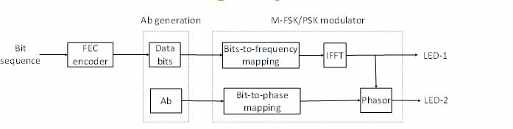

##### Figure 187—Reference architecture for modulator of using a pair of LEDs

* + - 1. **Outer FEC**

The payload carried by frequency symbols (i.e., sub-packets that consist of data bits and Ab) shall not be coded. However, PHR and PSDU may be protected by RS(15,11) as an outer FEC. The generation of RS(15,11) is described in 10.2. This option of outer FEC is implemented by configuring the PHY PIB attribute *phyCmfskFec*.

#### C-OOK

##### Reference architecture

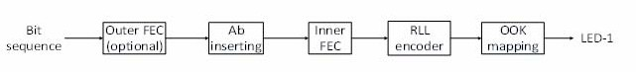A reference architecture to implement C-OOK is shown in Figure 188.

##### Figure 188—C-OOK block diagram

##### C-OOK encoder

* + - 1. **Encoder configuration**

A sub-packet of data shall be modulated using OOK modulation. The optical clock rate at which OOK symbols are clocked out is configurable over PHY PIB attribute *phyCookOpticalClockRate*.

The data packet structure is shown in Figure 189. A packet is the number of multiple repetitions of a data sub-packet to avoid missing data in between the gap time of adjacent images. The number of repetitions depends on the selected mode and is configurable over the PHY PIB attributes *phyCookPacketRate* and *phyCookSubPacketRate*. For example, if *phyCookPacketRate* =1 specifying 10 packet/sec and *phyCookSubPacketRate* =0 specifying 60 sub-packet/sec, every data sub-packet shall be repeated 6 times.

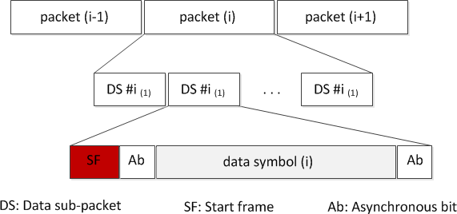

##### Figure 189—Data packet structure

A data sub-packet shall consist of two subfields: a preamble symbol and a payload section. The configuration of the preamble is performed over the PHY PIB attribute *phyCookPreambleSymbol*. The preamble shall be configured to be suitable for the selected RLL coding used in payload subfield. Manchester-coded payload shall require a short preamble, while 4B6B-coded payload shall require a longer preamble. Table 131 shows the suitable preamble for selected RLL code.

##### Table 131—Data sub-packet format

|  |  |  |  |
| --- | --- | --- | --- |
| **Preamble** | **Data sub-packet payload** | | |
| **Start Data Ab** | **Data** | **End Data Ab** |
| 011100 | Manchester coding | | |
| 0011111000 | 4B6B coding | | |

* + - 1. **RLL coding**

RLL coding shall be applied in the payload subfield to maintain an average brightness at 50%. The configuration of RLL code shall be implemented over the PHY PIB attribute *phyCookRLLCode*. Manchester code and 4B6B code are suggested for C-OOK mode.

##### Ab insertion

The data sub-packet payload shall consist of three subparts: a Start Data Ab, data, and a End Data Ab. The Start Data Ab and the End Data Ab shall carry the same information, which consists of a single asynchronous bit or more. The configuration of the number of asynchronous bits for the Start Data Ab and the End Data Ab subparts shall be implemented over the PHY PIB attribute *phyCookAb*.

The use of a single Ab to support Asynchronous Decoder shall be described in I.4. A pair of Ab bits to support the detection of missing packets shall be described in I.4.1.

##### Forward error correction (FEC)

The data sub-packet payload, including data bits and Ab bits, may be coded by inner FEC to protect the payload from error. Hamming (8,4) or (15,11) code may be used as an inner FEC.

Additionally, outer FEC may also be used to protect the PHR and PSDU. When outer FEC is enable, RS(15,11) shall be implemented. The generation of RS(15,11) is described in 10.2. Also, if outer FEC is applied, the output of FEC shall be fed into a block interleaver with the interleaver height *n*=15. The implementation description of the block interleaver is described in 10.3

Both inner FEC and outer FEC shall be configured via the PHY PIB attribute *phyCookFEC*.

Finally, a receiver may keep repeating the data reception to vote data and correct a possible error. This is considered as a temporal error correction.

The generation of Hamming(8,4) and Hamming (15,11) is described in J.1.

##### 14.3.3 Packet structure specification modes

Table 132 and Table 133 suggest some parameters for C-OOK modes.

##### Table 132—Suggested parameters for C-OOK modes

|  |  |  |  |  |
| --- | --- | --- | --- | --- |
|  | **Mode 1** | **Mode 2** | **Mode 3** | **Mode 4** |
| Optical clock rate | 2.2 kHz | 2.2 kHz | 4.4 kHz | 4.4 kHz |
| Sub-packet rate | 100  data sub-packet/s | 60  data sub-packet/s | 60  data sub-packet/s | 60  data sub-packet/s |
| RLL code | Manchester | 4B6B | Manchester | 4B6B |
| Uncoded bit rate | 80 bps | 180 bps | 330 bps | 400 bps |

**Table 133—Sub-packet structure on suggested C-OOK modes**

|  |  |  |  |  |
| --- | --- | --- | --- | --- |
|  | **Mode 1** | **Mode 2** | **Mode 3** | **Mode 4** |
| Data sub-packet clocks | 22 B | 37 B | 74 B | 74 B |
| Preamble | 6 B | 10 B | 6 B | 10 B |
| Data sub-packet payload (Ab, data bits, Ab) | (16 B)  8 bits | 18 bits  (27 B) | 33 bits  (66 B, 2 B unused) | 40 bits  (60 B, 4 B unused) |
| Inner FEC | Hamming(8,4) | Hamming(15,11) 3 bits unused | Hamming(15,11) 3 bits unused | None |
| Bit rate | 40 bps | 110 bps | 220 bps | 400 bps |

#### MPM

MPM PLCP adds the Sequence Number subfield and the Last Sequence Flag subfield to MPDU and converts them to the PLCP Header subfield, the Front Payload subfield, the PLCP Center subfield, the Back Payload subfield, and the PLCP Footer subfield as shown in Figure 190. MPM has two PHY modes (MPWM mode and MPPM mode), and *phyMpmMode* defines which mode shall be used.

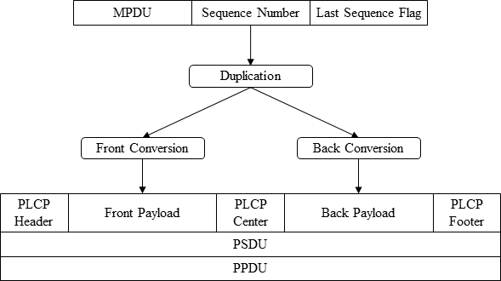

##### Figure 190—MPM PHY and PLCP

##### Sequence Number subfield

The Sequence Number subfield contains a sequence number, which is sent LSB first and starts from 0.

When *phyMpmDynamicSequenceNumberLength* is 0, the bit length of the Sequence Number subfield is a value of *phyMpmSequenceNumberLength*. Otherwise, it depends on whether the PPDU contains the last sequence and on the value of the last sequence number. When the PPDU contains the last sequence, the bit length of the Sequence Number subfield is a value of *phyMpmSequenceNumberLength*. That of the other

PPDU is

log 2*L*

, where *L* is a value of the sequence number of the last PPDU.

##### Last Sequence Flag subfield

The Last Sequence Flag subfield is a 1-bit flag. The value is 1 when the PPDU contains the last sequence and 0 otherwise.

When *phyMpmDynamicSequenceNumberLength* is 0, the Last Sequence Flag subfield is not sent.

##### PLCP Header/Center/Footer subfields

In MPWM mode, each of the PLCP Header subfield, the PLCP Center subfield, and the PLCP Footer subfield contains four symbols. Let *a* be *phyMpmPlcpHeaderSymbol*, *b* be *phyMpmPlcpCenterSymbol*, and *c* be *phyMpmPlcpFooterSymbol*. The symbols of the PLCP Header subfield are (*a*, *a* – 10, *a*, *a*), the symbols of the PLCP Center subfield are (*b*, *b* – 10, *b* – 10, *b*), and the symbols of the PLCP Footer subfield are (*c*, *c*, *c* – 10, *c*), as shown in Table 134.

In MPPM mode, each of the PLCP Header subfield, the PLCP Center subfield, and the PLCP Footer subfield consists of three symbols. The symbols of the PLCP Header subfield are (*a* + 10, *a*, *a*), the symbols of the PLCP Center subfield are (*b*, *b* + 10, *b*), and the symbols of the PLCP Footer subfield are (*c*, *c*, *c* + 10), as shown in Table 134.

##### Table 134—Symbols of PLCP Header/Center/Footer subfields

|  |  |  |
| --- | --- | --- |
| **Subfield** | **MPWM mode** | **MPPM mode** |
| PLCP Header (*a = phyMpmPlcpHeaderSymbol*) | a,a–10,a,a | a+10,a,a |
| PLCP Center (*b = phyMpmPlcpCenterSymbol*) | b,b–10,b–10,b | b,b+10,b |
| PLCP Footer (*c = phyMpmPlcpFooterSymbol*) | c,c,c–10,c | c,c,c+10 |

##### Front Payload subfield and Back Payload subfield

Each of the Front Payload subfield and the Back Payload subfield consists of *N* symbols. Let *M*odd be a bit length contained in an odd-numbered symbol, *M*even be a bit length contained in an even-numbered symbol, *W*1 be a symbol value offset, and *W*2 be a symbol value unit. The parameters *N*, *M*odd, *M*even, *W*1, and *W*2 are set in the PHY PIB in Table 115.

The input bit sequence, which consists of the MPDU, the Sequence Number subfield, and the Last Sequence Flag (*x*0*, x*1*, x*2*, …*), is converted as follows. Let *yi* be calculated as

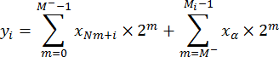

where

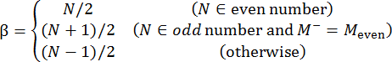*M-*=min(*M*odd, *M*even)

Then the *i*th Symbol of the Front Payload subfield is calculated as

*W*1 + *W*2 × (2*m* – 1 – *yi* )

and the *i*th Symbol of the Back Payload subfield is calculated as

*W*1 + *W*2 × *yi* .

##### MPWM/MPPM waveform

Symbols shall be transmitted as two states of light intensity: the bright state and the dark state. The transition period from 10% to 90% of the brightness change shall be shorter than 5 µs.

In PWM mode, the symbol value corresponds to continuous time of a state in microseconds. For example, the first symbol value corresponds to continuous time of the first bright state, and the second symbol value corresponds to continuous time of the following dark state as shown in Figure 191. The first state can be a dark state as well.

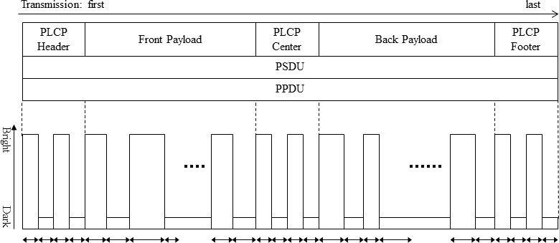

##### Figure 191—MPWM mode waveform

In MPPM mode, the symbol value corresponds to duration time between the beginning of a bright state and the beginning of the next bright state in microseconds. The duration time of continuous bright state shall be shorter than 90% of the symbol value. Figure 192 shows an example waveform.

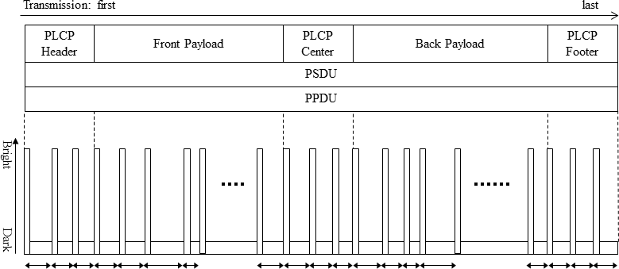

##### Figure 192—MPPM mode waveform

For both modes, a transmitter can transmit only a part of the symbols, but all symbols of the PLCP Center subfield and at least *N* symbols in total from the Front Payload subfield and the Back Payload subfield must be transmitted.

## PHY VI specifications

#### A-QL

##### Reference architecture

Figure 193 shows the A-QL system diagram with light sources of three colors (band *i*, *j*, *k*). The valid selection of these three bands is described in Table 123. The selection of tri-color bands shall be read by the PHY PIB attribute *phyAqlColorSelection*. An example of color band combination (110, 010, 000) for band *i*, *j*, *k*, respectively, is called “red, green, and blue” (or “RGB”) throughout this clause.

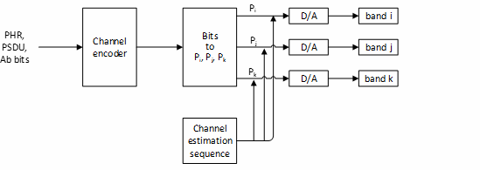optical sources

##### Figure 193—A-QL system diagram

The data sequence including PHR, PSDU, and Ab bits shall be fed into the channel encoder. This A-QL channel encoder controls the intensity of red, green, and blue channels (Pi, Pj, and Pk) based on the input bits. However, unlike the CSK system in PHY III, the intensity modulation of each color channel in the A-QL system is independent of the others, and there is no requirement of color combination such as Pi + Pj + Pk = 1. Thus, the A-QL modulation operates with flickering, and no effort is made to generate a desired color within the triangle IJK on the xy color coordinates (see 12.5.1).

##### Two-dimensional (2D) color code design

A 2D design of A-QL code for sequential transmission is shown in Figure 194. The outer area of the code is to support the detection of the code. The inner area is to modulate data. The configuration of the size of individual cells to be modulated and the size of the outer border are read by the PHY PIB attributes *phyAqlCellSize* and *phyAqlBolderSize*.

The number of cells on the A-QL code (*m*×*n*) is read by the PHY PIB attribute *phyAqlNumCells*.

Four cells (each cell is 2x2) at the four corners of the code (called reference cells) are to support the receiver in identifying the starting corner of the code. The intensity of these reference cells does not change over time (see 15.1.2.1). Also, a corner has the number of reference cells that is configurable via the PHY PIB attribute *phyAqlNumCellReference*.

The intensity of the remaining cells (called data cells) is to be modulated to transmit data.

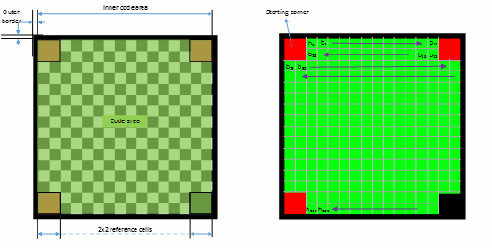

(a)

(b)

##### Figure 194—(a) Design example of 16x16-cell A-QL code and (b) allocation of bits onto A-QL code

The matrix of *m*×*n* cells is

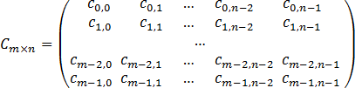

When each corner has four reference cells (totally 16 reference cells), the matrix of 4x4 reference cells is

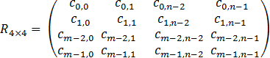

##### Channel encoder

* + - 1. **Encoder configuration**

A block of coded bits shall be mapped into the matrix of intensity values (binary values) to drive the data cells via three color channels (red, green, and blue) independently. The optical clock rate at which the intensity of all data cells is updated is configurable via PHY PIB attribute *phyAqlOpticalClockRate*.

In an *m*×*n* cell TX, (*m*×*n* – 16) data cells can carry 3× (*m*×*n* – 16) binaries each time through three color bands (*i*, *j*, and *k*) if the number of reference cells is *phyAqlNumCells* = 16.

The forming process of a matrix of binaries to drive all *m*×*n* cells is described as follows.

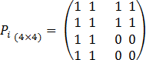The intensity matrix (bands *i*, *j*, and *k*, respectively) to drive 4x4 reference cells is constant over time:

, ,

The intensity values of data cells at the color bands are mapped from bits as described in 15.1.3. When the length of data does not fit the size of the A-QL code, zeros are inserted to the end of data; and the RX reads the value of the PHY PIB attribute *phyPSDULength* to pad the inserted bits.

##### Asynchronous bits (Ab) insertion

To support the RX’s dealing with its frame rate variation, Ab shall be generated and inserted into every block of data bits. Then, error correction is applied, and coded bits are mapped into intensity. The number of Ab bits generated for each block of data is configurable via PHY PIB attribute *phyAqlNumAb*. The A-QL decoding method with Ab support is described in I.5.

When *phyAqlNumAb* = 1, a single bit (zero or one) shall be generated for each block of data bit as described in Table 135 and then added at the beginning of the block of data.

##### Table 135—Generation of single Ab for each block of data bits (*phyAqlNumAb = 1*)

|  |  |  |
| --- | --- | --- |
| **Optical clock index** | 2i | 2i+1 |
| **Block of data** | block(2i) | block(2i+1) |
| **Ab** | 1 | 0 |

When *phyAqlNumAb* = 7, Ab that has 7 binaries (0101010, 1010101, 1111000, or 0000111) shall be generated for each block of data (as described in Table 136) according to the optical clock index of the block of data and then added at the beginning of the block of data. The Ab plays like a sequence number of each data block.

##### Table 136—Generation of single Ab for each block of data bits (*phyAqlNumAb = 7*)

|  |  |  |  |  |
| --- | --- | --- | --- | --- |
| **Optical clock index** | 4i | 4i+1 | 4i+2 | 4i+3 |
| **Block of data** | block(4i) | block(4i+1) | block(4i+2) | block(4i+3) |
| **Ab** | 0101010 | 1010101 | 1111000 | 0000111 |

* + - 1. **Error correction**

The PHR, PSDU, and Ab bits are coded to protect from noisy channels as described in Table 137.

##### Table 137—Error correction for A-QL

|  |  |  |  |
| --- | --- | --- | --- |
|  | **Outer code** | **Interleaver** | **Inner code** |
| PHR, PSDU, Ab bits | RS(15,7) | n=15 | CC(1/4) |

RS(15,7) shall be applied for an A-QL system. The generation of RS(15,7) is described in 10.2.

In addition, the inner code based on a rate-1/4 mother convolutional code of constraint length seven (K=7) shall be optionally used for each block of data. The generation of inner FEC is described in 10.4.

The selection of error correction is configurable by the value of PHY PIB attribute *phyAqlFec*.

When both RS(15,7) and CC(1/4) are applied, a block interleaver with the interleaver height n=15 shall be implemented between the inner convolutional code and the outer RS code. The description of the block interleaver is described in 10.3

##### Bits-to-intensity mapping

The intensity of band *i*, *j*, *k* is modulated independently based on the value of 3 bits of input (b0b1b2). Notably, there is no requirement of color combination while modulating the intensity; thus Pi + Pj + Pk is not equal to 1.

The mapping from coded bits to intensity (Pi, Pj, Pk) is given in Table 138.

##### Table 138—Bits to (Pi, Pj, Pk) mapping

|  |  |  |  |
| --- | --- | --- | --- |
| **Data input** | **Intensity output** | | |
| **b0 b1 b2** | **Pi (red)** | **Pj (green)** | **Pk (blue)** |
| 000 | 0 | 0 | 0 |
| 001 | 1 | 0 | 0 |
| 010 | 0 | 1 | 0 |
| 011 | 1 | 1 | 0 |
| 100 | 0 | 0 | 1 |
| 101 | 1 | 0 | 1 |
| 110 | 0 | 1 | 1 |
| 111 | 1 | 1 | 1 |

##### Channel estimation and color calibration

A channel estimation sequence shall be added as an extended subfield after the PHR subfields to support a receiver dealing with multi-color imbalance or multi-color interference. The block diagram with color calibration is described in Figure 195.

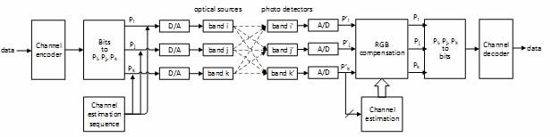

##### Figure 195—A-QL system with color calibration

Three Walsh codes, W(1,4), W(2,4), and W(3,4), are used for band R, G, B, respectively, for channel estimation before data communication (see Figure 196). Each bit of the Walsh code is transmitted twice. Accurate channel estimation can also be obtained as described in 12.9.

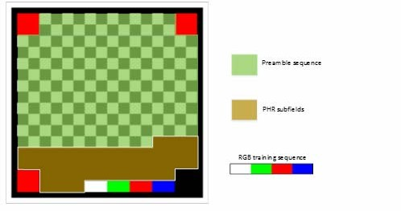

##### Figure 196—A block with the preamble and Walsh code for color calibration

#### VTASC specifications

VTASC works with variable transparency levels, sizes, shapes, and colors of the symbols. The VTASC PHY-supported data rates and operating conditions are shown for the PHY VI operating modes in Table 79.

##### VTASC reference architecture

The reference PHY architecture for VTASC is illustrated in Figure 197. The data sequence includes SHR (first byte), PSDU data packet length (second and third bytes used for PSDU data length), and PSDU coded on the screen symbol. The PSDU data length and PSDU shall be fed into the VTASC encoder. The data is embedded on the visual frame by overlaying VTASC symbols in a defined visual area. After spread spectrum (SS), data is transformed into VTASC-coded symbols according to the mapping rule on the transparency levels, sizes, shapes, and colors by the VTASC coding symbols.

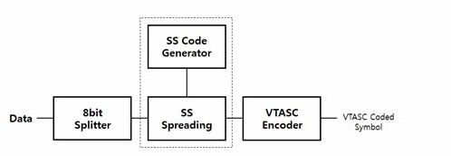

##### Figure 197—Reference architecture for VTASC system

The SS is used with VTASC to have effective asynchronous, distance-adaptive, scalable data-rate-controlled OWC. The VTASC is used for enhanced display-to-camera communication in real-time applications. The VTASC-specific working features are given in K.1.

The receiver-specific information for VTASC data decoder is given in I.8.

##### Synchronization sequence

The SS code is used as a synchronization sequence. SS is used with VTASC-, SS2DC-, and IDE-based display-to-camera OWC to have effective asynchronous, distance-adaptive scalable data-rate-controlled communication. SS can use any orthogonal codes (e.g., Walsh sequences, ZCD) or non-orthogonal codes (e.g., PN, Gold, and Kasami sequences). The display-to-camera communication adopted the binary zero- correlation duration (ZCD) code sequences as an optical spread code with the spreading code length. The initial basic matrix G used to generate binary ZCD is defined as follows:

1 1 1 –1

*G* = 1 1 –1 1

1 –1 1 1

–1 1 1 1

The binary ZCD sequences are constructed cyclically from the chip-shift operation using family of codes

{SN(a), SN(b)} shown in (xyz). Any row of G or –G is denoted as S4(a) = (S0(a), S (a), S2(a), S3(a)).

1

S4(b) = (S (b), S (b), S (b), S (b)) is generated from S (a), where S (b) = S (a) (q = 0, 1, 2, 3).

0

1

2

3

4

q

q

{S (a),S (b),Tdelta[S (a)],Tdelta[S (b)],T2delta[S (a)],T2delta[S (b)],…,T(k-1)delta[S (a)],T(k-1)delta[S (b)], Tkdelta[S (a)],Tkdelta[S (b)] } )

N N

N N N N N N N N

where

S (a) and S (b) are the pair of family sequence and *N* is the family size

N N

Tl is chip shift operator, which shifts a sequence cyclically to the left by l chip

delta is a chip-shift increment and k is a the maximum number of chips-shifts for a sequence and delta and k should satisfy |(k+1) delta| <= |N/4 + 1|, delta is a positive and k a non-negative integer.

The binary ZCD-based optical spreading code used for a specific data rate or distance transmission is defined in Table 139.

##### Table 139—Optical spreading code

|  |  |  |  |
| --- | --- | --- | --- |
| **Spread sequence** | **Spreading code** | **Distance (m)** | **Optical clock rate (Hz)** |
| SC1#00 | 1 1 1 –1 –1 –1 1 -1 | 1 | 30 |
| SC1#01 | 1 –1 1 1 –1 1 1 1 |
| SC2#00 | 1 –1 1 1 1 –1 –1 –1 | 2 | 30 |
| SC2#01 | 1 1 1 –1 1 1 –1 1 |
| SC3#00 | –1 –1 –1 1 1 1 -1 1 | 3 | 30 |
| SC3#01 | –1 1 –1 –1 1 –1 –1 –1 |
| SC4#00 | –1 1 –1 –1 –1 1 1 1 | above 4 | 30 |
| SC4#01 | –1 –1 –1 1 –1 –1 1 –1 |

Four sets of code are used for scalable and distance-adaptive transmission (see 15.2.6), and each set of code is coupled with a pair of codes for synchronization (see 15.2.5). The data spreading with spreading factor 1 is illustrated in Figure 198.

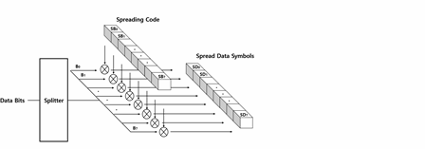

##### Figure 198—SS spreading example

The SS code length is configurable over PHY PIB attributes *phySSCode1Len*, *phySSCode2Len*, *phySSCode3Len*, *phySSCode4Len*; and the SS code pair is configurable over the PHY PIB attributes *phySSCode1FP00*, *phySSCode1FP01*, *phySSCode2FP00*, *phySSCode2FP01*, *phySSCode3FP00*, *phySSCode3FP01*, *phySSCode4FP00*, and *phySSCode4FP01*.

##### VTASC code design

VTASC is a modulation scheme for visible-light communication involving single or multiple displays (e.g., panel, LED) or light bulbs with variable transparency levels, sizes, shape models, and colors.

VTASC is coded by the T (transparency level) / A (amplitude, nothing but block size) / S (shapes) / C (colors) states as described in Figure 199.

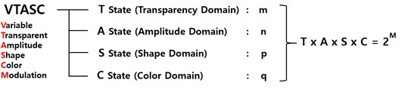

##### Figure 199—VTASC code states

The number of code levels in the VTASC modulation is (*m* × *n* × *p* × *q*) with two transparency levels, four block sizes, four shape models, and eight colors. In other words, 256 = 28, which allows an 8-bit symbol to be coded with two transparency levels, four block sizes, four shape models, and eight colors. The coded example model is given Figure 200.

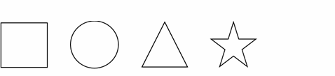

##### Figure 200—VTASC-coded pattern example

The shapes inside the symbols pixel region are equally spaced in the VTASC symbols coding region. The coded symbols are ordered sequentially row by row in the same order as English text order, and the coded region background color used shall be white. The zero padded VTASC-coded symbols are generated if the available number of data bits is less than the symbol mapping in the defined coding region. The VTASC code illustration is given Figure 201.

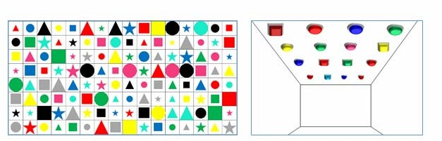

##### Figure 201—VTASC code symbols illustration (display and bulb source)

The coding states are configurable over PHY PIB attributes *phyVTASCTLevel*, *phyVTASCALevel*, *phyVTASCSLevel*, and *phyVTASCCLevel*. Table 140 describes the bits per symbol for VTASC code design.

##### Table 140—Bits per symbol for VTASC-coded block models

|  |  |  |
| --- | --- | --- |
| **Coding (*m*,*n*,*p*,*q*) states** | **Number of coded symbols (*m*×*n*×*p*×*q*)** | **Bits per symbol** |
| *m*=2, *n*=4, *p*=4, *q*=2 | 64=26 | 6 |
| *m*=2, *n*=4, *p*=4, *q*=4 | 128=27 | 7 |
| *m*=2, *n*=4, *p*=4, *q*=8 | 256=28 | 8 |

Table 141 describes the data bits to coding states mapping for VTASC code design.

##### Table 141—VTASC-coded symbol bit mapping with coding states (*m*,*n*,*p*,*q*)

|  |  |  |  |  |  |  |  |  |
| --- | --- | --- | --- | --- | --- | --- | --- | --- |
| **Bits per symbol** | **Data bits** | | | | | | | |
| **B7** | **B6** | **B5** | **B4** | **B3** | **B2** | **B1** | **B0** |
| 6 | — | — | *m* | *n* | *n* | *p* | *p* | *q* |
| 7 | — | *m* | *n* | *n* | *p* | *p* | *q* | *q* |
| 8 | *m* | *n* | *n* | *p* | *p* | *q* | *q* | *q* |

The number of horizontal and vertical symbols depends on the partial or full display coded mode by PHY PIB attribute *phyVTASCCodedArea*. The example VTASC-coded symbol of the full and partial display and the example light bulb coded mode are shown in Figure 202.

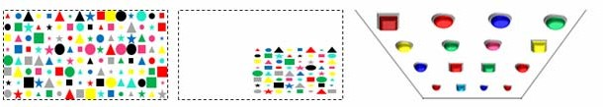

##### Figure 202—Left: full display coded mode; middle: partial display coded mode; right: light bulb coded mode

In partial display mode, the number of horizontal and vertical blocks is configurable over the PHY PIB attributes *phyVTASCAHSize* and *phyVTASCAVSize*. In full display mode, the number of horizontal and vertical blocks is estimable based on the screen size, resolution, aspect ratio, and the relative pixel ratio with a 42-inch, full high-definition display (1920 pixels of width and 1080 pixels of height with 16:9 aspect ratio).

The size of the block varies with display size and aspect ratio. For example, the block size of a 21-inch, full high-definition display differs from the reference 42-inch, full high-definition display. To generate a block size the same as the reference display, the pixel ratio needs to be calculated according to display specifications so that all display transmitters can generate the same block size as the reference display (e.g., [32x32] pixel block is transformed into [32*Pixelratio × 32*Pixelratio] pixel block). The pixel ratio calculation formula is as follows:

 *hNewResolution*  *InchesRef*   1 + *AspectRatioNew*2



*Pixelratio* =

 -------------------------------------------   ----------------------------   -----------------------------------------------------------

*hRefResolution*

*InchesNew*

 1 + *AspectRatioRef*2 

where

*hNewResolution* is horizontal resolution of display pixel to be estimated

*hRefResolution* is horizontal resolution of reference display *InchesRef* is inches of display pixel to be estimated *InchesNew* is inches of reference display

*AspectRatioNew* is aspect ratio of the used display and aspect ratio is expressed width by height

*AspectRatioRef* is aspect ratio of reference display

##### VTASC encoder

The display light-based transmitter with VTASC encoder works by overlaying the data-mapped color code on the visual scene as shown in Figure 203.

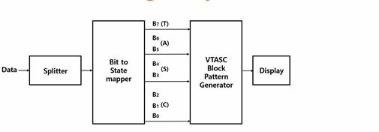

##### Figure 203—VTASC data encoder

The data is coded on the display by overlaying visual symbols in the display’s visual area. Overlaying visual symbols means refreshing the coded region pixels using VTASC-coded symbols. The overlaying coded symbol on the frame buffer and data rate achievement vary based on the kind of display used to design the transmitter and the distance between transmitter and receiver. Table 142 describes the example data rate supported by VTASC code design with a symbol block size of 32x32 pixels on a 42-inch, full high- definition display with a 16:9 aspect radio.

##### Table 142—VTASC data rate example

|  |  |  |  |  |
| --- | --- | --- | --- | --- |
| **Modulation (T/A/S/C)** | **RLL**  **code** | **Optical clock rate (Hz)** | **FEC** | **Data rate (kbps)** *Shown data rates are with no FEC* |
| 2-color VTASC code (*m*=2, *n*=4, *p*=4, *q*=2) | None | 30 | RS(64,32)/RS(160,128)/  None | 384 |
| 4-color VTASC code (*m*=2, *n*=4, *p*=4, *q*=4) | None | 30 | RS(64,32)/RS(160,128)/  None | 448 |
| 8-color VTASC code (*m*=2, *n*=4, *p*=4, *q*=8) | None | 30 | RS(64,32)/RS(160,128)/  None | 512 |
| 2-color SS VTASC code (*m*=2, *n*=4, *p*=4, *q*=2) | None | 30 | None | 192  (where spreading factor is 1) |
| 4-color SS VTASC code (*m*=2, *n*=4, *p*=4, *q*=4) | None | 30 | None | 224  (where spreading factor is 1) |
| 8-color SS VTASC code (*m*=2, *n*=4, *p*=4, *q*=8) | None | 30 | None | 256  (where spreading factor is 1) |

The data rate calculation for a display-based transmitter is described below:

DataRate = (NoofBlocks × BitsPerSymbol × OpticalClockrate × FECRate) / CodeLength) where

CodeLength is 1 for without SS spreading and respective spreading code factor used for with SS spreading

DisplayWidth is 1920

DisplayHeight is 1080

SymbolWidth is 32

SymbolHeight is 32

NoofHorizontalSymbols is (DisplayWidth/SymbolWidth) = 60 (approx. to even for coding efficiency) NoofVerticalBlocks is (DisplayHeight/SymbolHeight) = 32 (approx. to even for coding efficiency) NoofSymbols is (NoofHorizontalSymbols × NoofVerticalSymbols)

BitsPerSymbol is 7 (see Table 140)

OpticalClockrate is 30 Hz

FECRate is 1 (see Table 79)

The Data Rate for the two-color VTASC Code with four-amplitude scalability, four shape models, two transparency levels, and two colors without SS spreading code (CodeLength is 1) is as follows:

DataRate = (NoOfHorizontalSymbols × NoOfVerticalSymbols × BitsPerSymbol × OpticalClockrate × 1)

/ 1) = 403200 = 390 kbps (approximately)

VTASC uses two transparency levels in code design. The transparency defines the pixel with an observed color when given the pixel and a background VTASC-coded block symbol color. The symbol-to-bit mapping for transparency is shown in Table 143.

##### Table 143—Symbol-to-bit mapping for transparency level

|  |  |
| --- | --- |
| **Symbol bit (B7)** | **Transparency level (%)** |
| 1 | 0 |
| 0 | 50 |

VTASC symbol size is represented by amplitude state in code design. The symbol-to-bit mapping for symbol size is shown in Table 144.

##### Table 144—Symbol-to-bit mapping for block size

|  |  |
| --- | --- |
| **Symbol (B6,B5)** | **Block size (*m*×*n* pixels)** |
| 0 0 | 128 × 128 |
| 0 1 | 96 × 96 |
| 1 0 | 64 × 64 |
| 1 1 | 32 × 32 |

VTASC uses four shape models in code design. The symbol-to-bit mapping for shape is shown in Table 145.

##### Table 145—Symbol-to-bit mapping for shape model

|  |  |
| --- | --- |
| **Symbol (B4,B3)** | **Shapes** |
| 0 0 | Square |
| 0 1 | Circle |
| 1 0 | Hexagon |
| 1 1 | Star |

VTASC uses eight colors in code design. The symbol-to-bit mapping for color channel is shown in Table 146.

##### Table 146—Symbol-to-bit mapping for color channel

|  |  |
| --- | --- |
| **Symbol (B2,B1,B0)** | **Color channel** |
| 0 0 0 | Black |
| 0 0 1 | Red |
| 0 1 0 | Green |
| 0 1 1 | Blue |
| 1 0 0 | Yellow |
| 1 0 1 | Magenta |
| 1 1 0 | Cyan |
| 1 1 1 | White |

##### Asynchronous communication mode

A transmitter does not use any reference block for receiver synchronization with a receiver. The purpose of spreading codes is to support the receiver’s performance of asynchronous data decoding irrespective of the receiver frame rate variation. To provide efficient receiver synchronization, every frame in the video sequence uses spreading with one spreading code, and the alternative frames use the spreading code pairs sequentially. The spreading sequence order in the video frame sequence is shown in Figure 204.

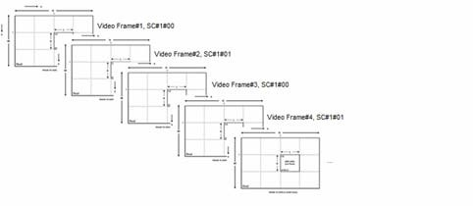

##### Figure 204—Video frame sequence SS code assignment

The receiver decoding for asynchronous communication and receiver error mitigation due to rolling effect is given in I.8.1.

##### Scalable bitrate controller

The VTASC and SS2DC PHYs for display-based OWC are designed with built-in scalable bitrate controller. Two types of scalable bitrate controller are supported:

* + - 1. Receiver frame-rate-adaptive multirate controller
      2. Receiver distance-adaptive data rate controller

The scalable bitrate control mode selection is configurable over the PHY PIB attribute

*phyVTASCScalRateCtrl*.

##### Receiver frame-rate-adaptive multirate controller

The screen is divided into 2x2 regions, and each region encodes with a different optical rate and renders the visual scene on screen. Each different optical-rate-coded region is spread by a pair of spread codes as defined in Table 139. The same coded symbol is rendered repeatedly at the rate of (displayRefreshRate / OpticalClockRate) to control the multirate data rate control on single screen. To achieve robust communication, the scalable multirate data transmission in PHY model design is shown in Figure 205. The region-based optical clock rate and SS code are configurable over the PHY PIB attributes *phyVTASCScalRegion1OpticalClockRate* to *phyVTASCScalRegion4OpticalClockRate* and *phySSCode1FP00* to *phySSCode4FP01*.

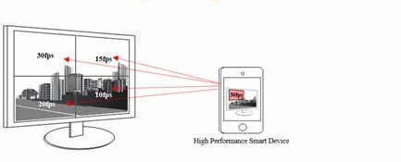

##### Figure 205—Scalable bitrate controller

* + - 1. **Receiver distance-adaptive data rate controller**

The receiver distance-adaptive data rate control is configurable by changing the symbol size small for short distance (example: 32x32 but varies with display) and big for long distance (example: 128x128 but varies with display). The receiver distance is calculated using a camera installed on the transmitter. The camera availability is configured by PHY attribute *phyVTASCTxCameraEnable*. The region-based distance adaptation is configurable over the PHY PIB attributes *phyVTASCScalRegion1DistanceRange*, *phyVTASCScalRegion2DistanceRange*, *phyVTASCScalRegion3DistanceRange*, and *phyVTASCScalRegion4DistanceRange*.

Each different distance range encoding is spread by a pair of spread codes as defined in Table 139. In this case the transmitter has built-in camera features as shown in Figure 206 to estimate the receiver’s distance when using the camera. The receiver distance estimation is not part of this standard. The distance- based optical clock rate and SS code are configurable over the PHY PIB attributes *phyVTASCScalRegion1OpticalClockRate* to *phyVTASCScalRegion4OpticalClockRate* and *phySSCode1FP00* to *phySSCode4FP01*.

For multiple users, distance adaptive is supported by combining with the receiver’s frame-rate-adaptive multirate controller. The receiver’s frame-rate-adaptive multirate controller is described in I.8.1.

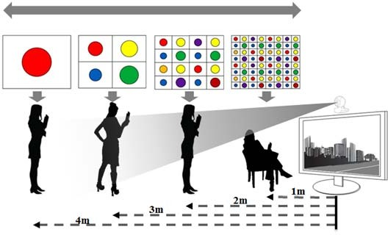

##### Figure 206—Distance-adaptive data rate control

#### SS2DC specification

The SS2DC code works with different 2D codes (e.g., QR, color code, VTASC, A-QL) organized in a combination of one or more codes sequentially in a row and column format. The SS2DC PHY supported data rates and operating conditions are shown for the PHY VI operating modes in Table 79.

##### SS2DC reference architecture

The reference PHY architecture for SS2DC is illustrated in Figure 207. The data is embedded on the visual frame by overlaying 2D-coded symbols in the defined display’s visual area. After SS, data is transformed into SS2C-coded 2D symbols according to the 2D code encoder.

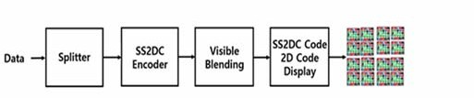

##### Figure 207—Reference architecture for SS2DC PHY system

The SS2DC is used for enhanced display-to-camera communication in real-time applications. The SS2DC- specific working features are given in K.2.

The receiver-specific information for SS2DC data decoder is given in I.9.

##### SS2DC code design

SS2DC is a design using different 2D codes for improved OWC throughput by sequentially arranging horizontal pixels and vertical pixels as shown in Figure 208. The data is coded using the 2D code principle and displayed on the display screen or panels. The number of horizontal and vertical 2D code blocks is

configurable over the PHY PIB attributes *phyVTASCAHSize* and *phyVTASCAVSize*. The horizontal and vertical size of the 2D code is configurable over the PHY PIB attributes *phySS2DCCODEHSIZE* and *phySS2DCCODEVSIZE*.



##### Figure 208—Reference architecture for SS2DC PHY system

##### SS2DC encoder

The display-light-based transmitter with SS2DC encoder works by overlaying the data mapped color code on the visual scene as shown in Figure 209.

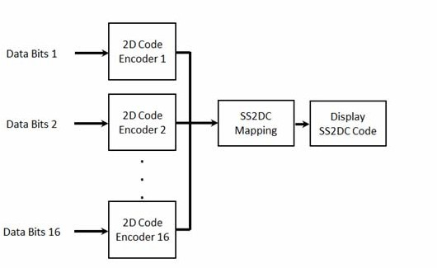

##### Figure 209—Sequential scalable 2D code data encoder

The data is coded on the display by overlaying visual symbols in the display’s visual area. Overlaying visual symbols means refreshing the coded region pixels using SS2DC-coded symbols. The overlaying coded symbols on frame buffer and data rate achievement vary based on the kind of display used to design the transmitter and the distance between transmitter and receiver. SS2DC uses one or more 2D codes, e.g., QR, VTASC, A-QL, HA-QL, IDE 2D.

The QR-based data encoder uses QR code version 40 and follows ISO/IEC 18004. The A-QL-based data encoding information is described in 15.1. The VTASC-based data encoding information is described in 15.2. The IDE-based data encoding information is described in 15.4. The VTASC-based data encoding information is described in 15.6. The minimum QR code size must be equal to (scanning distance / 10) to have an effective QR detection.

Table 147 describes the data rates supported by SS2DC code design with QR code. These data rates differ according to the 2D code specification.

##### Table 147—SS2DC data rate table example

|  |  |  |  |  |
| --- | --- | --- | --- | --- |
| **Modulation** | **RLL**  **code** | **Optical clock rate** | **FEC** | **Data rate (kbps)** |
| 2x2 SS2DC | None | 2DCodeDecodingRate | RS(64,32)/RS(160,128)/  None | 92 |
| 4x4 SS2DC | None | 2DCodeDecodingRate | RS(64,32)/RS(160,128)/  None | 368 |

The data rate calculation is described as follows:

DataRate = NoOfCodeSequence × 2DCodeDataCapacity × OpticalClockrate × FECRate where

NoofHorizontalBlocks is number of horizontal 2D code sequences NoofVerticalBlocks is number of vertical 2D code sequences NoOfCodeSequence is (NoofHorizontalBlocks × NoofVerticalBlocks)

The data rate for 2x2 SS2DC without SS spreading with QR code (the maximum data capacity is 2953 bytes) and DataRate = 4 × (2953 × 8) × 1 × 1) / 1) = 94494 = 92 kbps (approximately).

#### IDE specification

Invisible data embedding (IDE) works on embedding data on a visual frame in an unobtrusive mode using blending and watermarking. The IDE PHY-supported data rates and operating conditions are shown for the PHY VI operating modes in Table 79.

##### IDE reference architecture

The reference PHY architecture for IDE is illustrated in Figure 210. The data sequence includes the PSDU data packet length (first two bytes used for PSDU data length) and PSDU coded on the screen symbol. The PSDU data length and PSDU shall be fed into the IDE encoder. The data is embedded on the visual frame by invisible image blending and watermarking in the defined display’s visual area. After SS, data is transformed into IDE encoding according to the invisible blending and watermarking rules described in Figure 210.

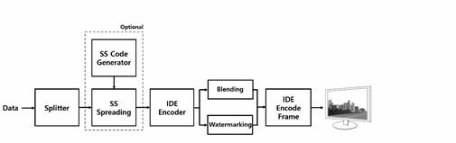

##### Figure 210—Reference architecture for IDE PHY system

SS is used with IDE to have effective asynchronous and distance-adaptive scalable data-rate-controlled OWC. The IDE is used for enhanced display-to-camera communication in real-time applications. The IDE- specific working features are given in K.3.

The receiver-specific information for IDE data decoder is given in I.10.

##### Synchronization sequence

The synchronization sequence is generated using SS code for IDE. The SS code is used with the IDE-coded display-based transmitter to add built-in adaptation on data recovery and to achieve the asynchronous communication with angle-free and distance-adaptive communication between transmitter and receiver. See 15.2.2 for more information about SS.

##### IDE encoder

IDE is a 2D block-based imperceptible data encoder for unobtrusive OWC communication between screen and camera. The visual display frame is divided into (*m*×*n*)*-*pixel blocks and the human imperceptible data is coded on the visual scene block using m-ary frequency shift keying (M-FSK) and/or m-ary phase shift keying (M-PSK) by image blending and 2D binary code by image watermarking. The display-light-based transmitter with IDE encoder works by using invisible overlay to map the data on the visual scene as shown in Figure 211. The Hybrid-MPFSK, 2D binary code, blending, and watermarking are described in 15.4.3.1, 15.4.3.2, 15.4.3.3, and 15.4.3.4, respectively.

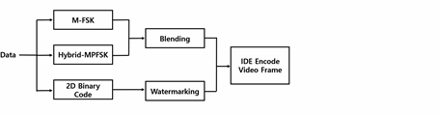

##### Figure 211—IDE data encoder

The IDE transmitter mode and modulation are configurable over the PHY PIB attributes *phyIDETxMode* and *phyIDEModulation*. The 16x16, 32x32, and 64x64 blocks sizes are used and configurable over the PHY PIB attribute *phyIDEMxNBlockSize*.

Table 148 describes the data rate supported modulation schemes. The IDE encoder data rate is estimated with reference to full HD display. The aspect ratio size (inches) does not impact the distance, but does change the scale of the block design.

##### Table 148—IDE PHY data rate example

|  |  |  |  |  |
| --- | --- | --- | --- | --- |
| **Modulation** | **RLL**  **code** | **Optical clock rate (Hz)** | **FEC** | **Data rate (kbps)**  *Shown data rates are with no FEC* |
| IDE-MPFSK-Blend | None | 30 | RS(64,32)/RS(160,128)/  None | 32 |
| IDE-2DBIN-WM | None | 30 | RS(64,32)/RS(160,128)/  None | 128 |
| SS IDE-Blend | None | 30 | None | 16 |
| SS IDE-Watermark | None | 30 | None | 64 |

* + - 1. **Hybrid-MPFSK modulation**

The Hybrid-MPFSK scheme is used to achieve double the data rate by combining frequency and phase on the modulation. Hybrid-MPFSK uses 16 frequencies and two phase ranges to map data symbols. The data bits spread with SS sequence are split as a 5-bit symbol and mapped into a selected 16-frequency conjunction with two phases as shown in Figure 212. The number of frequencies and phases used to map data shall be configured over the PHY PIB attributes *phyIDEFSKNoFrequency* and *phyIDEPSKNoPhase*. The Hybrid-MPFSK-coded symbol generates a 2D pattern of (*m*×*n*)-pixel blocks to blend with visual scene to be rendered on screen.

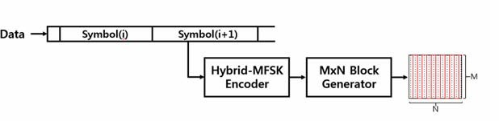

##### Figure 212—IDE Hybrid-MPFSK data encoder

The Hybrid-MPFSK encoder generates the sine waveform for the symbol-mapped frequency and phase according to Table 149 and stores the sine waveform in an *m*×*n* 2D pattern. The Hybrid-MPFSK-coded symbol generates a 2D pattern of (*m*×*n*)-pixel blocks to blend with the visual scene to be rendered on screen. The data blending is described in 15.4.3.4.

The 5-bit symbol-to-bit mapping for Hybrid-MPFSK is shown in Table 149. The symbol-coded patterns are generated based on the PHY PIB attributes.

##### Table 149—Symbol-to-bit mapping for Hybrid-MPFSK

|  |  |  |
| --- | --- | --- |
| **Symbol bits (B4, B3, B2, B1, B0)** | **Phase mapping** | **Frequency mapping** |
| 00000 | P0 | *f*0 |
| 00001 | P0 | *f*1 |
| ... | ... | ... |
| 01111 | P0 | *f*15 |
| 10000 | P1 | *f*0 |
| 10001 | P1 | *f*1 |
| ... | ... | ... |
| 11111 | P1 | *f*15 |

The frequency selection and configuration are described in 15.4.3.1.

The phases P0~P1 are selected to encode data, and the relationship between phases are Pi = P0 + i.dP (I = 1.2), where dP is the selected phase separation value.

The selection of all phases shall be configured over the first phase (P0), which shall be implemented over the PHY PIB attribute *phyIDEPhaseBase* (0 by default), and the phase separation, which shall be implemented over the PHY PIB attribute *phyIDEPhaseSeparation* (180).

##### Binary code

The horizontal and vertical encoding area pixel ranges shall be configured over the PHY PIB attributes *phyIDEENCHozAreaSize* and *phyIDEENCVerAreaSize*. The 2D binary encoder first calculates the number of (*m*×*n*)-pixel blocks in the visual display by dividing *phyIDEENCHozAreaSize* and *phyIDEENCVerAreaSize* by 8. The *m*×*n* number of encoding block-sized SS spread data is extracted and converted to 2D format of *m*×*n* dimension. The described 2D binary data encoder is shown in Figure 213.

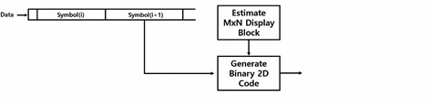

##### Figure 213—IDE 2D binary data encoder

* + - 1. **Invisible data blending**

The invisible data blending is the process of overlaying a foreground image with transparency over a visual rendering frame. The Hybrid-MPFSK-coded symbol 2D sine waveform pattern is generated as a block of (*m*×*n*) pixels. The coded 2D waveform is blended sequentially; row by row, (*m*×*n*)-pixel blocks are blended in the visual frame and rendered on the display screen as shown in Figure 214.

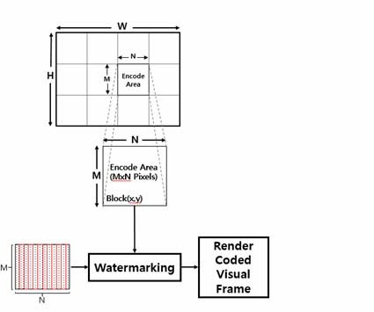

##### Figure 214—IDE encoder—blending

The visual blending rule is as follows:

IDEEncodedFRAME = alpha. VisualFrameBlock(*x*, *y*) + (1-alpha) M-PFSKCodeBlock. where

alpha is blending factor and equals 0.0~0.3 for invisible blending

1. is current row of *m*×*n* block in visual frame
2. is current column of *m*×*n* block in visual frame

##### Invisible watermarking

The human eye is more sensitive to lower frequency components than to higher frequency components. As a result, most of the important information in an image is contained in the lower frequency components. Therefore, the higher frequency components can be discarded without visibly degrading the image. Invisible watermarking utilizes the human eye’s visual imperceptibility in the middle-high–frequency component of every 8x8 block of the visual frame.

The binary 2D-coded *m*×*n* block is watermarked imperceptibly within the visual frame of every 8x8 block in a row and column format and rendered on a display screen as shown in Figure 215.

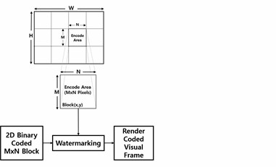

##### Figure 215—IDE encoder—watermarking

This frequency-based transform domain watermarking is dominant for IDE using the discrete cosine transform (DCT). The detailed frequency-based IDE procedure using DCT is described in Annex L.

#### Hidden A-QL (HA-QL)

##### Reference architecture

The reference architecture for HA-QL is specified in Figure 216. Data bits are fed into the FEC encoder. The coded sequence is split and then goes to the line encoder to generate pairs of images according to the data input. The channel encoder will allocate data to fit the screen size.

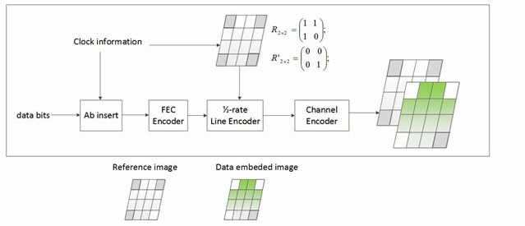

##### Figure 216—Reference architecture

##### Channel encoder

* + - 1. **Encoder configuration**

The number of hidden cells on the screen (*m*×*n*) to be modulated is read by the value of PHY PIB attribute *phyHAqlNumCells*. The TX checks the screen resolution and reads the number of cells to determine the size of individual cells.

##### Half-rate line encoder

The HA-QL encoder shall utilize 1/2-rate line coding (see Table 150).

Unlike the typical RLL code that is used to maintain the average brightness, the line coding applied here is used to provide the reference image (i.e., the image that has unmodulated intensity) for the decoder to extract the modulated intensity. Thus, from a block of data, the RLL encoder utilizes the 1/2-rate line code to generate a pair of two images, a reference image, and a data-embedded image.

##### Table 150—RLL encoding table

|  |  |  |
| --- | --- | --- |
| **Binary input** | **RLL output** | **Cell(ij) intensity description** |
| 0 | 0 0 | The state of the cell does not change between two image frames |
| 1 | 0 1 | The state of the cell changes between two image frames |

Additionally, within both reference image and data image, the reference cells at the corners of each image shall not carry any data, but rather carry the rotation information of the HA-QL code. These reference cells are modulated by a pair of the intensity matrix, R2×2 for the reference image and R'2×2 for the data image, to support the determination of the starting corner of the TX (see Table 151).

To support a receiver dealing with its frame rate variation, Ab shall be inserted at the beginning of every block of data. The number of Ab is configurable via the PHY PIB attribute *phyHAqlAb*. After that, a block of data along with Ab shall also be protected from error by using inner FEC (see 15.5.2.3).

The decoding guideline is described in I.6.

##### Table 151—HA-QL RLL and channel encoding

|  |  |  |  |  |  |  |  |  |  |  |  |
| --- | --- | --- | --- | --- | --- | --- | --- | --- | --- | --- | --- |
|  | **Data block time (2i)** | | | | | | **Data block time (2i+1)** | | | | |
| **Reference image** | | | **Data embedded image** | | | **Reference image** | | | **Data embedded image** | |
| *m*×*n* cells TX | *cmxn*  | |  | *c*0 0  *c*1 0   | *c*0 1  *c*1 1   |      | | *c*0 *n* – 2  *c*1 *n* – 2   | *c*0 *n* – 1  *c*1 *n* – 1   | |  |
|  |  | | *c**m* – 2 0 *c**m* – 2 1 | | |  | | *c**m* – 2 *n* – 2 | *c**m* – 2 *n* – 1 | |  |
|  |  | | *c**m* – 1 0 *c**m* – 1 1 | | |  | | *c**m* – 1 *n* – 1 | *c**m* – 1 *n* – 1 | |  |
| Reference cells  *R*  *c*0 0 *c*0 *n* – 1 2 *x*2  *c**m* – 1 0 *c**m* – 1 *n* – 1 | *R*2x2 = | 1 1  1 0 |  | *R’*2x2 = | 0 0  0 1 |  |  | *R*2x2 = 1 1  1 0 | | *R’*2x2 = | 0 0  0 1 |
| NOTE—R2×2 is the intensity matrix to modulate four reference cells for supporting the identification of the starting corner of the HA-QL code under rotation. | | | | | | | | | | | |

When the length of data does not fit the size of the HA-QL code, zeros are inserted to the end of data. The RX reads the value of the PHY PIB attribute *phyPSDULength* and then pads the inserted bits.

##### Error correction

RS(15,7) and CC(1/4) shall be implemented as an outer FEC and inner FEC, respectively, to protect the PSDU and Ab from errors. The value of PHY PIB attribute *phyHAqlFec* shall determine the error correction used if any change is applied.

##### 15.5.3 Bits-to-intensity mapping

The channel encoder converts a block of data bits into a pair of matrixes, in which the first matrix contains all zeros and the second matrix contains the data bits. The value of each element in a matrix (element # ij) shall be mapped into the intensity (Pij) to control the corresponding data cell (cell ij) of the HA-QL layer.

bit 0: Pg(ij) = 0

bit 1: Pg(ij) = 1

where Pg(ij) = 0 and Pg(ij) = 1 indicate that the intensity of data cell (ij) is unmodulated and modulated, respectively, in comparison to the intensity value of the original image. The change should less than 0.008 on Cb channel of YCbCr color space to be imperceptible to human eyes. The configuration of the level of intensity modulation is over the PHY PIB attribute *phyHAqlIntensity*.

Consequently, a block of data is carried by a pair of images including a reference image with unmodulated intensity of all data cells and a data-embedded image with the modulated intensity of data cells.

Four reference cells at corners are modulated by the clock information (2x2 matrix via reference cells). Thus only data bits (*n*×*m* – 4) bits are carried by data cells.

The optical clock rate at which the cells on the TX are updated is configurable over the PHY PIB attribute

*phyHAqlOpticalClockRate*.

# Annex A

### (informative)

**Bibliography**

* 1. **General**

Bibliographical references are resources that provide additional or helpful material but do not need to be understood or used to implement this standard. Reference to these resources is made for informational use only.

[B1] Berman, S. M., D. S. Greenhouse, I. L. Bailey, R. Clear, and T. W. Raasch, “Human electroretinogram responses to video displays, fluorescent lighting and other high frequency sources,” *Optometry and Vision Science*, 68:645–662, 1991.

[B2] CIE (1932) Commission internationale de l’Eclairage proceedings, 1931. Cambridge: Cambridge University Press.

[B3] Colman, R. S., F. Frankel, E. Ritvo, and B. Freeman, “The effects of fluorescent and incandescent illumination upon repetitive behaviors in autistic children,” *J. Autism Childhood Schz.,* 6:157–162, 1976.

[B4] Harding, G. F. A., and P. Jeavons, *Photosensitive Epilepsy*, Mac Keith Press, 1994.

[B5] IEEE 802.15 document 15-10-0151-01-0007, “High-power high-bandwidth linear driving circuit for OWC applications,” Baumgartner, R. et al., https://mentor.ieee.org/802.15/dcn/10/15-10-0151-01-0007- high-power-high-bandwidth-linear-driving-circuit-for-OWC-applications.pdf.

[B6] IEEE Std 802.11™-2007, Information technology—Telecommunications and information exchange between systems—Local and metropolitan area networks—Specific requirements—Part 11: Wireless LAN Medium Access Control (MAC) and Physical Layer (PHY) Specifications.10,11

[B7] IEEE Std 802.15.3™-2003, IEEE Standard for Information technology—Telecommunications and information exchange between systems—Local and metropolitan area networks—Specific requirements— Part 15.3: Wireless Medium Access Control (MAC) and Physical Layer (PHY) Specifications for High Rate Wireless Personal Area Networks (OWPANs).

[B8] ISO/IEC 7498-1:1994, Information technology—Open Systems Interconnection—Basic Reference Model: The Basic Model.12

[B9] Kang, T. G., et al., “White Paper: IEEE 802.15.7 OWC Regulations,” July 2010, IEEE802.15 contribution 15-10-0615-01-0007, https://mentor.ieee.org/802.15/dcn/10/15-10-0615-01-0007-white-paper- ieee-802-15-7-OWC-regulations.pdf.

[B10] Küller, R. and T. Laike, “The impact of flicker from fluorescent lighting on well-being, performance, and physiological arousal,” *Ergonomics*, 41(4): 433–447, 1998.

10IEEE publications are available from The Institute of Electrical and Electronics Engineers (<http://standards.ieee.org/>).

11The IEEE standards or products referred to in this annex are trademarks of The Institute of Electrical and Electronics Engineers, Inc. 12ISO publications are available from the International Organization for Standardization (<http://www.iso.org/>). ISO publications are also available in the United States from the American National Standards Institute (<http://www.ansi.org/>).

[B11] Lindner, H. and S. Kropf, “Asthenopic complaints associated with fluorescent lamp illumination (FLI): The role of individual disposition,” *Lighting Res. Technol*., 25:59–69, 1993.

[B12] Schubert, E. F., “Light Emitting Diodes,” Cambridge University Press, 2003.

[B13] Stone, P. T., “Fluorescent lighting and health,” *Lighting Res. Technol*., 24:55–61, 1990.

[B14] Walewski, J. W., “Color stabilization for CSK by use of visibility frames,” Jan. 2011, IEEE802.15 contribution 15-1-0262-05-0007, https://mentor.ieee.org/802.15/dcn/11/15-10-0262-05-0007-color- stabilization-for-csk-by-use-of-visibility-frames.pdf.

[B15] Wilkins, A. J., I. Nimmo-Smith, A. Slater, and L. Bedocs, “Fluorescent lighting headaches and eye- strain,” *Lighting Res. Technol*., 21:11–18, 1989.

[B16] Wright, P. S., “An overview of harmonic and flicker emission standards and their associated measurements,” *Power Eng. J*., 15(2): 87–93, 2001.

[B17] Yokoi, A., et al., “More description about CSK constellation,” Mar. 2011, IEEE 802.15 contribution 15-11-0247-00-0007, https://mentor.ieee.org/802.15/dcn/11/15-11-0247-00-0007-csk-constellation-in-all- color-band-combinations.pdf.

* 1. **Regulatory documents**

[B18] ANSI C82.77-2002, American National Standard for Harmonic Emission Limits—Related Power Quality Requirements for Lighting Equipment.13

[B19] ANSI C82.SSL1, Operational Characteristics and Electrical Safety of SSL Power Supplies and Drivers.

[B20] ANSI Z136.1, American National Standard for Safe Use of Lasers (2007).

[B21] ANSI Z136.6, American National Standard for Safe Use of Lasers Outdoors (2005).

[B22] ARIB STD-T66, Second Generation Low Power Data Communication System/Wireless LAN System 1999.12.14 (H11.12.14) Version 1.0.14

[B23] BS EN 29241-3:1993, Ergonomic requirements for office work with visual display terminals (VDTs).

Visual display requirements.15

[B24] ERC Recommendation 70-03, Relating to the Use of Short Range Devices (SRDs), April 2002.16

[B25] IEC 1000-3-3 (1994), Part 3: Limits—Section 3: Limitation of voltage fluctuations and flicker in low- voltage supply systems for equipment with rated current 16 A.17

13 ANSI publications are available from the American National Standards Institute (<http://www.ansi.org/>).

14 ARIB publications are available from the Association of Radio Industries and Businesses ([http://www.arib.or.jp](http://www.arib.or.jp/)).

15 This publication is from the British Standards Institution and available from the American National Standards Institute ([http://](http://www.ansi.org/) [www.ansi.org/](http://www.ansi.org/)).

16 ERC publications are available from Global Engineering Documents (<http://global.ihs.com/>).

17 IEC publications are available from the International Electrotechnical Commission (<https://www.iec.ch/>). IEC publications are also available in the United States from the American National Standards Institute (<http://www.ansi.org/>).

[B26] IEC 1000-3-5, Electromagnetic compatibility. Part 3: Limits—Section 5: Limitation of voltage fluctuations and flicker in low-voltage power supply systems for equipment with rated current greater than 16 A. 1994.

[B27] IEC 60050-112, Ed. 1.0 (2010-01), TC/SC 1—International Electrotechnical Vocabulary—Part 112: Quantities and units.

[B28] IEC 60050-300, Ed. 1.0 (2001-07), International Electrotechnical Vocabulary—Electrical and electronic measurements and measuring instruments—Part 311: General terms relating to measurements— Part 312: General terms relating to electrical measurements—Part 313: Types of electrical measuring instruments—Part 314: Specific terms according to the type of instrument.

[B29] IEC 60050-845, Ed. 1.0 (1987-12), International Electrotechnical Vocabulary, Lighting.

[B30] IEC 60825-1, Ed. 2.0 (2007-03), Safety of laser products—Part 1: Equipment classification and requirements.

[B31] IEC 60825-12, Ed. 1.0 (2004-02), Safety of laser products—Part 12: Safety of free space optical communication systems used for transmission of information.

[B32] IEC 61347-1, Ed. 2.0 (2007-01), Lamp control gear—Part 1: General and safety requirements.

[B33] IEC 61347-2-13, Ed. 1.0 (2006-05), Lamp control gear—Part 2-13: Particular requirements for d.c. or

a.c. supplied electronic control gear for LED modules

[B34] IEC 62384-am1, Ed. 1.0 (2009-07), Amendment 1—DC or AC supplied electronic control gear for LED modules—Performance requirements.

[B35] IEC 62471, Ed. 1.0 (2006-07), Photobiological safety of lamps and lamp systems.

[B36] IEC EN 61000-3-3, Electronic compatibility (EMC) Part 3: Limits—Section 3: Limitation of voltage fluctuations and flicker in low voltage supply systems for equipment with rated current 16 A and smaller. International Electrotechnical Commission, 1994.

[B37] IEC/TR 62471-2, Ed. 1.0 (2009-08), Photobiological safety of lamps and lamp systems—Part 2: Guidance on manufacturing requirements relating to non-laser optical radiation safety.

[B38] IEC/TS 61000-3-5, Ed. 2.0b, Cor.2:2010, Corrigendum 2—Electromagnetic compatibility (EMC)— Part 3-5: Limits—Limitation of voltage fluctuations and flicker in low-voltage power supply systems for equipment with rated current greater than 75 A.

[B39] IESNA RP-16-05, Nomenclature and Definitions for Illuminating Engineering.18

[B40] IESNA RP-27.1-05, Photobiological Safety for Lamps and Lamp Systems—General Requirements.

[B41] IESNA LM-79-08, IES Approved Method for the Electrical and Photometric Measurements of Solid- State Lighting Products.

[B42] IESNA LM-80-08, IES Approved Method: Measuring Lumen Maintenance of LED Light Sources. [B43] IESNA TM-16-05, Technical Memorandum on Light Emitting Diode (LED) Sources and Systems.

18 IESNA documents are the Illuminating Engineering Society Standards and are available from the American National Standards Institute (<http://www.ansi.org/>).

[B44] ITU-Recommendation RA.1630, Technical and operational characteristics of ground-based astronomy systems for use in sharing studies with active services between 10 THz and 1000 THz.19

[B45] ITU-Recommendation RS.1744, Technical and operational characteristics of ground-based meteorological aids systems operating in the frequency range 272–750 THz.20

19 ITU-T publications are available from the International Telecommunications Union (<http://www.itu.int/>).

20 This recommendation replaces ITU-R SA.1744.

# Annex B

### (normative)

**Service-specific convergence sublayer (SSCS)**

* 1. **IEEE 802.2 convergence sublayer**

The IEEE 802.2 convergence sublayer exists above the IEEE 802.15.7 MCPS. This sublayer provides an interface between an instance of an IEEE 802.2 LLC sublayer and the IEEE 802.15.7 MCPS.

#### MA-UNITDATA.request

The MA-UNITDATA.request primitive requests the transfer of a LLC protocol data unit (LPDU) (i.e., MSDU) from a local IEEE 802.2 Type 1 LLC sublayer entity to a single peer IEEE 802.2 Type 1 LLC sublayer entity or multiple peer IEEE 802.2 Type 1 LLC sublayer entities in the case of a group address.

The semantics of the MA-UNITDATA.request primitive is as follows:

MA-UNITDATA.request ( SrcAddr, DstAddr,

RoutingInformation, data,

priority, ServiceClass

)

Table B.1 specifies the parameters for the MA-UNITDATA.request primitive.

##### Table B.1—MA-UNITDATA.request parameters

|  |  |  |  |
| --- | --- | --- | --- |
| **Name** | **Type** | **Valid range** | **Description** |
| SrcAddr | IEEE  address | Any valid IEEE address | The individual IEEE address of the entity from which the MSDU is being transferred. |
| DstAddr | IEEE  address | Any valid IEEE address | The individual IEEE address of the entity to which the MSDU is being transferred. |
| RoutingInformatio n | — | null | This parameter is not used by the MAC sublayer and shall be specified as a null value. |
| data | Set of octets | — | The set of octets forming the MSDU to be transmitted by the MAC sublayer entity. |
| priority | — | null | This parameter is not used by the MAC sublayer and shall be specified as a null value. |
| ServiceClass | — | null | This parameter is not used by the MAC sublayer and shall be specified as a null value. |

* + - 1. **Appropriate usage**

The MA-UNITDATA.request primitive is generated by a local IEEE 802.2 Type 1 LLC sublayer entity when an LPDU (MSDU) is to be transferred to a peer IEEE 802.2 Type 1 LLC sublayer entity or entities.

##### Effect on receipt

On receipt of the MA-UNITDATA.request primitive, the MAC sublayer entity shall begin the transmission of the supplied MSDU.

The MAC sublayer first builds an MPDU to transmit from the supplied arguments. The MPDU shall be transmitted using the unslotted CSMA-CA algorithm in the contention period of the frame and without requesting a handshake.

If the unslotted CSMA-CA algorithm indicates a busy channel, the MAC sublayer shall issue the MA- UNITDATA-STATUS.indication primitive with a status of CHANNEL_ACCESS_FAILURE. If the MPDU was successfully transmitted, the MAC sublayer shall issue the MA-UNITDATA-STATUS.indication primitive with a status of SUCCESS.

#### MA-UNITDATA.indication

The MA-UNITDATA.indication primitive indicates the transfer of an LPDU (i.e., MSDU) from the MAC sublayer to the local IEEE 802.2 Type 1 LLC sublayer entity.

The semantics of the MA-UNITDATA.indication primitive is as follows:

MA-UNITDATA.indication ( SrcAddr, DstAddr,

RoutingInformation, data, ReceptionStatus, priority, ServiceClass

)

Table B.2 specifies the parameters for the MA-UNITDATA.indication primitive.

##### Table B.2—MA-UNITDATA.indication parameters

|  |  |  |  |
| --- | --- | --- | --- |
| **Name** | **Type** | **Valid range** | **Description** |
| SrcAddr | IEEE  address | Any valid IEEE address | The individual IEEE address of the entity from which the MSDU has been received. |
| DstAddr | IEEE  address | Any valid IEEE address | The individual IEEE address of the entity to which the MSDU is being transferred. |
| RoutingInformatio n | — | null | This parameter is not used by the MAC sublayer and shall be specified as a null value. |

**Table B.2—MA-UNITDATA.indication parameters *(continued)***

|  |  |  |  |
| --- | --- | --- | --- |
| **Name** | **Type** | **Valid range** | **Description** |
| data | Set of octets | — | The set of octets forming the MSDU received by the MAC sublayer entity. |
| ReceptionStatus | — | null | This parameter is not used by the MAC sublayer and shall be specified as a null value. |
| priority | — | null | This parameter is not used by the MAC sublayer and shall be specified as a null value. |
| ServiceClass | — | null | This parameter is not used by the MAC sublayer and shall be specified as a null value. |

* + - 1. **When generated**

On receipt of a data frame at the local MAC sublayer entity, the FCS field is checked. If it is valid, the MAC sublayer shall issue the MA-UNITDATA.indication primitive to the IEEE 802.2 Type 1 LLC sublayer entity, indicating the arrival of a MSDU. If the FCS is not valid, the frame shall be discarded, and the IEEE 802.2 Type 1 LLC sublayer entity shall not be informed.

##### Appropriate usage

The appropriate usage of the MA-UNITDATA.indication primitive by the IEEE 802.2 Type 1 LLC sublayer entity is not specified in this standard.

#### MA-UNITDATA-STATUS.indication

The MA-UNITDATA-STATUS.indication primitive reports the results of a request to transfer a LPDU (MSDU) from a local IEEE 802.2 Type 1 LLC sublayer entity to a single peer IEEE 802.2 Type 1 LLC sublayer entity or to multiple peer IEEE 802.2 Type 1 LLC sublayer entities.

The semantics of the MA-UNITDATA-STATUS.indication primitive is as follows:

MA-UNITDATA-STATUS.indication (

SrcAddr, DstAddr, status, ProvPriority,

ProvServiceClass

)

Table B.3 specifies the parameters for the MA-UNITDATA-STATUS.indication primitive.

##### Table B.3—MA-UNITDATA-STATUS.indication parameters

|  |  |  |  |
| --- | --- | --- | --- |
| **Name** | **Type** | **Valid range** | **Description** |
| SrcAddr | IEEE  address | Any valid IEEE address | The individual IEEE address of the entity from which the MSDU has been transferred. |
| DstAddr | IEEE  address | Any valid IEEE address | The individual IEEE address of the entity to which the MSDU has been transferred. |
| status | Enumeration | SUCCESS, TRANSMISSION_PENDING, NO_BEACON, CHANNEL_ACCESS_FAILURE | The status of the last MSDU transmission. |
| ProvPriority | — | null | This parameter is not used by the MAC sublayer and shall be specified as a null value. |
| ProvServiceClass | — | null | This parameter is not used by the MAC sublayer and shall be specified as a null value. |

* + - 1. **When generated**

The MA-UNITDATA-STATUS.indication primitive is generated by the MAC sublayer entity in response to an MA-UNITDATA.request primitive issued by the IEEE 802.2 Type 1 LLC sublayer.

##### Appropriate usage

The receipt of the MA-UNITDATA-STATUS.indication primitive by the IEEE 802.2 Type 1 LLC sublayer entity signals the completion of the current data transmission.

# Cyclic redundancy check (CRC)

The CRC field is 2 octets in length. The CRC shall be calculated using the following standard generator polynomial of degree 16:

*G*16*x*

= *x*16 + *x*12 + *x*5 + 1

(C.1)

The CRC shall be calculated for transmission using the following algorithm:

— Let *M**x* =

*b xk* – 1 + *b xk* – 2 +  + *b x* + *b*

be the polynomial representing the sequence of

bits for which the checksum is to be computed.

0 1 *k* – 2 *k* – 1

* Multiply *M*(*x*) by *x*16, giving the polynomial *x*16  *M**x* *.*
* Divide *x*16  *M**x* modulo 2 by the generator polynomial, *G*16(*x*)*,* to obtain the remainder

0 1 14 15

polynomial, *R**x*

= *r x*15 + *r x*14 +  + *r x* + *r* .

* The CRC field is given by the coefficients of the remainder polynomial, *R(x)*.

Here, binary polynomials are represented as bit strings, in highest polynomial degree first order. A typical implementation is depicted in Figure C.1.

CRC-16 Generator Polynomial: G(x) = x16 + x12 + x5 + 1

Input Data Field (LSB first)

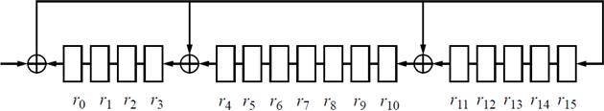

1. Initialize the remainder register (*r*0 through *r*15) to all ones.
2. Shift the data into the divider in the order of transmission (LSB).
3. After the last bit of the data field is shifted into the divider, the remainder register contains the CRC.
4. The CRC is appended to the data so that *r*0 is transmitted first.

##### Figure C.1—Typical CRC implementation

**Annex D**

(normative)

**Channel assignment**

Table D.1 shows the bit patterns that are used to assign multiple channels for visible light OWC. Note that band code 111 is not used for multiple channel assignments.

*Table legend: X=not used and O=used*

##### Table D.1—Multiple channel assignment table

|  |  |  |  |  |  |  |  |
| --- | --- | --- | --- | --- | --- | --- | --- |
| **Bit** | **Band code 000** | **Band code 001** | **Band code 010** | **Band code 011** | **Band code 100** | **Band code 101** | **Band code 110** |
| 0000000 | No multiple channel mode | | | | | | |
| 0000001 | X | X | X | X | X | X | O |
| 0000010 | X | X | X | X | X | O | X |
| 0000011 | X | X | X | X | X | O | O |
| 0000100 | X | X | X | X | O | X | X |
| 0000101 | X | X | X | X | O | X | O |
| 0000110 | X | X | X | X | O | O | X |
| 0000111 | X | X | X | X | O | O | O |
| 0001000 | X | X | X | O | X | X | X |
| 0001001 | X | X | X | O | X | X | O |
| 0001010 | X | X | X | O | X | O | X |
| 0001011 | X | X | X | O | X | O | O |
| 0001100 | X | X | X | O | O | X | X |
| 0001101 | X | X | X | O | O | X | O |
| 0001110 | X | X | X | O | O | O | X |
| 0001111 | X | X | X | O | O | O | O |
| 0010000 | X | X | O | X | X | X | X |
| 0010001 | X | X | O | X | X | X | O |
| 0010010 | X | X | O | X | X | O | X |
| 0010011 | X | X | O | X | X | O | O |
| 0010100 | X | X | O | X | O | X | X |
| 0010101 | X | X | O | X | O | X | O |
| 0010110 | X | X | O | X | O | O | X |
| 0010111 | X | X | O | X | O | O | O |

|  |  |  |  |  |  |  |  |
| --- | --- | --- | --- | --- | --- | --- | --- |
| **Bit** | **Band code 000** | **Band code 001** | **Band code 010** | **Band code 011** | **Band code 100** | **Band code 101** | **Band code 110** |
| 0011000 | X | X | O | O | X | X | X |
| 0011001 | X | X | O | O | X | X | O |
| 0011010 | X | X | O | O | X | O | X |
| 0011011 | X | X | O | O | X | O | O |
| 0011100 | X | X | O | O | O | X | X |
| 0011101 | X | X | O | O | O | X | O |
| 0011110 | X | X | O | O | O | O | X |
| 0011111 | X | X | O | O | O | O | O |
| 0100000 | X | O | X | X | X | X | X |
| 0100001 | X | O | X | X | X | X | O |
| 0100010 | X | O | X | X | X | O | X |
| 0100011 | X | O | X | X | X | O | O |
| 0100100 | X | O | X | X | O | X | X |
| 0100101 | X | O | X | X | O | X | O |
| 0100110 | X | O | X | X | O | O | X |
| 0100111 | X | O | X | X | O | O | O |
| 0101000 | X | O | X | O | X | X | X |
| 0101001 | X | O | X | O | X | X | O |
| 0101010 | X | O | X | O | X | O | X |
| 0101011 | X | O | X | O | X | O | O |
| 0101100 | X | O | X | O | O | X | X |
| 0101101 | X | O | X | O | O | X | O |
| 0101110 | X | O | X | O | O | X | O |
| 0101111 | X | O | X | O | O | O | X |
| 0110000 | X | O | O | X | X | X | X |
| 0110001 | X | O | O | X | X | X | O |
| 0110010 | X | O | O | X | X | O | X |
| 0110011 | X | O | O | X | X | O | O |
| 0110100 | X | O | O | X | O | X | X |
| 0110101 | X | O | O | X | O | X | O |
| 0110110 | X | O | O | X | O | O | X |
| 0110111 | X | O | O | X | O | O | O |
| 0111000 | X | O | O | O | X | X | X |

|  |  |  |  |  |  |  |  |
| --- | --- | --- | --- | --- | --- | --- | --- |
| **Bit** | **Band code 000** | **Band code 001** | **Band code 010** | **Band code 011** | **Band code 100** | **Band code 101** | **Band code 110** |
| 0111001 | X | O | O | O | X | X | X |
| 0111010 | X | O | O | O | X | X | X |
| 0111011 | X | O | O | O | X | X | X |
| 0111100 | X | O | O | O | O | X | X |
| 0111101 | X | O | O | O | O | X | X |
| 0111110 | X | O | O | O | O | O | X |
| 0111111 | X | O | O | O | O | O | O |
| 1000000 | O | X | X | X | X | X | X |
| 1000001 | O | X | X | X | X | X | O |
| 1000010 | O | X | X | X | X | O | X |
| 1000011 | O | X | X | X | X | O | O |
| 1000100 | O | X | X | X | O | X | X |
| 1000101 | O | X | X | X | O | X | O |
| 1000110 | O | X | X | X | O | O | X |
| 1000111 | O | X | X | X | O | O | O |
| 1001000 | O | X | X | O | X | X | X |
| 1001001 | O | X | X | O | X | X | O |
| 1001010 | O | X | X | O | X | O | X |
| 1001011 | O | X | X | O | X | O | O |
| 1001100 | O | X | X | O | O | X | X |
| 1001101 | O | X | X | O | O | X | O |
| 1001110 | O | X | X | O | O | O | X |
| 1001111 | O | X | X | O | O | O | O |
| 1010000 | O | X | O | X | X | X | X |
| 1010001 | O | X | O | X | X | X | O |
| 1010010 | O | X | O | X | X | O | X |
| 1010011 | O | X | O | X | X | O | O |
| 1010100 | O | X | O | X | O | X | X |
| 1010101 | O | X | O | X | O | X | O |
| 1010110 | O | X | O | X | O | O | X |
| 1010111 | O | X | O | X | O | O | O |
| 1011000 | O | X | O | O | X | X | X |
| 1011001 | O | X | O | O | X | X | O |

|  |  |  |  |  |  |  |  |
| --- | --- | --- | --- | --- | --- | --- | --- |
| **Bit** | **Band code 000** | **Band code 001** | **Band code 010** | **Band code 011** | **Band code 100** | **Band code 101** | **Band code 110** |
| 1011010 | O | X | O | O | X | O | X |
| 1011011 | O | X | O | O | X | O | O |
| 1011100 | O | X | O | O | O | X | X |
| 1011101 | O | X | O | O | O | X | O |
| 1011110 | O | X | O | O | O | O | X |
| 1011111 | O | X | O | O | O | O | O |
| 1100000 | O | O | X | X | X | X | X |
| 1100001 | O | O | X | X | X | X | O |
| 1100010 | O | O | X | X | X | O | X |
| 1100011 | O | O | X | X | X | O | O |
| 1100100 | O | O | X | X | O | X | X |
| 1100101 | O | O | X | X | O | X | O |
| 1100110 | O | O | X | X | O | O | X |
| 1100111 | O | O | X | X | O | O | O |
| 1101000 | O | O | X | O | X | X | X |
| 1101001 | O | O | X | O | X | X | O |
| 1101010 | O | O | X | O | X | O | X |
| 1101011 | O | O | X | O | X | O | O |
| 1101100 | O | O | X | O | O | X | X |
| 1101101 | O | O | X | O | O | X | O |
| 1101110 | O | O | X | O | O | O | X |
| 1101111 | O | O | X | O | O | O | O |
| 1110000 | O | O | O | X | X | X | X |
| 1110001 | O | O | O | X | X | X | O |
| 1110010 | O | O | O | X | X | O | X |
| 1110011 | O | O | O | X | X | O | O |
| 1110100 | O | O | O | X | O | X | X |
| 11101001 | O | O | O | X | O | X | O |
| 1110110 | O | O | O | X | O | O | X |
| 1110111 | O | O | O | X | O | O | O |
| 1111000 | O | O | O | O | X | X | X |
| 1111001 | O | O | O | O | X | X | O |
| 1111010 | O | O | O | O | X | O | X |

|  |  |  |  |  |  |  |  |
| --- | --- | --- | --- | --- | --- | --- | --- |
| **Bit** | **Band code 000** | **Band code 001** | **Band code 010** | **Band code 011** | **Band code 100** | **Band code 101** | **Band code 110** |
| 1111011 | O | O | O | O | X | O | O |
| 1111100 | O | O | O | O | O | X | X |
| 1111101 | O | O | O | O | O | X | O |
| 1111110 | O | O | O | O | O | O | X |
| 1111111 | O | O | O | O | O | O | O |

An example is shown in Figure D.1 where it is assumed that red (R), green (G), and blue (B) are available at the optical sources. If a certain optical source uses Hopping Pattern 1 (HP1) (00001) and another optical source in the adjacent cell uses Hopping Pattern 2 (HP2) (00011), then hopping pattern application in the adjacent cell is that HP1 operates R in first frame or time slot, B in second frame or time slot, G in third frame or time slot, but HP2 is operating at G in first frame or time slot, G and R in second frame or time slot, R and B in third frame or time slot. This mechanism can avoid interference between optical sources. Also the hopping pattern application is not limited to one frame or one time slot. A hopping pattern across multiple frames or time slots is fine.

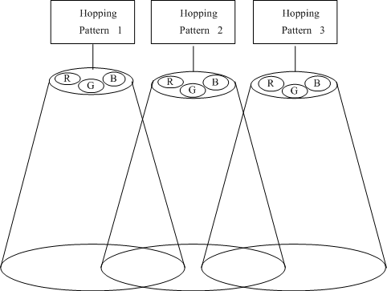

##### Figure D.1—Hopping pattern assignment

Table D.2 shows a hopping pattern example applicable to OWC. If coordinator assign pattern '00001' to a device by using H_pattern, then the device’s frame or time slot moves according to the hopping pattern. Also one hopping pattern or multiple hopping patterns can be assigned to one user.

##### Table D.2—Example of hopping pattern (HP) assignment

|  |  |  |  |
| --- | --- | --- | --- |
| **Pattern** | **00001** | **00011** | **00101** |
| **Frame/time slot** | **HP1** | **HP2** | **HP3** |
| 1 | R | G | B |
| 2 | B | G/R | B |
| 3 | G | R/B | G |
| 4 | G/R | B | G/R |
| 5 | G/R | R | G/B |
| 6 | R/B | G | R/B |
| 7 | G | B | R |
| 8 | B | R | G |
| 9 | R | G/B | R |

**Annex E**

(informative)

**Considerations for OWC using LED displays**

* 1. **Introduction—Dynamic displays vs. addressed displays**

This annex discusses two types of LED involved displays: dynamic displays and addressed displays. The fundamental different between the two has to do with the amount of time the pixel is illuminated. In dynamic displays the pixels on a line are illuminated once every frame for T_frame/N_line seconds where N_line is the number of lines controlled by a line scan controller and T_frame is the time to sweep N_line once; that is, the pixels on a line are operated dynamically so that they are only on for a fraction of the total frame time (hence the name “dynamic”). In the addressed display, the pixel is illuminated for the duration of the frame and is readdressed once per frame for possible state change.

* 1. **Dynamic displays**

#### Operation mechanism

In general, a dynamic display consists of a host controller, a line scan controller, a display data buffer, and LED matrix, as shown in Figure E.1. The line scan controller selects a line for display, and the display data buffer transmits state information, such as the ON/OFF state or the color selection, to each LED pixel on the selected line. The line scan controller determines the active time of each line, where the active time indicates whether the LED pixels on the selected line are switched ON or OFF as per the display data buffer for the active time of the selected line. Therefore, OWC using a dynamic display is tightly coupled with the active time.

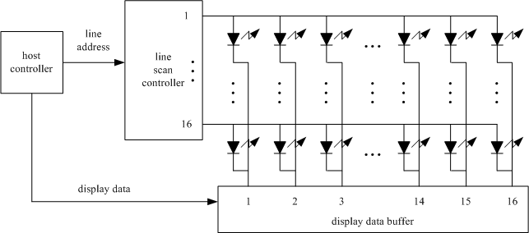

##### Figure E.1—General architecture of LED signboard operated by the dynamic display mechanism

It is well known that most of PC monitors and TV display images use 60 displayed-frames per second. In the case of PC monitors or TVs, the total displayed-frame number (i.e., different display information) is actually 30 frames per second because each displayed-frame is transmitted twice. The display mechanism of a dynamic display is similar to a PC monitor or TV. Assuming that a dynamic display consists of 16x16 lines and displays images or text through 60 displayed-frames per second, with 16 lines per displayed-frame, the active time slot period for OWC assigned to each line is 1.042 ms per displayed-frame, as shown in Figure E.2. Therefore, an active time slot can transmit 130 byte at 1 Mbit/s, as shown in Figure E.3.

line 1

1 display frame time = 1/60 sec

1.042ms

•

•

•

line 2

•

•

•

line 16

active time per display-frame per line = (1/60)/16 sec

##### Figure E.2—Operation mechanism of dynamic display

line 1

slot 1

slot 1

line 2

slot 2

slot 2

data

header

130 bytes

•

•

•

•

• •

•

•

line 16

slot 16

##### Figure E.3—An example of OWC data transmission on a dynamic display

* + 1. **Reduced brightness mitigation on OWC dynamic displays**

The OWC dynamic display may be less bright than the non-OWC dynamic display because of the OWC modulation during the active time periods. Therefore, it is important to minimize the reduction of the average brightness of the dynamic display during the shortest time period that the human can distinguish. This is done to keep the display performing adequately for its intended function. Figure E.4 shows an example of an operational mechanism to mitigate the average brightness reduction per display frame time that can arise for a dynamic display having 16x16 lines operating as shown in Figure E.2 (i.e., the OWC data is carried during the active time of each line). The average brightness per display frame time in Figure E.4 is twice as large as that in Figure E.2 because the active time is twice as long.

line 1

line 2

line 8

line 9

line 10

line 16

active time per display -frame per line = (1/60)/8 sec

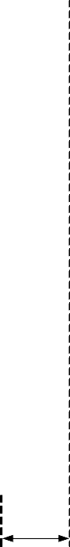

|  |  |  |  |  |  |  |  |
| --- | --- | --- | --- | --- | --- | --- | --- |
|  | 1 frame time = 1/60 sec | | | |  | | |
| slot 1 |  | | | slot 1 |  | |
|  |  | | | |  | | |
|  | slot 2 | • • • | |  | slot 2 |  |
|  | header | | data | •  •  • | 260 bytes | | |
|  |  | | | slot 8 |
|  | | | |  | | |
| slot 1 |  | | | slot 1 |  | |
|  |  | | | |  | | |
|  | slot 2 | • • • | |  | slot 2 |  |
|  | header | | data | •  •  • | 260 bytes | | |
|  |  | | | slot 8 |
|  | | | |  | | |

##### Figure E.4—An example for the mitigation of the average brightness reduction on the OWC dynamic display

* + 1. **OWC application using dynamic displays**

A OWC enabled dynamic display can be used in the broadcast topology. The OWC broadcast topology in this standard consists of mainly the beacon and the downlink, as shown in Figure 18. Therefore, the OWC broadcast topology using a dynamic display can be constructed by the assignment of the active time slots and the use of GTS field in the beacon frame. Figure E.5 shows the OWC broadcast topology construction using the dynamic display. The active time slot #1 is assigned to the beacon and the active time slots from #2 to #8 are assigned to the downlink in Figure E.5. The GTS fields of the beacon frame can be used to indicate the GTS number, GTS length, and GTS direction for the broadcast topology. Multiple GTS slots can also be used depending upon the desired service level, the subscriber’s grade, and the quality of service policy.

line 1

CFP

beacon

beacon

GTS #2

GTS #2

•

•

•

GTS #7

beacon

beacon

•

•

•

GTS #7

line 2

|  |  |  |  |  |
| --- | --- | --- | --- | --- |
|  | GTS #1 |  | GTS #1 |  |

•

•

•

•

•

line 9

line 10

|  |  |  |  |  |
| --- | --- | --- | --- | --- |
|  | GTS #1 |  | GTS #1 |  |

•

•

•

line 16

##### Figure E.5—OWC broadcast topology construction using the dynamic display

* 1. **Addressed displays**

In an addressed display a particular pixel is addressed (i.e., refreshed) once every frame; that is, once addressed the pixel maintains its current state until readdressed during the next frame. The role of the LED can be either to provide pixel back lighting, as in the case of an LCD (liquid crystal display), or the pixel can be formed directly from a LED device as in the case of LED signage (which would typically be implemented as a pixel constructed from a compound RGB LED). Generally the addressed pixels in a frame are serially updated and there is no need for a retrace blanking interval as in the old days of cathode ray tubes.

#### LCD display using LED backlighting modulation

In LED backlighting, there are numerous LEDs that provide illuminance for all LCD pixels, while the intensity of a particular pixel is determined by the transmittance of the pixel LCD. In other words, data modulation of the LED backlighting is going to radiate from all the pixels. The radiation is a density (mW/unit area) and the best performance occurs when the sensor views the whole screen (i.e., ingests the most power). Viewing the whole screen also provides intensity averaging over all the pixels, which is advantageous since in the some scenes various pixels might go dark. Given enough area averaging, there no particular relationship between the data rate and the frame refresh rate.

#### LED pixel modulation

One has the option of either modulating individual pixels or groups of pixels. In other words, one can generate at least two display sections that can transmit different data. One could even go further and create intermediate sections that transmit an aggregate of the data transmitted in the adjacent sections. For this to work one needs a detector capable of spatially resolving such sections. Partitioning of the display is done by using the cell mechanism and the PHY switch, which were introduced for mobility support (see 5.1.11). For example, the cell partitioning in Figure 37 can be interpreted as a 2x2 display with four sections if the transmitters are operated in the broadcast mode. Also, wavelength division multiplexing of RGB pixels can be enabled with this mechanism, so that each color carries a different data stream. Averaging over an area of the sign allows some insensitivity to scene-to-scene pixel intensity variation.

# Annex F

### (informative)

**Receiver performance variation on multi-color channels**

Many applications using colored light sources can be considered in OWC. For example, Figure F.1 describes the scenario that a OWC receiver receives some information from a traffic signal light sources with color “A” and color “B”. Figure F.2 describes that an user with a OWC receiver can get the audio information from a color “A” lamp, the video information from a color “B” lamp, or the navigation information from a color “C” lamp. Figure F.3 shows that the multiplexing technologies such as wavelength division multiplexing (WDM) can be applied to OWC applications using colorful light sources.

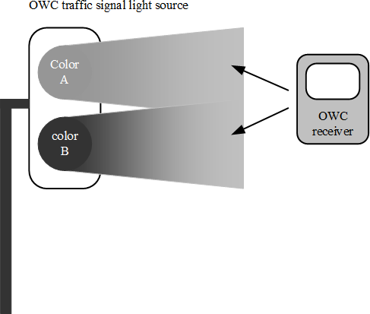

##### Figure F.1—OWC application using traffic signal light sources

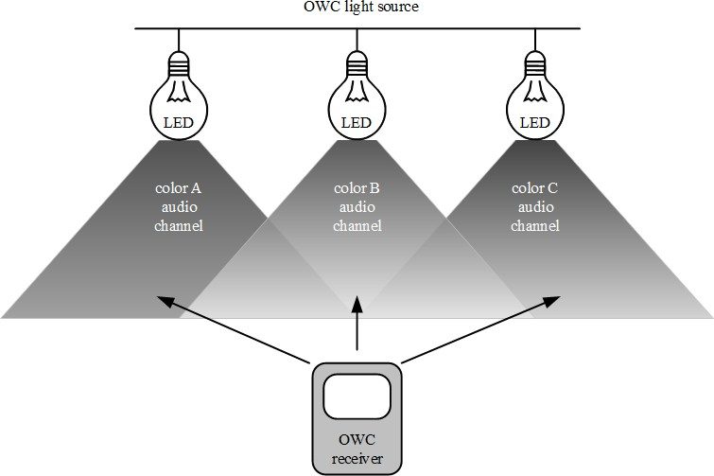

**Figure F.2—OWC application using colored light sources**

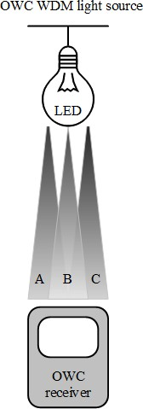

**Figure F.3—OWC application using WDM technology**

OWC services, using multiple color channels according to the OWC band plan, should be attained by only one OWC receiver. It is undesirable if a OWC receiver exhibits better receiver performance only on, for example, the color “A” channel but it does not exhibit the same performance on the color “B” or color “C” channel as on the color “A” channel. Therefore, a uniform performance on each color channel may be desired.

There are two main factors influencing the performance variation of a multi-color OWC receiver. One is the conversion relations between the radiometric and photometric units. The other is the photo sensitivity characteristics of a photodetector, such as a Si photodetector that depends on the wavelength variation, assuming such photodetectors will be used as a receiver in OWC.

First, suppose that there are two light sources or OWC transmitters with red color and green color respectively and a OWC receiver to perceive the variation of received powers under the multiple color channels which originates from the conversion relations between the radiometric and photometric units. Also suppose that each color light radiates from two light sources at the same divergence angle, and they radiate with the same luminous flux, (lumens), so that the human eye senses the same brightness when simultaneously viewing the two light sources respectively at the same distance. However, when each color light radiates with the same luminous flux then the radiation of the two light sources in radiometric power (Watts) are each different, which is the origin of the CIE sensitivity curves. The CIE sensitivity curves indicate what the human eye senses, and it turns out that the green light is perceived as being brighter than red light when the radiometric radiation powers of the two light sources are equal. Therefore, the radiometric received powers of a receiver are different on red and green channels, respectively, even though the divergence angles and luminous fluxes of two light sources are equal, the same receiver is used, and the distances between the receiver and the light source are equal.

Of course, the OWC light source power can be also defined in radiometric units, i.e., watts. However, it is more reasonable that the light source power is defined in photometric unit because the light sources will be used not only for a OWC transmitter but also for illumination or visual display related to human eye.

Table F.1 describes the receiver input powers, calculated in Watts, from the assumption of 1 lumen on each of the seven color bands (given in Table 80). The assumption that the lights have only monochromatic component (shown as example wavelength in Table F.1) on each color band is also used for simple calculations. V() is the human eye sensitivity function, which indicates CIE sensitivity curves (Schubert [B12]).

##### Table F.1—Calculated color channel power at receiver

|  |  |  |  |  |  |
| --- | --- | --- | --- | --- | --- |
| **Wavelength band (nm)** | | **Spectral width (nm)** | **Example wavelength (nm)** | **V(****)**  **at example wavelength** | **Receiver input power at 1 m (W)** |
| 380 | 478 | 98 | 430 | 0.0273 | 0.0536 |
| 478 | 540 | 62 | 510 | 0.5030 | 0.0029 |
| 540 | 588 | 48 | 565 | 0.9788 | 0.0015 |
| 588 | 633 | 45 | 610 | 0.5030 | 0.0029 |
| 633 | 679 | 46 | 655 | 0.0817 | 0.0179 |
| 679 | 726 | 47 | 700 | 0.0041 | 0.3571 |
| 726 | 780 | 54 | 750 | 0.0001 | 14.6413 |

The second factor causing the performance variation of a OWC receiver across multiple color channels is the photo sensitivity characteristics of optical receivers, such as Si photodetectors, which is wavelength dependent. Figure F.4 shows the photo sensitivity characteristics of a Si photodetector according to the wavelength variation. It has been known that the photo sensitivity value of Si photodetector is higher on longer wavelength than on shorter wavelength in the visible band as shown in Figure F.4. Figure F.4 shows that a Si photodetector produce more electrical current on red color channel than on green or blue color channel even though the radiometric received powers on each color channel are equal.

0.8

|  |  |  |  |  |  |  |
| --- | --- | --- | --- | --- | --- | --- |
|  |  |  |  |  |  |  |
|  |  |  |  |  |  |  |
|  |  |  |  |  |  |  |
| (0.46) | Red |  |  |  |  |  |
| (0.3) | Green |  |  |  |  |  |
| (0.21) |  |  |  |  |  |  |
|  | Blue |  |  |  |  |  |
|  | 430 | 510 | 655 |  |  |  |

0.7

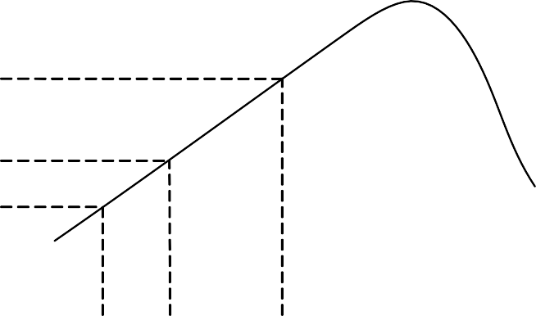0.6

photo sensitivity (A/W)

0.5

0.4

0.3

0.2

0.1

0.0

300 400 500 600 700 800 900 1000

wavelength (nm)

##### Figure F.4—Typical Si photodetector wavelength sensitivity

Table F.2 shows the photodetector output current obtained from both the wavelength dependence of photo sensitivity shown in Figure F.4 and the conversion relations between the radiometric and photometric units described in Table F.1. The photodetector output currents in Table F.2 were calculated only at 430 nm, 510 nm, and 655 nm among the example wavelengths in seven color bands, as shown in Table F.1, for convenience.

Table F.2 indicates that a OWC receiver with Si photodetector performs differently on multiple color channels even though the radiometric received powers are equal on each color channel. Therefore, two main factors, the unit conversion and the photo sensitivity of a photodetector depending on wavelength, need to be sufficiently considered in order that the performance of a OWC receiver can be maintained uniformly on multiple color channels.

##### Table F.2—Photodetector current from Figure F.4 with conditions of Table F.1

|  |  |  |  |
| --- | --- | --- | --- |
| **Example wavelength (nm)** | **Receiver input power at 1 m (W)** | **Photo sensitivity (A/W)** | **Photodetector output current at 1 lm**  **(mA)** |
| 430 | 0.0536 | 0.21 | 11.26 |
| 510 | 0.0029 | 0.30 | 0.87 |
| 655 | 0.0179 | 0.46 | 8.23 |

**Annex G**

(informative)

**RS-FSK tutorial**

* 1. **RS-FSK transmitted waveform**

RS-FSK takes advantage of the rolling shutter sampling mechanism in the optical camera receiver; hence, the “rolling shutter” prefix in the name. However, from the perspective of the transmitter, RS-FSK uses simple frequency shift keying signal format. Firstly, a number of K frequencies are used to represent a bit pattern of log2*K* bits. Secondly, the transmitter uses “square wave pulse shaping,” i.e., it will use only two levels, an ON level and an OFF level. As a result, complex driving circuitry, in particular, a digital-to-analog converter, may be avoided, and the cost of the transmitter may be reduced. Moreover, a clean stripe pattern is observed in the captured image at the receiver side, which is utilized by the demodulation process. (See G.4 for a description of the relationship between the width of the strips observed in the pattern in the camera-captured image and see Figure G.1 for an illustration.)



|  |
| --- |
|  |
|  |
|  |
|  |
|  |
|  |
|  |
|  |

Wide Strip

Narrow Strip

TX: Use signal frequency to represent data. RX: Use strip width to demodulate data.

Low Frequency square wave

High Frequency square wave

Time Time

##### Figure G.1—RS-FSK signal waveform and camera-captured image

* 1. **Transmitted signal frequency**

With the exception of the frequency used by the preamble, which is used to detect the start of a PPDU by the receiver, the actual set of frequencies used for data transmission is determined by the user, based on the read- out time of the supported optical camera receiver (see G.5). It can be specified by the optical field of the PPDU.

RS-FSK specifies the preamble frequency at 2.2 kHz. The majority of the commercially available image sensors have a read-out time of 20 μs to 30 μs. With this preamble frequency, the width of a pair of bright and dark strips in the observed stripe pattern in the camera-captured image is between 15 pixels and 23 pixels (see G.5 for the method to calculate this width) and can be reliably detected. In addition, the information obtained from the reception of the preamble frequency can be used to calibrate the value of the read-out duration, allowing better reception error performance.

For the set of frequencies used by the data symbols, it is recommended to use frequencies between 500 Hz and 1.4 kHz. The former corresponds to a strip width of 66 pixels to 100 pixels, while the latter corresponds to a stripe width of 23 pixels to 36 pixels.

* 1. **Symbol duration**

RS-FSK uses a symbol duration that equals the receiving camera's frame duration. Since most of the cameras use a frame rate of 30 fps when capturing video, the default symbol duration is set to be 1/30 s. Note that the symbol can be configured by using the RS-FSK mode optional field through the PIB attributes in the PPDU (see Table 115).

## Relation between signal frequency and the observed strip width in the captured image

This clause describes the relationship between the transmitted frequency *f* and the strip width *W*. This background knowledge is required to determine the set of frequencies that is used by the transmitters based on the specification of the receiving optical camera.

The strip width is defined as the number of pixels occupied by a set of bright strip (exposure during the transmitter is in the ON state) and a dark strip (exposure during the transmitter is in the OFF state) in a received image. Note that, for a square wave of frequency *f* Hz, the duration of a complete cycle is 1/*f* s. Therefore, for every 1/*f* s a camera exposes, it should be able to read out a pair of bright and dark strips in the received image. On the other hand, the time a camera spends to read out a row of pixels is denoted as its read-out duration *T*r. Denote the width of a bright strip as *W*b and the width of a dark strip as *W*d, and the width of a pair of bright strip and dark strip as W = (W_b + W_d). Therefore, in theory, the width of a pair of bright strip and dark strip can be found by *W* = (1/*f*)/*T*r = 1/(*fT*r ) (see Figure G.2). Note that *W* is a real number. In practice, a receiver would need to observe the width of a large number of pairs of strips to calculate the average number of rows occupied by a pair of strips, *W'*, as an estimate of *W*, and demodulate the symbol by *f'* = 1/(*W' T*r ).



2

2

Image Y axis

Transmitted

Time Signal

2

Tr : read-out duration

**Figure G.2—Relationship between RS-FSK signal frequency and the strip width**

………….

The ratios to be assigned to the data symbols are determined with the rule that *1/fi* is an arithmetic sequence. It was shown that the observed strip width in the image is *W* = 1/(*fTr*). RS-FSK aims to assign the frequency of the data symbols according to their observed strip width, i.e., to allow the biggest (and equal) width difference between the symbols, in order to cope with variable size of the transmitter in the image. Denote the difference of signal periods of consecutive frequency symbols as *dti* = 1/*fi* – 1/*f(i*+1) or *f(i*+1) = 1/(1/*fi* – *dti*), which will be used to construct the frequency group.

## Survey of parameters of commercially available image sensors

The sample read-out duration for some smartphone models are given in Table G.1.

##### Table G.1—Read-out duration of cameras

|  |  |  |  |  |  |
| --- | --- | --- | --- | --- | --- |
| **Brand** | **Product name** | **Image resolution** | **Frame rate** | **Measured read-out duration**  **(μs)** | **Gap between frames (ms/%)** |
| Apple | iPhone 6 plus | 1920x1080 | 30 | 21.42 | 10.20/30.60 |
| Apple | iPhone 5s | 1920x1080 | 29.98 | 20.65 | 11.03/33.10 |
| Apple | iPhone 4s | 1920x1080 | 29,87 | 24.48 | 7.04/21.03 |
| HTC | New One | 1920x1080 | 29.94 | 19.08 | 12.79/38.30 |
| Samsung | Galaxy S4 | 1920x1080 | 29.93 | 25.53 | 5.84/17.48 |

From Table G.1, most cameras have a read-out duration of 20 μs to 30 μs; and based on this duration, RS- FSK selected the frequency.

As mentioned in G.2, the preamble frequency *aPreambleFrequency* is chosen for the following two main reasons:

* + 1. Preamble frequency must be reliably detected by commodity cameras (which have different read-out durations ranging from 20 μs to 30 μs).
    2. Preamble frequency can be easily generated by mainstream low-cost microcontroller units, which normally operate with clock rates of 8 MHz or 16 MHz.

# Annex H

### (informative)

**PHY modes TX and RX profile**

The PHY Mode TX profile defines the PHY mode-specific modulation schemes based on the transmitter source classification, and the RX profile defines the types of receivers supported based on the modes and modulation schemes.

* 1. **PHY modes TX profiles**

The transmitter sources are classified into the following groups based on modulation schemes proposed in this standard:

* + - **Discrete or single source:** In this type of device, light rays originating from a single point in space are emanated in all directions. This light source can be designed with a single LED or multiple LEDs, but light ray emanation is considered as a single point space. This type of light source includes directional lights, point lights, and spotlights.
    - **Two-dimensional or multi-source:** In this type of device, light rays originating from multiple points are emanated in all directions, and the light rays are parallel to each other in space. This light can be designed with multiple source points with each source point emanation considered as separate single source emanation.
    - **Surface source:** For this type of device, a primary light source is disposed at the side of a light guide plate, and one surface of the light guide plate serves as a luminous surface.
    - **Display or screen source:** This type of device utilizes visual scene output surface adopting image projection technologies that show text and often graphic images. This type includes video display terminals (VDTs), liquid crystal displays (LCDs), LEDs, gas plasmas, tablet screens, surface screens, smart phone screens, smart watch screens, and other image projection technologies.

Table H.1 shows the TX profiles mainly supported by each PHY mode.

##### Table H.1—Image sensor communication and photodetector PHY modes TX profile

|  |  |  |  |  |  |
| --- | --- | --- | --- | --- | --- |
| **PHY mode** | | **Discrete or single source** | **Two-dimensional or multi-source** | **Surface source** | **Display or screen source** |
| PHY I | | X |  | X |  |
| PHY II | | X |  | X |  |
| PHY III | | X |  | X |  |
| PHY IV | UFSOOK | X | X | X |  |
| Twinkle VPPM | X | X | X |  |
| S2-PSK | X |  |  |  |
| DS8-PSK | X |  |  |  |
| HS-PSK | X |  |  |  |
| Offset-VPWM | X | X | X |  |

**TX profile *(continued)***

|  |  |  |  |  |  |
| --- | --- | --- | --- | --- | --- |
| **PHY mode** | | **Discrete or single source** | **Two-dimensional or multi-source** | **Surface source** | **Display or screen source** |
| PHY V | RS-FSK |  |  | X |  |
| C-OOK |  |  | X |  |
| CM-FSK |  |  | X |  |
| MPM |  |  | X |  |
| PHY VI | A-QL |  |  |  | X |
| HA-QL |  |  |  | X |
| VTASC | X | X | X | X |
| SS2DC | X | X |  | X |
| IDE-MPFSK-Blend |  | X |  | X |
| IDE-2DBIN-WM |  | X |  | X |

## PHY modes RX profile

The PHY Modes RX Profile gives types of decoders used for particular PHY modes. This standard includes two types of RX decoders: photodiode and image sensor. The photodiodes are categorized into monochrome and color photodiodes. The image sensors are categorized into global shutter, rolling shutter, and high-speed or region of interest (high-speed/ROI) types of cameras.

Table H.2 shows RX profiles each PHY mode mainly supports. Additional detail about each RX mode can be found in Annex I.

##### Table H.2—Image sensor communication and photodetector PHY modes RX profile

|  |  |  |  |  |  |
| --- | --- | --- | --- | --- | --- |
| **PHY mode** | | **Photodiode** | **Image sensor** | | |
| **Global shutter** | **Rolling shutter** | **High-speed ROI** |
| PHY I | | X |  |  |  |
| PHY II | | X |  |  |  |
| PHY III | | X |  |  |  |
| PHY IV | UFSOOK | X | X | X | X |
| Twinkle VPPM | X | X | X | X |
| S2-PSK | X | X | X | X |
| HS-PSK | X | X |  | X |
| Offset-VPWM | X | X | X | X |

**Table H.2—Image sensor communication and photodetector PHY modes RX profile *(continued)***

|  |  |  |  |  |  |
| --- | --- | --- | --- | --- | --- |
| **PHY mode** | | **Photodiode** | **Image sensor** | | |
| **Global shutter** | **Rolling shutter** | **High-speed ROI** |
| PHY V | RS-FSK | X |  | X | X |
| C-OOK | X |  | X | X |
| CM-FSK | X |  | X |  |
| MPM | X |  | X | X |
| PHY VI | A-QL |  | X | X |  |
| HA-QL |  | X | X |  |
| VTASC |  | X | X |  |
| SS2DC |  | X | X |  |
| IDE |  | X | X |  |

**Annex I**

**(informative)**

**PHY IV, PHY V, and PHY VI OCC waveforms decoding guide**

* 1. **S2-PSK decoding method**

At a sampling time, a camera captures two light sources (LED-1 and LED-2). The RX determines the states of LEDs from the captured image and implements the XOR operator. The data bit is the output of the XOR operator whose inputs are a pair of LED states (see Figure I.1).

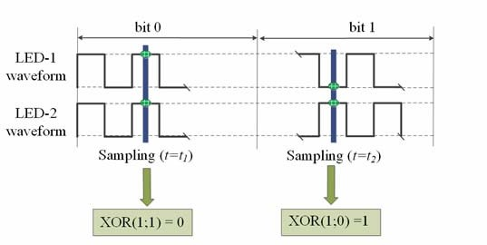

##### Figure I.1— An example of S2-PSK decoding

When the RX captures at the ON-OFF transition time of the waveform, the states of LEDs are unclear. Thus, an error may happen at the output of the XOR operator. The ratio of the exposure time and the duty cycle of the transmitted waveform has an effect on the error probability caused by the long exposure.

Suggested solutions for this problem are as follows:

* + 1. An RX samples multiple times per bit period (in which the sampling period = (*n*+0.5) times the duty cycle of the transmitted waveform to avoid all samplings being unclear).
    2. Moreover, FEC is helpful.

## DS8-PSK decoding method

At a sampling time, a camera captures two groups of light sources; and from an image, each group forms a set of eight ON/OFF states. The captured set of a group shall be represented by **S_Phase** as shown in Table I.1.

Also, a sampling called bad-sampling (when the camera captures the transition time of a single LED among LEDs of the group) shall generate a presence of an unclear state (x_state) among a set of eight states. The determination of S_Phase value under the presence of x_state is as shown in Table I.2.

##### Table I.1—S-Phase representing the captured set of states of a light source under dimming

|  |  |  |  |  |  |  |  |
| --- | --- | --- | --- | --- | --- | --- | --- |
| **Eight-state input** | | | | | | | **S-Phase output** |
| **Dimming 1/8** | **Dimming 2/8** | **Dimming 3/8** | **Dimming 4/8** | **Dimming 5/8** | **Dimming 6/8** | **Dimming 7/8** |
| 1000 0000 | 1000 0001 | 1000 0011 | 1000 0111 | 1000 1111 | 1001 1111 | 1011 1111 | 1 |
| 0100 0000 | 1100 0000 | 1100 0001 | 1100 0011 | 1100 0111 | 1100 1111 | 1101 1111 | 2 |
| 0010 0000 | 0110 0000 | 1110 0000 | 1110 0001 | 1110 0011 | 1110 0111 | 1110 1111 | 3 |
| 0001 0000 | 0011 0000 | 0111 0000 | 1111 0000 | 1111 0001 | 1111 0011 | 1111 0111 | 4 |
| 0000 1000 | 0001 1000 | 0011 1000 | 0111 1000 | 1111 1000 | 1111 1001 | 1111 1011 | 5 |
| 0000 0100 | 0000 1100 | 0001 1100 | 0011 1100 | 0111 1100 | 1111 1100 | 1111 1101 | 6 |
| 0000 0010 | 0000 0110 | 0000 1110 | 0001 1110 | 0011 1110 | 0111 1110 | 1111 1110 | 7 |
| 0000 0001 | 0000 0011 | 0000 0111 | 0000 1111 | 0001 1111 | 0011 1111 | 0111 1111 | 8 |

**Table I.2—S-Phase representing the captured set of states of a light source (with x_state) under dimming**

|  |  |  |  |  |  |  |  |
| --- | --- | --- | --- | --- | --- | --- | --- |
| **Eight-state input** | | | | | | | **S-Phase output** |
| **Dimming 1/8** | **Dimming 2/8** | **Dimming 3/8** | **Dimming 4/8** | **Dimming 5/8** | **Dimming 6/8** | **Dimming 7/8** |
| xx00 0000 | 1x00 000x | 1x00 00x1 | 1x00 0x11 | 1x00 x111 | 1x0x 1111 | 1xx1 1111 | 1 |
| 0xx0 0000 | x1x0 0000 | 11x0 000x | 11x0 00x1 | 11x0 0x11 | 11x0 x111 | 11xx 1111 | 2 |
| 00xx 0000 | 0x1x 0000 | x11x 0000 | 111x 000x | 111x 00x1 | 111x 0x11 | 111x x111 | 3 |
| 000x x000 | 00x1 x000 | 0x11 x000 | x111 x000 | 1111 x00x | 1111 x0x1 | 1111 xx11 | 4 |
| 0000 xx00 | 000x 1x00 | 00x1 1x00 | 0x11 1x00 | x111 1x00 | 1111 1x0x | 1111 1xx1 | 5 |
| 0000 0xx0 | 0000 x1x0 | 000x 11x0 | 00x1 11x0 | 0x11 11x0 | x111 11x0 | 1111 11xx | 6 |
| 0000 00xx | 0000 0x1x | 0000 x11x | 000x 111x | 00x1 111x | 0x11 111x | x111 111x | 7 |
| x000 000x | x000 00x1 | x000 0x11 | x000 x111 | x00x 1111 | x0x1 1111 | xx11 1111 | 8 |

From an image, two groups of light sources shall produce a pair of S_Phase values (S_Phase(1) representing the captured state of the group 1 and S_Phase(2) representing the captured state of the group 2). Then, the value of **S_Phase_Shift** is calculated as follows:

##### S_Phase_Shift = S_Phase(1) - S_Phase(2)

Figure I.2 illustrates the decoding procedure of DS8-PSK. Finally, the de-mapping from S_Phase_Shift to 3 bits shall be done inversely as the mapping table (Table I.2) showed.

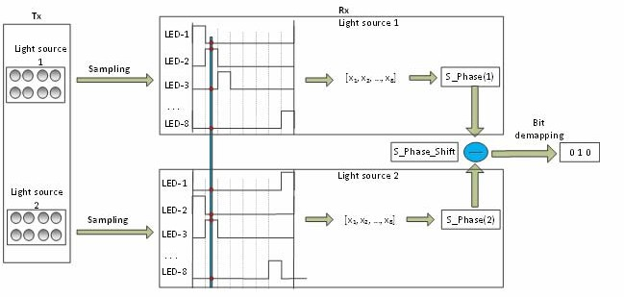

##### Figure I.2—Illustration of DS8-PSK decoding procedure

* 1. **HS-PSK decoding method**

For a dual-camera receiver system, the hybrid signal can be demodulated as below:

* + 1. A low frame rate camera (the frame rate should be greater than the S2-PSK optical clock rate) is to detect the S2-PSK signal. Either a global shutter or a rolling shutter camera can be used.
    2. A global shutter and high-speed camera (the frame rate should be greater than the DS8-PSK optical clock rate) is to decode the DS8-PSK signal.

## C-OOK decoding method

To demodulate the entire data sub-packet (DS), the distance from a camera to the LED transmitter should be close enough. Figure I.3 shows the relationship between the amount of data being captured by the camera and the distance from the camera to the LED transmitter.

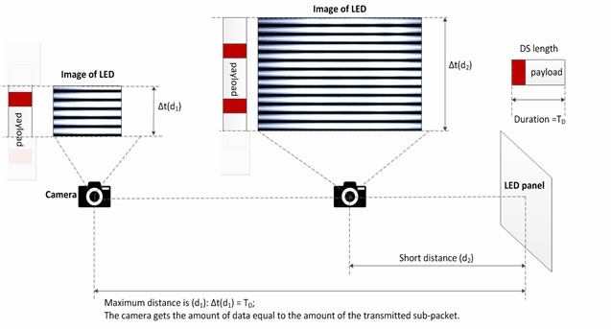

##### Figure I.3—Decoding scenario

From Figure I.3, the maximum distance achieved is the distance at which the camera can get the amount of data equal to the amount of the sub-packet.

##### Decoding case 1: Fuse incomplete parts of a sub-packet into a complete one.

At this far distance, distance d1 as shown in Figure I.3, the camera detects the preamble symbol and then demodulates an amount of data for a sub-packet; however, the uncertainty of whether the forward part and the backward part counted from the position of the preamble belong to a sub-packet is problematic. The problem of a small amount of data also happens at a shorter distance when the transmitted sub-packet is long.

Asynchronous bits representing the clock information of the packet are used for the asynchronous decoding algorithm in this case.

Figure I.4 illustrates the decoding algorithm to recover a packet of data from the forward part and the backward part of an image when the size of LED is small in the captured image. By observing the values of an asynchronous bit before and an asynchronous bit after the preamble, two statements of fusing those two parts of a sub-packet are addressed:

* + 1. Case 1: Interframe data fusion: Fusing two parts of a packet at two different images into a complete packet.

This type of data fusion is applied in case two Ab bits on an image are different.

* + 1. Case 2: Intraframe data fusion: Recovering a complete packet from an image.

This type of data fusion is applied in case two Ab bits on an image are similar.

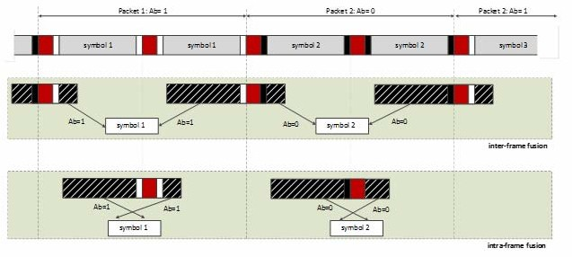

##### Figure I.4—Decoding algorithm at a far distance

**Decoding case 2: Combine data fusion and majority voting.**

When the camera goes closer to the LED transmitter, the amount of data being captured per image is greater than that of a sub-packet. Therefore, the extra amount of data is used for correcting the possible error by applying a majority vote.

At distance d2 on Figure I.4, the amount of data equivalent to two sub-packets is captured. The majority voting is used in this case to correct the error throughout the entire sub-packet.

Figure I.5 shows an experimental example of decoding under Intraframe data fusion. The extra data after fusing a sub-packet is used for correcting the error by voting.

Assume that the camera frame rate may vary but be greater than the packet rate of transmission. Therefore, any extra data after fusion is useful for the error correction by grouping multiple images that belong to a sub- packet to vote. The voting is on the amount of data grouped from all of the forward parts and backward parts of images as well as extra data.

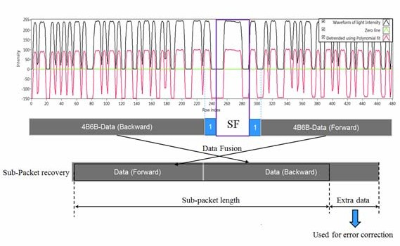

##### Figure I.5—An example of decoding employing intraframe fusion along with error correction

**I.4.1 Missing packet detection on frame rate drop**

In some circumstances, the frame rate may drop to less than the packet rate, and this low rate may cause an entire packet to be missed.

For example, two bits (Ab1, Ab2) are inserted at the forward part and the backward part of the data sub- packet payload. Those two bits together bring the clock information of the sub-packet and are modulated as shown in Figure I.6.

|  |  |  |  |
| --- | --- | --- | --- |
| Preamble | Data sub-packet payload | | |
| Ab (start) | data bits | Ab (end) |

2 bits (Ab1Ab2) Variable 2 bits (Ab1Ab2)

##### Figure I.6—Data sub-packet structure

Ab1 and Ab2 are square signals. Ab1 changes from zero/one into one/zero every time of single data packet, while Ab2 changes every time of two data packets.

The combination of two Ab (Ab1 and Ab2) generates four different values, 00 01 10 and 11. Therefore, the usage of those two Ab enables the detection of a maximum of two missed packets continuously. In other words, the detection of missed packets is successful for any frame rate drop to no less than 1/3 of the packet rate. For example, a packet rate at 10 Hz with 2 Ab allows the frame rate to drop to 3.3 fps while all the missed packets are detectable. See Figure I.7.

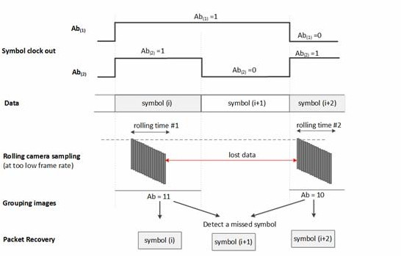

##### Figure I.7—An example of the detection of a missed symbol by using two Ab inserted

* 1. **A-QL decoding method**
     1. **Rotation support**

From the reference cells at the corners of the A-QL code, the rotation angle can always be determined. The rotation support is mandatory in A-QL system. See Figure I.8.

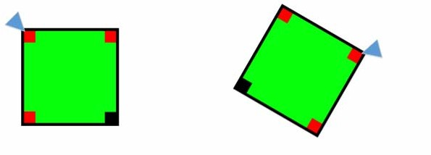

Non-rotated A-QL code

120° rotated A-QL code

##### Figure I.8—The starting corner determination from reference cells under rotation

* + 1. **Down-sampling using Ab**

A camera that has a frame rate greater than the optical clock rate (three times at least, to avoid the sampling in the symbols transition time) is to receive data. The down-sampling is challenging for a time-variant frame rate RX.

Assume that there is more than one image sampled per block of data (no symbol is missed during the sampling). The decoder demodulates data from every block and extracts the Ab bit. The adjacent blocks that have the same Ab bits as shown in Figure I.9 will be down-sampled. During the down-sampling process, the majority voting may be applied for each group of adjacent blocks that have the same Ab to mitigate possible error.

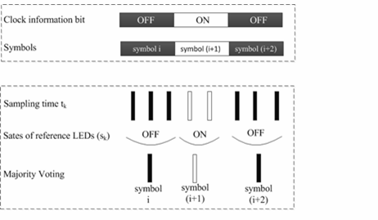

##### Figure I.9—Asynchronous decoding

* + 1. **Rolling effect detection and removal**

When a rolling shutter camera captures in between the transition time of two adjacent blocks of data, four Ab bits at four reference cells on the captured image shall not be the same. The image is detected as a rolling affected image as shown in Figure I.10 and is discarded.

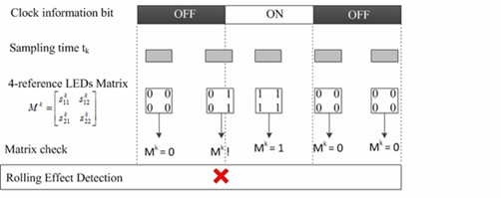

##### Figure I.10—Detection and removal of a rolling effected image

Also, to support a rotated camera decoding, the transmission of four rotation-indication bits via reference cells over the blue channel allows a receiver to identify the starting corner of the code. The starting corner shall have values similar to its two adjacent reference cells.

## HA-QL decoding method

#### RX oversampling requirement

An RX with a frame rate no less than three times the optical clock rate is used to demodulate HA-QL code. The RX extracts the code area, and then it extracts the *m*×*n* matrix of intensity with the number of hidden cells *m*×*n* as read from the PHY PIB attribute *phyHAqlNumCells*.

The matrix of intensity is extracted by comparing a data-embedded image to its adjacent reference image (see Figure I.11).

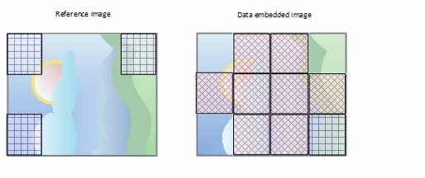

##### Figure I.11—Illustration of a reference image and a data-embedded image

* + 1. **Down-sampling method using Ab**

Assume that the RX frame rate is *N* times the TX optical clock rate. The Ab subtraction between two samplings is applied for the down-sampling process as follows:

ΔAb(*i*) = Sampling(*i*) – sampling(*i*–*N*)

applied for all samplings. Based on the sign of Ab subtraction, the down-sampling decision is made (see Figure I.12).

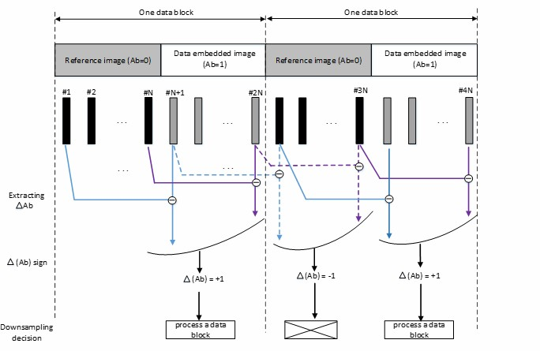

##### Figure I.12—Illustration of the down-sampling process for HA-QL

* 1. **Offset-VPWM decoding method**

The Offset-VPWM receiver can synchronize rising edge and check pulse width length using Rolling-shutter method. The receiver detection process in the wave formatted approach is show in Figure I.13.

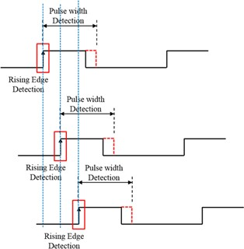

##### Figure I.13—Receiver detection process

* 1. **VTASC decoding method**

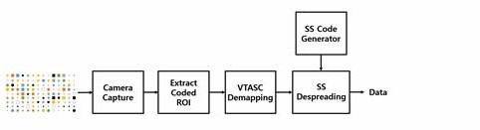VTASC data decoding is shown Figure I.14.

##### Figure I.14—VTASC receiver functional block diagram

The ROI of screen visual area is extracted from the captured visual frame, and then the VTASC-coded symbols are detected based on the mapping scheme applied on the transmitter. The data is recovered by applying SS despreading on the VTASC-decoded data streams. The receiver frame rate required for optimum decoding is twice the topical clock rate of the transmitter.

#### Asynchronous communication

The optical clock rate and SS codes are configurable over the PHY PIB attributes *phyVTASCScalRegion1OpticalClockRate* to *phyVTASCScalRegion4OpticalClockRate* and *phySSCode1FP00* to *phySSCode4FP01*. The receiver synchronizes using SS code (any one of the four pair SS code at first time) and decodes the data.

In the next consecutive capture frames, if the camera receives the same frame, for example, #*N* video frame is received twice, then the receiver will discard the video frames by despreading the next code in the SS pair code. If the current processing frame detects a pair of SS codes in a single frame, then that frame is a rolling effect fault capture frame and is discarded.

#### Angle-free communication

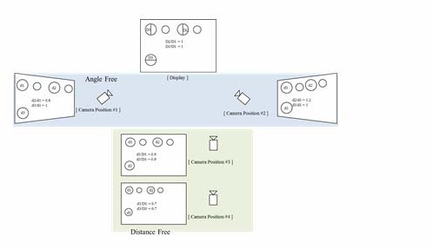The angle-free communication between transmitter and receiver is shown in Figure I.15.

##### Figure I.15—Angle-free and distance-adaptive communication

The angle-free communication is achieved by warping the ROI of the transmitter to get the original shape alignment and then synchronizing with the spreading code to decode the original transmitted information.

When a rolling shutter camera captures in between the transition time of two adjacent symbols of data, the SS code on the captured image shall not be the same. The image is identified as a rolling affected image and is discarded.

Also, to support a rotated camera decoding, the decoder rotates the captured frame and applies the decoding procedure if the captured image fails on SS detection of SHR symbol.

## SS2DC decoder

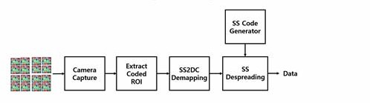SS2DC data decoding is shown Figure I.16.

##### Figure I.16—SS2DC receiver functional block diagram

The ROI of screen visual area is extracted from the captured visual frame, and then the SS2DC detector is applied based on the mapping scheme applied on the transmitter. The data is recovered by applying SS despreading on the SS2DC data decoded. The receiver frame rate required for optimum decoding is twice the optical clock rate of the transmitter.

## IDE decoder

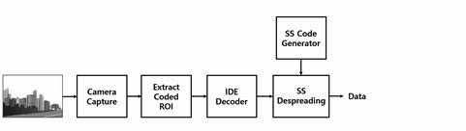The IDE data decoding is shown in Figure I.17.

##### Figure I.17—IDE receiver functional block diagram

To decode the data stream, the ROI of display visual area is extracted from the captured visual frame using image processing methods, and then invisibly embedded data is extracted using blending or watermark extraction procedure.

The blending- or watermark-based data extraction is applied based on modulation used to invisibly embed the data on the transmitter. The blending works with a combination of M-PSK and M-FSK, and the decoder uses the FFT to detect the coded frequency and phase to decode the data.

The blending of coded data works with a combination of M-PSK and M-FSK. The decoder applies the FFT on translucency changes to demodulate the data from the (*m*×*n*)-pixel block window on the captured video frame. The decoder detects the coded frequency and phase to extract the coded data symbols.

The data embedded using high-frequency visual coefficients on the visual frame is extracted by applying DCT on every 8x8 block and then using the high-frequency coefficient values to extract the data. The recovered high-frequency coefficient-based data is SS-coded data so SS decoding is applied to recover original data from the visual sequence.

When a rolling shutter camera captures in between the transition time of two adjacent symbols of data, the SS code on the captured image shall not be the same. The image is identified as a rolling affected image and is discarded.

Also, to support a rotated camera decoding, the decoder rotates the captured frame and applies the decoding procedure if the captured image fails on SS detection of SHR symbol.

# Annex J

## (normative)

**Hamming code and majority bit voting**

* 1. **Generation of Hamming code**

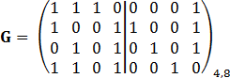Hamming block coding (*n*,*k*) maps a block of k data bits input into n bits output. For (*n*,*k*)=(8,4), the generator matrix G is defined as

.

The parity check matrix is defined as

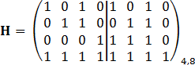.

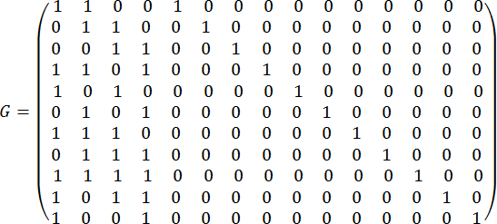For (*n*,*k*) = (15,11), the generator matrix G is defined as

.

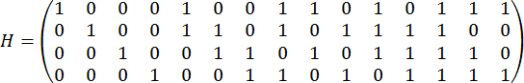The parity check matrix is defined as

.

#### Encoding rule

The block of output bits **x** is generated by multiplying the block of input bits **a** with the generation matrix G.

**x** = **aG**

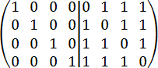For example, by applying Hamming (8,4), with **a** = 1011,

**x** = **aG** = (1 0 1 1) = (2 3 1 2 0 1 1 2) = (0 1 1 0 0 1 1 0).

1011 is coded into 01100110. Finally, it can be shown that the minimum distance has increased from 3, in the [7,4] code, to 4 in the [8,4] code. See Table J.1.

##### Table J.1—4-to-8 Hamming encoding

|  |  |
| --- | --- |
| **Input bits** | **Output bits** |
| 0 0 0 0 | 0 0 0 0 0 0 0 0 |
| 0 0 0 1 | 1 1 0 1 0 0 1 0 |
| 0 0 1 0 | 0 1 0 1 0 1 0 1 |
| 0 0 1 1 | 1 0 0 0 0 1 1 1 |
| 0 1 0 0 | 1 0 0 1 1 0 0 1 |
| 0 1 0 1 | 0 1 0 0 1 0 1 1 |
| 0 1 1 0 | 1 1 0 0 1 1 0 0 |
| 0 1 1 1 | 0 0 0 1 1 1 1 0 |
| 1 0 1 1 | 0 1 1 0 0 1 1 0 |
| 1 0 0 1 | 0 0 1 1 0 0 1 1 |
| 1 0 1 0 | 1 0 1 1 0 1 0 0 |
| 1 0 1 1 | 0 1 1 0 0 1 1 0 |
| 1 1 0 0 | 0 1 1 1 1 0 0 0 |
| 1 1 0 1 | 1 0 1 0 1 0 1 0 |
| 1 1 1 0 | 0 0 1 0 1 1 0 1 |
| 1 1 1 1 | 1 1 1 1 1 1 1 1 |

* + 1. **Decoding guideline**

Error may occur at the receiver side: r = x + e

By using the parity check matrix H, the syndrome parity checking result is calculated by s = rHT.

If s = 0, the r is an effective codeword; otherwise, determine whether r is correctible by checking the error

pattern.

## J.2 Temporal error correction using majority bit voting

Assume that the number of samplings repeated in the RX is no less than three. The majority voting is applied to a selected set of three samplings (which belong to a transmitted bit) as given in Table J.2.

##### Table J.2—Transmitted bit—received sequence

|  |  |
| --- | --- |
| **Transmitted bit** | **Received sequence** |
| 0 | 0 0 0 |
| 1 | 1 1 1 |

When an error has happened, a majority bit voting is applied to a set of three bits (repeating code R3). The decoding algorithm for R3 is shown in Table J.3.

##### Table J.3—Decoding rule for R3

|  |  |
| --- | --- |
| **Received sequence** | **Decoded bit** |
| 0 0 0 | 0 |
| 0 0 1 | 0 |
| 0 1 0 | 0 |
| 1 0 0 | 0 |
| 1 0 1 | 1 |
| 1 1 0 | 1 |
| 0 1 1 | 1 |
| 1 1 1 | 1 |

If two or more errors fall into a single bit, then the decoding rule produces an erred output.

# Annex K

### (informative)

**PHY mode-specific characteristics**

* 1. **VTASC**

VTASC works on the following:

* + - Receiver angle-free and distance-adaptive communication
    - Receiver distance-adaptive communication achieved by screen with interactive camera
    - Asynchronous and receiver frame rate independent communication
    - Scalable bitrate controller for distance-adaptive data rate control
    - Enhanced multi-display model for transmission
  1. **SS2DC**

SS2DC works on the following:

* + - Receiver angle-free and distance-adaptive communication
    - Receiver distance-adaptive communication achieved by screen with interactive camera
    - Asynchronous and receiver frame rate independent communication
    - Scalable bitrate controller for distance-adaptive data rate control
    - Enhanced multi-display model for transmission

## IDE

IDE works on the following:

* + - Unobtrusive to screen viewer on dynamic visual scene
    - Receiver angle-free and distance-adaptive communication
    - Asynchronous and receiver frame rate independent communication
    - Enhanced multi-display model for transmission

### (normative)

**Frequency-based invisible watermarking**

The human eyes are more sensitive to noise in the lower frequency range than in the higher frequency range, while the energy of most natural images is concentrated on the lower frequency range. Therefore, the reasonable tradeoff is to embed the watermark into the middle-high–frequency range of the image.

The watermarking method based on discrete cosine transform (DCT) is used for frequency-based image watermarking and could survive several kinds of image processing. The frequency-based invisible watermarking using DCT is described in principle by the block diagram in Figure L.1.

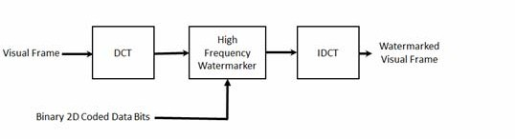

##### Figure L.1—DCT-based watermarking block diagram

The visual rendering frame is divided into 8x8 blocks of pixels, and the 2D DCT is applied independently to each block. Then, the four coefficients of the high-frequency range are selected from the DCT coefficients for watermarking. An example of defining the high-frequency coefficients is shown in Figure L.2.

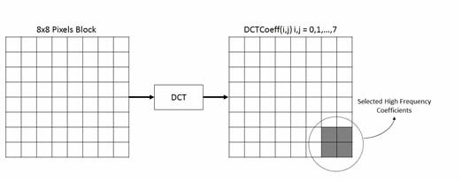

##### Figure L.2—High-frequency coefficient selection for watermarking

The selected DCT coefficients for embedding data using watermarking are DCTCoeff (6, 6), DCTCoeff (6, 7), DCTCoeff (7, 6), and DCTCoeff (7, 7). The data is embedded on DCT coefficients as follows:

* + - If the data bit is 1, then WaterMARKDCTCoeff(i,j) = DCTCoeff(i,j)+127.0.
    - If the data bit is 0, then WaterMARKDCTCoeff(i,j) = DCTCoeff (i,j)+0.0.

The inverse discrete cosine transform (IDCT) is applied on watermarked DCT coefficients to restore the visual frame on the spatial domain for rendering on screen for OWC.

# Annex M

### (informative)

**UFSOOK MIMO decoder protocol**

This annex provides explanation on how to process the UFSOOK MIMO protocol shown in 13.1.5. The text in this annex pertains to the flowchart shown in Figure M.1.

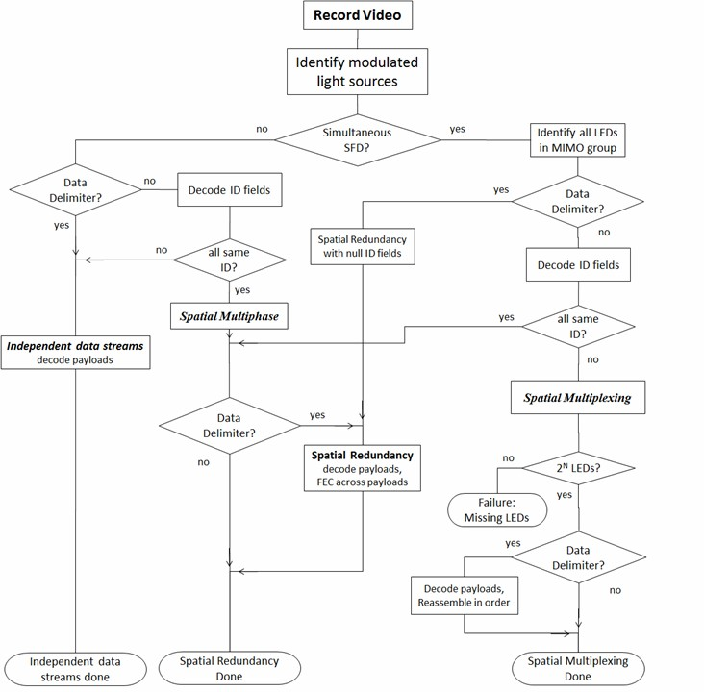

##### Figure M.1—UFSOOK MIMO protocol

1. **Identification of all the LEDs in a MIMO group.** All LEDs in a MIMO group simultaneously transmit the normal SFD. This identifies all the visible MIMO group members. The camera does a frame-by-frame scan of the lights looking for an occurrence of when a group of lights are simultaneously flashing the SFD.
2. **ID field decoding.** If the ID field is present, it will be between the SFD and data delimiter. LEDs that are doing spatial redundancy all use the same identifier number, which includes the null identifier code (no ID field). For spatial multiplexing, there must be exactly 2*N* LEDs in a MIMO group, and each LED shall fill the ID field with its group sequence number. The anchor LED is assigned the value zero, and the last LED in the group is assigned the value 2*N*–1. The group sequence number indicates the order in which to concatenate the payloads to reconstruct the original message. If mixed spatial multiplexing with subgroup redundancy is being done, then all the LEDs in a sub-group use the same identifier number.
3. **Spatial redundancy decoding of payloads and FEC across payloads.** For spatial redundancy the payload sent by each light is identical and is decoded using the UFSOOK demodulation algorithm. Once the payload has been decoded, FEC can be accomplished by bit voting across all the received payloads in the MIMO group. There is no constraint on the number of LEDs in a spatial redundancy MIMO group.
4. **Spatial multiplexing failure due to missing LEDs.** As previously mentioned, the number of LEDs in a spatial multiplexing MIMO group must be 2*N* (i.e., 1,2,4,8,16, and so on). For spatial multiplexing there should be 2*N* sequentially decoded sequence identifier numbers with no missing numbers. If there are not 2*N*, then some LEDs are missing from view, and spatially multiplexed communications cannot take place.
5. **Spatial multiplexing decoding of payloads and reassembly of ordered payload.** During spatial multiplexing, after the optional data delimiter flash, each LED sends its optional payload. If there is a payload, it shall be preceded with a data delimiter. All the individual payloads shall be the same length and shall be repetitive (cyclic); that is, the payload is repetitively and unchangingly sent in each packet. Bit stuffing should be used for any payloads requiring additional length.
6. **Significance of anchor identifier number.** In a physically dispersed array of LEDs doing MIMO, the anchor identifier represents the assigned physical location for the overall array; that is, it is the anchor location. All other LEDs in the array are not at this physical location. This concept is most useful for spatial multiplexing MIMO that is transmitting the anchor LED physical coordinates.

# Annex N

### (informative)

**Receiver details on Twinkle VPPM processing**

For the Twinkle VPPM preamble, shown in 8.6.1.2.2, the Nyquist sampled communications considers the communications to be quasi-synchronous. No effort is made to actually synchronize the receiver timing to the transmitter timing; rather, the preamble is oversampled, and a down-sampling phase is selected that offers the best performance for the given sample phases.

Figure N.1 details the receiver signal processing needed to extract the Twinkle VPPM signal.

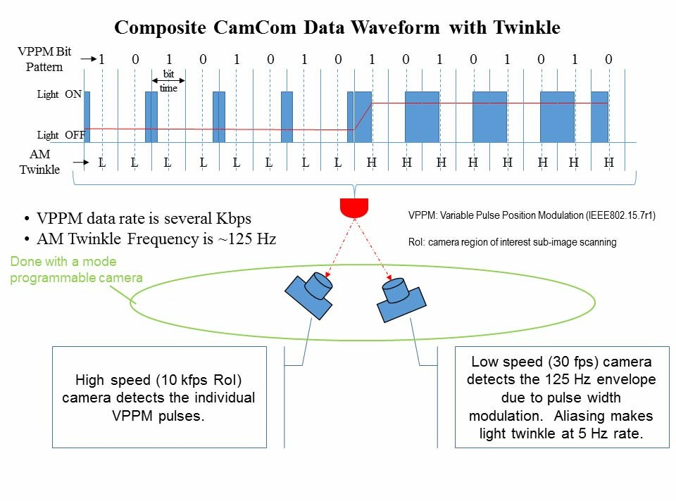

**Figure N.1—Twinkle VPPM receiver signal processing**



### I333

standajds¸ieee¸ojg

Phone: +f fS2 98f 0060 Fax: +f fS2 562 f5ff

© I333

Authorized licensed use limited to: McGill University. Downloaded on July 24,2019 at 08:17:21 UTC from IEEE Xplore. Restrictions apply.